|  |
| --- |
| ADI Study Watch  New Task Addition |
| REV 1.0.0,MAR 2021 |

Table of Contents

1 Prerequisite 4

2 Steps to add a new Task 5

List of Figures

Figure 1: New task addition 5

Figure 2: Add path to new task header 6

List of Tables

No table of figures entries found.Copyright, Disclaimer & Trademark Statements

Copyright Information

Copyright (c) 2021 Analog Devices, Inc. All Rights Reserved. This documentation is proprietary and confidential to Analog Devices, Inc. and its licensors. This document may not be reproduced in any form without prior, express consent from Analog Devices, Inc.

Disclaimer

Analog Devices, Inc. (“Analog Devices”) reserves the right to change this product without prior notice. Information furnished by Analog Devices is believed to be accurate and reliable. However, no responsibility is assumed by Analog Devices for its use; nor for any infringement of patents or other rights of third parties which may result from its use. No license is granted by implication or otherwise under the patent or other rights of Analog Devices

Trademark and Service Mark Notice

Analog Devices, the Analog Devices logo, Blackfin, SHARC, TigerSHARC, CrossCore, VisualDSP, VisualDSP++, EZ-KIT Lite, EZ-Extender, SigmaStudio and Collaborative are the exclusive trademarks and/or registered trademarks of Analog Devices, Inc (“Analog Devices”).

All other brand and product names are trademarks or service marks of their respective owners.

Analog Devices’ Trademarks and Service Marks may not be used without the express written consent of Analog Devices, such consent only to be provided in a separate written agreement signed by Analog Devices. Subject to the foregoing, such Trademarks and Service Marks must be used according to Analog Devices’ Trademark Usage guidelines. Any licensee wishing to use Analog Devices’ Trademarks and Service Marks must obtain and follow these guidelines for the specific marks at issue.

# Prerequisite

The steps given below expects that the reader is familiar with the Study Watch source code and source files.

# Steps to add a new Task

The steps to add a new FreeRTOS task to the watch application is listed here:

1. Take an existing application task source & header file as reference and add the new_task.c, new_task.h file into a relevant folder within adi_study_watch/modules/ folder. As an example, pedometer_task.c and pedometer_task.h file can be taken as reference.
2. Fill in the functions in these files appropriately: task initialization function, task function, m2m2 commands handling function, send_new_task_app_data() to be used for sending messages from post office, etc.
3. Update watchv4_nrf52840 SES project:

* Add the new_task.c file from the SES Project explorer:

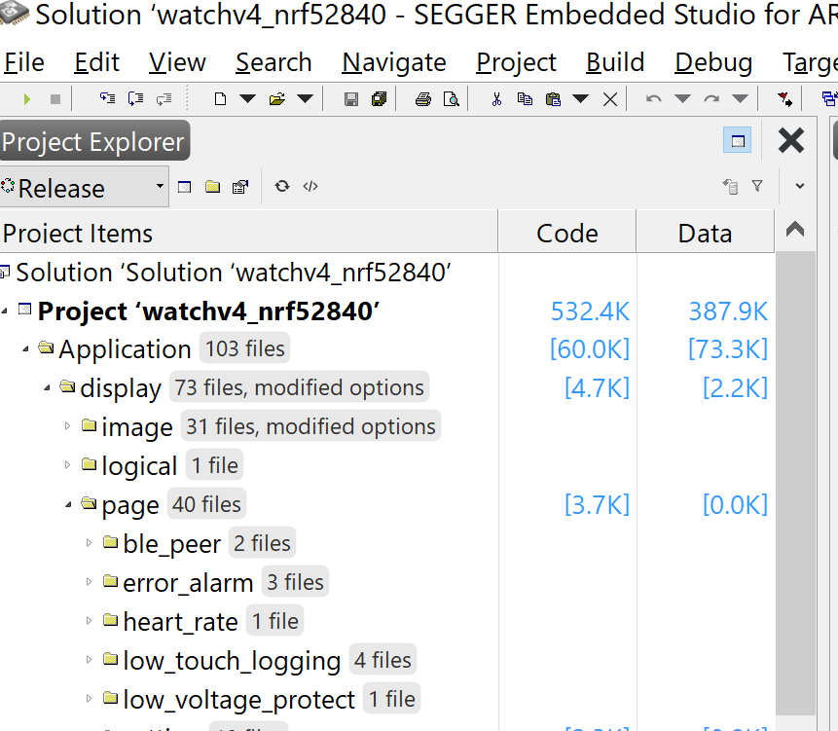

Figure 1: New task addition

* Add the path to new_task.h file from Project options:

Figure 2: Add path to new task header

1. Edit adi_study_watch/modules/system/**post_office.h** file:

* Update task_queue_index_t, to add new task index, for the new task.

1. Edit adi_study_watch/modules/system/**post_office.c** file:

* Include new_task.h
* Update relevant fields in post_office_routing_table_entry_t m2m2_routing_table[]

1. Edit adi_study_watch/cli/m2m2/inc/c/**m2m2_core.h**file:

* Add the m2m2 address for the new task and new task stream into M2M2_ADDR_ENUM_t enum list

1. Edit adi_study_watch/cli/m2m2/inc/python/**m2m2_core_def.py**file:

* Add the m2m2 address for the new task and new task stream into class M2M2_ADDR_ENUM_t enum list

1. Add files in adi_study_watch/cli/m2m2/inc c, python, cpp, master_definitions folders to add the new_task_interface .h/.py/.hpp/.py definitions
2. Edit adi_study_watch/app/nRF52840_app/**app_cfg.h**

* Add following defines as relevant for new task:

#define  APP_OS_CFG_NEW_TASK_PRIO                      6

#define  APP_OS_CFG_NEW_TASK_STK_SIZE             1024

1. Edit adi_study_watch/app/nRF52840_app/**main_freertos.c** file:
   * Include new_task.h
   * Call the new_task_init(); before vTaskStartScheduler(); call
2. Add relevant test commands for new task or streams in adi_study_watch/cli/m2m2/tools/**CLI.py**file
3. Add the app task address and stream address in application_name_map and stream_name_map list in adi_study_watch/cli/m2m2/tools/**m2m2_common.py**file
4. Add a new “class new_task_plot” to plot the data from new task onto adi_study_watch/cli/m2m2/tools/plot_parsers.py file