Safari Multi-Sensor

Mezzanine Card Demo

User Guide

**Version 0.1 1/16/2019**

Table of Contents

1. Introduction 3

2. Kit Contents 3

3. Required Hardware 3

3.1 a 3

4. Required Software 3

4.1 Required Applications 3

5. Hardware Setup 4

5.1 Connect the Safari board to the Meerkat using the 40 pin low-speed connector J7. 4

5.2 Plug the microUSB connector end of the USB cable into the FTDI UART chip. Plug the other end into a PC running Windows 10. 4

5.3 Plug the dual power supply in 4

6. Software Setup 5

6.1 Download and Run Software 5

7. Running the Demonstration 5

7.1 Initial Setup 5

7.2 Connecting to the Demo Kit 5

7.3 Connecting the Demo Kit to Wi-Fi 6

7.4 Connecting the PC to Arrow Connect 9

7.5 Running the Demo 9

7.6 Understanding the Data 10

8. APPENDIX 12

8.1 More Information 12

8.2 Troubleshooting 12

8.3 FAQ 13

9. REVISION HISTORY 14

# Introduction

Describe what the Safari board is, what it was designed for, and what is contained within this User Guide.

# Kit Contents

Safari board

Meerkat

MicroUSB to USB Type B cable

Analog Devices ADXL203B Accelerometer

Sparkfun PT100 Platinum RTD temperature sensor

Sensirion Differential Pressure Sensor

Sensirion Combination Humidity and Temperature Sensor

? 12V/?A, 24V/?A dual power supply

# Required Hardware

Safari board

<INSERT PICTURES OF SAFARI, MEERKAT, Motor, all sensors, cables>

## a

# Required Software

**s**

## Required Applications

# Hardware Setup

This

## Connect the Safari board to the Meerkat using the 40 pin low-speed connector J7.

## Plug the microUSB connector end of the USB cable into the FTDI UART chip. Plug the other end into a PC running Windows 10.

## Plug the dual power supply in

# Software Setup

The instructions in this section will guide you through the software setup of the Safari multi-sensor demo.

## Download and Run Software

Download the Safari software by downloading the safari.exe file from [here](https://github.com/ArrowElectronicsESC/Safari).

# Running the Demonstration

This section describes how to run the Safari demo software.

## Initial Setup

1. Power up the Safari demo kit
2. Wait approximately 15 seconds for the demo kit to fully power up
3. Launch Safari GUI software
4. Connect your laptop to any network without restricted ports, preferably a hotspot from a mobile device.
   1. If there is no suitable Wi-Fi network, the demo will still function however the data will only be sent across the serial connection and not to the cloud. See section 7.6.b for more details.
5. Connect your laptop to the safari demo kit by plugging the attached USB cable into your laptop

## Connecting to the Demo Kit

1. In the Serial section of the Setup tab in the GUI, select the appropriate serial port and click the connect button.

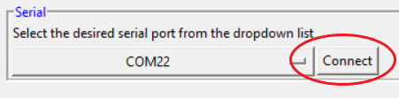

1. Wait approximately 10 seconds for the connection to complete

## Connecting the Demo Kit to Wi-Fi

1. The demo kit will attempt to connect to the last Wi-Fi network it used.
2. If the demo kit successfully connects to a network, the Status field in the Wi-Fi section will update to "Connected", and the SSID and IP Address fields will show the current network settings

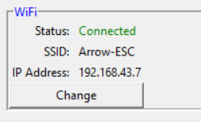

1. If you would like to change the current network, click the Change button. If the current network is correct, skip to step 7.4.

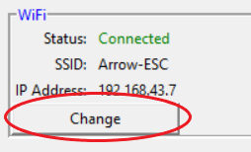

1. If the demo kit cannot connect to a network or the Change button was clicked (step 7.3.3 above), the GUI will prompt for the SSID and Password of the desired network.
   1. Demo kit could not connect to Wi-Fi

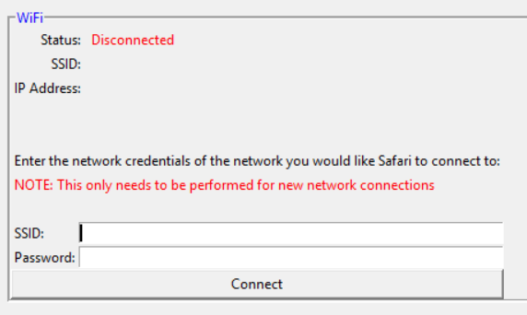

* 1. Change button clicked

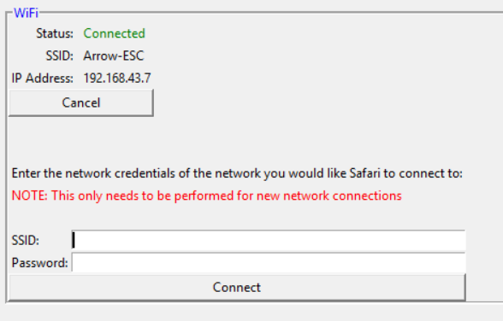

1. Enter the SSID and Password of the network for the demo kit to connect to. This should be the same network used in step 7.1.4 above.

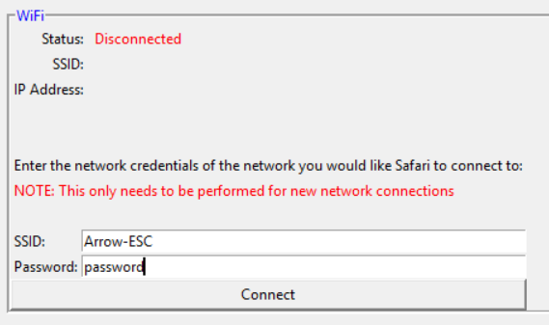

* 1. To disconnect from the current network or to clear out any previous Wi-Fi connections, simply leave **BOTH** the SSID and Password fields blank

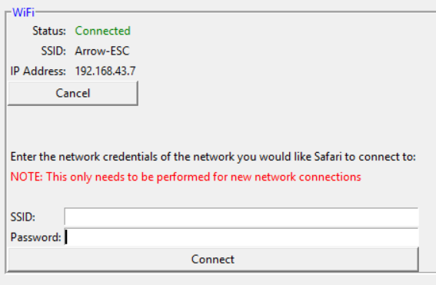

1. Click the Connect button.

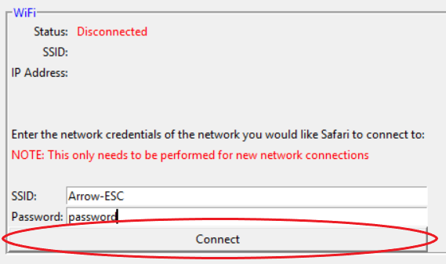

* 1. The demo kit will now attempt to connect to the specified network. In some cases, it may be necessary to reboot the Safari board in order to complete the Wi-Fi connection. If this is needed, the GUI will prompt the user to reset the device with a pop-up dialog box. If this happens, click Ok in the dialog box and then press the reset button on the Safari board. The reset button is located at the top left corner of the board near pin 1 of connector J7 and is labeled “MCU RST”.

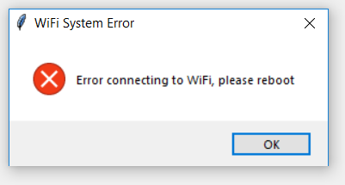

* 1. If a Wi-Fi connection cannot be made on the demo kit, sensor data will be sent across the serial connection instead of to the cloud.

## Connecting the PC to Arrow Connect

1. Your laptop will automatically connect to Arrow Connect using credentials read from the demo kit during step 2.
   1. If the connection to Arrow Connect is successful, the Status field in the Arrow Connect section will indicate Connected and the Device Name and Device HID fields will update with values matching the demo kit.

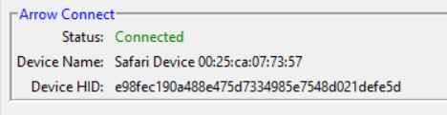

* 1. If the connection to Arrow Connect is unsuccessful, the status field will indicate Disconnected. The most likely cause of this error is selecting a network with restricted ports in step 7.1.4. Close the GUI, relaunch, and start again from step 7.1.1

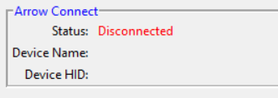

If problems still persist, please refer to the Troubleshooting section in the appendix.

## Running the Demo

1. Navigate to the Safari Data tab in the GUI
2. Click the Start Demo button in the Safari section of the GUI



1. Click the Stop Demo button to stop the demo



## Understanding the Data

1. Navigate to the Safari Data tab in the GUI to view the data
2. The Data Streaming Method indicates how the GUI software is receiving the data. This field will either indicate “Cloud” if data is being received from Arrow Connect via MQTT or “Serial” if data is being received via the serial port connection to the demo kit or “None” if no data is currently being received.
   1. None



* 1. Cloud



* 1. Serial



1. When the Data Format radio button at the bottom Safari Data tab is set to Raw:



* 1. The top subplot, Channel 0 Voltage, shows the raw voltage from channel 0 of the AD7124 (accelerometer). Note the X-axis is sample number and the Y-axis is Voltage. The annotation to the right of the plot shows the maximum, mean, and minimum values for the data currently displayed by the plot as well as the last value received. The value of any point on the plot can also be seen by hovering over the desired point.

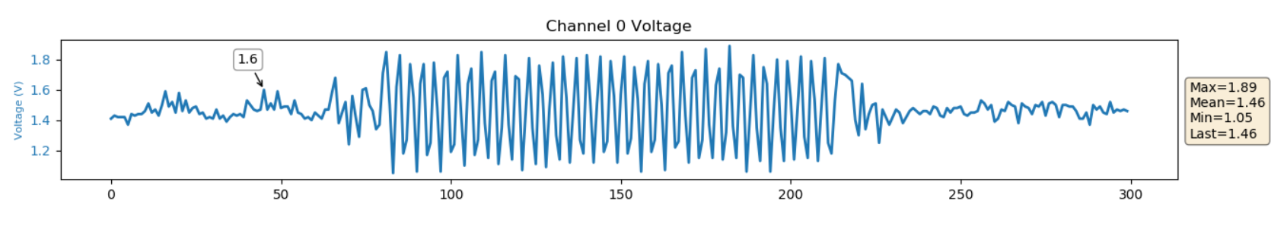

* 1. The next subplot, Channel 4 Voltage, shows the raw voltage from channel 4 of the AD7124 (temperature sensor). Note when the demo kit receives data via the cloud, the X-axis is time in the format MM:SS.ms; when the demo kit receives data via serial, the X-axis is sample number. The Y-axis is Voltage regardless of how data is received. The annotation to the right of the plot shows the maximum, mean, and minimum values for the data currently displayed by the plot as well as the last value received. The value of any point on the plot can also be seen by hovering over the desired point.

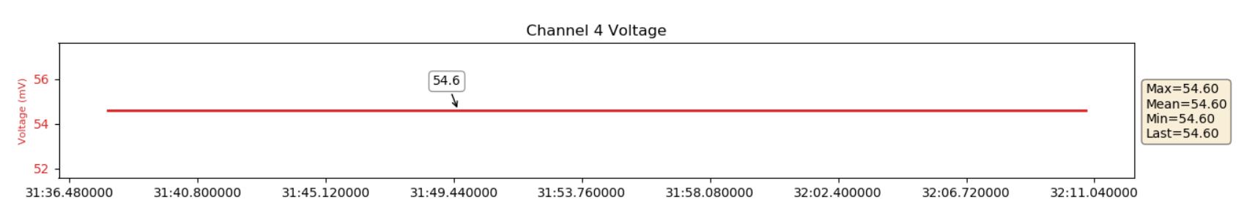

* 1. The bottom subplot, Channel 6 Voltage, shows the raw voltage from channel 6 of the AD7124 (pressure sensor). Note when the demo kit receives data via the cloud, the X-axis is time in the format MM:SS.ms; when the demo kit receives data via serial, the X-axis is sample number. The Y-axis is Voltage regardless of how data is received. The annotation to the right of the plot shows the maximum, mean, and minimum values for the data currently displayed by the plot as well as the last value received.

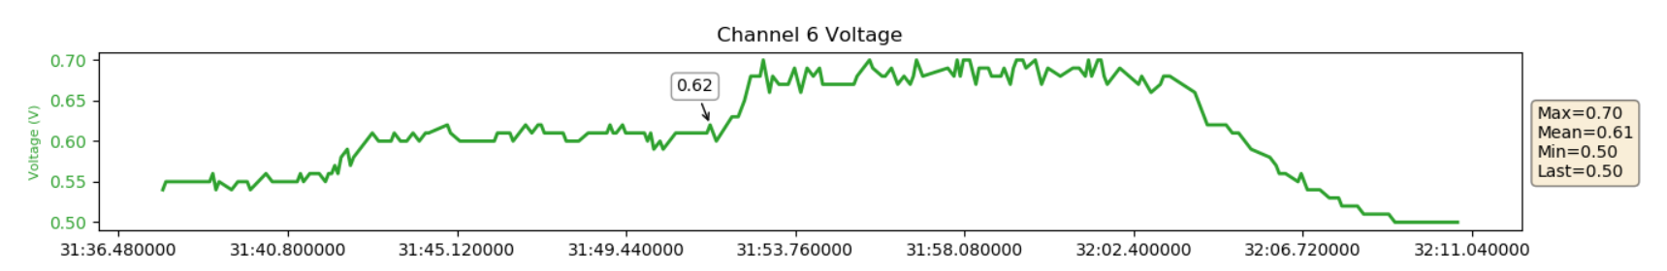

1. When the Data Format radio button at the bottom Safari Data tab is set to Converted:



* 1. The top subplot, Accelerometer, shows the reading from the accelerometer. Note the X-axis is sample number and the Y-axis is acceleration measured in G’s. The annotation to the right of the plot shows the maximum, mean, and minimum values for the data currently displayed by the plot as well as the last value received. The value of any point on the plot can also be seen by hovering over the desired point.

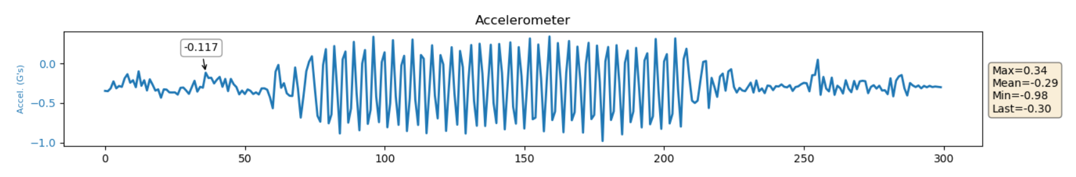

* 1. The next subplot, Temperature, shows the reading from the temperature sensor. Note when the demo kit receives data via the cloud, the X-axis is time in the format MM:SS.ms; when the demo kit receives data via serial, the X-axis is sample number. The Y-axis is temperature measured in degrees Celsius regardless of how data is received. The annotation to the right of the plot shows the maximum, mean, and minimum values for the data currently displayed by the plot as well as the last value received. The value of any point on the plot can also be seen by hovering over the desired point.

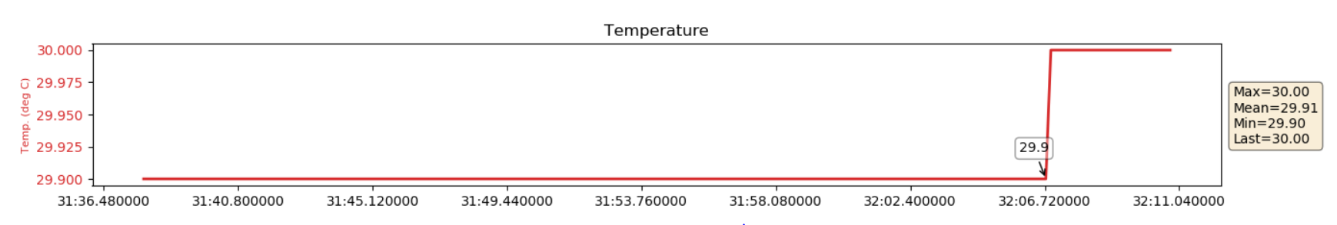

* 1. The bottom subplot, Pressure, shows the reading from the pressure sensor. Note when the demo kit receives data via the cloud, the X-axis is time in the format MM:SS.ms; when the demo kit receives data via serial, the X-axis is sample number. The Y-axis is pressure measured in Pascals regardless of how data is received. The annotation to the right of the plot shows the maximum, mean, and minimum values for the data currently displayed by the plot as well as the last value received. The value of any point on the plot can also be seen by hovering over the desired point.

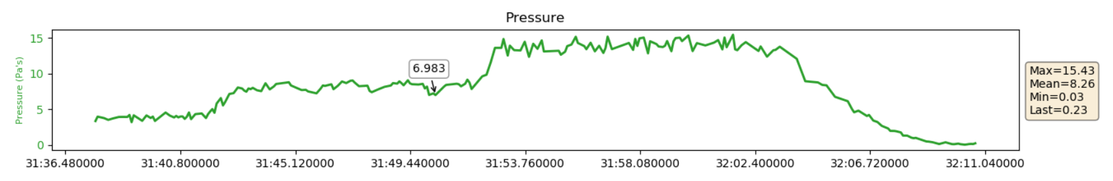

# APPENDIX

## More Information

96boards.org

AD7124 Product Page

## Troubleshooting

|  |  |
| --- | --- |
| Problem | Fix |
| There is no Wi-Fi network available | Proceed running the demo without connecting to Wi-Fi. All the data will be received using the serial connection |
| The PC and demo kit are connected to Wi-Fi but there doesn’t appear to be any data received from the cloud | The port used for MQTT (1883) is most likely blocked/restricted on the network preventing data from being sent from the demo kit as well as data being received from Arrow Connect. Try using a different Wi-Fi network or no network at all. |
| The setup process has been completed but the demo isn’t working as expected. | Close the GUI software and power off the demo kit. Wait approximately 30 seconds and then restart the demo. |
| The GUI doesn’t show any serial devices or COM ports | Check the Device Manager to see if the serial device is present. If it is not, unplug the serial cable and plug it into a different USB port if possible. If the serial device is present in the Device Manager, close and relaunch the GUI. |
| The GUI shows the Data Streaming Method as Cloud or Serial but no data appears | There is most likely a problem communicating with the Safari mezzanine card. Close the GUI software and power off the demo kit. Wait approximately 30 seconds and then restart the demo. |

## FAQ

**Q: How is the GUI getting the data to plot?**

**A**: When the demo kit is connected to Wi-Fi, the temperature and pressure data is sent to Arrow Connect using MQTT and the accelerometer data is sent to the GUI using the serial (UART) connection. The GUI plots the accelerometer data when it is received from the serial port, while the temperature and pressure data are plotted by subscribing to the same Arrow Connect MQTT topic to which the demo kit is publishing. In the case when the demo kit is not connected to Wi-Fi, all data is sent to the GUI using the serial connection.

**Q: Why does there seem to be a delay in some of the temperature and pressure data timestamps.**

**A**: This is a result of network latency. The demo kit is sending data to Arrow Connect while the laptop is receiving data from Arrow Connect, if the network is slow or congested there will be delays. There should be no missed packets due to the MQTT quality of service (QoS) setting.

**Q: Why MQTT and not REST?**

**A**: MQTT is lower power, allows for the device to always be connected to the cloud, and is faster than REST.

**Q: What programming language was used to create the demo?**

**A**: Python.

**Q: Why Python?**

**A**: Python was used because of it's portability across platforms, allowing the Safari demo to be run on any 96Boards platform with Python support.

# REVISION HISTORY

|  |  |  |
| --- | --- | --- |
| Revision | Changes | Date |
| 0.0 | Pre-release | 1/8/2019 |
| 0.1 | Added Software Setup, Running the Demonstration, and FAQ sections. | 1/16/2019 |
| 0.2 | Updated document with pictures for clarity. | 1/21/2019 |
| 0.3 | Updated with additional pictures | 1/21/2019 |
| 0.4 | Updated Running the Demo and Understanding the Data sections to reflect updated GUI | 1/23/2019 |
| 1.0 | Initial release |  |