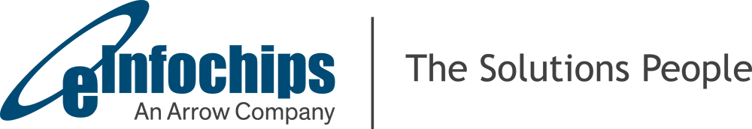

User Guide
Blue Gecko Test Setup

Version  Status  Date | 0.1  Draft  27/09/2019

Confidentiality Notice
Copyright (c) 2018 eInfochips. - All rights reserved
This document is authored by eInfochips and is eInfochips intellectual property, including the copyrights in all countries in the world. This document is provided under a license to use only with all other rights, including ownership rights, being retained by eInfochips. This file may not be distributed, copied, or reproduced in any manner, electronic or otherwise, without the express written consent of eInfochips.

Contents

1 Document Details 3
1.1 Document History 3
1.2 Definition, Acronyms and Abbreviations 3
1.3 References 3
2 Introduction 4
3 System Overview 5
4 Hardware Setup 6
4.1 Blue Gecko Kit 6
4.2 Interposer Board 6
4.3 LoRa Radio Module from Semtech 7
4.4 Interconnections 7
5 Source code 8
5.1 Download Repository 8
5.2 Create a Build and Flash 8
6 Test Setup 9
6.1 Code Updates for BLE Tests 9
6.1.1 Connection Interval test updates 9
6.1.2 MTU test updates 9
6.1.3 Fixed Time, Fixed Data and Free data test updates 9
6.2 Code Updates for LoRa Tests 9
6.3 Code Updates for FUOTA Test 9
7 Appendix A 10

Document Details

Document History
Version | Author |  | Reviewer |  | Approver
Version | Name | Date  (DD-MM-YYYY) | Name | Date  (DD-MMM-YYYY) | Name | Date  (DD-MM-YYYY)
Draft 0.1 | Ankush Kapile | 27/09/2019

Version | Description of Change
Draft 0.1 | Created initial draft version

Definition, Acronyms and Abbreviations
Definition/ Acronym/ Abbreviation | Description

References

# | Document | Version | Remarks

Introduction

This document involves test setup details for Blue Gecko devices having BLE and LoRa protocol stack support with BLE throughput tester application and LoRaWAN application.
Overall system consists of following system blocks -
- EFR32 Blue Gecko (SLWSTK6020B) Starter Kit with Blue Gecko SoC module (BRD4103A A01)
- Semtech SX1261/2 RF module
- Interposer card
- Multitech Gateway
- Ubuntu Machine installed with Lora Server and Lora App Server

It also includes LoRaWAN FUOTA application in Class A and Class C mode.

System Overview

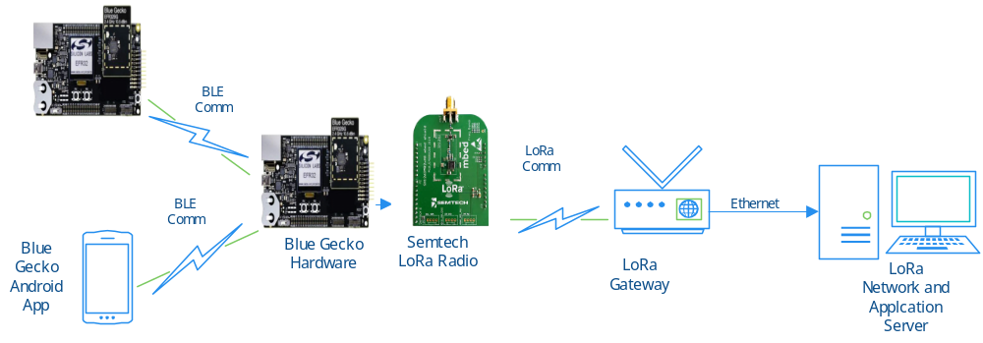
Figure 1: Setup Block Diagram for BLE and LoRaWAN concurrent Test

End node consisting of Blue Gecko and Semtech LoRa radio communicates with LoRa Network server and LoRa Application server via Multitech LoRa gateway. Concurrently Bluetooth Low Energy (BLE) application runs on the Blue Gecko which communicates with another bluetooth device either in master/slave modes. End node runs applications with micrium OS, BLE Stack and LoRa Stack. LoRaWAN supports two modes of operation Class A or Class C.
Semtech LoRa radio is connected with Blue Gecko board via SPI interface. Multitech Gateway connected with end node and LoRa network server. Lora server handles received uplink frames from the gateway, handles LoRaWAN Mac layer and schedules downlink data transmission. LoRa app server handles join requests and encryption of application payloads. Output parameters are captured in application server on host machine. Output parameters are captured in application server on host machine. Bit rate is measured on LCD screen of Blue Gecko board.

Hardware Setup
Required Hardware details are as below:

# | Hardware Details | Description | Version | Remarks
1 | EFR32 Blue Gecko Starter kit | Wireless Kit | EFR32 (SLWSTK6020B)
2 | EFR32BG12 Blue Gecko SoC | End device with MCU | EFR32BG12 (BRD4103A A01)
3 | Semtech SX1261 Radio module | Radio module | SX1261MB2BAS
4 | Semtech SX1262 Radio module | Radio module | SX1262MB1DAS
5 | Multitech gateway | Gateway for communicating with end node and network server | MTCDT-246A-915-SLZD  MTCDT-246A-868-SLZD

Blue Gecko Kit

Given below are the Blue Gecko board details which have been used for the development and testing of the BLE and LoRa concurrency tests.

EFR32 Dev Kit: Bluetooth Kit for EFR32™ Blue Gecko SoCs SLWSTK6020B
https://www.silabs.com/products/development-tools/wireless/bluetooth/blue-gecko-bluetooth-low-energy-soc-starter-kit

EFR32BG12 Blue Gecko Bluetooth Low Energy +10 dBm Output Power Radio Board
https://www.silabs.com/products/development-tools/wireless/bluetooth/slwrb4103a-wireless-radio-board

Interposer Board

Interposer board is designed to provide the connection between Blue Gecko interface and the LoRa radio module which is Arduino compatible.

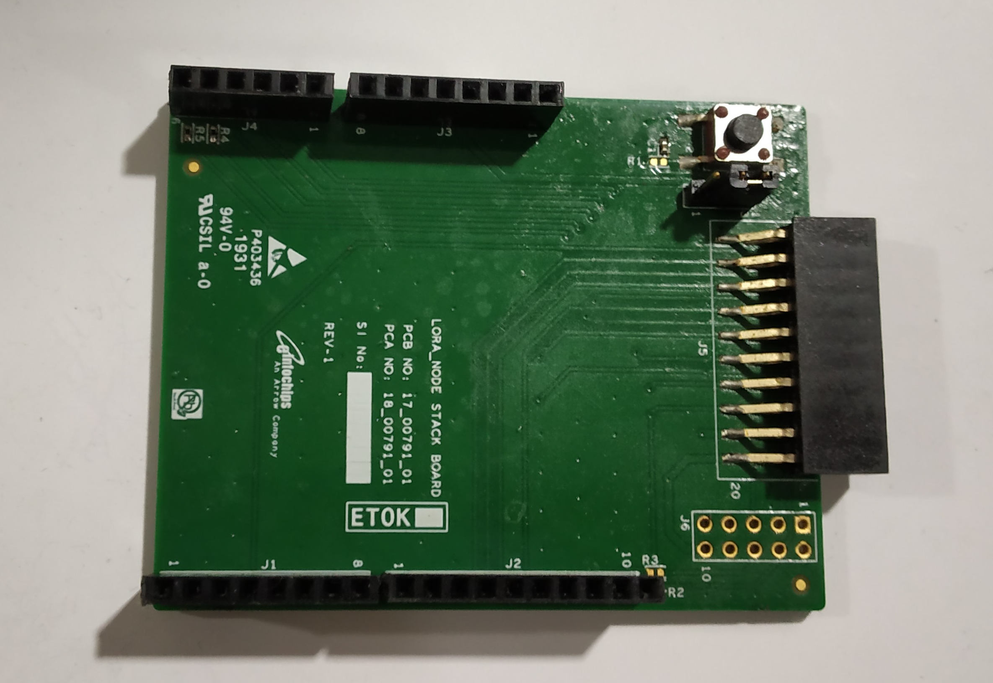

Figure 2: Interposer Board

LoRa Radio Module from Semtech

Semtech radio SX1261 and SX1262 will be required for the EU and US region.

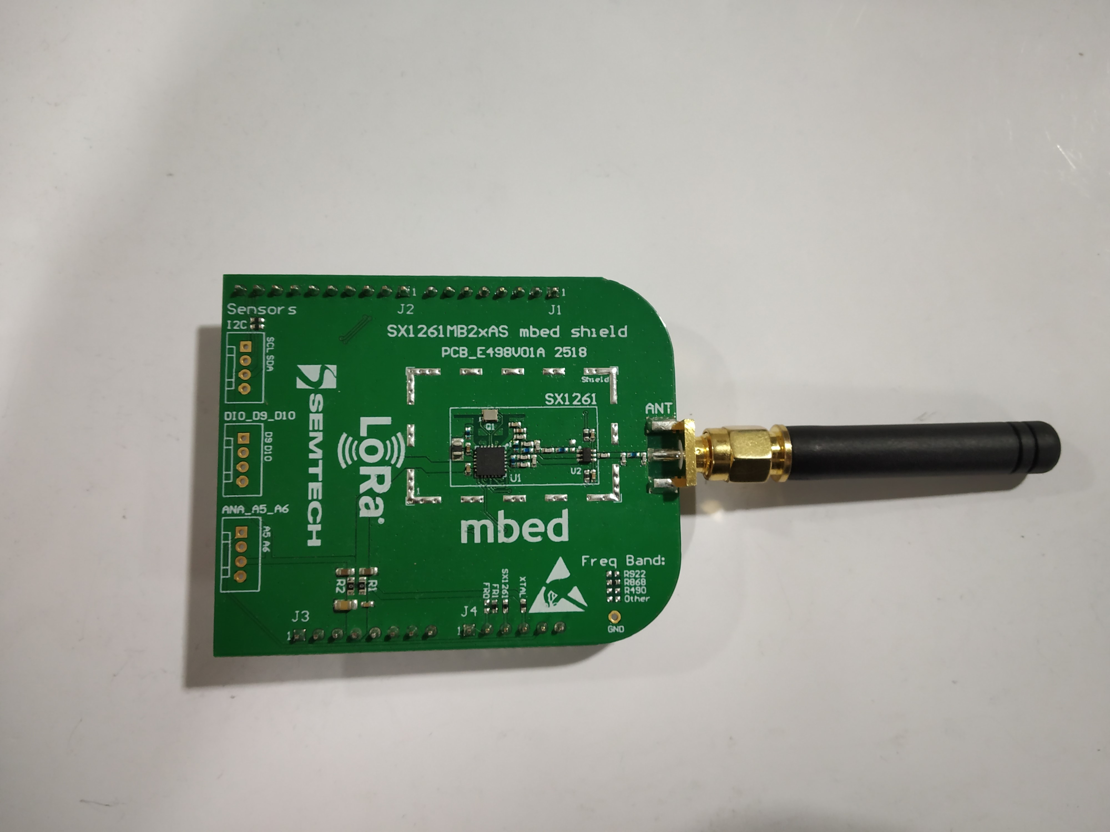

Figure 3: Semtech LoRa radio SX1261

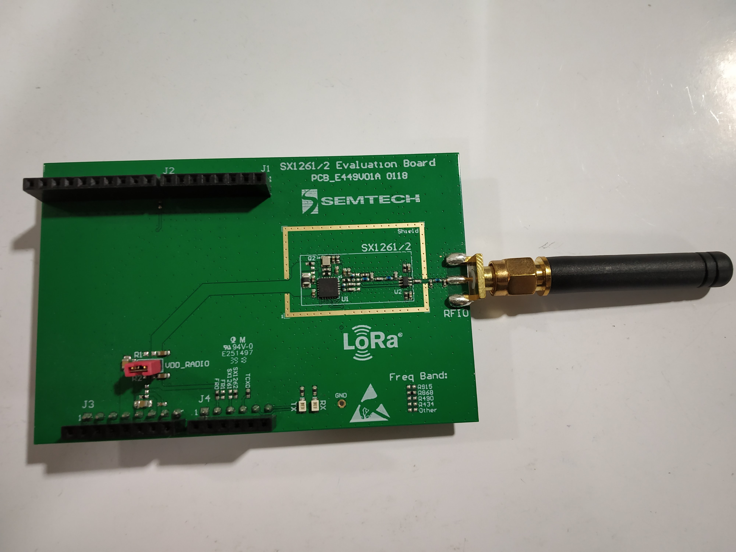

Figure 4: Semtech LoRa radio SX1262

Interconnections

All three boards will be connected as shown below:

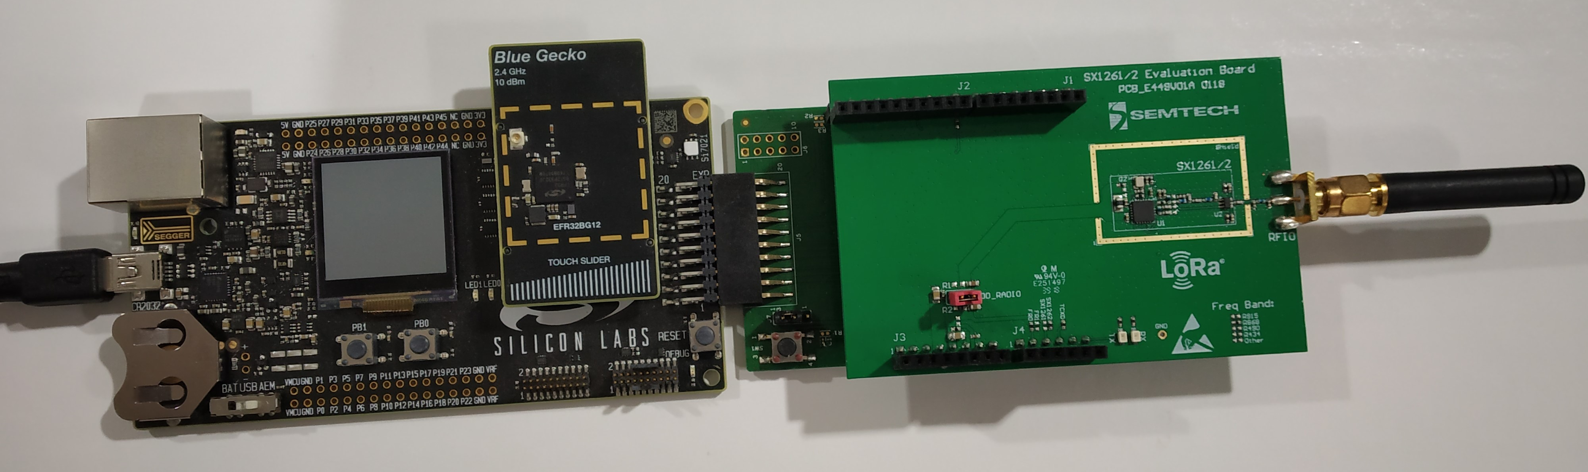

Figure 5: LoRa radio + Interposer board + Blue Gecko interconnections

Source code

Download Repository

Blue Gecko repository for BLE + LoRa application is available at:
https://github.com/ArrowElectronicsESC/SiLabsLoRa_EFR_BG.git

Blue Gecko repository for FUOTA application is available at:
https://github.com/ArrowElectronicsESC/SiLabsLoRa_EFR_BG_FUOTA.git

Create a Build and Flash

Follow the steps to import the project and compile the downloaded repository as per Simplicity Studio process. Once the build is ready as per required test cases, flash it to the particular target.

Follow below steps:

1. Connect end node hardware Blue Gecko board to host using USB.

2. Build BLE and LoRa concurrent application in Simplicity Studio.

3. Flash binary (.bin) generated to Blue Gecko board.

4. Check the output parameters of BLE throughput tests displayed on LCD display of Master Blue Gecko board.

5. Check the output parameters of LoRa tests on Gateway server or LoRa application server.

Test Setup

Code Updates for BLE Tests

Below changes are for Blue Gecko repository for BLE + LoRa application only.

Connection Interval test updates

Update below params in file src/ble/app_master.c line: 14 and 15 to value x:
CONN_INTERVAL_1MPHY_MAX <x>
CONN_INTERVAL_1MPHY_MIN <x>

set x = 8 for TC_35 Connection interval is set to 10 ms,
set x = 40 for TC_39 Connection interval is set to 50 ms and
set x = 320 for TC_41 Connection interval is set to 400 ms,

Note: Here Test Cases are referred as per BLE+LoRa Test Case document.

MTU test updates

For TC_41, update src/ble/app.c line:93 in function gecko_cmd_gatt_set_max_mtu(x)
where x should be max MTU value set to 25

Fixed Time, Fixed Data and Free data test updates

For Fixed Time, Fixed Data and Free data transfer mode Comment/uncomment #defines SEND_FIXED_TRANSFER_COUNT and SEND_FIXED_TRANSFER_TIME accordingly in file src/ble/app_utils.h line: 77 and 78 as following:
Free Mode: Comment both macros
Fixed Data Mode: Uncomment SEND_FIXED_TRANSFER_COUNT only
Fixed Time Mode: Uncomment SEND_FIXED_TRANSFER_TIME only

Code Updates for LoRa Tests

Below changes are for Blue Gecko repository for BLE + LoRa application only.

- OTAA mode -
To connect LoRa end node in OTAA mode set following parameters in mbed_config.h file –
E.g. Set macro values as following -
MBED_CONF_LORA_OVER_THE_AIR_ACTIVATION - 1
MBED_CONF_LORA_DEVICE_EUI - { 0x00, 0x80, 0x00, 0x00, 0x00, 0x00, 0xfe, 0x69 }
MBED_CONF_LORA_APPLICATION_EUI - { 0x01, 0x02, 0x03, 0x04, 0x05, 0x06, 0x07, 0x10 }
MBED_CONF_LORA_APPLICATION_KEY - { 0x01, 0x02, 0x03, 0x04, 0x05, 0x06, 0x07, 0x10, 0x01, 0x02, 0x03, 0x04, 0x05, 0x06, 0x07, 0x10 }

On Gateway/LoRa app server set same APP_EUI and APP_KEY as mentioned above.
.

- ABP mode –
To connect LoRa end node in ABP mode set following parameters in mbed_config.h file –
E.g. Set macro values as following -
MBED_CONF_LORA_OVER_THE_AIR_ACTIVATION - 0
MBED_CONF_LORA_DEVICE_EUI - { 0x00, 0x80, 0x00, 0x00, 0x00, 0x00, 0xfe, 0x69 }
MBED_CONF_LORA_APPSKEY - { 0x01, 0x02, 0x03, 0x04, 0x05, 0x06, 0x07, 0x10, 0x01, 0x02, 0x03, 0x04, 0x05, 0x06, 0x07, 0x10 }
MBED_CONF_LORA_NWKSKEY - { 0x01, 0x02, 0x03, 0x04, 0x05, 0x06, 0x07, 0x10, 0x01, 0x02, 0x03, 0x04, 0x05, 0x06, 0x07, 0x10 }
MBED_CONF_LORA_DEVICE_ADDRESS - 0x00000010

On Gateway/LoRa app server set same DEV_EUI, APPS_KEY, NWKS_KEY and DEV_ADDR as mentioned above.

- PHY Region –
Set Parameters in mbed_config.h as following -
MBED_CONF_LORA_PHY - EU868 / US915
MBED_CONF_LORA_FREQ_SELECT – 0 for EU868 and 1 for US915
MBED_CONF_LORA_DEVICE_SELECT – 0 for SX1261 and 1 for SX1262
Note for US915 region set –
MBED_CONF_LORA_FSB_MASK - { 0x00FF, 0x0000, 0x0000, 0x0000, 0x0001 }

On gateway side select FSB as 1.

Code Updates for FUOTA Test

Below changes are for Blue Gecko repository for FUOTA application only.

Steps to execute FUOTA Test –

- Flash gecko bootloader on EFM32GG11 board. For example flash “bootloader-storage-internal-single-2048k_2-combined.s37” provided in source code under folder
Gecko_bootloader_combined_image.

- Connect end node in OTAA mode with following parameters –
In mbed_config.h set -
MBED_CONF_LORA_OVER_THE_AIR_ACTIVATION - 1
In main.cpp set -
MBED_CONF_LORA_DEVICE_EUI - { 0x00, 0x80, 0x00, 0x00, 0x00, 0x00, 0xfe, 0x69 }
MBED_CONF_LORA_APPLICATION_EUI - { 0x01, 0x02, 0x03, 0x04, 0x05, 0x06, 0x07, 0x10 }
MBED_CONF_LORA_APPLICATION_KEY - { 0x00, 0x01, 0x02, 0x03, 0x04, 0x05, 0x06, 0x07, 0x08, 0x09, 0x0A, 0x0B, 0x0C, 0x0D, 0x0E, 0x0F }
On LoRa app server set same APP_KEY as mentioned above for the DEVICE_EUI.
Rest of the setting for PHY region are same as mentioned in step 3 of Code Updates for LORA Tests.

- Build the code and flash the binary in debug mode.

- Follow LoRaServer setup user guide to setup LoRa server, LoRa App server on host machine
- On host machine having LoRa server setup run FUOTA server script as mentioned in LoRaServer document with newer firmware image input to the script. (Generate fragmented packets.txt from .gbl file of newer firmware to give input to script. Refer FUOTA server setup document for the same. See Note below for .gbl file generation.)
e.g. Use packets.txt present in folder Upgrade_test_firmware having LED1 toggle application firmware to upgrade the firmware.

- Upon successful firmware update onboard LED1 will toggle continuously.

Note for generating newer firmware image –
- Version number for the application firmware image to be upgraded must be greater than current running application. For that set APP_PROPERTIES_VERSION in application_properties.c file greater than base version.
- How to generate .gbl file from .s37 file –
Put .s37 file in C:\SiliconLabs\SimplicityStudio\v4\developer\adapter_packs\commander where commander application .exe is present, go to cmd line and execute following command -
“commander gbl create LoRa_Stack_Port_CxxProject.gbl --app LoRa_Stack_Port_CxxProject.s37”

Appendix A
<Provide Project Specific Appendix, if any >

