### Steps to setup Alexa Custom Skill

1. Amazon Developer Skills portal:
   1. Go to the link: https://developer.amazon.com/alexa/console/ask
   2. Login or create an account with the same Amazon account that your Echo is linked to
   3. Click on the "Create Skill" button
   * 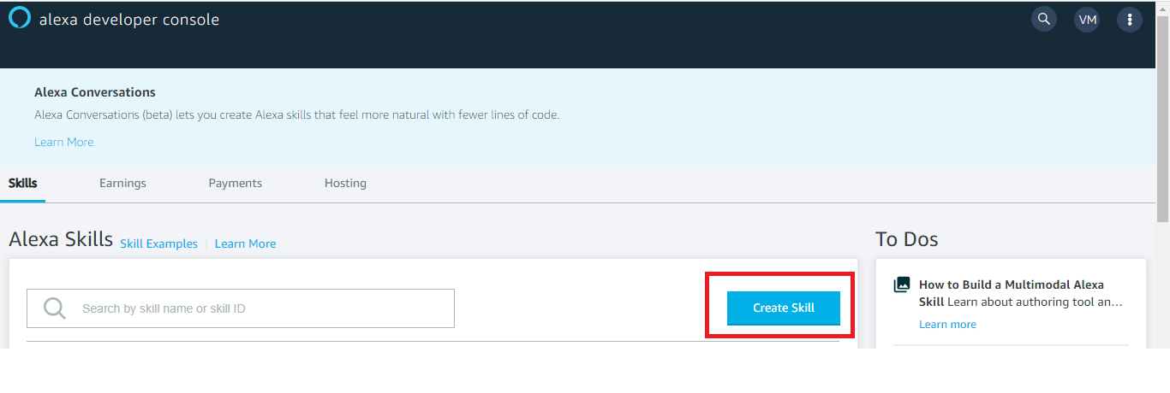
   1. Enter a relevant name in the "Skill Name" field and select "Custom"  
        
      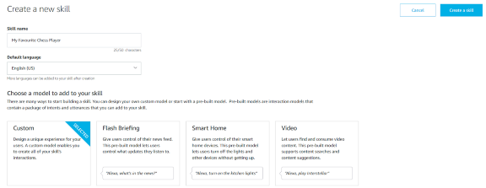
   2. In the "Choose a method to host your skill's backend resources" section, select "Provision your own."
   3. Click the "Create Skill"
   4. In the "Choose a template for skill", select the "Hello World template"
2. Building the Interaction Model
   1. Select the "Invocation" tab.
   2. Enter "efr iot gateway" in the "Skill Invocation Name" field.
   * The invocation name is what we say to start the interaction with our skill.
   * 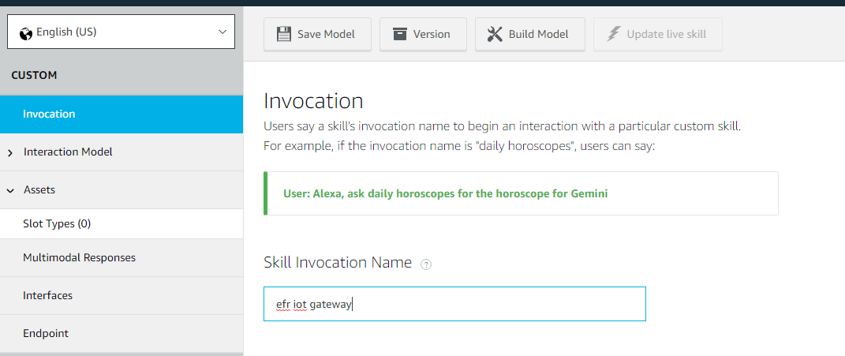
   1. Open "Interaction Model > JSON editor"  
        
      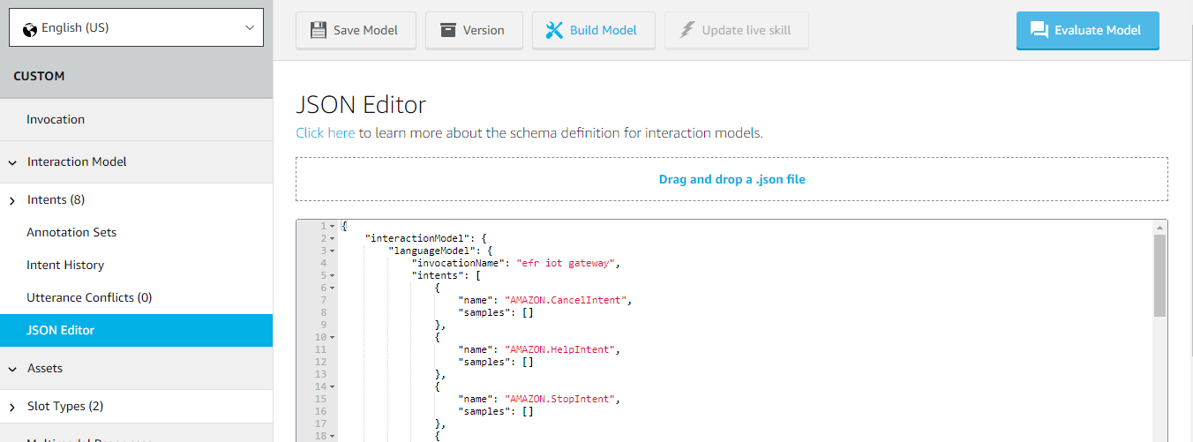
   2. Copy the contents of the file "alexa-skills-efr32-gateway.json" or drag and drop the json file.  
      This will add the necessary "intents" and "slots" required for our skill
   3. Click on "Save Model" and you should be able to see the "Intents" and "Slot Types" populated with the values added in the json.
3. Adding the endpoint
   1. In order for the Alexa Skill to work, you need to configure an endpoint, which will be invoked by Alexa.
   2. Go to "Endpoint" tab, and select the radio button "AWS Lambda ARN", if not already selected.  
        
      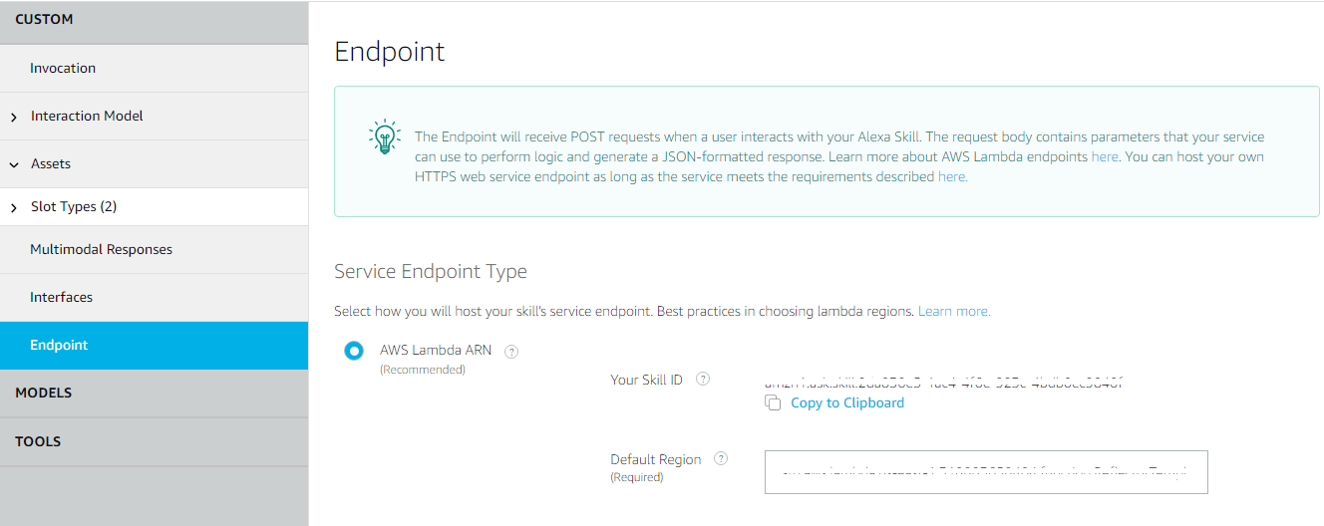
   3. In the "Default Region" field, add the ARN of the Lambda function for our skill.  
      set it to arn:aws:lambda:us-east-1:454143665149:function:sampleAlexa_EFR32Gateway
4. Enable Permissions and Account Linking
   1. You need to give permissions to access email and name of the customer.
   2. To do this, go to the "Permissions" tab and enable "Customer Name (Full Name)" and "Customer Email"  
        
      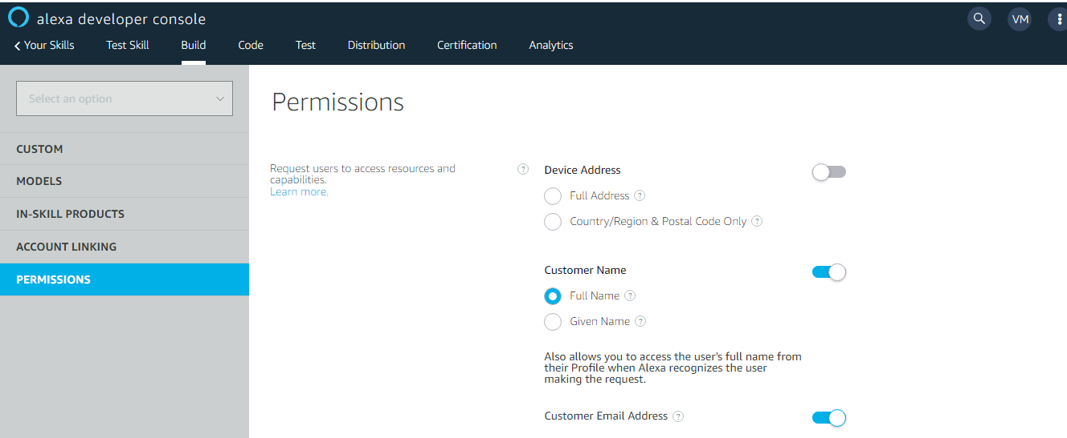
   3. Go to the "Account Linking" tab, and enable the option "Do you allow users to create an account or link to an existing account with you?"  
        
      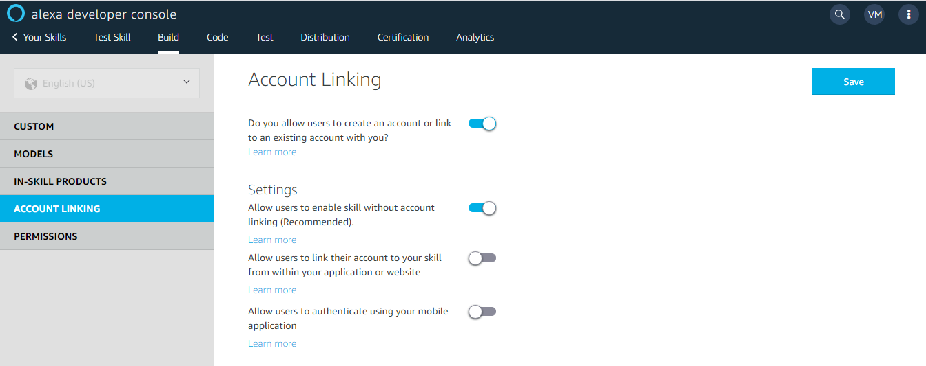
   4. Select the authorization grant type to "Auth Code Grant"
   5. We need to link the Amazon Cognito User Pool with the Alexa App.
   6. In Amazon Cognito, open the app pool that you created. Under **General Settings**, choose **App Clients**. Next, choose **Show Details** in the section for the Alexa Client that you we've already setup. Make a note of the App client ID and the App client secret.  
        
      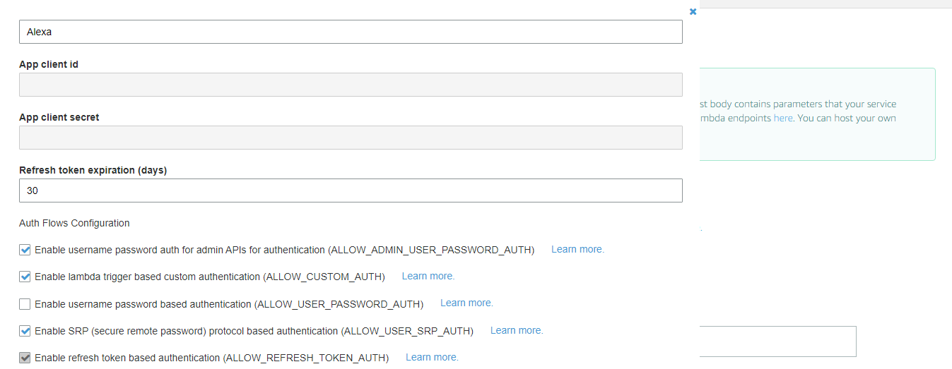
   7. In Amazon Alexa > Account Linking, set the **Authorization URI**:  
      https://efr32gateway.auth.us-east-1.amazoncognito.com/oauth2/authorize?response_type=code&redirect_uri=https://pitangui.amazon.com/api/skill/link/M1X5I7DMM1MHBP
   8. Set the **Access Token URI** :  
      https://efr32gateway.auth.us-east-1.amazoncognito.com/oauth2/token
   9. **Client ID** and **Client Secret** which you got from the step 6 above.
   10. Refer [here](https://aws.amazon.com/blogs/compute/amazon-cognito-for-alexa-skills-user-management/#:~:text=Linking%20Alexa%20with%20Amazon%20Cognito&text=In%20Amazon%20Cognito%2C%20open%20the,and%20the%20App%20client%20secret.) for more details.
   11. Click on "Save".
5. Go to "Custom > Interaction Model > JSON Editor" and **Build Model**
6. Once the Model is successfully built, you can go "Test" tab and try the skill from the Alexa Simulator.
7. Test Alexa Skill using below two different patterns
   1. can you get the temperature of my kitchen from efr iot gateway
   2. ask efr iot gateway

what is temperature of my kitchen