

System Requirement Specification
SiLabs Door Lock

Version  Status  Date | 1.1  Draft  01-Sep-2020

Confidentiality Notice
Copyright (c) 2026 eInfochips. - All rights reserved
This document is authored by eInfochips and is eInfochips intellectual property, including the copyrights in all countries in the world. This document is provided under a license to use only with all other rights, including ownership rights, being retained by eInfochips. This file may not be distributed, copied, or reproduced in any manner, electronic or otherwise, without the express written consent of eInfochips.

Contents

1 Document Details 4
1.1 Revision & Approval History 4
1.2 Definition, Acronyms and Abbreviations 4
1.3 References 5
2 introduction 6
2.1 Purpose of the Document 6
2.2 Intended Audience 6
3 system overview 6
3.1 Overview 6
3.2 Scope 7
4 functional RequiREment 9
4.1 Door lock application with Authentication 9
4.1.1 Setup environment and replicate the DynamicMultiprotocolLight example application for EFR32MG21 9
4.1.2 User Enrollment 10
4.1.3 1- Step & 2-Step Authentication 13
4.1.4 OTA Update 20
4.1.5 Power Consumption 21
4.1.6 Verify ZigBee control side 22
4.2 Support for Android App to work with EFR32 Board 23
4.2.1 Bluetooth connection with EFR32 Boards 23
4.2.2 Obtaining the initial device parameters 25
4.2.3 Communication with EFR32 26
4.2.4 Authentication for the lock/unlock request 26
4.2.5 Notifications on mobile app 27
4.2.6 OTA Update 28
4.3 Business Rules 29
4.4 Screen(s)/ Wireframes 29
5 External Interface 30
5.1 User Interface 30
5.2 Hardware Interface 31
5.3 Software Interface 33
6 Acceptance Criteria 34
6.1 Overall Acceptance Criteria 34
6.2 Acceptance Test Scenarios 34
7 Special user requirements 35
7.1 Performance Requirements 35
7.2 Security 35
7.3 Portability 35
7.4 Reliability 35
7.5 Usability 35
7.6 Maintainability 35
7.7 Data Definition and Database 35
7.8 Transaction Volume and Data Volume 35
7.9 Backup and Recovery 35
7.10 Legal (Statutory Demand) 35
7.11 Regulatory Demand 36
7.12 Data Migration 36
7.13 Data Retention 36
7.14 Alarms/Warnings 36
7.15 Installation 36
7.16 User Training 36
7.17 User Manual and Help 36
8 Standards 37
9 requirement Management 38
10 ASsumptions 39
11 Queries on requirement 40
12 Risk Analysis 42
13 Appendix 43

Document Details

Revision & Approval History
Version | Author |  | Reviewer |  | Approver
Version | Name | Date  (DD-MM-YYYY) | Name | Date  (DD-MMM-YYYY) | Name | Date  (DD-MM-YYYY)
Draft 0.1 | Manish Thakur,  Prassanna Sakore,  Hardik Kumar Patel,  Vipul Kole | 24/06/2020 | Shachi Mahajan,  Archana Benur |  | - | -
Draft 0.2 | Manish Thakur,  Prassanna Sakore,  Hardik Kumar Patel,  Vipul Kole | 29/06/2020 | Shachi Mahajan,  Archana Benur,  Ben Klingelhefer,  Jan Schnepp
Draft 0.3 | Manish Thakur,  Prassanna Sakore,  Hardik Kumar Patel,  Vipul Kole | 14/07/2020 | Ben Klingelhefer,  Jan Schnepp
Draft 0.4 | Manish Thakur,  Prassanna Sakore,  Hardik Kumar Patel,  Vipul Kole | 22/07/2020 |  |  | Ben Klingelhefer | 23-Jul-20
Baseline 1.0 | Manish Thakur,  Prassanna Sakore,  Hardik Kumar Patel,  Vipul Kole | 23/07/20
Draft 1.1 | Prassanna Sakore | 01/09/20 | Manish Thakur | 01/09/20

Version | Description of Change
Draft 0.1 | Created initial draft version
Draft 0.2 | Incorporated review comments by Shachi and Archana
Draft 0.3 | Updated ZigBee as backend networking protocol
Draft 0.4 | Incorporated review comments by Ben
Baseline 1.0 | Approved received from customer
Draft 1.1 | Updated high level system diagram

Definition, Acronyms and Abbreviations
Definition/Acronym/Abbreviation | Description
SOW | Statement of Work
SoC | System on Chip
NCP | Network co-processor
UI | User Interface
OTA | Over The Air
UUID | Universal unique identifier

References
No. | Document | Version | Remarks
1 | AEI_EIC_SOW3_200200610.pdf |  | SOW document
2 | https://www.silabs.com/products/development-tools/software/bluetooth-low-energy/mobile-apps | NA | Silabs Bluetooth applications

introduction

Purpose of the Document
The purpose of the document is to cover the detailed requirements of door lock on Silicon Labs EFR32MG21 kit.

Intended Audience
Intended audience of this document is developers, project team members, testers and all stakeholders.

system overview

Overview

Door lock is used to achieve the smart locking of home, building and commercial space. This reference platform provides locking and unlocking of door using authentication. It has 1 step and 2 step authentication to open/close the door.

1 step authentication is using:
- Fingerprint sensor authentication
- Keypad input
- Face recognition

2 step authentication is using:
- Keypad input and Face recognition
- Keypad input and Fingerprint match

Silicon labs EFR32MG kits will use BLE protocol for communication between device and mobile application. Mobile application will have option to show the door lock status, user’s entry for lock/unlock and providing OTA update. Application will use ZigBee as backend networking protocol. SiLabs dynamic multiprotocol (DMP) allows Bluetooth and ZigBee to work concurrently with EFR32MG21. So user can operate with the mobile application to control BLE and ZigBee.

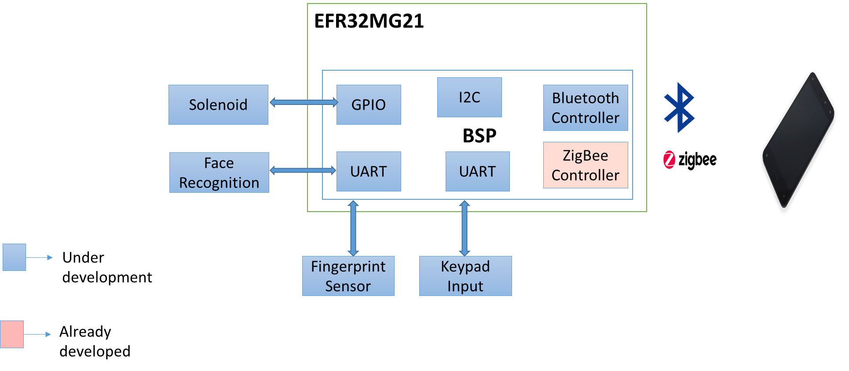

Fig 01: High level system diagram

Module | Description
EFR32MG21 kit | This is reference device kit of Silicon Labs, This reference device will be connected to different input and output devices.
Face Recognition Kit | Omron B5T face recognition kit is used to face recognition authentication.
Fingerprint Sensor | Fingerprint sensor module is used as input device to authenticate the user.
Keypad | Keypad module is used as input device to authenticate the user.
Motor control kit | Solenoid lock: Solenoid lock denotes a latch for electrical locking and unlocking

Scope
- Hardware Reference Platform: Assemble reference platform using following off the shelf development kits for development purposes
  - EFR32MG21 Development kit(Zigbee, Thread, BLE)
  - Omron B5T face Recognition module
  - Fingerprint sensor kit to be used (R307)
  - Electronic solenoid kit OR motor control kit for lock simulation (Unique Bargains model no a15030600ux0563)
  - 4x4 keypad kit (TTP229)
  - Develop simple interposer board or a cable to connect various kits if required.

- Firmware & Software: Develop/Port door lock Software reference solution that can be used for demonstration and productization by customers.
  - Develop & integrate fingerprint sensor driver/sdk, face recognition sdk, keypad driver, and solenoid kit control/motor control kit driver with OS & BSP supported on EFR32MG21
  - Develop demonstration door open/close use case for 1-step authentication for
    - Face based authentication
    - Fingerprint based authentication
    - Keypad entry (numerical digits) based authentication
  - Develop demonstration door open/close use case for 2-step authentication for
    - Keypad and face
    - Keypad and fingerprint
  - Develop demonstration use case or perform characterization showing that 4xAA (6V) battery can last for at least 1 year with 20 Open/Close transaction using keypad based authentication. – Since the kit does not have battery support this will be done by simulation/excel sheet based on power consumption of dev kits.
  - Perform characterization showing power consumption for 1-step and 2-step authentication use cases listed above.
  - OTA firmware provisioning of EFR32MG21
  - For demo purpose, 1 users will be enrolled for authentication.

- Web app (to serve as Mobile application):
  - Preferably add functionality to Silicon Labs development app to connect over BLE with the reference platform. Develop simple web app with a 1-2 screens.
  - App to provide 3x4 keypad interface that would be used to open/close lock using 1-step authentication at the reference platform
  - Secure code transmission over BLE to lock reference kit for lock open/close
  - Show door lock open/close status
  - Receive notification when door lock is opened or closed
  - OTA firmware provisioning of EFR32MG21

functional RequiREment

Door lock application with Authentication

Setup environment and replicate the DynamicMultiprotocolLight example application for EFR32MG21
Term | Description
REQ ID | RQ01
Purpose | Implementation of EFR32 lock example application
Derived Requirement | Verify the DynamicMultiprotocolLight application for BLE bring up on EFR
Access Restrictions | NA
Input(s) | NA
Output(s) | NA
Process | - Setup environment - Download simplicity studio and installed relevant software  - Take the DynamicMultiprotocolLight source  - Compile for the EFR32 and load into the devkit.  - Check the application is working as expected.
Mandatory Fields | Simplicity studio,
Pre Loaded Values | NA
Default Values | NA
Data Latency Period | NA
Data Retention Period | NA
Data Rate/ <Daily> Number of transaction | NA
External Events | NA
Temporal Events | NA
Validation Rules | Check the .elf file generated by build process.
Constraints | Have light bulb code integrated in sample application, has to use as base for door lock
Effects on other systems/sub system | NA
Testability with respect to test environment  (Yes/No) | No

User Enrollment
Term | Description
REQ ID | RQ02
Purpose | Application should provide way to enroll user
Derived Requirement | - Application should able to do face enrollment.  - Application should able to do finger print enrollment.  - Application should able to do pass-key enrollment.
Access Restrictions | NA
Input(s) | NA
Output(s) | NA
Process | NA
Mandatory Fields | NA
Pre Loaded Values | NA
Default Values | NA
Data Latency Period | NA
Data Retention Period | NA
Data Rate/ <Daily> Number of transaction | NA
External Events | NA
Temporal Events | NA
Validation Rules | NA
Constraints | TBD
Effects on other systems/sub system | NA
Testability with respect to test environment  (Yes/No) | No

Term | Description
REQ ID | RQ03
Purpose | Application should able to do face enrollment
Derived Requirement | - Application should do face enrollment  - Application should do user id creation for every user.
Access Restrictions | NA
Input(s) | User need to show the face to enroll into the system
Output(s) | Face data will be stored with user id
Process | NA
Mandatory Fields | NA
Pre Loaded Values | NA
Default Values | NA
Data Latency Period | NA
Data Retention Period | NA
Data Rate/ <Daily> Number of transaction | NA
External Events | NA
Temporal Events | NA
Validation Rules | NA
Constraints | NA
Effects on other systems/sub system | NA
Testability with respect to test environment  (Yes/No) | No

Term | Description
REQ ID | RQ04
Purpose | Application should able to do fingerprint enrollment
Derived Requirement | - Application should able to do fingerprint enrollment  - Application should be able to do user id creation for every user.
Access Restrictions | NA
Input(s) | User need to put the finger on the sensor to enroll into the fingerprint system
Output(s) | Fingerprint data will be stored with user id
Process | TBD
Mandatory Fields | NA
Pre Loaded Values | NA
Default Values | NA
Data Latency Period | NA
Data Retention Period | NA
Data Rate/ <Daily> Number of transaction | NA
External Events | NA
Temporal Events | NA
Validation Rules | NA
Constraints | NA
Effects on other systems/sub system | NA
Testability with respect to test environment  (Yes/No) | No

Term | Description
REQ ID | RQ05
Purpose | Application should able to do pass-key enrollment
Derived Requirement | - Application should able to do pass-key enrollment  - Application should be able to do user id creation for every user.
Access Restrictions | NA
Input(s) | - User need to input the default key to enroll into the keypad system.  - User need to input a new passkey to enroll into the keypad system.
Output(s) | - Pass-key data will be stored with user id  - LED indication Green/Red
Process | TBD
Mandatory Fields | NA
Pre Loaded Values | NA
Default Values | NA
Data Latency Period | NA
Data Retention Period | NA
Data Rate/ <Daily> Number of transaction | NA
External Events | NA
Temporal Events | NA
Validation Rules | NA
Constraints | TBD
Effects on other systems/sub system | NA
Testability with respect to test environment  (Yes/No) | No

1- Step & 2-Step Authentication

Term | Description
REQ ID | RQ06
Purpose | Application should be able to do 1-step authentication
Derived Requirement | - Application should have functionality to switch between 1 step and 2 step authentication  - Application should have functionality for selecting the mode of authentication  - Application should be able to do authentication using face detection  - Application should be able to do authentication using finger print.  - Application should be able to do authentication using keypad.  - Application should open door lock on successful authentication  - Application should indicate if authentication fails.
Access Restrictions | NA
Input(s) | - Buttons to select step of authentication and mode of authentication  - Face in case of face authentication  - Fingerprint in case of fingerprint authentication  - Pass-key in case of keypad authentication
Output(s) | - LED’s to indicate the step of authentication and mode of authentication  - Authentication result  - Door Unlock  - LED indication Green/Red
Process | User need to select button to configure 1 step authentication
Mandatory Fields | NA
Pre Loaded Values | NA
Default Values | NA
Data Latency Period | NA
Data Retention Period | NA
Data Rate/ <Daily> Number of transaction | NA
External Events | NA
Temporal Events | NA
Validation Rules | Check LEDs for success/failure authentication, Door lock status
Constraints | At a time one authentication step will work.
Effects on other systems/sub system | NA
Testability with respect to test environment  (Yes/No) | No

Term | Description
REQ ID | RQ07
Purpose | Application should be able to do 2-step authentication
Derived Requirement | - Application should have functionality to switch between 1 step and 2 step authentication  - Application should be able to do 2 step authentication using Keypad input and Face recognition  - Application should be able to do 2 step authentication using Keypad input and Fingerprint match
Access Restrictions | NA
Input(s) | - Buttons to select step of authentication and mode of authentication  - Keypad input and face recognition both inputs will be provided for authentication  - Keypad input and fingerprint both inputs will be provided for authentication
Output(s) | - LED’s to indicate the step of authentication and mode of authentication  - Authentication result  - Door Unlock  - LED indication Green/Red
Process | User need to button to configure 2 step authentication
Mandatory Fields | NA
Pre Loaded Values | NA
Default Values | NA
Data Latency Period | NA
Data Retention Period | NA
Data Rate/ <Daily> Number of transaction | NA
External Events | NA
Temporal Events | NA
Validation Rules | Check LED for success/failure attempt
Constraints | At a time one authentication step will work.
Effects on other systems/sub system | NA
Testability with respect to test environment  (Yes/No) | No

Term | Description
REQ ID | RQ08
Purpose | Application should have functionality to switch between 1 step and 2 step authentication
Derived Requirement | - Add support to change between 1 step and 2 step authentication using key  - Add support to indicate which step is selected using LED
Access Restrictions | NA
Input(s) | Key to change the step selection
Output(s) | LED to indicate the step selected
Process | TBD
Mandatory Fields | NA
Pre Loaded Values | NA
Default Values | NA
Data Latency Period | NA
Data Retention Period | NA
Data Rate/ <Daily> Number of transaction | NA
External Events | Key Press event
Temporal Events | NA
Validation Rules | - Step of authentication should be changed after pressing the key  - It should be indicated on the LED provided for the same
Constraints | NA
Effects on other systems/sub system | NA
Testability with respect to test environment  (Yes/No) | No

Term | Description
REQ ID | RQ09
Purpose | Application should have functionality for selecting the mode of authentication
Derived Requirement | - Add support for changing the mode of authentication when 1 step authentication is selected  - Face recognition  - Finger print  - Keypad  - Add support for changing the mode of authentication when 2 step authentication is selected  - Face recognition with keypad  - Finger print with keypad  - Add indication for displaying modes
Access Restrictions | NA
Input(s) | Key for changing mode
Output(s) | Led for indication of selected mode
Process | - User need to select the button to configure mode of authentication  - User need to select the button to configure step of authentication
Mandatory Fields | NA
Pre Loaded Values | NA
Default Values | NA
Data Latency Period | NA
Data Retention Period | NA
Data Rate/ <Daily> Number of transaction | NA
External Events | Keypad Press event
Temporal Events | NA
Validation Rules | - Mode of authentication should be changed after pressing the key  - It should be indicated on the LED provided for the same
Constraints | NA
Effects on other systems/sub system | NA
Testability with respect to test environment  (Yes/No) | No

Term | Description
REQ ID | RQ10
Purpose | Application should be able to do finger print authentication
Derived Requirement | - UART bring up on the EFR32 development kit  - Integrating finger print library with the UART APIs
Access Restrictions | NA
Input(s) | - Button to select finger print authentication  - User finger print scanning
Output(s) | - Authentication result  - Door Unlock  - LED indication Green/Red  - Event to Mobile application
Process | - Start the UART driver at EFR32  - Integrate it with finger print sensor Module  - Integrate this finger print sensor algorithm and verify with the authentication step 1 and step 2
Mandatory Fields | Flash/Space to store finger print  UART
Pre Loaded Values | User finger print should be already store in the device to compare the face detection  Algorithm for the face detection
Default Values | TBD
Data Latency Period
Data Retention Period
Data Rate/ <Daily> Number of transaction | TBD
External Events | finger print event
Temporal Events | TBD
Validation Rules | - Individual identification result should be passed with saved finger print  - Invalid finger print detect should reject  - Check LED for success/failure attempt
Constraints | Finger print sensor algorithm is going to use of 3rd party so accuracy and limitation will be based on it.
Effects on other systems/sub system | NA
Testability with respect to test environment  (Yes/No) | No

Term | Description
REQ ID | RQ11
Purpose | Application should be able to do authentication using keypad
Derived Requirement | - Add support for Keypad module  - Add support for user pin enrollment and modification  - Add support for user keypad authentication
Access Restrictions | NA
Input(s) | User defined pin
Output(s) | - Authentication result  - Door Unlock  - LED indication Green/Red  - Event to Mobile application
Process | - Start the I2C driver at EFR32  - Integrate it with keypad module  - Integrate this keypad input algorithm and verify with the authentication step 1 and step 2
Mandatory Fields | NA
Pre Loaded Values | NA
Default Values | NA
Data Latency Period | NA
Data Retention Period | NA
Data Rate/ <Daily> Number of transaction | NA
External Events | Keypad Press events
Temporal Events | NA
Validation Rules | - Device should unlock door lock for only the enrolled password  - User should be able to successfully change the password  - Device should reject incorrect passwords and not take any action
Constraints | NA
Effects on other systems/sub system | NA
Testability with respect to test environment  (Yes/No) | <Yes/ No>

Term | Description
REQ ID | RQ12
Purpose | Application should be able to do authentication using face recognition
Derived Requirement | - Omron b5t GitHub source code for face recognition should be able to run on the Linux host  - Omron b5t face recognition should be able to connect via either UART or USB. Use the Linux appropriate driver to do communication with it for the enrollment and authentication  - Integrate EFR32 with Linux host on UART for communication with Omron b5t module and add UART support in EFR32  - Prepare small chunk protocol of UART for communication between EFR32 and Linux host  - face recognition should be able to use Omron b5t sdk code to detect the face detection  - face recognition algorithm should be Integrate with the authentication step 1 and step 2
Access Restrictions | NA
Input(s) | - Button to select way of face authentication  - User face as input for authentication
Output(s) | - Authentication result  - Door Unlock  - LED indication Green/Red  - Event to Mobile application
Process | - Start the UART driver at EFR32  - Integrate it with the Face Recognition Module b5t  - Integrate this face detection algorithm and verify with the authentication step 1 and step 2
Mandatory Fields | Flash/Space to store face detection Image  Camera  UART
Pre-Loaded Values | face detection Image should be already store in the device to compare the face detection  Algorithm for the face detection
Default Values | TBD
Data Latency Period
Data Retention Period
Data Rate/ <Daily> Number of transaction | UART:- 9600 (Default value), should be configurable from software upto Max:- 921600
External Events | Face detection interrupt/event
Temporal Events | TBD
Validation Rules | - Individual identification result should be passed with saved image  - Invalid object detect should reject  - Check LED for success/failure attempt
Constraints | Image detection algorithm is going to use of 3rd party so accuracy and limitation will be based on it.
Effects on other systems/sub system | No
Testability with respect to test environment  (Yes/No) | No

OTA Update

Term | Description
REQ ID | RQ13
Purpose | Reference platform should have support for OTA
Derived Requirement | - EFR32MG21 SDK should have support for OTA update using sample application of BLE soc-empty example added in the DMP light APP.  - Implement the user application OTA just for the BLE and apply it to the DMP application.
Access Restrictions | NA
Input(s) | Firmware image
Output(s) | Upgraded Firmware
Process | NA
Mandatory Fields | Bluetooth connectivity with Mobile Application
Pre Loaded Values | NA
Default Values | NA
Data Latency Period | NA
Data Retention Period | NA
Data Rate/ <Daily> Number of transaction | NA
External Events | NA
Temporal Events | NA
Validation Rules | NA
Constraints | - We are assuming that BLE soc app OTA example is working one and the same will be used in the sample application.  - We are assuming EFR connect app have the support of OTA update for EFR platforms. So EFR connect app will use as a base to develop door lock mobile application.  - To enable Bluetooth OTA upgrade, the target device must be programmed with Gecko Bootloader that is configured as Internal Storage Bootloader.
Effects on other systems/sub system | NA
Testability with respect to test environment  (Yes/No) | No

Power Consumption
Term | Description
REQ ID | RQ14
Purpose | Perform characterization showing power consumption
Derived Requirement | - Simulate a power consumption scenario to use the 4xAA (6V) battery for door open/close transaction.  - Show power consumption for 1 step authentication.  - Show power consumption for 2 step authentication.
Access Restrictions | NA
Input(s) | TBD
Output(s) | TBD
Process | Measure power consumption for dev kits & calculate the power consumption for different scenario.
Mandatory Fields | NA
Pre Loaded Values | NA
Default Values | NA
Data Latency Period | NA
Data Retention Period | NA
Data Rate/ <Daily> Number of transaction | NA
External Events | NA
Temporal Events | NA
Validation Rules | TBD
Constraints | TBD
Effects on other systems/sub system | NA
Testability with respect to test environment  (Yes/No) | No

Verify ZigBee control side
Term | Description
REQ ID | RQ15
Purpose | Verifying ZigBee control side
Derived Requirement | - Connect to a ZigBee network.  - Bind to a switch.  - Toggle the lock.
Access Restrictions | NA
Input(s) | TBD
Output(s) | TBD
Process | 1. DMP Door/Switch Demo that consists of two devices: Door lock: it runs Micrium OS to switch between ZigBee and Bluetooth on a single radio. Switch: it supports ZigBee to provide wireless control of the door lock.  2. In the original demo, users press a push button on the wireless Switch device, which in turn, sends a ZigBee ZLL command to toggle the door lock On or Off.  3. The door lock device runs Micrium OS to switch between ZigBee and Bluetooth while sharing the same radio. This allows a mobile application to connect to the door lock via Bluetooth.  4. Users tap the mobile application to toggle the door lock On/Off.
Mandatory Fields | NA
Pre Loaded Values | NA
Default Values | NA
Data Latency Period | NA
Data Retention Period | NA
Data Rate/ <Daily> Number of transaction | NA
External Events | NA
Temporal Events | NA
Validation Rules | Door lock should turn on and off through ZigBee.
Constraints | TBD
Effects on other systems/sub system | NA
Testability with respect to test environment  (Yes/No) | No

Support for Android App to work with EFR32 Board

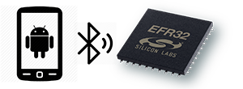

Fig 02: Mobile app Bluetooth connectivity with EFR32MG21

Bluetooth connection with EFR32 Boards

Term | Description
REQ ID | RQ16
Purpose | Mobile application should be able to do Bluetooth Discovery for EFR32
Derived Requirement | - Mobile application should support Bluetooth discovery of specified hardware platforms (EFR32).
Access Restrictions | <Role based>
Input(s) | User has to initiate a scan from mobile device
Output(s) | List of nearby EFR devices
Process | - Open Mobile App  - Scan for the available devices  - Filter out specific platform names based on UUID
Mandatory Fields | NA
Pre Loaded Values | NA
Default Values | NA
Data Latency Period | NA
Data Retention Period | NA
Data Rate/ <Daily> Number of transaction | NA
External Events | NA
Temporal Events | NA
Validation Rules | NA
Constraints | NA
Effects on other systems/sub system | NA
Testability with respect to test environment  (Yes/No) | Yes

Obtaining the initial device parameters

Term | Description
REQ ID | RQ17
Purpose | App should connect to EFR32MG21 and show the device parameters on screen
Derived Requirement | - App will connect to a specified EFR platform/ device.  - App UI should display the EFR32 device parameters on the screen.  - App UI should display the external events by its user-ids
Access Restrictions | NA
Input(s) | User should pair/connect to EFR32 from mobile app
Output(s) | Notification for connection status (Successful/Failed)  List of user actions by user_id (if applicable)
Process | Open Mobile App  Scan for the available devices  Filter out specific platform names  Connect to device.  Display device parameters after connection established. (connection state, door state)  Get User records from the EFR device. (syncing)
Mandatory Fields | NA
Pre Loaded Values | NA
Default Values | Connection State: Not Connected  Door State: Unavailable
Data Latency Period | NA
Data Retention Period | NA
Data Rate/ <Daily> Number of transaction | NA
External Events | NA
Temporal Events | NA
Validation Rules | Check for connected device is correct  Check for device parameters shown on screen are correct.
Constraints | NA
Effects on other systems/sub system | NA
Testability with respect to test environment  (Yes/No) | Yes

Communication with EFR32
Term | Description
REQ ID | RQ18
Purpose | App should have one screen for showing option lock and unlock door
Derived Requirement | - App should be connect to a specified EFR platform/ device.  - App should be able to send the lock/unlock commands using UI events
Access Restrictions | Numeric Secret key
Input(s)
Output(s) | User should be able to see the Lock / unlock option
Process | Open Mobile App  Scan for the available devices  Filter out specific platform names  Connect to device.  Display device parameters after connection established. (connection state, door state, hardware user events)  Click the Lock/Unlock button on UI
Mandatory Fields | NA
Pre Loaded Values | NA
Default Values | Connection State: Not Connected  Door State: Unavailable
Data Latency Period | NA
Data Retention Period | NA
Data Rate/ <Daily> Number of transaction | NA
External Events | NA
Temporal Events | NA
Validation Rules | Check for connected device is correct  Check for device parameters shown on screen are correct.  Check for proper event is generated for lock and unlock
Constraints | NA
Effects on other systems/sub system | NA
Testability with respect to test environment  (Yes/No) | Yes

Authentication for the lock/unlock request
Term | Description
REQ ID | RQ19
Purpose | App should have second screen for capturing secret key to lock/unlock door
Derived Requirement | - App should have UI with numeric keypad 3x4  - App should update the status on UI.
Access Restrictions | NA
Input(s) | Secret key (numeric value)
Output(s) | Key Result (Valid/invalid)
Process | Open Mobile App  Scan for the available devices  Filter out specific platform names  Connect to device.  Display device parameters after connection established. (connection state, door state)  Click the Lock/Unlock button on UI  Secret key (3x4 Numeric keypad) UI will show on screen  Input the secret key  Submit
Mandatory Fields | NA
Pre Loaded Values | NA
Default Values | Connection State: Not Connected  Door State: Unavailable
Data Latency Period | NA
Data Retention Period | NA
Data Rate/ <Daily> Number of transaction | NA
External Events | NA
Temporal Events | NA
Validation Rules | Check for connected device is correct  Check for device parameters shown on screen that are correct and synced with the latest state.
Constraints | NA
Effects on other systems/sub system | NA
Testability with respect to test environment  (Yes/No) | Yes

Notifications on mobile app

Term | Description
REQ ID | RQ20
Purpose | App should have feature to show door lock/unlock notifications on screen
Derived Requirement | - App should be able to show the device connection notification  - Show door notifications  - Show external actions(actions directly by user ids
Access Restrictions | NA
Input(s) | Events from EFR32 board
Output(s) | Notification (Popup, Toast, Sound)
Process
Mandatory Fields | NA
Pre Loaded Values | NA
Default Values | NA
Data Latency Period | NA
Data Retention Period | NA
Data Rate/ <Daily> Number of transaction | NA
External Events | NA
Temporal Events | NA
Validation Rules | Check for event is categorised properly.  Check for notification is visible on screen  Check for permanent/temporal state of notification
Constraints | NA
Effects on other systems/sub system | NA
Testability with respect to test environment  (Yes/No) | Yes

OTA Update

Term | Description
REQ ID | RQ21
Purpose | Mobile application should have option for OTA
Derived Requirement | - Mobile application should have option for OTA update.
Access Restrictions | NA
Input(s) | Firmware image
Output(s) | Upgraded Firmware
Process | NA
Mandatory Fields | Bluetooth connectivity with Mobile Application
Pre Loaded Values | NA
Default Values | NA
Data Latency Period | NA
Data Retention Period | NA
Data Rate/ <Daily> Number of transaction | NA
External Events | NA
Temporal Events | NA
Validation Rules | NA
Constraints | - We are assuming that OTA is already implemented in BSP provided by Silicon labs  - We are assuming EFR connect app have the support of OTA update for EFR platforms.
Effects on other systems/sub system | NA
Testability with respect to test environment  (Yes/No) | No

Business Rules

ID | Rule Definition | Type of Rule  (Fact/ Constraint) | Static or Dynamic | Source/Originator

Screen(s)/ Wireframes

External Interface
- The EFR32MG21 Kit connects with the modules via following interfaces

S.No | Module Name | Interface
1 | Finger Print Sensor (R305) | UART
2 | Keypad Module | I2C
3 | Face Recognition (Omron B5T) | UART
4 | Solenoid Door lock | GPIO

- Number of Interfaces available on EFR32

S.No | Interface | Number of Interfaces
1 | UART | 3
2 | SPI | 1
3 | I2C | 2
4 | GPIO | 20

User Interface

- User will be using mobile app to connect with the EFR board and control the door lock and view the status of the lock.
- User can authenticate using the Face recognition by looking into the camera.
- User can authenticate using the registered finger print by placing the finger in the finger print sensor.
- User can authenticate using the keypad by entering the correct password.

Hardware Interface

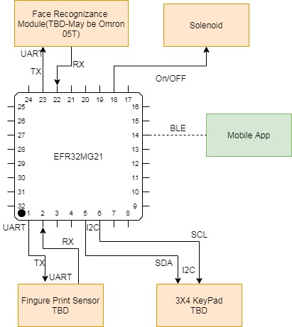

Fig 03: Block level diagram of EFR32MG21

Note: As of now all the module are not finalized however for the reference block diagram provided in section 5.2

- For Face Recognition used Omron B5T face Recognition module.This module will be controlled by the EFR32 on the UART as per below diagram, UART Buadrate will be 9600 (Default value), should be configurable from software up to Max:- 921600.

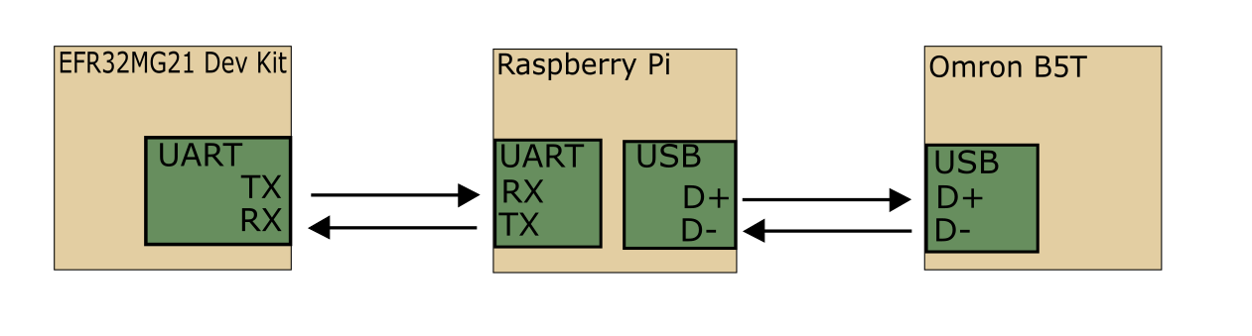

Fig 04: EFR32MG21 interface with Omron B5T
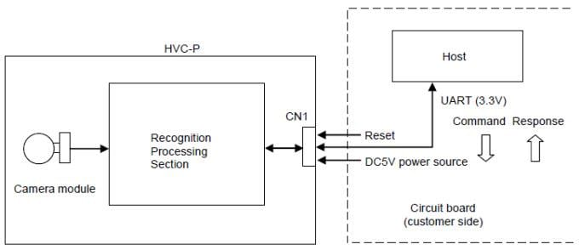

Fig 05: Omron B5T camera module internals

- TTP229 module will be used for keypad. This module will be connected to EFR board using I2C interface.
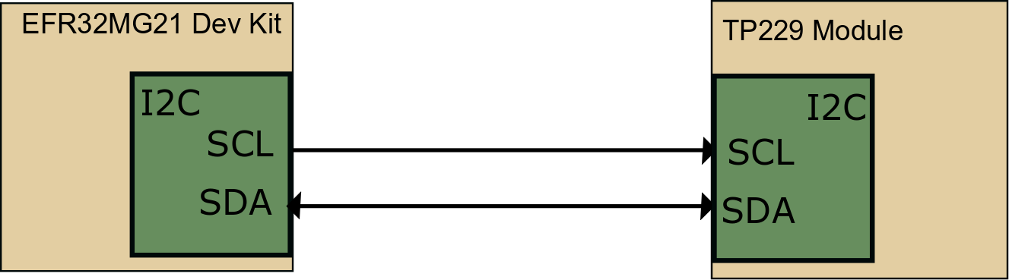

Fig 06: EFR32MG21 interface with TTP229 keypad

- R305 Finger print sensor will be used for finger print authentication. This module will be connected to EFR board using UART.

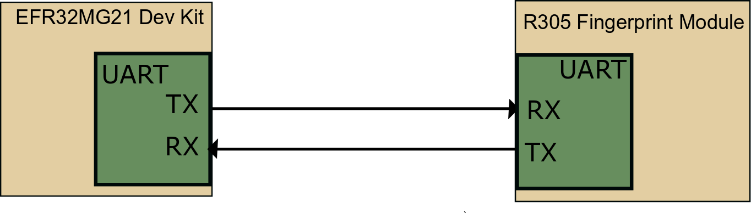

Fig 07: EFR32MG21 interface with R305 fingerprint sensor

- EFR board will be using GPIO for controlling Solenoid door lock

Software Interface
NA

Acceptance Criteria

Overall Acceptance Criteria
Below are the criteria:
- End product solution should be based on ZigBee and BLE DMP application.
- End product solution should provide 1 step and 2 step authentication (Details are provided in section 4.1.3).
- End product solution should be having Bluetooth connectivity via mobile to EFR32MG21. App should have two pages to show the status of lock/unlock and keypad input.
- End product solution should provide OTA update through mobile using Bluetooth connectivity.

Acceptance Test Scenarios
A detailed test plan document will be shared separately.

Special user requirements

Performance Requirements
NA

Parameter <functionality based> | Performance Requirement

Security

NA

Portability
NA

Reliability
NA

Usability
NA

Maintainability
NA

Data Definition and Database
NA

Transaction Volume and Data Volume
NA

Backup and Recovery
NA

Legal (Statutory Demand)
NA

Regulatory Demand
NA

Data Migration
NA

Data Retention
NA

Alarms/Warnings
NA

Installation

User Training

User Manual and Help
NA

Standards
NA

requirement Management
NA

ASsumptions
  - The Sample application will be based on DynamicMultiprotocolSampleLightSoC which uses EmberZNet and Bluetooth SDK.
  - OTA feature available for EFR32 & same will be used for OTA provisioning requirement
  - Silabs ‘EFR Connect App‘applications will be used as base application for feature development. Android app version will be used for adding required features.
  - Omron B5T face recognition module driver provided by Omron is stable and working.
  - For demo 1 user will be enrolled.

Queries on requirement
S. No | Query | Resolution
1 | Is Silabs EFR connect application able to connect with EFR32MG21. | The EFR connect app will discover any Bluetooth device and is fully capable of connecting to the EFR32MG21.  I do not believe EFR connect can be used to traffic user access information as we need for this project, but I am currently circulating the question internally.
2 | We want to understand requirement "Secure code transmission over BLE to lock reference kit for lock open/close" | User will have an additional passkey which will entered to lock/unlock reference kit.
3 | How is user enrollment is supposed to take place? | Einfochips needs to decide how the enrollment of input devices will take place.
4 | In offline mode, how the openWeave connectivity is going to work? | BLE connectivity is not needed for lock operation.
5 | SLWSTK6006A board are we going to use for demonstaration? Didn't find the SDK for the given board? | The given board number is correct.
6 | Does EFR connect app has the webpage UI?
7 | Is Omron B5T UART based driver available for EFR32MG21 on freeRTOS? | I think with our limited time, we can probably rule out porting a Linux driver to FreeRTOS. We have two options in my eyes:  1. Add a Linux host (example: raspberry pie)  2. Find another facial part that has better driver support
8 | Regarding the interfacing of RS9116W with the EFR32MG21 board. | Ben has clarified, since we are not going to use Wi-Fi connectivity hence we can use mighty gecko for bluetooth connectivity with mobile.
9 | DMP BLE/Zigbee SDK: We are referring the below link:  https://www.silabs.com/support/getting-started/multiprotocol/zigbee-ble  Here we found 2 SDK's:  -EmberZNet SDK  -Bluetooth SDK  We are able to load Bluetooth SDK in the simplicity studio. But we are not able to access "EmberZNet SDK". So can you give us the access of "EmberZNet SDK" | If the kit you acquired allows you access to those SDK’s along with numerous others.  You can use the Package Manager to review access and download the most up to date SDK’s.  Ember ZNet SDK – 6.7.6.0  Bluetooth SDK – 2.13.6.0  (You may not see everything under the “Demos” section of the “Launcher” tab.)  Click “New Project”  Select Silicon Labs Zigbee  Then select “EmberZNet 6.7.6.0 GA SoC” stack
10 | DMP BLE/Zigbee sample application: On the same link we found out there are two demonstration application:  -DynamicMultiprotocolSampleLightSoC  -DynamicMultiprotocolSampleZigbeeSwitch  Which application to be used as base for development? Do we have any demo application for Door Lock? | Continuing from our previous steps, a door lock would be more like the “DynamicMultiprotocolLight”. (Do not use the sleepy light.)  There will be some work removing the light related plugins and adding door lock plugins. (Our support ticket system will be your friend here.)
11 | The same demo application uses 'Wireless Gecko' app. Can we use "EFR connect" with this application? | EFR Connect replaced the Gecko app. I believe that all previous demos are supported.
12 | Which mode EFR32MG21 is supposed work 'Central' or 'Peripheral'? If it’s peripheral which central app will connect to EFR32MG21? | This question is not clear to me.  BLE and Zigbee will be running concurrently to lock/unlock, but all of the peripherals will be ran by the BLE application.  I was mistaken to say that Zigbee will only be an NCP. It looks to me that the whole stack will be running to preform the Zigbee SoC lock/unlock functions.
13 | BLE User registration : Please elaborate the point? | All user access registration (keypad codes, fingerprints, facial rec) will need to be handled via BLE.  I would think all this data will live in lock storage AND in some sort of remote user account.
14 | Face recognition : We are planning to USE B5T either through Linux host(RPi4/3)/ directly with EFR32. | With our timeline than using a RPi Linux host is probably the best path. We can explore eliminating it later.
15 | How OTA works with FreeRTOS in EFR32MG21 board? Also there are 5-6 bootloader we found out while loading in Simplicity studio, Can you point out which bootloader we need to use over BLE? | Please submit Studio questions through our support system.  www.silabs.com/support

Risk Analysis
- Delay in receiving HW might affect schedule – Identify & Procure HW as soon as possible to avoid delays.

Appendix
NA

