**Arrow Tech Expo 2025 – Event Lead Retrieval**

2001 Butterfield Rd

Suite 1800

Downers Grove, IL 60515

[ChicagoATE@arrow.com](mailto:ChicagoATE@arrow.com)

Your team will have immediate access to attendee contact information through QR-Code vCard barcodes printed on each badge. These 2-D barcodes enable quick and seamless addition of key customer details directly to your phone’s contact list.

Additionally, you can use a compatible Android or iPhone app to scan badges, capture data, add notes, and export the information as a .CSV file to any email address you choose. Recommended is BadgeScanner™ Lead Retrieval – [iPhone](https://apps.apple.com/us/app/badgescanner-lead-retrieval/id1341776784) - [Android](https://play.google.com/store/apps/details?id=com.eventpilot.scan18&hl=en-US)

This streamlined process ensures fast and efficient follow-up with every customer interaction during the event.

Please ensure your team reviews this letter and the instructions below to prepare for a successful experience. Sample customer labels are included to help you test your data capture method in advance.

There are 3 potential ways we suggest that you capture customer information.

1. Use your phone’s camera to input vCard information directly into you phone contacts
2. Use of a QR-Code scanner App to capture information and add to your phone contacts
3. Use of BadgeScanner™ Lead Retrieval – [iPhone](https://apps.apple.com/us/app/badgescanner-lead-retrieval/id1341776784) - [Android](https://play.google.com/store/apps/details?id=com.eventpilot.scan18&hl=en-US)

**USE OF YOUR PHONES CAMERA TO INPUT vCARD INFORMATION**

Both iPhone and Android have the capability of capturing QR-Code’s by just using your camera. Open your camera application and focus on a QR-Code – an icon should appear when the camera notices this is a QR-Code. You can then tap the icon, and you will be given several options, one to save this on your phone contacts.

**You can download BadgeScanner(tm) software here**...

**Apple iPhone**...

<https://apps.apple.com/us/app/badgescanner-lead-retrieval/id1341776784>

**Android**...

<https://play.google.com/store/apps/details?id=com.eventpilot.scan18&hl=en-US>

The interface has a simple Scan Contact Code button that will allow you to scan attendee badges. After scanning a badge you can Add Notes.

At anytime during the event or after, you can Export All Contacts to the email address of your choosing. You will be emailed a .CSV file that you can use for follow up.

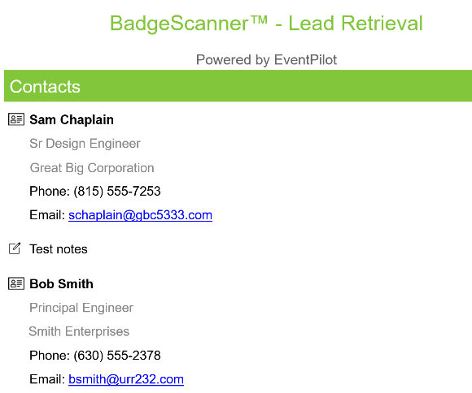

**Summary**

Ensure your team is aligned with the method you'll use to collect customer contacts during the Expo and finalize the approach well in advance of the event. Refer to the example below.

