Game Design Document

Super Mario Bros

George Edmon, Hamidreza Oloumi, Jace Ettinger

**Index:**

Description

Game Outline

Characters

Gameplay

***Description:***

Super Mario Bros is a platform game developed and published by Nintendo and it was released in 1985. In early 1986 the arcade machine version was released.

The game was designed by Shigeru Miyamoto and Takashi Tezuka. The game has single-player and multiplayer modes. Super Mario Bros contains 8 worlds. Each world has 4 levels and in total 32 levels.

Intended Game Systems: Arcade Machine.

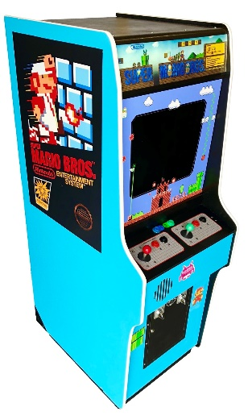

Intended ESRB Rating: E for Everyone.

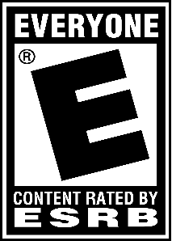

***Game Outline:***

* A plumber named Mario and his brother Luigi travel through the Mushroom Kingdom to save the princess from the evil Bowser.
* Plumber brothers Mario and Luigi from Brooklyn have just arrived in an outlandish realm called the Mushroom Kingdom. It was ruled by Princess Toadstool and her faithful Mushroom people. But one day, evil cast a shadow over the land and the evil King Bowser Koopa emerged with his army of Goombas, Spinies, Flying Koopas, and other malignant creatures. King Koopa abducted Princess Toadstool and trapped her faithful Mushroom People in seven of his castles. So Mario and Luigi must intrepid deep and hazardous waters, jump from tree to tree (don't look down!), and visually examine their steps in the dark evil castles filled with fire balls and lava pits and must utilize their magic powers to subjugate the evil King Koopa and rescue the Princess.

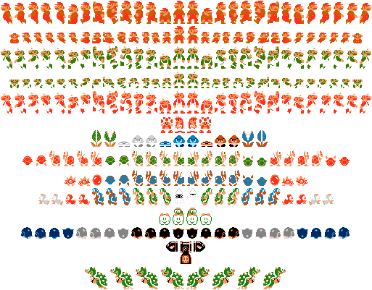

***All Characters:***

Mario:

Mario is the older brother, who serves as the first player. He looked the role of a plumber. Mario has several abilities, most notably his jump, which can be used in both defense and offense, such as by jumping onto an enemy’s head as an attack.

Luigi:

Luigi is Mario's brother. He began as a simple palette swap of Mario but was later differentiated. In his later forays, he provides comic relief.

Princess Peach:

Princess Peach Toadstool is usually the damsel in distress from the Mario franchise. She gets kidnapped frequently by Bowser, though she's not averse to being captured by various other villains from time to time.

Yoshi:

Yoshi is a recurring character in the Mario franchise and has since gone on to star in his own games.

Toad:

The Toad is a member of the Toad species. He is a loyal attendant of Princess Peach and often assists Mario on his journeys in a variety of ways.

Bowser:

Bowser is one of the most iconic villains in gaming. His role as the main antagonist in the Mario franchise has cemented this King of Koopas' status in video game history.

Bowser Jr:

Bowser Jr. is the son of Bowser and the main antagonist of Super Mario Sunshine and New Super Mario Bros. He loves to play sports with his dad in various Mario sport titles like tennis, golf, basketball and kart racing!

Big Boo:

Basically, he's the big Boo. The leader of the legions of Boo, even though he has an equally big problem with shyness as his underlings.

Boom Boom:

Boom Boom is the loyal servant of Bowser, found in every castle as a pre boss in Super Mario Bros 3 before the actual battle.

Hammer Bro:

One half of the deadly twosome, the Hammer Bros. from Super Mario Bros fame. They jump from platform to platform in a seemingly random pattern throwing goshdarn hammers!

Kamek:

A Magikoopa and a well recognized enemy in many Mario games. Kamek traditionally shoots magic attacks at the player.

Enemies:

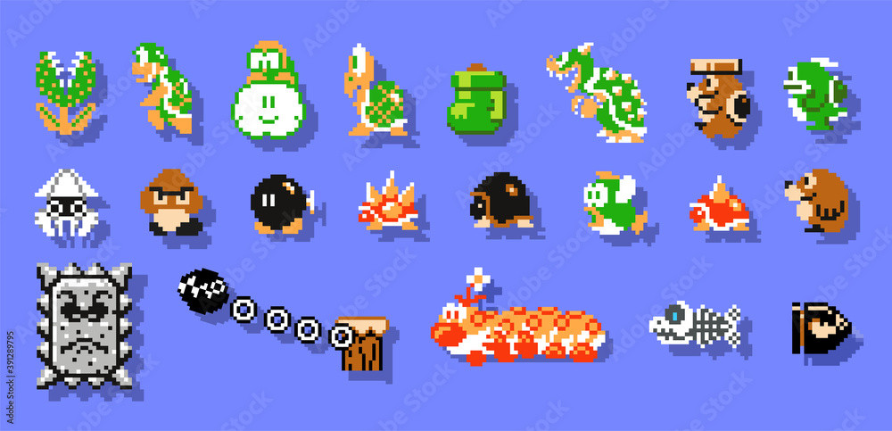

Name Sprite Description

Bloober A squid-like sentry that persistently pursues the player.

Bullet Bill A slow but steady bullet that has eyes and arms. They come from Turtle Cannons, and the only way to defeat them is to stomp on them or hit them while under the influence of a Starman.

Buzzy Beetle A small turtle that hides in its shell when jumped on, just like Koopa Troopas; unlike them, however, it is immune to fireballs. They replace Little Goombas in Hard Mode.

Cheep-cheep A red or gray fish normally found swimming in water. Gray ones are slightly slower. In certain levels, starting with World 2-3, the red ones will leap from the water, trying to hit Mario or Luigi.

Fire-Bar Various fireballs stacked together moving either clockwise or counterclockwise. Their length may vary.

Hammer Brother A green biped, helmeted Koopa that comes in a pair. They throw an endless number of hammers towards Mario and at certain times they jump.

Koopa Paratroopa A Koopa Troopa with wings. Green ones (which appear blue-green underground and in castles) jump towards the player or fly back and forth, while red ones fly up and down.

Koopa Troopa A soldier of the Turtle Empire that marches onwards. If stomped, it retreats in its shell, which can be kicked to hit other enemies and gain points. Green ones (which appear blue-green underground and in castles) walk back and forth just like Little Goombas, and red ones turn around when they find a pit.

Lakitu A bespectacled Koopa hiding in a small cloud. It throws an infinite number of Spiny's eggs towards the player.

Little Goomba A mushroom traitor that walks back and forth. They are the weakest and most common enemies throughout the game and can be stomped or hit with fireballs or a Starman. They are replaced with Buzzy Beetles in Hard Mode.

Piranha Plant A carnivorous plant that lives in a pipe. It rises, trying to hit Mario and retreats. If Mario is near, it will not rise.

Podoboo A fireball guardian of the Koopa King's lair. It jumps from the lava, trying to hit Mario.

Spiny Lakitu's small yet tough pet with a red, spiked shell. If Mario tries to stomp it, he will get damaged.

Spiny's egg A red, spiked egg thrown by Lakitus. Once it hits the ground, it immediately hatches into a Spiny.

Turtle Cannon An indestructible cannon. It shoots an endless number of Bullet Bills; however, it does nothing if the player is near it.

The above text is from the Super Mario Wiki and is available under a Creative Commons license. Attribution must be provided through a list of authors or a link back to the original article. Source: https://www.mariowiki.com/Super_Mario_Bros.

***Gameplay:***

The game is divided by levels and worlds

You can enter some chambers and go into these secret areas where you can collect extra coins.

***Game World:***

World 1-1 Overworld Little Goomba, Koopa Troopa

World 1-2 Underground Little Goomba, Koopa Troopa, Piranha Plant

World 1-3 Athletic Little Goomba, Koopa Troopa, Koopa Paratroopa

World 1-4 Castle Fire-Bar, fake Bowser (Little Goomba)

World 2-1 Overworld Little Goomba, Koopa Troopa, Koopa Paratroopa, Piranha Plant

World 2-2 Underwater Blooper, Cheep-cheep, Piranha Plant

World 2-3 Athletic Cheep-cheep

World 2-4 Castle Fire-Bar, Podoboo, fake Bowser (Koopa Troopa)

World 3-1 Overworld Little Goomba, Koopa Troopa, Koopa Paratroopa, Piranha Plant, Hammer Brother

World 3-2 Overworld Little Goomba, Koopa Troopa, Koopa Paratroopa, Piranha Plant

World 3-3 Athletic Little Goomba, Koopa Troopa, Koopa Paratroopa

World 3-4 Castle Fire-Bar, Podoboo, fake Bowser (Buzzy Beetle)

World 4-1 Overworld Piranha Plant, Lakitu, Spiny

World 4-2 Underground Little Goomba, Koopa Troopa, Piranha Plant, Buzzy Beetle

World 4-3 Athletic Koopa Troopa, Koopa Paratroopa

World 4-4 Castle Piranha Plant, Podoboo, Fire-Bar, fake Bowser (Spiny)

World 5-1 Overworld Little Goomba, Koopa Troopa, Koopa Paratroopa, Piranha Plant, Bullet Bill

World 5-2 Overworld Little Goomba, Koopa Troopa, Koopa Paratroopa, Piranha Plant, Buzzy Beetle, Bullet Bill, Hammer Brother (Bloober, Cheep-cheep)

World 5-3 Athletic Little Goomba, Koopa Troopa, Koopa Paratroopa, Bullet Bill

World 5-4 Castle Podoboo, Fire-Bar, fake Bowser (Lakitu)

World 6-1 Overworld Piranha Plant, Lakitu, Spiny

World 6-2 Overworld Little Goomba, Koopa Troopa, Koopa Paratroopa, Piranha Plant, Buzzy Beetle (Bloober, Cheep-cheep)

World 6-3 Athletic Bullet Bill

World 6-4 Castle Podoboo, Fire-Bar, fake Bowser (Bloober)

World 7-1 Overworld Koopa Troopa, Koopa Paratroopa, Piranha Plant, Buzzy Beetle, Hammer Brother, Bullet Bill

World 7-2 Underwater Bloober, Cheep-cheep, Piranha Plant

World 7-3 Athletic Cheep-cheep, Koopa Troopa, Koopa Paratroopa

World 7-4 Castle Podoboo, Fire-Bar, fake Bowser (Hammer Brother)

World 8-1 Overworld Little Goomba, Koopa Troopa, Koopa Paratroopa, Piranha Plant, Buzzy Beetle

World 8-2 Overworld Little Goomba, Koopa Paratroopa, Piranha Plant, Buzzy Beetle, Lakitu, Spiny, Bullet Bill

World 8-3 Overworld Koopa Troopa, Koopa Paratroopa, Piranha Plant, Bullet Bill, Hammer Brother

World 8-4 Castle Little Goomba, Koopa Paratroopa, Piranha Plant, Fire-Bar, Podoboo, Buzzy Beetle, Hammer Brother, Bloober, Cheep-cheep, Bowser

***Game Experience:***

***Gameplay Mechanics:***

The core mechanic of the Super Mario series is the ability to jump: which can be used to kill enemies, avoid projectiles and in later releases navigate high-structures or impassable terrain courtesy of wall jumps and spin-jumps respectively.

***Multiplayer And Bonus Materials:***

There are 2 Players.

***Monetization:***