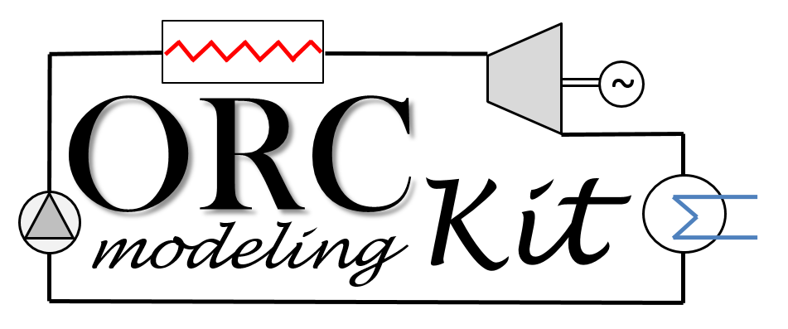

Documentation

Matlab Codes

**ExpanderModel.mat**

1. **Model name:**

ExpanderModel.mat

1. **Model description:**

ExpanderModel.mat is a matlab function developed for the simulation of volumetric expanders. Three modelling paradigms are currently implemented to simulate the expander, i.e.

* CstEff: a “constant efficiency” model into which constant values for both the isentropic efficiency and the filling factor are provided by the user, i.e.

$ε_{is}=\frac{ {\dot{W}}_{exp,mec}}{ {\dot{m}}_{exp} (h_{su}- h_{ex,is})}= {\overline{ε}}_{is}$

$FF=\frac{{\dot{V}}_{exp}}{{\dot{V}}_{th}}= \overline{FF}$

Heat losses to the ambience are also included by means of a global AUloss coefficients i.e.

${\dot{Q}}_{loss}=AU_{loss}(T_{su}-T_{amb})$

${\dot{m}}_{exp}\left(h_{su}-h_{ex}\right)= {\dot{W}}_{exp}+ {\dot{Q}}_{loss}$

* PolEff: a “polynomial efficiency” model into which quadratic polynomial regressions are used to evaluate both the volumetric efficiency (i.e. the filling factor) and the isentropic efficiency, i.e.

$ε_{vol}=\sum_{i=0}^{2}{\sum_{j=0}^{2}{\sum_{k=0}^{2}{{a_{ijk}N}_{pp}^{j} {\left(\frac{P_{ex}}{P_{su}}\right)}^{i}{ρ_{su}}^{k}}}}$

$FF=\sum_{i=0}^{2}{\sum_{j=0}^{2}{\sum_{k=0}^{2}{{a_{ijk}N}_{pp}^{j} {\left(\frac{P_{ex}}{P_{su}}\right)}^{i}{ρ_{su}}^{k}}}}$

Heat losses to the ambience are also included by means of a global AUloss coefficients as in the CstEff model.

* SemiEmp: a “semi-empirical” model implementing physics-based equations as proposed by Lemort et al. in [1]. This model decomposes the evolution of the fluid into a series of 6 consecutives steps and a detailed description of the modelling scheme can be found in [1].[1]

1. **Model inputs:**

The model inputs are the following ones:

* P_su (Pa) : inlet pressure of the pump;
* P_ex (Pa) : outlet pressure of the pump;
* h_su (J/kg) : inlet enthalpy of the pump;
* fluid (-) : fluid name;
* N_exp (rpm) : pump rotational speed;
* T_amb (K) : ambient temperature;
* param : a structure variable that contains the model parameters (see next section);

1. **Model parameters:**

Depending of the type of model chosen by the user, *param* will need to include the following variables:

* if param.modelType = 'CstEff':
  + param.V_s (m³) : machine displacement volume;
  + param.V (m³) : machine volume;
  + param.epsilon_is (-): isentropic efficiency;
  + param.FF (-): filling factor (volumetric efficiency);
  + param.AU (W/K) : global heat losses coefficient;
* if param.modelType = 'PolEff':
  + param.V_s (m³), machine displacement volume;
  + param.V (m³) : machine volume;
  + param.N_pp_nom, pump nominal shaft speed;
  + param.coeffPol_is (-), polynomial coefficients for epsilon_is;
  + param.coeffPol_ff (-), polynomial coefficients for FF;
  + param.AU (W/K) : global heat losses coefficient;
* if param.modelType = 'SemiEmp':
  + param.V_s (m³), machine displacement volume;
  + param.V (m³) : machine volume;
  + param.alpha (-), proportional losses coefficient;
  + param.W_dot_loss_0 (W), constant losses term;
  + param.C_loss (Nm), losses torque;
  + param.r_v_in (-), built-in volumetric ration;
  + param.A_leak0 (m²), nozzle cross section area for the leakage;
  + param.d_su (m), nozzle diameter for supply pressure drop;
  + param.AU_su_n (W/K), global heat transfer coefficient for supply heat transfer;
  + param.AU_ex_n (W/K), global heat transfer coefficient for exhaust heat transfer;
  + param.AU_amb (W/K), global heat transfer coefficient for ambient heat losses;
  + param.M_dot_n (kg/s), nominal mass flow rate;

1. **Model outputs:**

The outputs are two structure variables, namely *out* and *TS*, and they contain the following sub-variables:

* **out** (structure variable with all the relevant model outputs). At minimum, **out** will include
  + T_ex (K): outlet temperature of the expander;
  + h_ex (J/kg): outlet temperature of the expander;
  + M (kg) : mass of fluid inside the component;
  + M_dot (kg/s) : fluid mass flow rate;
  + W_dot (W) : net mechanical power;
  + Q_dot_amb (W) : heat losses;
  + epsilon_is (-) : expander isentropic efficiency;
  + FF (-) : filling factor;
  + time (sec) : the simulation time
  + flag (-): the model flag (>0 if the model run correctly, <0 if not)

In the case of the SemiEmp model, **out** will also include all the intrinsic variables of the model;

* **TS** (structure variable only used to plot the Ts diagram)
  + T (K) : vector of the fluid temperatures
  + s (J/kg.K) : vector of the fluid entropies

1. **External function requirements:**

The user must install CoolProp (<http://www.coolprop.org/>) to run ExpanderModel.

1. **Matlab version:**

This code has been developed under Matlab R2015a

1. **Contact:**

For any further information, please contact one of the main developers of ORCmKit:

* Rémi Dickes ([rdickes@ulg.ac.be](mailto:rdickes@ulg.ac.be)) – University of Liège (Belgium)
* Davide Ziviani ([davide.ziviani@ugent.be](mailto:davide.ziviani@ugent.be) ) – Ghent University (Belgium)

1. [1] V. Lemort, S. Quoilin, C. Cuevas, and J. Lebrun, “Testing and modeling a scroll expander integrated into an Organic Rankine Cycle,” *Appl. Therm. Eng.*, vol. 29, no. 14–15, pp. 3094–3102, 2009.