Introduction

As we all know, computer is one of most helpful electronic device that manage the school records by storing information in a way that allows for rapid sorting, searching and retrieval of data. We can use the web-based system to help the school admin to manage the record of the student. It allows the administrative staff to make their works easier. Besides reducing the use and handling of papers, an additional advantage of a computerized system is that it can help to analyze the recorded data and quickly generate the detailed school management information such as lists of student.

Objectives

* To develop Students Record System applying Html – Css Language, Python Programming and MySQL Database.
* To create a web-design to express the visualized concept with Use Case, Activity, Conceptual class, and Detailed class diagrams.
* And to apply all the lessons learned in this course.

Detailed Diagram

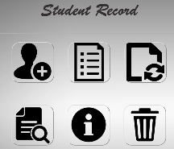



Admin can update

students



Admin can view

students



Admin can add

students

Admin can search student



Admin can view students list

Admin can delete

students