Dataset Description
The selected fruit-quality image dataset consists of 19,526 JPEG images organized hierarchically according to fruit quality and fruit type. At the top level, the dataset contains three quality-related folders: Bad Quality Fruits (6,788 images), Good Quality Fruits (11,664 images), and Mixed Quality Fruits (1,074 images). Each quality folder is further divided into fruit-specific subcategories including apple, banana, guava, citrus fruit, orange, and pomegranate. Initial inspection also confirmed that the dataset does not contain predefined training, validation, and testing partitions.

Observation: The initial class distribution is non-uniform, with Good Quality Fruits representing the largest group and Mixed Quality Fruits the smallest. A particularly high number of good-quality pomegranate images is also present, indicating that the source of class imbalance should be examined before model training.

Image Characteristics:
A random sample of 300 images was examined to determine the image characteristics of the dataset. The majority of the sampled images had a resolution of 256 × 256 pixels, while additional resolutions such as 192 × 256, 256 × 192, 3000 × 4000, and 8000 × 6000 were also observed. Among the sampled images, 288 were RGB images and 12 were grayscale images. No unreadable or corrupted images were detected in the inspected sample.

Observation: The dataset contains images with varying spatial resolutions and both RGB and grayscale representations. Therefore, image resizing and consistent channel handling will be required during preprocessing before model training.

Visual Inspection:
Representative images from all 18 fruit-specific subfolders were examined to understand the visual characteristics of the dataset. The bad-quality categories generally contain fruits exhibiting visible quality deterioration, while the good-quality categories predominantly contain visually healthy fruits. The mixed-quality categories contain images with multiple fruits and visibly varying quality conditions, introducing additional variation in the classification task.

Observation: The dataset exhibits considerable visual diversity in terms of fruit type, number of fruits per image, background, orientation, and quality appearance. The presence of mixed-quality images makes the classification problem more challenging and should be considered when designing preprocessing, augmentation, and evaluation strategies.

Class Distribution
The dataset was organized into three image-level quality categories: Good, Bad, and Mixed. The Good Quality category contains 11,664 images (59.74%), followed by Bad Quality with 6,788 images (34.76%). The Mixed Quality category contains 1,074 images (5.50%), making it the minority class in the dataset. Overall, the dataset contains 19,526 images.
Observation: The dataset exhibits a noticeable class imbalance, with Good Quality images forming the majority and Mixed Quality images representing only 5.50% of the dataset. The relatively small representation of the Mixed class makes it particularly important for the class-imbalance experiments in Phase 2.
Data Leakage Check:
Before partitioning the dataset, an exact-duplicate analysis was performed using the image file size and CRC information available in the dataset archive. No exact duplicate groups were detected among the 19,526 images. Therefore, no identical image files were identified that could directly cause leakage between the training, validation, and testing subsets.
Observation: The dataset did not contain any detected exact duplicate images. The subsequent dataset partitioning will therefore be performed on the original images, with augmentation restricted to the training subset to prevent augmented samples from entering the validation or test sets.

Dataset Partitioning:
Since the original dataset did not provide predefined training, validation, and testing subsets, the 19,526 images were partitioned using a stratified 80:10:10 train-validation-test split with a fixed random seed of 42. The training set contains 15,620 images, while the validation and test sets contain 1,953 images each. Stratification was applied to preserve the relative representation of the Good, Bad, and Mixed quality classes across all three subsets.

Dataset Split | Bad | Good | Mixed | Total
Training | 5,430 | 9,331 | 859 | 15,620
Validation | 679 | 1,166 | 108 | 1,953
Test | 679 | 1,167 | 107 | 1,953
Total | 6,788 | 11,664 | 1,074 | 19,526

Observation: The stratified partition maintains a similar class distribution across the training, validation, and test sets. All three quality classes are adequately represented in each subset, including the minority Mixed class, providing a consistent basis for model training and evaluation.
Observation: The class-distribution plot demonstrates a clear imbalance among the three quality categories. Good-quality images form the majority with 11,664 samples, while Mixed-quality images are substantially underrepresented with 1,074 samples. This imbalance will be specifically investigated through the three class-imbalance experiments in Phase 2.
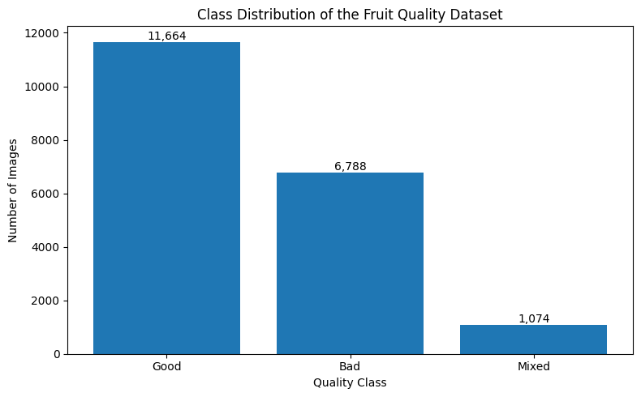
Fig. 2 Class distribution of the selected fruit-quality dataset.

Image Preprocessing:
Due to the variation in image resolution and color representation observed during dataset inspection, a standardized preprocessing pipeline was established. All input images are converted to RGB format and resized to 224 × 224 pixels to provide a consistent input dimension for the deep learning models. For the custom CNN preprocessing pipeline, pixel intensities are converted to floating-point representation and normalized to the [0,1] range by dividing pixel values by 255.
Observation: The preprocessing check successfully converted the sampled images into a consistent tensor shape of 224 × 224 × 3, with normalized pixel values ranging from 0 to 1. Visual inspection confirmed that the resized images retained their relevant fruit characteristics without obvious distortion.

Data Augmentation:
Moderate geometric augmentation was applied to the training images to improve robustness to natural variations in image orientation, position, and scale. The augmentation pipeline uses random rotation of approximately ±11°, horizontal and vertical translation of up to 5%, zoom variation of up to 10%, and horizontal flipping. Vertical flipping and aggressive transformations were avoided to prevent generating unrealistic fruit appearances. Augmentation is applied only to the training data, while the validation and test sets remain unchanged.

Observation: Visual inspection of the augmented samples showed that the selected transformations introduce moderate variations while preserving the original fruit characteristics. The augmentation strategy is therefore suitable for increasing training diversity without intentionally altering the quality-related visual features.

Dataset Split and Experimental Configuration
The complete dataset contains 19,526 images distributed across three quality classes: Good, Bad, and Mixed. Since predefined partitions were not provided, the dataset was divided into training, validation, and testing subsets using a stratified 80:10:10 split with a fixed random seed of 42. The resulting subsets contain 15,620 training images, 1,953 validation images, and 1,953 test images. The same partition will be maintained across all models and experiments to ensure a fair comparison.

Table 1. Summary of the selected fruit-quality dataset.
Parameter | Details
Total images | 19,526
Image format | JPEG (.jpg)
Quality classes | Good, Bad, Mixed
Good-quality images | 11,664
Bad-quality images | 6,788
Mixed-quality images | 1,074
Original train/validation/test split | Not provided
Dataset split used | 80% Train / 10% Validation / 10% Test
Random seed | 42

Table 2. Distribution of images across the three fruit-quality classes.
Quality Class | Number of Images | Percentage
Good | 11,664 | 59.74%
Bad | 6,788 | 34.76%
Mixed | 1,074 | 5.50%
Total | 19,526 | 100%

Observation: The baseline CNN contains three convolutional blocks with progressively increasing feature channels, followed by global average pooling and a compact classification head. The final model contains 110,147 trainable parameters, providing a relatively lightweight baseline for comparison with the transfer-learning models.

Table 3. Image characteristics observed from a random sample of 300 images.
Property | Observation
Images inspected | 300
Most common resolution | 256 × 256 pixels
Other observed resolutions | 192 × 256, 256 × 192, 3000 × 4000, 8000 × 6000
RGB images in sample | 288
Grayscale images in sample | 12
Corrupted images detected in sample | 0

Table 4. Stratified train-validation-test distribution used throughout the experiments.

Dataset Split | Bad | Good | Mixed | Total
Training | 5,430 | 9,331 | 859 | 15,620
Validation | 679 | 1,166 | 108 | 1,953
Test | 679 | 1,167 | 107 | 1,953
Total | 6,788 | 11,664 | 1,074 | 19,526

Table 5. Image preprocessing configuration used for model development.

Preprocessing Step | Configuration
Image resizing | 224 × 224 pixels
Color conversion | RGB
Input channels | 3
Pixel normalization | [0, 1] for custom CNN pipeline
Augmentation | Training data only
Validation augmentation | Not applied
Test augmentation | Not applied
Random seed | 42

TensorFlow Data Pipeline
A TensorFlow tf.data pipeline was developed to efficiently load and preprocess the image dataset. Images are read from the extracted dataset, decoded as three-channel RGB images, resized to 224 × 224 pixels, converted to floating-point representation, and normalized to the [0,1] range for the custom CNN pipeline. A batch size of 32 was selected for model training. The training dataset is shuffled and prefetched, while validation and test datasets are kept free from training-time augmentation.

Observation: The TensorFlow pipeline successfully produced batches with dimensions 32 × 224 × 224 × 3, with floating-point pixel values normalized between 0 and 1. The label mapping was also verified, with Bad, Good, and Mixed represented by class indices 0, 1, and 2 respectively.

Observation: Visual verification of a batch generated directly through the TensorFlow pipeline confirmed that the images were loaded correctly and associated with their corresponding quality labels. The preprocessing pipeline preserved the relevant visual characteristics of the fruit images while standardizing their dimensions and color representation.

Layer | Configuration | Purpose
Input | 224 × 224 × 3 | RGB image input
Conv2D | 32 filters, 3×3, ReLU | Low-level feature extraction
MaxPooling2D | 2×2 | Spatial reduction
Conv2D | 64 filters, 3×3, ReLU | Intermediate feature extraction
MaxPooling2D | 2×2 | Spatial reduction
Conv2D | 128 filters, 3×3, ReLU | Higher-level feature extraction
MaxPooling2D | 2×2 | Spatial reduction
GlobalAveragePooling2D | — | Spatial feature aggregation
Dense | 128 units, ReLU | Feature combination
Dropout | 0.5 | Reduce overfitting
Output Dense | 3 units, Softmax | Good/Bad/Mixed classification

CNN Model Architecture
A baseline Convolutional Neural Network (CNN) was developed for three-class fruit-quality classification. The model takes preprocessed RGB images of size 224 × 224 × 3 as input and uses three convolutional layers with increasing filter sizes to extract low-, intermediate-, and high-level visual features. Max-pooling layers reduce the spatial dimensions after each convolutional block. Global Average Pooling is then used to aggregate the extracted features before classification.
The classification head consists of a 128-unit dense layer with ReLU activation, followed by 0.5 dropout to reduce overfitting. The final dense layer contains 3 neurons with Softmax activation corresponding to the Good, Bad, and Mixed quality classes.

Layer | Configuration | Purpose
Input | 224 × 224 × 3 | RGB image input
Conv2D | 32 filters, 3×3, ReLU | Low-level feature extraction
MaxPooling2D | 2×2 | Spatial reduction
Conv2D | 64 filters, 3×3, ReLU | Intermediate feature extraction
MaxPooling2D | 2×2 | Spatial reduction
Conv2D | 128 filters, 3×3, ReLU | Higher-level feature extraction
MaxPooling2D | 2×2 | Spatial reduction
GlobalAveragePooling2D | — | Spatial feature aggregation
Dense | 128 units, ReLU | Feature combination
Dropout | 0.5 | Reduce overfitting
Output Dense | 3 units, Softmax | Good/Bad/Mixed classification
Observation: The CNN architecture successfully combines progressively deeper convolutional layers with pooling and Global Average Pooling to extract discriminative fruit-quality features. A dropout layer was included before the final classifier to reduce the possibility of overfitting

CNN Model Compilation
The CNN model was compiled using the Adam optimizer with a learning rate of 0.001. Sparse Categorical Crossentropy was selected as the loss function because the dataset contains three mutually exclusive classes represented using integer class labels. Accuracy was used as the initial training metric.

Parameter | Configuration
Optimizer | Adam
Learning Rate | 0.001
Loss Function | Sparse Categorical Crossentropy
Evaluation Metric | Accuracy
Number of Classes | 3
Observation: The CNN was successfully compiled using Adam optimization with a learning rate of 0.001 and Sparse Categorical Crossentropy loss. The configuration is suitable for the three-class classification problem with integer-encoded labels.

Training Callbacks
Early stopping and model checkpointing were configured before CNN training. Early stopping monitors validation loss and stops training when the model no longer shows improvement for five consecutive epochs. Model checkpointing saves the model corresponding to the lowest validation loss.
Callback | Configuration | Purpose
EarlyStopping | Validation loss, patience = 5 | Prevent unnecessary training and overfitting
ModelCheckpoint | Validation loss, save best only | Preserve the best-performing model
Observation: Training callbacks were successfully configured to monitor validation performance. Early stopping will terminate training when validation loss stops improving, while checkpointing will retain the model with the best validation loss.
CNN Model Training
The custom CNN model was trained using the prepared TensorFlow training and validation datasets. The model was configured with the Adam optimizer, a learning rate of 0.001, and Sparse Categorical Crossentropy loss for the three-class fruit-quality classification task. Training was performed for a maximum of 30 epochs with early stopping and model checkpointing based on validation loss.
Training Configuration
Parameter | Configuration
Model | Custom CNN
Optimizer | Adam
Learning Rate | 0.001
Loss Function | Sparse Categorical Crossentropy
Maximum Epochs | 30
Early Stopping Patience | 5
Monitoring Metric | Validation Loss
Best Model Restoration | Enabled
Batch Size | 32

Observation
The CNN training completed successfully and was automatically stopped at epoch 27 through early stopping. At the final displayed epoch, the model achieved a training accuracy of 97.29% and validation accuracy of 95.80%. The best model weights were restored from epoch 22 based on validation loss, ensuring that the subsequently evaluated model corresponds to the best validation performance rather than simply the final training epoch.

CNN Training and Validation Loss
The training and validation loss curves were analyzed to monitor the learning behavior of the CNN. Training loss showed a consistent overall decrease throughout the training process, while validation loss decreased with some fluctuations across epochs. The increasing fluctuation in validation loss during the later epochs supported the use of early stopping to retain the model weights corresponding to the best validation performance.
Observation:
The CNN demonstrated effective learning as the training loss decreased from approximately 0.33 to 0.07. Validation loss also showed an overall downward trend, although fluctuations were observed at several epochs. Early stopping restored the model weights from epoch 22 based on the lowest validation loss.
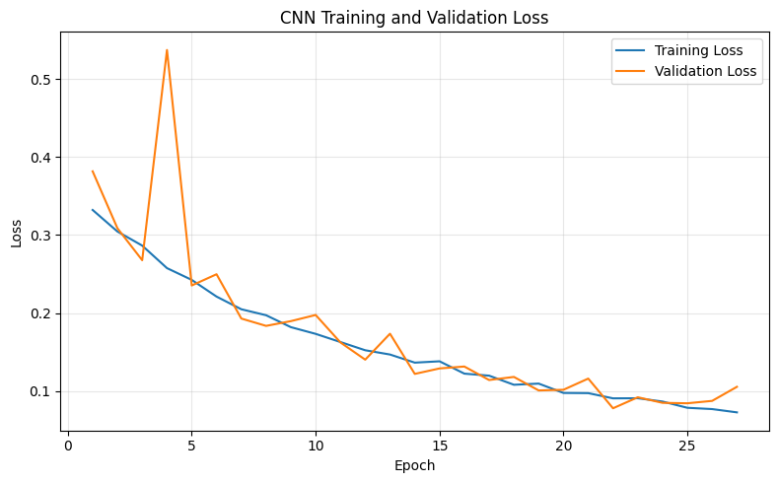
CNN Test Set Evaluation
The trained CNN was evaluated on the held-out test set containing 1,953 images. Accuracy, weighted precision, weighted recall, weighted F1-score, and class-wise classification metrics were calculated. A confusion matrix was also generated to examine the classification behavior across the Bad, Good, and Mixed quality classes.
CNN Test Results
Metric | Score
Accuracy | 97.13%
Weighted Precision | 97.42%
Weighted Recall | 97.13%
Weighted F1-score | 97.21%
Class-wise Performance
Class | Precision | Recall | F1-score | Support
Bad | 0.98 | 0.98 | 0.98 | 679
Good | 0.99 | 0.97 | 0.98 | 1167
Mixed | 0.77 | 0.95 | 0.85 | 107

Observation
The CNN achieved 97.13% test accuracy with a weighted F1-score of 97.21%, indicating strong overall classification performance on the unseen test set. The Bad and Good classes achieved F1-scores of 0.98, while the minority Mixed class achieved a recall of 0.95 and an F1-score of 0.85.
The relatively lower precision of the Mixed class (0.77) indicates that some Good and Bad images were incorrectly predicted as Mixed. This class-wise behavior is important for the subsequent class-imbalance experiments.

CNN Confusion Matrix
The confusion matrix was used to examine the class-wise predictions of the CNN on the test dataset. The diagonal elements represent correctly classified images, while the off-diagonal elements represent misclassified images across the Bad, Good, and Mixed quality classes.
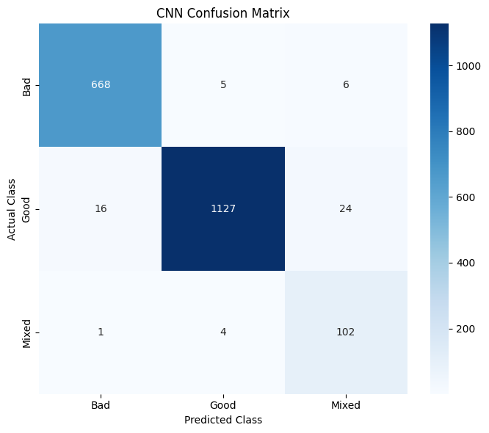
Observation:
The CNN correctly classified 668 Bad, 1,127 Good, and 102 Mixed images. Most predictions are concentrated along the diagonal, indicating strong classification performance. The main misclassification was observed between the Good and Mixed classes, where 24 Good images were predicted as Mixed

MobileNetV2 Model
A transfer learning model based on MobileNetV2 was implemented for fruit quality classification. The pretrained MobileNetV2 feature extractor was used with the ImageNet weights, while the pretrained layers were kept frozen. A Global Average Pooling layer was followed by a 128-unit dense layer, dropout, and a three-class softmax output layer for Bad, Good, and Mixed fruit quality classification.
The model was trained using the same training and validation datasets used for the baseline CNN to maintain consistency in the model comparison. Early stopping was applied with a patience of 5 epochs, and the best-performing model weights were restored after training.
Observation:
The MobileNetV2 model completed training successfully. Training stopped at epoch 15, with the best model weights restored from epoch 10 based on validation loss. The training loss decreased substantially during training, while the validation loss showed some fluctuations across epochs.
Test Set Evaluation
The trained MobileNetV2 model was evaluated on the 1,953-image test dataset.
Metric | MobileNetV2
Accuracy | 0.9923
Precision | 0.9923
Recall | 0.9923
F1-score | 0.9923
Class-wise Performance
Class | Precision | Recall | F1-score | Support
Bad | 0.99 | 0.99 | 0.99 | 679
Good | 0.99 | 0.99 | 0.99 | 1167
Mixed | 0.98 | 0.99 | 0.99 | 107
Overall Accuracy | 0.99 | 0.99 | 0.99 | 1953
Macro Average | 0.99 | 0.99 | 0.99 | 1953
Weighted Average | 0.99 | 0.99 | 0.99 | 1953
Observation:
MobileNetV2 achieved a test accuracy of 99.23%, with precision, recall, and F1-score also equal to 99.23%. The class-wise results show consistently high performance across all three quality categories. In particular, the Mixed class achieved a recall of 0.99, indicating that the model correctly identified almost all Mixed-quality samples despite this class having the smallest test-set support.
Confusion Matrix
Actual / Predicted | Bad | Good | Mixed
Bad | 673 | 5 | 1
Good | 7 | 1159 | 1
Mixed | 0 | 1 | 106
Observation:
The confusion matrix shows that MobileNetV2 correctly classified 673 of 679 Bad, 1,159 of 1,167 Good, and 106 of 107 Mixed images. Only a small number of samples were misclassified between the three categories. The results indicate strong classification performance across all quality classes.
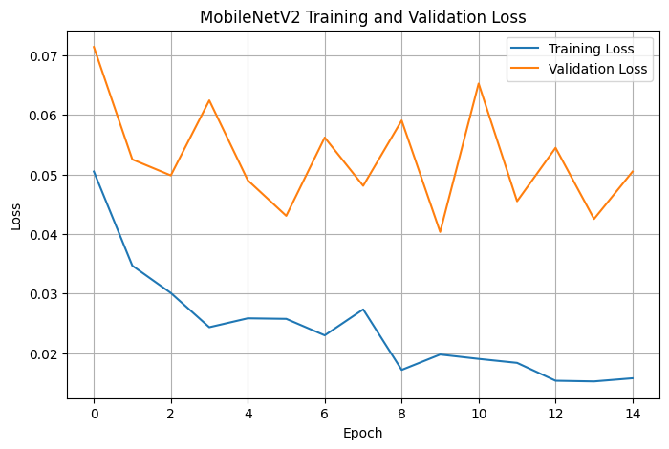
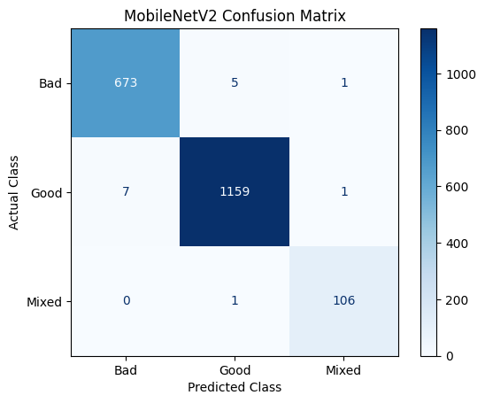
ResNet50 Test Performance
- Accuracy: 0.9908
- Precision: 0.9909
- Recall: 0.9908
- F1-score: 0.9908
Class-wise performance:

Class | Precision | Recall | F1-score | Support
Bad | 0.99 | 0.99 | 0.99 | 679
Good | 1.00 | 0.99 | 0.99 | 1167
Mixed | 0.95 | 0.97 | 0.96 | 107
Confusion Matrix:
Actual \ Predicted | Bad | Good | Mixed
Bad | 674 | 5 | 0
Good | 4 | 1157 | 6
Mixed | 3 | 0 | 104
Training observation:
ResNet50 training stopped at Epoch 13 due to early stopping, with the best model weights restored from Epoch 8, where the validation loss reached 0.0247.
EfficientNetB0 — Results
1. Model Used
1. Model Architecture
EfficientNetB0 was implemented using transfer learning with ImageNet-pretrained weights. The pretrained convolutional base was used as a feature extractor, while a custom classification head was added for the three fruit-quality classes: Bad, Good, and Mixed.
The classification head consists of:
- Global Average Pooling
- Dense layer with 128 neurons
- Dropout layer
- Final Dense layer with 3 output neurons
Input image size: 224 × 224 × 3
Total parameters: 4,213,926
Trainable parameters: 164,355
Non-trainable parameters: 4,049,571
2. Training Configuration
EfficientNetB0 was trained on the fruit-quality dataset containing the three classes Bad, Good, and Mixed.
The model was trained for a maximum of 30 epochs, with early stopping based on validation loss.
Early stopping patience: 5 epochs
Best model: Saved based on minimum validation loss
Best validation loss: approximately 0.0131
Best epoch: Epoch 19
Training continued until epoch 24, after which early stopping was triggered. The model restored the weights from the best-performing epoch.
3. Training and Validation Loss
The training and validation loss curves show a strong reduction in loss during the initial training epochs.
The training loss decreased from approximately 0.13 at the beginning to approximately 0.01 toward the end of training. The validation loss also decreased considerably, reaching its lowest value of approximately 0.0131 around epoch 19.
After the best validation performance was achieved, the validation loss began to fluctuate while the training loss continued to decrease. This indicates that additional training was not consistently improving generalization.
Early stopping therefore restored the best model weights from the optimal epoch.
Observation:
EfficientNetB0 demonstrated rapid convergence and maintained a small gap between training and validation loss for most of the training process. The model achieved very low validation loss while avoiding prolonged unnecessary training.
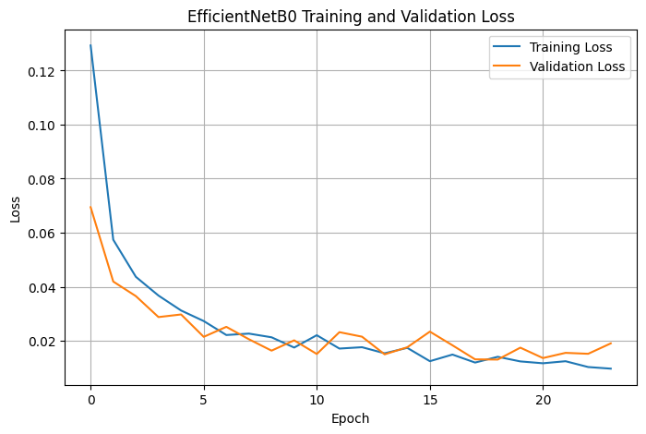
4. Test Performance
EfficientNetB0 was evaluated on the independent test dataset containing 1,953 images.
The model achieved:
Metric | Score
Accuracy | 99.18%
Precision | 99.18%
Recall | 99.18%
F1-score | 99.18%
These results indicate that EfficientNetB0 achieved highly accurate classification across the three fruit-quality categories.
5. Classification Report
Based on the obtained test results:
Class | Precision | Recall | F1-score | Support
Bad | 0.99 | 0.99 | 0.99 | 679
Good | 0.99 | 0.99 | 0.99 | 1167
Mixed | 0.99 | 0.95 | 0.97 | 107
The Mixed class has a slightly lower recall compared with the Bad and Good classes. This indicates that some Mixed-quality fruits were incorrectly classified as either Bad or Good.
6. Confusion Matrix Analysis
The EfficientNetB0 confusion matrix was:
Actual / Predicted | Bad | Good | Mixed
Bad | 674 | 5 | 0
Good | 5 | 1161 | 1
Mixed | 1 | 4 | 102
The model correctly classified:
- 674 Bad samples
- 1161 Good samples
- 102 Mixed samples
Only a small number of samples were misclassified.
The majority of the errors involving the Mixed class were predictions as Good, with 4 Mixed samples classified as Good. This is understandable given the relatively small number of Mixed samples in the test dataset.
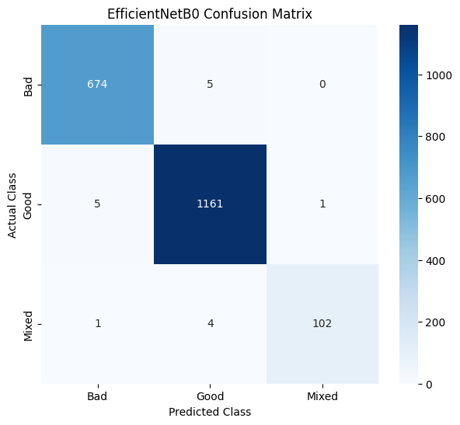
7. EfficientNetB0 Conclusion
EfficientNetB0 demonstrated excellent performance on the fruit-quality classification task, achieving 99.18% test accuracy with an F1-score of approximately 99.18%.
The model showed fast convergence and achieved a very low validation loss. The confusion matrix also demonstrates that the majority of Bad, Good, and Mixed samples were correctly classified.
However, the Mixed class showed comparatively lower recall (0.95), indicating that this minority class remains relatively more challenging to classify.
Overall, EfficientNetB0 provides a strong balance between classification performance and model efficiency, making it a strong candidate for fruit-quality classification.

DenseNet121 Model
1. Model Architecture
DenseNet121 was implemented using ImageNet-pretrained weights through transfer learning. The pretrained DenseNet121 feature extractor was combined with a custom classification head for the three fruit-quality categories: Bad, Good, and Mixed.
The classification head consists of:
- Global Average Pooling
- Dense layer with 128 neurons
- Dropout layer
- Final Dense layer with 3 output neurons
Input image size: 224 × 224 × 3
Total parameters: 7,169,091
Trainable parameters: 131,587
Non-trainable parameters: 7,037,504
2. Training Configuration
DenseNet121 was trained for a maximum of 30 epochs using early stopping based on validation loss.
Early stopping patience: 5 epochs
Best model: Saved based on minimum validation loss
Best epoch: Epoch 22
Training continued until epoch 27, when early stopping was triggered. The weights from the best-performing epoch were restored.
3. Training and Validation Loss
The DenseNet121 training curve shows a substantial reduction in training loss from approximately 0.15 at the beginning to below 0.01 toward the end of training.
The validation loss also decreased considerably during the initial training phase, although it showed fluctuations during later epochs.
The model achieved its best validation performance around epoch 22. After this point, validation loss did not show consistent improvement, while training loss continued to decrease.
Therefore, early stopping was used to restore the weights from the best-performing epoch.
Observation:
DenseNet121 successfully learned the fruit-quality classification task and achieved very low training loss. The fluctuations in validation loss during later epochs indicate that continued training was not providing consistent generalization improvements.
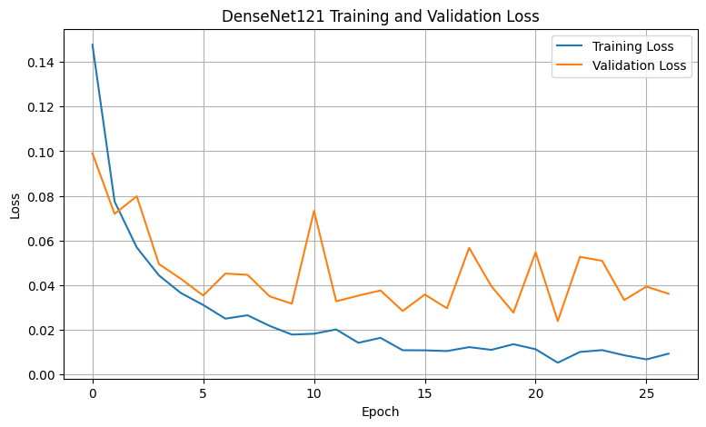
4. Test Performance
DenseNet121 was evaluated on the independent test set containing 1,953 images.
From the confusion matrix, the model correctly classified:
- 673 Bad samples
- 1161 Good samples
- 103 Mixed samples
The overall test accuracy calculated from the confusion matrix is approximately 99.18%.
Metric | Score
Accuracy | ≈99.18%
Precision | Use actual evaluation output
Recall | Use actual evaluation output
F1-score | Use actual evaluation output

5. Confusion Matrix Analysis
The DenseNet121 confusion matrix was:
Actual / Predicted | Bad | Good | Mixed
Bad | 673 | 5 | 1
Good | 4 | 1161 | 2
Mixed | 0 | 4 | 103
The model correctly classified the majority of samples in all three classes.
The largest source of errors was between Good and Mixed, where some Mixed samples were classified as Good and a small number of Good samples were classified as Mixed.
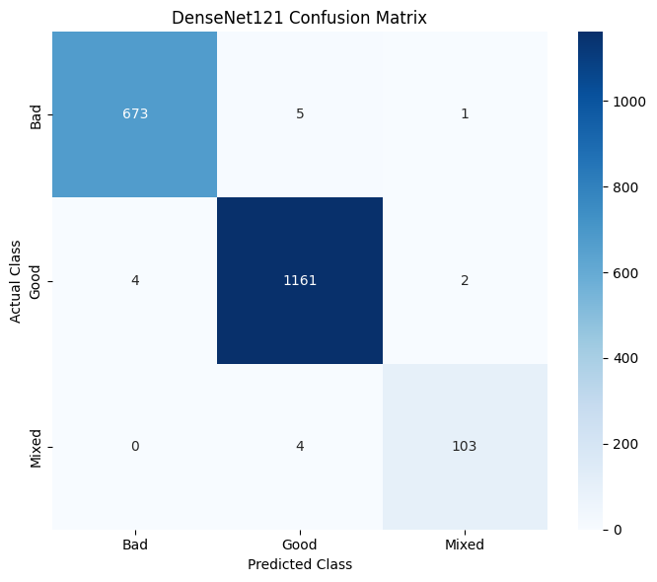
6. DenseNet121 Conclusion
DenseNet121 achieved excellent classification performance on the fruit-quality dataset, with approximately 99.18% test accuracy.
The confusion matrix demonstrates that the model correctly identifies the majority of samples across all three categories. Only a small number of classification errors were observed.
The Mixed category remains relatively more challenging because it contains considerably fewer samples than the Bad and Good categories.
Overall, DenseNet121 demonstrates that transfer-learning-based deep CNN architectures can achieve highly accurate fruit-quality classification.
PHASE 1 — MODEL COMPARISON
1. Objective
The objective of Phase 1 is to implement and compare two transfer-learning-based deep learning models, EfficientNetB0 and DenseNet121, for three-class fruit quality classification:
- Bad
- Good
- Mixed
Both models were trained under the same dataset and evaluation setup. The models were compared using Accuracy, Precision, Recall, F1-score, confusion matrices, and class-wise performance.
2. Models Used
EfficientNetB0
EfficientNetB0 was selected as a lightweight and computationally efficient convolutional neural network. The pretrained ImageNet feature extractor was kept frozen, while a custom classification head consisting of Global Average Pooling, Dense, Dropout and a final 3-class output layer was added.
Model configuration:
- Input size: 224 × 224 × 3
- Pretrained backbone: EfficientNetB0
- Feature extractor parameters: 4,049,571
- Trainable parameters: 164,355
- Number of output classes: 3
DenseNet121
DenseNet121 was selected as a second transfer-learning architecture for comparison. Its dense connectivity allows features from earlier layers to be reused by later layers, which can help preserve useful visual information.
Model configuration:
- Input size: 224 × 224 × 3
- Pretrained backbone: DenseNet121
- Feature extractor parameters: 7,037,504
- Trainable parameters: 131,587
- Number of output classes: 3
- 3. Overall Performance Comparison
Model | Accuracy | Precision | Recall | F1-Score
EfficientNetB0 | 99.18% | 99.18% | 99.18% | 99.18%
DenseNet121 | 99.18% | 99.18% | 99.18% | 99.18%
Observation
Both EfficientNetB0 and DenseNet121 achieved an overall test accuracy of 99.18%. Their overall Precision, Recall and F1-score were also identical at 99.18%.
This indicates that both architectures were highly effective in distinguishing the three fruit-quality categories. Therefore, overall accuracy alone does not provide a sufficient basis for selecting one model over the other.
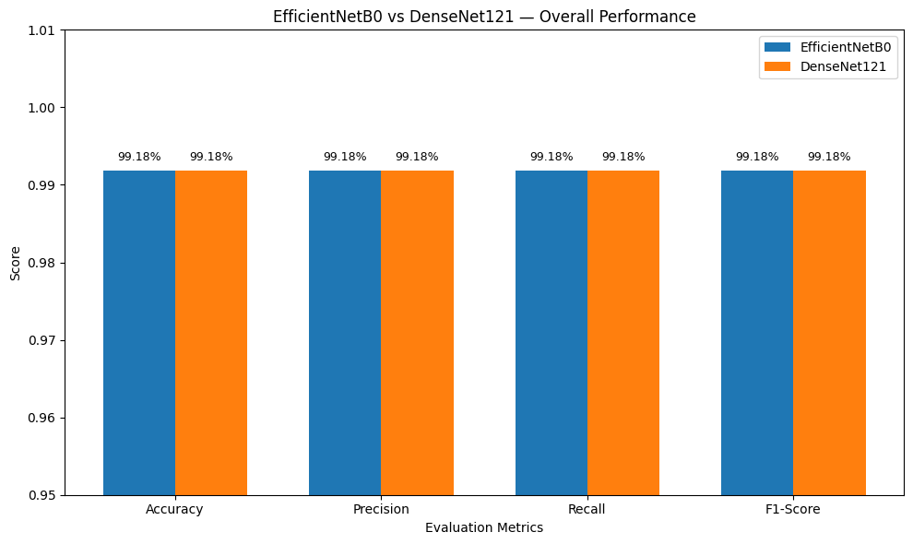
4. Class-Wise Performance Comparison
The class-wise results provide a more detailed understanding of model performance.
Class | EfficientNetB0 Precision | EfficientNetB0 Recall | EfficientNetB0 F1 | DenseNet121 Precision | DenseNet121 Recall | DenseNet121 F1
Bad | 99% | 99% | 99% | 99% | 99% | 99%
Good | 99% | 99% | 99% | 99% | 99% | 99%
Mixed | 99% | 95% | 97% | 97% | 96% | 97%

Observation
Both models performed almost identically on the Bad and Good classes.
The major difference was observed in the Mixed class. DenseNet121 achieved a 96% recall, compared with 95% recall for EfficientNetB0. This indicates that DenseNet121 correctly identified a slightly higher proportion of Mixed-quality fruits.
Since the Mixed class has significantly fewer samples than the Good and Bad classes, its recall is an important indicator when evaluating model robustness under class imbalance.
5. Mixed-Class Recall Comparison
Observation
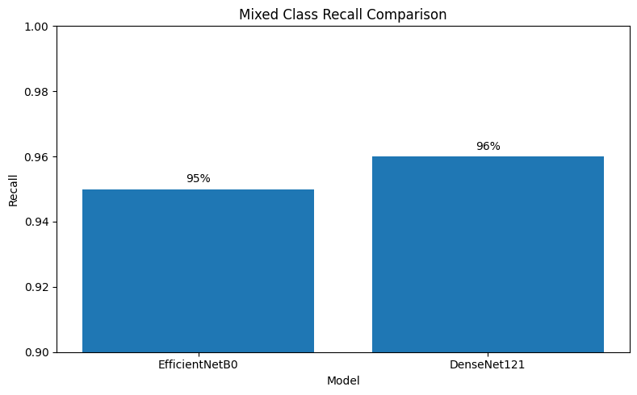
DenseNet121 achieved 96% recall for the Mixed class, while EfficientNetB0 achieved 95% recall.
Although the difference is only 1 percentage point, DenseNet121 demonstrates slightly better detection capability for the minority Mixed class.
This is important because a model can achieve very high overall accuracy while still performing relatively poorly on an underrepresented class. Therefore, class-wise recall was considered alongside overall performance.
6. Confusion Matrix Analysis
EfficientNetB0
The EfficientNetB0 confusion matrix was:
Actual / Predicted | Bad | Good | Mixed
Bad | 674 | 5 | 0
Good | 5 | 1161 | 1
Mixed | 1 | 4 | 102
The model correctly classified the majority of samples in all three classes. Most errors occurred between the Mixed and Good classes.
DenseNet121
The DenseNet121 confusion matrix was:
Actual / Predicted | Bad | Good | Mixed
Bad | 673 | 5 | 1
Good | 4 | 1161 | 2
Mixed | 0 | 4 | 103
DenseNet121 also correctly classified the overwhelming majority of samples. It correctly identified 103 out of 107 Mixed samples, resulting in approximately 96% Mixed-class recall.
7. Final Comparison and Model Selection
Comparison Summary
Both EfficientNetB0 and DenseNet121 demonstrated excellent performance on the fruit-quality classification task, achieving 99.18% overall accuracy.
However, DenseNet121 showed a small advantage in identifying the minority Mixed class, achieving 96% recall compared with 95% for EfficientNetB0.
Therefore, based on Phase 1 results:
DenseNet121 is selected as the preferred model for further experimentation because it provides slightly better minority-class recall while maintaining the same overall performance as EfficientNetB0.
This selection is particularly relevant to the project's focus on class imbalance and robust fruit-quality classification.
“Both models demonstrated comparable overall performance, while DenseNet121 showed a slight advantage in Mixed-class recall.”

