**COMSATS University Islamabad (CUI)**

**Assignment-01**

**(CLO-01)**

**Project Proposal**

(SCOPE DOCUMENT)

**for**

**Project Title**

(XOTRON)

Version 1.0

***By***

**ARSLAN AMIN SP21-BCT-005**

**HALEEMA SAADIA SP21-BCT-007**

**BCT-4-A**

***Supervisor*MR. TEHSEEN RIAZ ABBASI**

***Bachelor of Science in Computer Science (2021-2024)***

**Table of Contents**

Abstract 1

1. Introduction 2

2. Problem Statement 2

3. Problem Solution/Objectives of the Proposed System 2

3.1 Objectives 3

4. Related System Analysis/Literature Review 3

5. Vision Statement 3

6. Advantages/Benefits of Proposed System 4

7. Scope 4

8. Modules 4

8.4 Module 4 Bot training 6

8.5 Module 5: Health care 6

8.6 Module 6: Chatbot Analytics 7

8.7 Module 7: Generals 7

8.8 Module 8: Sentiment analysis 7

8.9 Module 9: Personal assistance 8

8.10 Module 10: The Help and Support 8

9. System Limitations/Constraints 8

10. Software Process and Design Methodology 9

11. Data Gathering Approach 9

12. Concepts 9

Basic concepts of Smartphone Development: 9

13. Tools and Technologies 10

14. Project Stakeholders and Roles 11

15. Module based Work Division 11

16. WBS and Gantt Chart 12

17. Mockups 14

18. Conclusion 20

19. References 20

20. Plagiarism Report 21

**Project Category:**

□ **B-**Web Application □ **E-**Smartphone Application

□ **K-** Artificial intelligence and Machine learning

# Abstract

AI chatbot can simulate a person communication with an herbal language via messaging applications. AI Chatbot saves our time, money and offers higher customer.

Now a days chatbots are more responsible and useful. Like Endurance, a partner for Dementia Patients. Also, Alexa, Siri, and Google Assistance are the commonly used chatbots.

Our chatbot system will enable the agile and dynamic conversations. This will help in serving huge number of customers at the same time by using their existing resources, FAQs, and knowledge articles. Chatbot system will permit **to** hook up with clients in a non-public manner without the price of human representatives. Objectives of the chatbot system include cost saving to business, boost efficiency, reduce customers waiting time, their health issues, basic daily problems and enhance customer engagement.

chatbot system will provide some personalization by engaging customers in one-on-one conversations, maintaining a natural tone. Chatbot system will communicate with the real person behaving like a human being providing 24/7 service to the customers. Chatbot system will be applicable to the health industry and general personal assistant.

# Introduction

Today in any of the business, consumers want instant solutions and delivery. Now a days, time management and fast delivery means survival. All the necessary information must be provided to employees and technology platforms by businesses. Not only to provide customer service but also to anticipate what they require or want. This is how companies create and implement strategies at incredible speed. And any business that operates and collects large amounts of data and relies on making quick decisions in real time requires intelligent bots combined with AI. So chatbot system will be very helpful in such an environment. One of the best things about chatbots System is that it is simple to connect people who don't like them with real employees. One of a sales chatbot's most important features is the ability to switch between assisted and unassisted selling and the option to use a human sales assistant if necessary. Businesses are now able to offer more to their digital customers, often at a lower cost, due to chatbots System. Chatbots system improves the communication rate, improve customer service experience and workflow in many areas of a growing business.

# Problem Statement

Today the whole business sector is going through tough competition new technologies are the only way to stay competitive. Competition in the business makes it mandatory to adopt the innovations. Innovations in the sector of health are necessary So, chatbots also can be one of the important elements of everyday health issues. Some of the problem that the Existing chatbot systems don’t exactly use grammar correctly sometimes. even they answer questions and give solutions that are not relevant from what we asked and shared. Usually, a chatbot cannot understand the mood of the consumer which results in providing wrong information to the user. AI automated chatbot systems have some limitations. One of the major issues of AI chatbots system is security. people want to trust that if they share their data with chatbots. So, our Chatbot System will be solving this issue.

# Problem Solution/Objectives of the Proposed System

The way businesses sell their products has changed completely but there are some issues with the quality of customer service. It may take a long time for a company employee to respond, especially in live chats, and the responses may not always be pertinent. Customers will be supported by a lot of businesses through our chatbot system. The chatbot System will be available to customers 24 hours a day. Will allow them to submit their inquiries regardless of time. As for as the security is concerned, our chatbot system will therefore only ask for relevant data which will only be used to solve their issues or offer personalized experiences. to improve the worth of client correspondence. chatbot system will comprehend the mind-set of the client by sentence structures and verbal prompts. For health queries ChatBot systemwill be a trained Bot that would be able to understand user’s problem and will try to give a proper solution.

**Example:**

## Objectives

*-1 Save Time and Money*

*-2 Provide After Hours Support 24/7*

*-3 Guide Users to Better results*

*-4 Customers engagement*

*-5 ensure security of consumer*

# Related System Analysis/Literature Review

Lark is a chatbot like our project.it offers personalized health plans, nutrition coaching, and unlimited check-ins to its users, include treatment for high blood pressure, diabetes management and prevention, and general wellness.

Briefly provide an analysis of the related system which may help you to specify the contribution of the proposed project.

Table 1 Related System Analysis with proposed project solution

|  |  |  |
| --- | --- | --- |
| **Application Name** | **Weakness** | **Proposed Project Solution** |
| * LARK | * Asks too many personal information hence there exists security risk * No use of sentiment analysis * Does not keep old conversation record | * Our proposed system will only ask the relevant questions, and provide the solutions and results * Our system will use sentiment analysis to add value to the customer service * Our system will keep record of old conversation. |

# Vision Statement

For the hospitals or clinics that are very far away from the patients or do not have branches in the other cities, this chatbot system can be very helpful in dealing with their patients without the need of their physical appearance. System will be helpful for the patients who are old. The chatbot system will remind the user his work on the daily bases. Chatbot will provide a more precise way for the checkup unlike current Chatbots. Our System will save cost and time of being physically present. System will ensure the confidentiality of the user’s information and security risks. The System will also respond to general problems and talks as a person’s assistant.



# Advantages/Benefits of Proposed System

### Affordability:

System may save 50% of the expenses of the users by shifting the activities to online rather than physical.

### Security:

System lessons the security risk by limiting the user’s sensitive information. Only required information is gathered from the user. Keeps the data confidential.

### Efficiency:

System will be efficient because it is AI based. Will keep the record of old conversations.

### Availability:

System will be available 24/7 to the user.

Improves users’ satisfaction.

Answering questions from the user.

Will Makes the suggestions available to the person even without leaving his/her place.

# Scope

The way businesses communicate with and comprehend their customers is being transformed by chatbots. Chatbots will be able to provide a more individualized customer experience thanks to AI. Through customer service, internal processes, and marketing efforts, it is also saving businesses money. The credibility of a business and the quality of its customer service are two essential aspects of a successful business model. To keep up with the ever-changing world, numerous well-known businesses are now employing chatbots powered by artificial intelligence. The goal of this chatbot system is to lower the work burden on the humans and provide a useful way to the consumers in their daily based task. Also, a check and balance on their health. Everyone needs a personal assistance, so this AI based chatbot is the best system for assessing a user without the interaction of other humans. User work will be easier and efficient.

# Modules

**8.1 Module 1: Profile management/ Registration page:**New users can create an account by entering their name, phone number, email address and password. Their ID will be created, and they will be provided with a username and password. By entering his username and password, the user can log in.

### Sign Up

This will enable the new users/patients to sign up for a new account on the application.

### Sign In

This use case will allow the users/patients to sign-in or log-in for already registered account

### 8.1.3 Change Avatar

This use case allows the new users/patients to change the avatar the user selected during sign-up on the app.

### Change Password

This use case allows the new users/patients to change password of the account.

### 8.1.5 Forgot Password

This use case allows the users/patients to reset the password.

### 8.1.6 View Profile

This use case allows the new users/patients to view his profile and information

### 8.1.7 Logout

This use case allows the user to logout.

**8.2 Module 2: Daily base Communication**:

In this module the daily communication of user with the bot will be managed and displayed.

User will be able to chat with the bot and will receive auto generated messages from the bot.

### 8.2.1 Navigate to Chat Box

Through this action user can navigate to the chat box and can chat with the bot.

### Display daily auto generated messages.

Through this action bot will generate a new message in chat box after every 24 hours to interact with the user and the system will display that message on screen

### Chat Replies

Through this action bot will reply to user’s messages after going through some machine learning techniques and then retrieving some data from data base (if related data is available) the system will display the resultant reply to the user

### Refresh Chat Box

Through this action bot can refresh the chat box.

* 1. **Module 3: Registered People Management:**

**8.3.1 Email id**

The email id is kept and managed here.

* + 1. **Customers Data**

Customer private and personal data is kept and managed here.

* + 1. **Customers conversations**

The conversations among the bot and the customer are kept and managed in this module.

* + 1. **Customers password**

The Customers password details are in this module.

* + 1. **Customer problems**

All customer problems are added in this module.

## Module 4 Bot training

This module will primarily handle the process of training our bot with a related data set. The bot will learn what kind of response to give to what kind of message, and the trained set will be stored in a database so that machine learning algorithms can evaluate the messages.

### Pre-processed info

In this data related to the daily routine and daily health problems and their recommended solution. Bot will train to the data provided.

### Validating of users Messages

When a user sends a message, the message's validity is checked before any ML techniques are applied. If the message contains all special characters, more special characters, or a message that is too short, the system will reject it.

### Message Replies

after the process bot will receive the message and bot will try to find a reply for the particular message.

### Data storage

The messages and other data must be organized Ly stored in a data base following all operations on the sample messages and incoming user messages, which will be done in this section.

## Module 5: Health care

### Daily health form

The user will be able to complete a form with some basic questions about health by taking this action. After completing the form, the user will be given recommendations for self-recovery exercises.

### Analysis Form

By performing this action, the system will examine the form in accordance with the algorithm, draw conclusions from the form, and then recommend exercises to the user based on the condition.

### Exercises

By taking this action, the system will look over the form and tell the user which exercises are best for them.

### Every possible solution or exercise

The user can use this action to view all the exercises and solutions, then user move on to any solution.

### Relaxation stuff

The user can be able to listen the music or quranic verses for relaxation.

### Medication

Suggest the user specific medicines

## Module 6: Chatbot Analytics

### Number of unique users

### Number of daily messages

This will contain number of daily messages.

### Activity status

Number of hours spent on the site or the app.

### Chat history

All the previous messages and problems

### Clear Chat history

Gives an option of Clearing chat history.

### Discover busiest period

Using heatmap to find when user is most active.

### Clear Chat history

## Module 7: Generals

### Feeling Alone need to talk

User will have a company when feeling alone

### Personal diary

In this user will be able to maintain his personal diary. Can add things he likes.

### Motivational support

Issues other than health will be entertained.

### Education help

User can share the queries regarding studies and get help.

## Module 8: Sentiment analysis

### User input

User talk and conversation

### Recognizing the sentiment

How the user is feeling

### NLP

This bot will be able to comprehend user messages, extract keywords from messages, and possibly generate messages that can be read by humans. Spell checking and other aspects will also be examined.

### Intensity of emotion

Judging the intensity of the emotion by the user’s response

### Detecting range of emotion

Range of emotion is detected

### Relevant reply

There is a relevant reply

## Module 9: Personal assistance

### Daily schedule

Personal assistance is done daily.

### Remainders

Help User to set remainders

### Routine planner

A routine planner is present

## Module 10: The Help and Support

### Guide for user

Allows user to view the guideline to use the system.

### Tutorials

Having video tutorials

### report issues

allows user to report any issue regarding anything and submit

### Send feedback

allows user to send feedback regarding the application

# System Limitations/Constraints

*1- IN case of serious health issues or injuries this System will not be able to entertain the user. However, the user will have to go physically for the treatment.*

*2-The chatbot system will be task specific hence poses question based on determined options in health sector.*

*3-The user should have a reliable internet connection to access.*

*4-The app only uses and understands English language*

# Software Process and Design Methodology

Incremental Process Model will be used in the software process methodology. As the requirements are known and there is very low chance that they will be changed so incremental process model is more suitable for this project. The incremental process model has requirements, design, implementation, testing and coding. Because some features of the app are dependent on others, some modules are interconnected, and various functionalities share data with one another, we will employ an object-oriented methodology. Additionally, the app will be used by a lot of people looking for counseling, so OOP is the best approach for our project. Also, we will be using such programming languages which or object oriented so oop is the best choice

# Data Gathering Approach

We generated questionnaires for gathering the data. Also, we observed different people and tried to understand their issues. Questionnaires consist of the experience of people suffering from different problems. The goal was to get an idea of the kinds of questions that users might ask and the kinds of health or general problems cases that might come up. The requirements were developed in accordance with all the usual observations and concepts. In addition, we examined comparable apps to improve the user experience of our app and locate treatments and solutions.

# Concepts

The concepts that we will learn while doing the targeted project are:

Artificial Intelligence Concepts:

**Basic concepts of Artificial Intelligence:**

* Supervised Learning.
* Unsupervised Learning.
* Semi-supervised Learning.
* Reinforcement Learning.

**Basic concepts of Natural Language Processing:**

**The top 7 techniques Natural Language Processing (NLP) uses to extract data from text are:**

* Sentiment Analysis.
* Named Entity Recognition.
* Text Classification.
* Keyword Extraction.

## Basic concepts of Smartphone Development:

For the App development, IntelliJ, Flutter Dart and Python (for Machine Learning Algorithms) are used to develop Android App.

# Tools and Technologies

NLP is a technology that allows chat bots to become more humane than they were used to when they were tasked with replicating common customer service scripts. This interpretation is possible through a process known as natural language understanding (NLU).

|  |  |  |  |
| --- | --- | --- | --- |
| **TOOLS AND TECHNOLOGIES** | **TOOLS** | **VERSION** | **RATIONALE** |
| 1.MobileMonkey | 1.1.5 | Virtual chatbot |
| 2.TARS | 1.13.1 | Virtual chatbot |
| 3.BOTSIFY | 1.3 | Virtual chatbot |
| 4.BOTKIT | 4.15.0 | Virtual chatbot |
| 5.Wit.ai | 4.1.2 | Virtual chatbot |
| 6.Replika | 10.2.0 | Virtual chatbot |
| 7.Chatfuel | 1.0.4 | Virtual chatbot |
| **TECHNOLOGY** | **VERSION** | **RATIONALE** |
| 1.AI | 0.0.1 | Programming language |
| 2.NLP | 4.3.0 | Programming language |

# Project Stakeholders and Roles

|  |  |
| --- | --- |
| **Project Sponsor** | **Mr. Tehseen Riaz Abbasi**  Comsats University Islamabad, Islamabad campus Comsats University Islamabad is the project's executive sponsor, and it is responsible for the project's success by providing resources and support. |
| **Stakeholder** | The project supervisor is **Mr.** **Tehseen Riaz Abbasi**. He will observe and see our project coordination from start to end. Uses project management approaches and tools to guarantee that projects meet their objectives in terms of scope, schedule, and money.   * The project's team members are **Arslan Amin** and **Haleema Saadia**. They oversee carrying out specific project tasks in order to meet the project's requirements |

# Module based Work Division

Table 2 Team Member Work Division for Proposed Project

|  |  |  |
| --- | --- | --- |
| **Student Name** | **Student Registration Number** | **Responsibility/ Modules** |
| * ARSLAN AMIN * HALEEMA SAADIA | * Sp21-BCT-005 * Sp21-BCT-007 | * Half of the headings have been done by Arslan Amin and remaining half have been done by Haleema Saadia   ARSLAN AMIN (Module4-Module8  Abstract, problem statement, solution, Advantages, Scope, Gantt chart, Data gathering  )  HALEEMA SAADIA (Module 1-Module3  Tools and technologies, Mockups, references, Conclusion Concepts, System Limitations  ) |

# WBS and Gantt Chart

|  |  |  |  |
| --- | --- | --- | --- |
| ID | **Task** | Duration | Resources |
| 1 | **Anaysis** | **10days** | Arslan,Haleema |
| 2 | Requirement Meeting | 6d | Arslan,Haleema |
| 3 | Docuent Current System | 2d | Arslan |
| 4 | Analysis Finished | 2d |  |
| 5 | **Design** | **25d** | Arslan,Haleema |
| 6 | Design Database | 6d | Haleema |
| 7 | Design Software | 6d | Arslan |
| 8 | Interface Design | 5d | Arslan |
| 9 | Design Finished | 8d |  |
| 10 | **Developement** | 15d | Arslan,Haleema |
| 11 | Develop System Module | 6d | Arslan,Haleema |
| 12 | Integrate System Module | 5d | Arslan |
| 13 | Perform Initial testing | 4d | Haleema |
| 14 | Development Finished |  |  |
| 15 | **Testing** | 8d | Arslan,Haleema |
| 16 | Perform System Testing | 6d | Haleema |
| 17 | Issue Found | 1d | Haleema |
| 18 | Correct Issue | 1d | Arslan |
| 19 | Testing Finished |  |  |
| 20 | **Implementation** | 3d | Arslan,Haleema |
| 21 | On site installation | 3d | Arslan,Haleema |
| 22 | **Completion** | 16d |  |
| 23 | System maintenance | 8d | Arslan,Haleema |
| 24 | Evaluation | 8d | Arslan |

# Mockups

FOR Mobile:

**MOCKUP 1:**

**Front page**

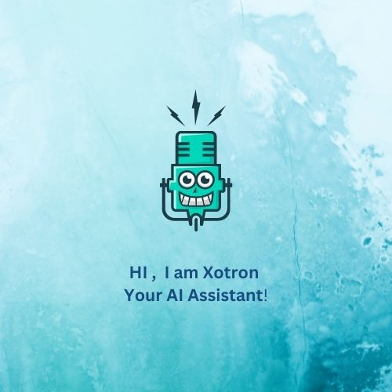

**MOCKUP 2:**

**Home Page**

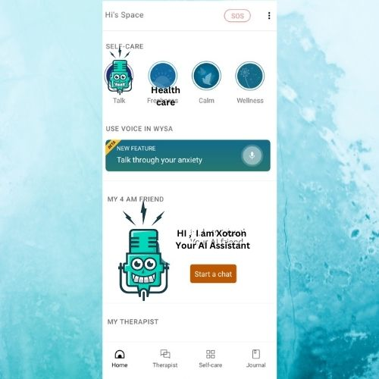

**Mockup 3:**

**Security**



**Mockup 4:**

**Choose from Options**

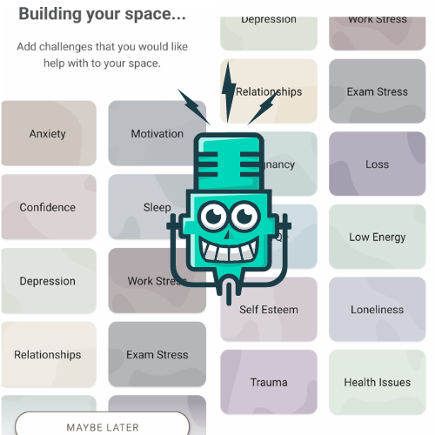

**FOR WEB**

**Mockup 5**

**Chat screen for Web**

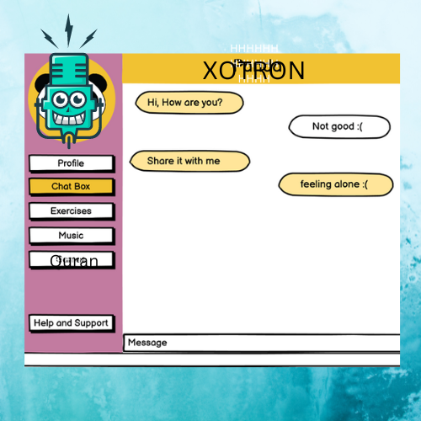

**MOCKUP 6**

**Chat analysis**

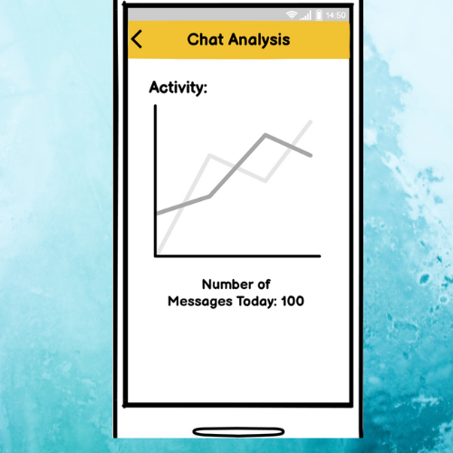

# Conclusion

Chatbots are effective tools when it comes to education, IR, e-commerce, Health etc.

The healthcare chatbot we will create will take care of our customers health and medical routines by reminding them at certain intervals of time.

The aim of our chatbot design is a tool built that helps people, facilitate their work, and their interaction with computers using natural language; but not to replace the human role totally, or imitate human conversation perfectly.

Even with high volume of customer queries, chatbots can **offer the required solutions in no time**. Being available always is a strength of chatbots over humans. So, in the AI chatbots vs human scenario, a chatbot is the clear winner.

# References

* [**https://ui8.net/the-madbrains/products/madbrainsui--chatbot--ai-startup-agencyux**](https://ui8.net/the-madbrains/products/madbrainsui--chatbot--ai-startup-agencyux)
* [**https://www.analyticsvidhya.com/blog/2021/10/complete-guide-to-build-your-ai-chatbot-with-nlp-in-python/**](https://www.analyticsvidhya.com/blog/2021/10/complete-guide-to-build-your-ai-chatbot-with-nlp-in-python/)
* [**https://vilmate.com/blog/how-to-develop-a-chatbot/**](https://vilmate.com/blog/how-to-develop-a-chatbot/)
* [**https://youtu.be/1XHp8WrZzoc**](https://youtu.be/1XHp8WrZzoc)
* [**https://www.ameyo.com/blog/key-advantages-and-use-cases-of-healthcare-chatbot/**](https://www.ameyo.com/blog/key-advantages-and-use-cases-of-healthcare-chatbot/)
* [**https://geekflare.com/create-chatbot/**](https://geekflare.com/create-chatbot/)
* [**https://www.tutorialspoint.com/artificial_intelligence/artificial_intelligence_natural_language_procssing.htm**](https://www.tutorialspoint.com/artificial_intelligence/artificial_intelligence_natural_language_procssing.htm)

# Plagiarism Report

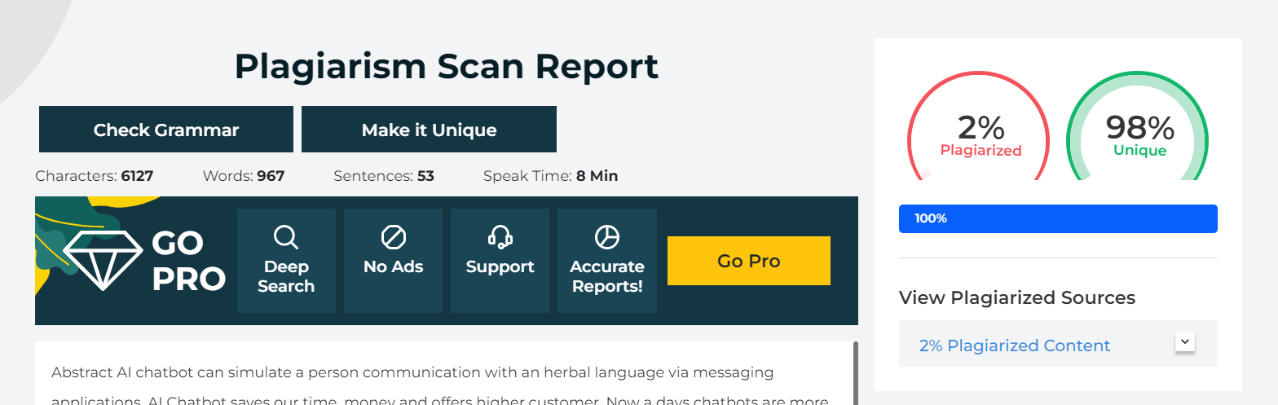

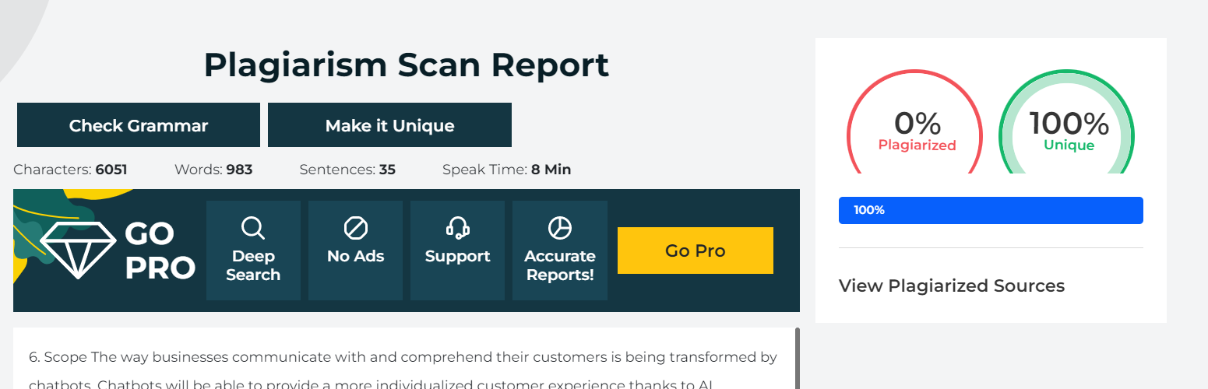

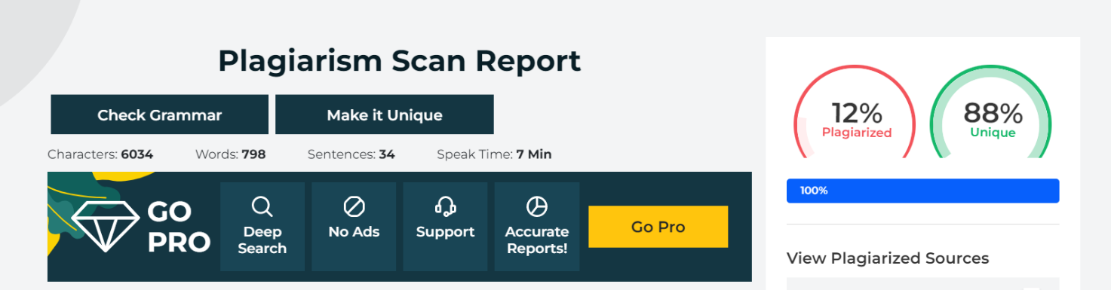

**AVERAGE PLAGIARISM = 2+0+12/3 = 4.67**