**COMSATS University Islamabad (CUI)** 

**Assignment-02**

**CLO-2**

**Software Requirement Specification**

**(SRS DOCUMENT)**

**for**

**Project Title**

*XOTRON*

Version 1.0

**Submitted By:**

**Arslan Amin SP21-BCT-005 BCT-4A**

**Haleema Saadia SP21-BCT-007 BCT-4A**

***Supervisor***

**Mr. Tehseen Riaz Abbasi.**

***Bachelor of Science in Cyber Security (2020-2024)***

**Table of Contents**

**1.** **Introduction 1**

**1.1** **Purpose** 1

**1.2** **Scope** 1

**1.3** **Modules** 1

**1.4** **Overview** 1

**2.** **Overall Description 1**

**2.1** **Product Perspective** 1

**2.2** **User classes and characteristics** 1

**2.3** **Operating Environment** 1

**2.4** **Design and Implementation Constraints** 2

**3.** **Requirement Identifying Technique 2**

**3.1.** **Use Case(s) Diagram:** 2

**4.** **Functional Requirements 3**

**4.1.** **Use Case(s) (List):** 3

**4.2.** **Use Case(s) (Tabular):** 4

**4.3.** **Functional Requirement X** 6

**5.** **Non-Functional Requirements 7**

**5.1** **Reliability** 7

**5.2** **Usability** 7

**5.3** **Performance** 7

**5.4** **Security** 7

**6.** **External Interface Requirements 8**

**6.1** **User Interfaces Requirements** 8

**6.2** **Software interfaces** 8

**6.3** **Hardware interfaces** 9

**6.4** **Communications interfaces** 9

**7.** **Conclusion 9**

**8.** **References 9**

**9.** **Plaragism Report 10**

i

# Introduction

This chapter provides the overview of the project, in this chapter we discussed the vision statement of AI chat bot and its limitations, what we are going to deliver, tool and technologies which we used to build Chatbot and how this project related to our course module.

Additionally, businesses that operate, gather a lot of data, and depend on making quick judgments in real time need to mix AI and intelligent bots. Therefore, a chatbot system will be quite useful in this setting. The ease with which those who dislike chatbots can be connected to actual personnel is one of their best features. The flexibility to switch between assisted and unassisted selling and the choice to engage a human sales assistant when necessary is one of a sales chatbot's most crucial capabilities. Thanks to chatbots, businesses can now provide more to their online clients, frequently for less money. The use of chatbots in many areas of business increases communication rates, customer satisfaction, and workflow.

## Purpose

This document's primary goal is to give a thorough description of the application. In order to effectively accomplish this project, all application functionalities will be listed in this document. The project "AI Chatbot" is described in general terms in this paper, together with its functional and nonfunctional requirements, user interfaces, attributes, and use case diagrams. The document is meant for documentation writers, users, and project managers.

## Modules

**Module1: Profile management/ Registration page:**New users can create an account by entering their name, phone number, email address and password. Their ID will be created, and they will be provided with a username and password. By entering his username and password, the user can log in.

**Sign Up**

This will enable the new users/patients to sign up for a new account on the application.

**Sign In**

This use case will allow the users/patients to sign-in or log-in for already registered account

**Change Avatar**

This use case allows the new users/patients to change the avatar the user selected during sign-up on the app.

**Change Password**

This use case allows the new users/patients to change password of the account.

**Forgot Password**

This use case allows the users/patients to reset the password.

**View Profile**

This use case allows the new users/patients to view his profile and information

**Logout**

This use case allows the user to logout.

**Module 2: Daily base Communication**:

In this module the daily communication of user with the bot will be managed and displayed.

User will be able to chat with the bot and will receive auto generated messages from the bot.

**Navigate to** **Chat Box**

Through this action user can navigate to the chat box and can chat with the bot.

**Display daily auto generated messages.**

Through this action bot will generate a new message in chat box after every 24 hours to interact with the user and the system will display that message on screen

**Chat Replies**

Through this action bot will reply to user’s messages after going through some machine learning techniques and then retrieving some data from data base (if related data is available) the system will display the resultant reply to the user

**Refresh Chat Box**

Through this action bot can refresh the chat box.

**Module 3: Registered People Management:**

**Email id**

The email id is kept and managed here.

**Customers Data**

Customer private and personal data is kept and managed here.

**Customers conversations**

The conversations among the bot and the customer are kept and managed in this module.

**Customers password**

The Customers password details are in this module.

**Customer problems**

All customer problems are added in this module.

**Module 4 Bot training**

This module will primarily handle the process of training our bot with a related data set. The bot will learn what kind of response to give to what kind of message, and the trained set will be stored in a database so that machine learning algorithms can evaluate the messages.

**Pre-processed info**

In this data related to the daily routine and daily health problems and their recommended solution. Bot will train to the data provided.

**Validating of users Messages**

When a user sends a message, the message's validity is checked before any ML techniques are applied. If the message contains all special characters, more special characters, or a message that is too short, the system will reject it.

**Message Replies**

after the process bot will receive the message and bot will try to find a reply for the particular message.

**Data storage**

The messages and other data must be organized Ly stored in a data base following all operations on the sample messages and incoming user messages, which will be done in this section.

**Module 5: Health care**

**Daily health form**

The user will be able to complete a form with some basic questions about health by taking this action. After completing the form, the user will be given recommendations for self-recovery exercises.

**Analysis Form**

By performing this action, the system will examine the form in accordance with the algorithm, draw conclusions from the form, and then recommend exercises to the user based on the condition.

**Exercises**

By taking this action, the system will look over the form and tell the user which exercises are best for them.

**Every possible solution or exercise**

The user can use this action to view all the exercises and solutions, then user move on to any solution.

**Relaxation stuff**

The user can be able to listen the music or quranic verses for relaxation.

**Medication**

Suggest the user specific medicines

**Module 6: Chatbot Analytics**

**Number of unique users**

**Number of daily messages**

This will contain number of daily messages.

**Activity status**

Number of hours spent on the site or the app.

**Chat history**

All the previous messages and problems

**Clear Chat history**

Gives an option of Clearing chat history.

**Discover busiest period**

Using heatmap to find when user is most active.

**Clear Chat history**

**Module 7: Generals**

**Feeling Alone need to talk**

User will have a company when feeling alone

**Personal diary**

In this user will be able to maintain his personal diary. Can add things he likes.

**Motivational support**

Issues other than health will be entertained.

**Education help**

User can share the queries regarding studies and get help.

**Module 8: Sentiment analysis**

**User input**

User talk and conversation

**Recognizing the sentiment**

How the user is feeling

**NLP**

This bot will be able to comprehend user messages, extract keywords from messages, and possibly generate messages that can be read by humans. Spell checking and other aspects will also be examined.

**Intensity of emotion**

Judging the intensity of the emotion by the user’s response

**Detecting range of emotion**

Range of emotion is detected

**Relevant reply**

There is a relevant reply

**Module 9: Personal assistance**

**Daily schedule**

Personal assistance is done daily.

**Remainders**

Help User to set remainders

**Routine planner**

A routine planner is present

**Module 10: The Help and Support**

**Guide for user**

Allows user to view the guideline to use the system.

**Tutorials**

Having video tutorials

**report issues**

allows user to report any issue regarding anything and submit

**Send feedback**

allows user to send feedback regarding the application

## Overview

This subsection should describe what the rest of the **SRS** contains and explain how the document is organized.

# Overall Description

This section presents a high-level overview of the product and the environment in which it will be used, the anticipated users, and known constraints, assumptions, and dependencies.

## Product Perspective

Many firms will provide customer help using our chatbot system. Customers will have constant access to the chatbot system throughout the day. will enable people to submit their questions at any moment. In order to maintain their security, our chatbot system will only ask for information that is necessary to address their problems or provide a customized experience. to increase the value of client communications. By using verbal prompts and phrase structures, a chatbot system will be able to understand the client's mindset. For health-related questions, the chatbot system will use a trained Bot that can comprehend the user's issue and attempt to provide a suitable answer.

.

## Operating Environment

OE-1: AI Chatbot is an android and IOS based mobile application which will perfectly work on all versions of android and IOS on smartphones.

OE-2: It will operate in all famous web browsers; Google Chrome, Microsoft Internet Explorer, Safari, Mozilla Firefox, Opera, Torr etc.

## Design and Implementation Constraints

CO-1: Business users must use their predefined credentials to login into the application.

CO-2: The system shall use email/password for signup/login feature.

CO-3: The user should have a reliable internet connection to access.

CO-4 The app only uses and understands English language

# Requirement Identifying Technique

This section describes the requirements identifying technique(s) which further help to derive functional requirements specification. The selection of the technique(s) will depend on the type of project. For instance,

* **Use case (use case diagram + detail use case)** is an effective technique for interactive enduser applications.
* **Event- response table** is for real-time system in which most of the functionalities are performed at backend.
* **Storyboarding** for graphically intensive applications.

Examples of above techniques are given in Appendix A

## Use Case(s) Diagram:

|  |  |
| --- | --- |
| **Create Use Case Diagrams of your system. Create diagrams as per actor Role.** | |
| **Create Use Case Diagram Using MS VISIO as per UML standard notations** |  |

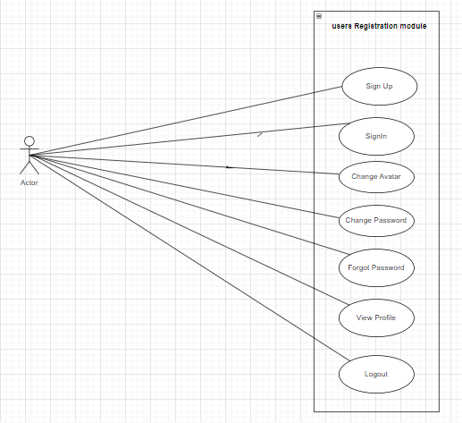

Figure 1:This use case Diagram shows network Registration management.

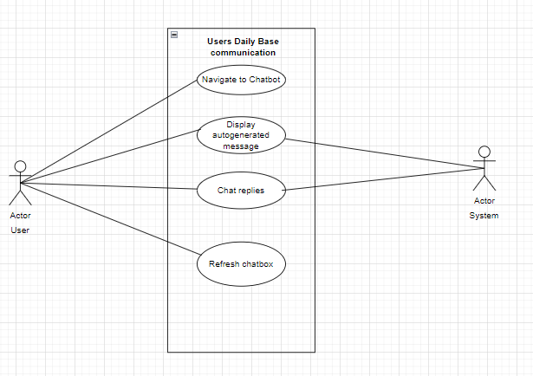

Fig 2: This Diagram shows Users Daily Base Communication.

.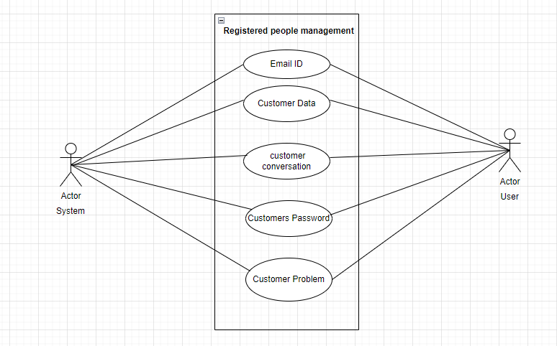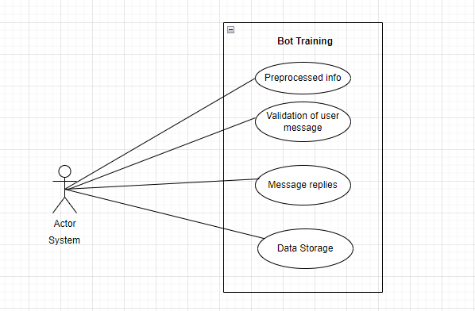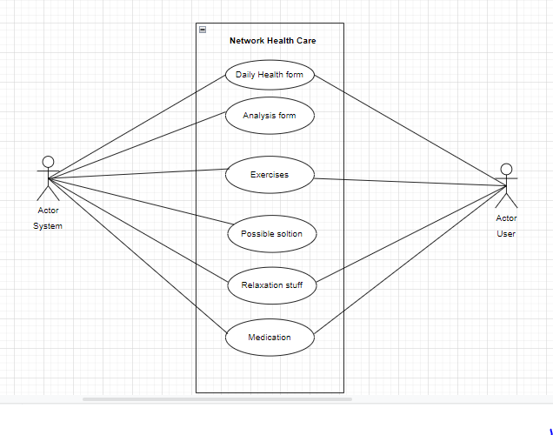

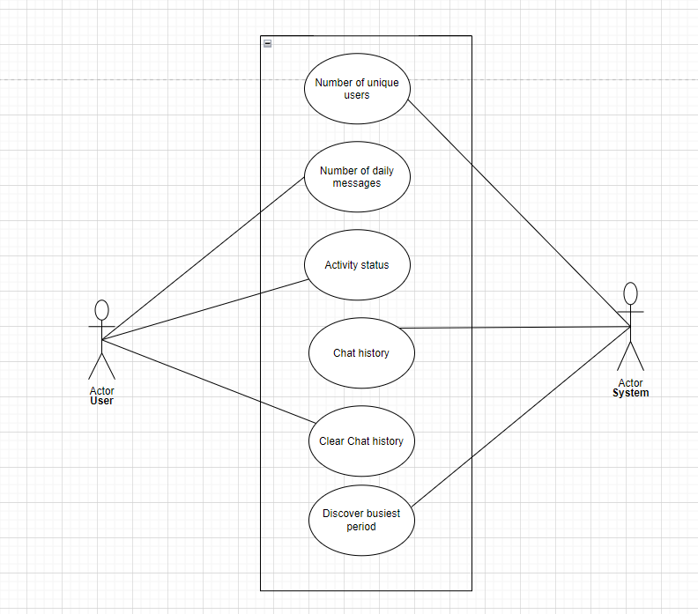

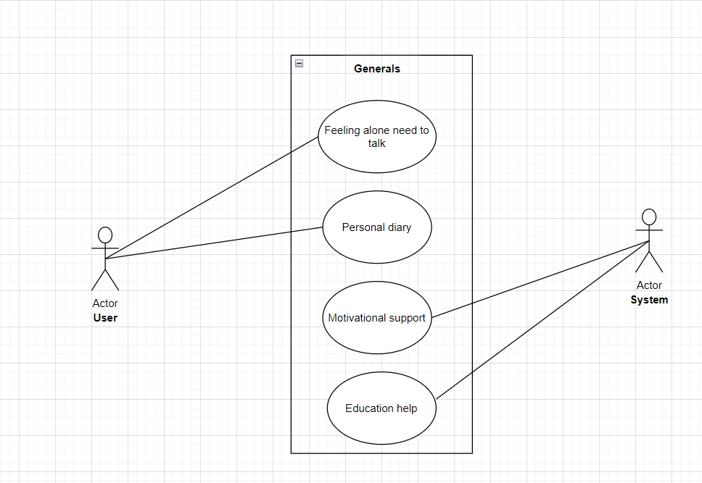

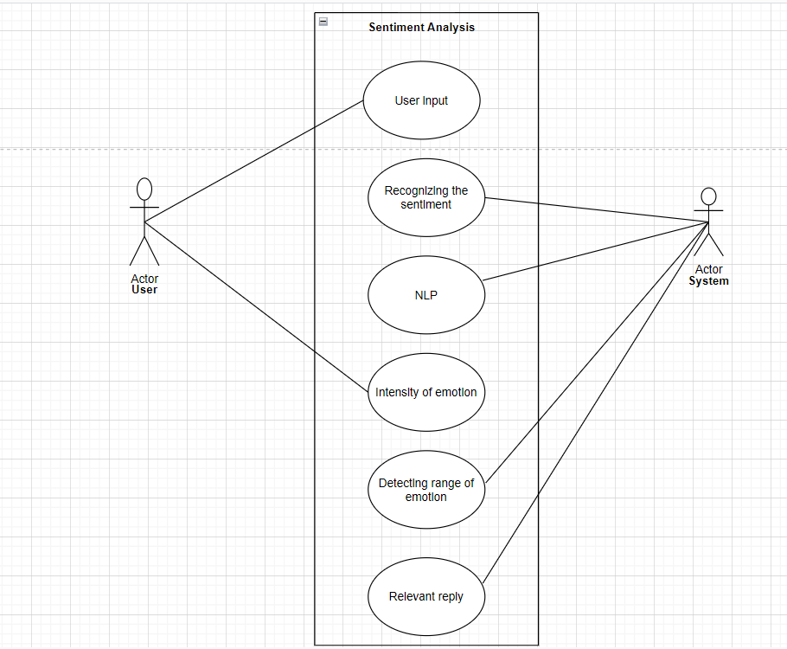

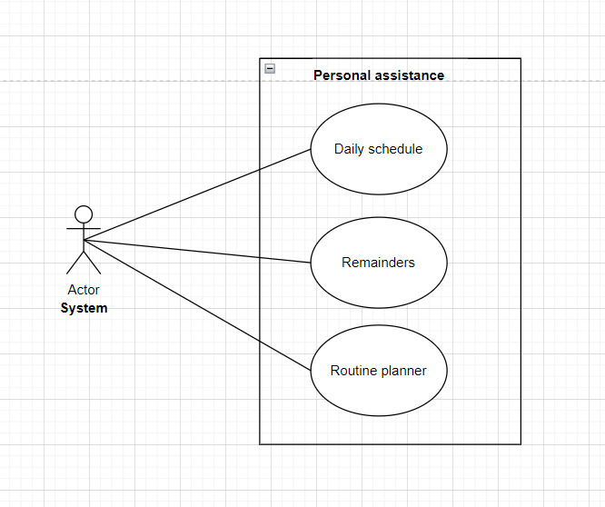

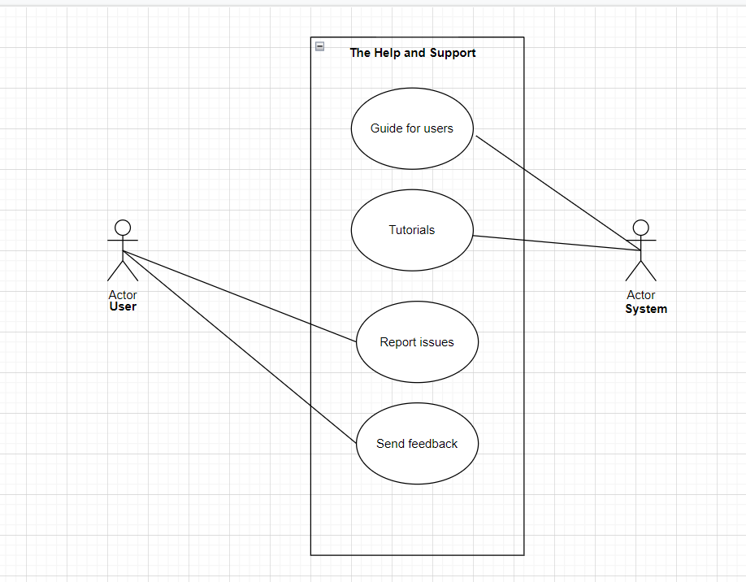

# Functional Requirements

This section describes the functional requirements of the system expressed in the natural language style. This section is typically organized by feature as a system feature name and specific functional requirements associated with this feature. It is just one possible way to arrange them. Other organizational options include arranging functional requirements by use case, process flow, mode of operation, user class, stimulus, and response depend on what kind of technique has been used to understand functional requirements. Hierarchical combinations of these elements are also possible, such as use cases within user classes. For further detail see Chapter 10 “Documenting the requirements”. Let consider the feature scheme as an example.

## Use Case(s) (List):

|  |  |
| --- | --- |
| M1-UC1 | SignUp |
| M1-UC2 | SignIn |
| M1-UC3 | Change Avatar |
| M1-UC4 | Change Password |
| M1-UC5 | Change Password |
| M1-UC6 | View Profile |
| M1-UC7 | Logout |
| M2-UC1 | Navigate to Chatbox |
| M2-UC2 | Display Daily Auto Generated Message |
| M2-UC3 | Chat replies |
| M2-UC4 | Refresh Chatbox |
| M3-UC1 | Email’-ID |
| M3-UC2 | Customers Data |
| M3-UC3 | Customer Conversation |
| M3-UC4 | Customer Password |
| M3-UC5 | Customer Problems |
| M4-UC1 | Preprocessed info |
| M4-UC2 | Validation of user message |
| M4-UC3 | Message replies |
| M4-UC4 | Data Storage |
| M5-UC1 | Daily Health Form |
| M5-UC2 | Analysis form |
| M5-UC3 | Exercises |
| M5-UC4 | Every Possible Solution |
| M5-UC5 | Relaxation Stuff |
| M5-UC6 | Medication |
| M6-UC1 | Number of unique users |
| M6-UC2 | Number of daily messages |
| M6-UC3 | Activity Status |
| M6-UC4 | Chat History |
| M6-UC5 | Clear chat history |
| M6-UC6 | Discover busiest period |
| M6-U7 | clear chat history |
| M7-UC1 | Feeling alone need to talk |
| M7-UC2 | Personal Diary |
| M7-UC3 | Motivational support |
| M7-UC4 | Educational Help |
| M8-UC1 | User input |
| M8-UC2 | Recognizing the statement |
| M8-UC3 | NLP |
| M8-UC4 | Intensity of the emotion |
| M8-UC5 | Detecting range of emotion |
| M8-UC6 | Relevant reply |
| M9-UC1 | Daily schedule |
| M9-UC2 | Remainders |
| M9-UC3 | Routine planner |
| M10-UC1 | Guide for the user |
| M10-UC2 | Tutorials |
| M10-UC3 | report issues |
| M10-UC4 | Send feedback |
|  |  |
|  |  |
|  |  |
|  |  |
|  |  |
|  |  |
|  |  |
|  |  |
|  |  |
|  |  |
|  |  |
|  |  |
|  |  |
|  |  |
|  |  |
|  |  |
|  |  |
|  |  |
|  |  |
|  |  |

## Use Case(s) (Tabular):

This section of the SRS should contain all the details the software developer needs to create a design. This is typically the largest and most important part of the SRS. This section contains an **overview of the use-case model** or the subset of the use-case model that is applicable for this subsystem or feature. **This includes a list of names and brief descriptions of all use cases and actors, along with applicable relationships.**

Write all the use cases as per given tabular format w.r.t to each module.

**Note:** You can get Use Case List as per module aspect from list created in Section-4.1

**4.2.1. SignIn**

### Table 1 Show the detail use case template and example

|  |  |
| --- | --- |
| **Use Case ID:** | M1-UC-1. |
| **Use Case Name:** | SignIn |
| **Actors:** | User  System |
| **Description:** | The user will log in to his/her account by entering the correct Data. |
| **Trigger:** | When the user presses the sign in button. |
| **Level:** | User |
| **Preconditions:** | User must have an application installed on his/her device.  Users must have an existing account. |
| **Postconditions:** | If the user enters wrong login information, then he/she will stay on the same screen; otherwise, will login to the system. |

|  |  |
| --- | --- |
| **Normal Flow:** | . Open AI Chatbot application/webpage**.**   1. Click on getting started. 2. Choose from two options: “**Create account” or “SignIn”.** 3. following details will be entered by the user. 4. Enter the username. 5. Enter password of the account. |
| **Alternative Flows:** | N/A |
| **Exceptions:** | If a user enters wrong information, then an error will be shown and the user will be asked to re enter the details. |
| **Business Rules** | N/A |
| **Assumptions:** | User/Admin will have access to the internet. |

**4.2.2.** **SignUp**

|  |  |
| --- | --- |
| **Use Case ID:** | M1-UC-2. |
| **Use Case Name:** | SignUp |
| **Actors:** | User  System |
| **Description:** | An Account will be created. |
| **Trigger:** | When the user presses the sign up button. |
| **Preconditions:** | Users must have a valid email id.  User must have installed the Application. |
| **Post conditions:** | Users accounts will be created. |
| **Normal Flow:** | 1. Open AI Chatbot System**.** 2. Click on getting started. 3. Click on “Create Account” Account. 4. Enter first name. 5. Enter last name. 6. Enter email. 7. Enter password. 8. Confirm the password. 9. Enter phone number/email. 10. Press the sign up Button. |
| **Alternative Flows:** | User will be asked to confirm email/phone number on another screen |
| **Exceptions:** | 1. In step 7, if a user enters a password which does not contain uppercase and lowercase letters having a total length of 8 characters then an error message will be shown “Password should contain uppercase and lower case characters of length 8. 2. If the password in 7 and 8 steps is not the same, then the error message will be shown “Password does not match”. 3. If email format is not correct, then error message will be shown “Invalid email” 4. If the user enters invalid phone, then an error message will be shown “Invalid phone number”. |
| **Business Rules** | N/A |
| **Assumptions:** | Users must have a valid phone number and email. |

**4.2.3.** **Change Password**

|  |  |
| --- | --- |
| **Use Case ID:** | M1-UC-5. |
| **Use Case Name:** | Change Password |
| **Actors:** | User  System |
| **Description:** | User will be able to change his password. |
| **Trigger:** | User will click on the password button in the user profile. |
| **Preconditions:** | Users must be logged in to the system. |
| **Post conditions:** | User account’s password will be changed. |
| **Normal Flow:** | 1. Open “**AI Chat bot System”** 2. Click on the change password button. 3. Enter the old password. 4. Enter a new password. 5. Confirm new password. 6. Click on the save button. |
| **Alternative Flows:** | User will be asked to confirm email/phone number before changing password |
| **Exceptions:** | In step 3, if the old password does not match, then an error message will be displayed “Invalid password”.  In step 4, if the new password does not match with the correct password or enters invalid password then an error message will be displayed “Please enter the correct password”. |
| **Business Rules** | N/A |
| **Assumptions:** | Users must have an account logged in to the system. |

**4.2.4: Navigate to chatbot**

|  |  |
| --- | --- |
| **Use Case ID:** | M2-UC-1. |
| **Use Case Name:** | Navigate to chatbot |
| **Actors:** | User  System |
| **Description:** | user can chat with bot |
| **Trigger:** | When the user presses the talk button |
| **Preconditions:** | User must be logged in  User must have installed the Application. |
| **Post conditions:** | chatbot will talk with user |
| **Normal Flow:** | Open AI Chatbot System**.**  Click on getting started.  Click on SignIn  Enter email.  Enter password.  press talk button and talk. |
| **Alternative Flows:** | Users will Stay on the same screen. |
| **Exceptions:** | If the password is not the same, then the error message will be shown “Password does not match”.  If email format is not correct, then error message will be shown “Invalid email” |
| **Business Rules** | N/A |
| **Assumptions:** | Users must signIn |

**4.2.5: Daily autogenerated Messages**

|  |  |
| --- | --- |
| **Use Case ID:** | M2-UC-2. |
| **Use Case Name:** | Daily auto generated Message |
| **Actors:** | System |
| **Description:** | a message is generated by bot after every 24 hours |
| **Trigger:** | N/A |
| **Preconditions:** | User must have installed the app |
| **Post conditions:** | message shown in notification. |
| **Normal Flow:** | auto generated message is shown by the bot after each 24 hour.  Asking for queries  Asking for health |
| **Alternative Flows:** | N.A |
| **Exceptions:** | If the application is not installed, a message will not be shown. |
| **Business Rules** | N/A |
| **Assumptions:** | N/A |

**4.2.6:Chatrplies**

|  |  |
| --- | --- |
| **Use Case ID:** | M2-UC-3 |
| **Use Case Name:** | Chat Replies |
| **Actors:** | user |
| **Description:** |  |
| **Trigger:** | N/A |
| **Preconditions:** | User must have logged in and pressed talk button |
| **Post conditions:** | system will give replies. |
| **Normal Flow:** | options will be given to the user  Asking for queries  Asking for health  asking for general talk  stress issues  problem statement  problems solution  select from predefined messages  type message |
| **Alternative Flows:** | N.A |
| **Exceptions:** | if the system doesn't understood the query it will display a message”tell me more” |
| **Business Rules** | N/A |
| **Assumptions:** | N/A |

**4.2.7: Email-Id**

|  |  |
| --- | --- |
| **Use Case ID:** | M3-UC-1. |
| **Use Case Name:** | Email-Id |
| **Actors:** | System |
| **Description:** | Email Id will be managed |
| **Trigger:** | N/A |
| **Preconditions:** | User must have and existing account |
| **Post conditions:** | N/A |
| **Normal Flow:** | existing account |
| **Alternative Flows:** | N.A |
| **Exceptions:** | If the user has no existing account he will have to create one. |
| **Business Rules** | N/A |
| **Assumptions:** | N/A |

\

**4.2.8: Customers Password**

|  |  |
| --- | --- |
| **Use Case ID:** | M3-UC-2 |
| **Use Case Name:** | Customers Password |
| **Actors:** | System |
| **Description:** | Customers will be managed by the system |
| **Trigger:** | N/A |
| **Preconditions:** | User must have and a password to authenticate |
| **Post conditions:** | N/A |
| **Normal Flow:** | N/A |
| **Alternative Flows:** | N.A |
| **Exceptions:** | user cannot be validated without the password |
| **Business Rules** | N/A |
| **Assumptions:** | N/A |

**4.2.9: User Conversations**

|  |  |
| --- | --- |
| **Use Case ID:** | M3-UC-3 |
| **Use Case Name:** | User conversation |
| **Actors:** | System |
| **Description:** | Customers conversation will be managed by the system uniquely |
| **Trigger:** | N/A |
| **Preconditions:** | user must have go through the chat or talk mod. |
| **Post conditions:** | N/A |
| **Normal Flow:** | gives option to user  1.Space to talk    2.feelings  tell:  3.jokes  4.quran |
| **Alternative Flows:** | N.A |
| **Exceptions:** | N/A |
| **Business Rules** | N/A |
| **Assumptions:** | N/A |

**4.2.10: Validation of the user message**

|  |  |
| --- | --- |
| **Use Case ID:** | M4-UC-1 |
| **Use Case Name:** | Validation of the users message |
| **Actors:** | System |
| **Description:** | message by the user will be validated |
| **Trigger:** | N/A |
| **Preconditions:** | N/A |
| **Post conditions:** | ML applied after validation |
| **Normal Flow:** | 1.message length should be precise.  2.less special characters  3.correct replies |
| **Alternative Flows:** | N.A |
| **Exceptions:** | N/A |
| **Business Rules** | N/A |
| **Assumptions:** | N/A |

**4.2.11: Message replies**

|  |  |
| --- | --- |
| **Use Case ID:** | M4-UC-2 |
| **Use Case Name:** | Message replies |
| **Actors:** | System |
| **Description:** | chatbot will reply the user |
| **Trigger:** | N/A |
| **Preconditions:** | N/A |
| **Post conditions:** | N/A |
| **Normal Flow:** | 1.Chatbot will reply according to the question  2.predefined words  3.maintain context  4.unnatural conversation |
| **Alternative Flows:** | N.A |
| **Exceptions:** | N/A |
| **Business Rules** | N/A |
| **Assumptions:** | N/A |

**4.2.12: Daily health form**

|  |  |
| --- | --- |
| **Use Case ID:** | M5-UC-1 |
| **Use Case Name:** | **Daily health form** |
| **Actors:** | System  User |
| **Description:** | a form will be filled by user daily |
| **Trigger:** | N/A |
| **Preconditions:** | N/A |
| **Post conditions:** | N/A |
| **Normal Flow:** | A health form will be created on a daily basis .  daily bases checkcup.  enlight the problems |
| **Alternative Flows:** | bot will work on previous record |
| **Exceptions:** | N/A |
| **Business Rules** | N/A |
| **Assumptions:** | N/A |

4.2.13 ;Analysis form

|  |  |
| --- | --- |
| **Use Case ID:** | M5-UC-2 |
| **Use Case Name:** | Analysis Form |
| **Actors:** | System  User |
| **Description:** | analysis form with help of a chart |
| **Trigger:** | press Analysis button |
| **Preconditions:** | N/A |
| **Post conditions:** | N/A |
| **Normal Flow:** | 1.Chatbot will analyze the form  2.draw algorithms  3.examine the health issue |
| **Alternative Flows:** | N.A |
| **Exceptions:** | N/A |
| **Business Rules** | N/A |
| **Assumptions:** | N/A |

4.2.14 ;Exercises

|  |  |
| --- | --- |
| **Use Case ID:** | M5-UC-3 |
| **Use Case Name:** | Exercises |
| **Actors:** | System  user |
| **Description:** | solutions to the problem |
| **Trigger:** | N/A |
| **Preconditions:** | N/A |
| **Post conditions:** | N/A |
| **Normal Flow:** | 1.Chatbot will analyze the form  2.suggest exercises  3.outer  4.home |
| **Alternative Flows:** | N.A |
| **Exceptions:** | N/A |
| **Business Rules** | N/A |
| **Assumptions:** | N/A |

4.2.14 ;Medication

|  |  |
| --- | --- |
| **Use Case ID:** | M5-UC-4 |
| **Use Case Name:** | Medication |
| **Actors:** | System  user |
| **Description:** | suggestion of medicines |
| **Trigger:** | N/A |
| **Preconditions:** | After analyzing form |
| **Post conditions:** | N/A |
| **Normal Flow:** | 1.Chatbot will analyze the form  2.suggest medicines  3.suggest rest  4.exercises. |
| **Alternative Flows:** | N.A |
| **Exceptions:** | N/A |
| **Business Rules** | N/A |
| **Assumptions:** | N/A |

Module 6: Chatbot analytics

## 4.6.1 Number of unique users

## 

|  |  |
| --- | --- |
| **Use Case ID:** | M6-UC-1 |
| **Use Case Name:** | Number of unique users |
| **Actors** | System |
| **Description:** | The system will keep a check on different users data and analyze it. |
| **Priority:** | High |
| **Precondition:** | Every user must have a unique identity. |
| **Trigger:** | N/A |
| **Include:** | None |
| **Normal Flow:** | 1.The system will check the username of each user.  2. Each user must have a different name.  3.The email-id of all users must be unique.  4-The difference between users will be understood. |
| **Alternative flows:** | None. |
| **Exceptions:** | -If the user could not be able to identify if the users are unique or not,  then the user will generate an OTP (one time pad).  -The code will make it easier to know the unique user.  -After which the normal flow will resume. |
| **Post condition:** | After the successful recognition of the unique users, the system will be able to communicate properly. |
| **Business Rules:** | User should have an authentic email and contact info added. |
| **Notes and Issues:** | None. |
| **Assumptions:** | 1-User will enter data correctly.  2-User will have a stable internet connection. |

## 

## 4.6.2: Number of daily messages

|  |  |
| --- | --- |
| **Use Case ID:** | M6-UC-2 |
| **Use Case Name:** | Number of daily messages |
| **Actors** | User |
| **Description:** | The user can do daily messaging with the chatbot. |
| **Priority:** | High |
| **Precondition:** | The user must have a secure internet connection. |
| **Trigger:** | N/A |
| **Include:** | None |
| **Normal Flow:** | 1-The user will connect to the internet.  2-The user will text the system.  2-The user will wait for a reply. |
| **Alternative flows:** | None. |
| **Exceptions:** | -If the user won't be able to chat then he would try sending a complaint to the system. |
| **Post condition:** | Daily messaging with the user will lead to user satisfaction and relaxation. |
| **Business Rules:** | User should have authentic contact info added. |
| **Notes and Issues:** | None. |
| **Assumptions:** | 1-User will enter data correctly.  2-User will have a stable internet connection. |

## 

## 4.6.3: Activity Status:

|  |  |
| --- | --- |
| **Use Case ID:** | M6-UC-3 |
| **Use Case Name:** | Activity status |
| **Actors** | User |
| **Description:** | The user's activity status can be shown online or offline both as the user likes. |
| **Priority:** | Low |
| **Precondition:** | The user must have a secure internet connection. The user must know where the information is placed. |
| **Trigger:** | N/A |
| **Include:** | None |
| **Normal Flow:** | 1-The user will connect to the internet.  2-The user will go to settings.  2-The user will change their activity status according to their own liking. |
| **Alternative flows:** | None. |
| **Exceptions:** | N/A |
| **Post condition:** | N/A |
| **Business Rules:** | Users should have authentic contact info added. |
| **Notes and Issues:** | None. |
| **Assumptions:** | 1-User will enter data correctly.  2-User will know how to change the activity status.  -User will have a stable internet connection. |

## 4.6.4:Clear Chat history

|  |  |
| --- | --- |
| **Use Case ID:** | M6-UC-4 |
| **Use Case Name:** | Clear Chat History |
| **Actors** | User |
| **Description:** | The user will have all the access to the chat history stored in the backend. |
| **Priority:** | Low |
| **Precondition:** | The user must keep a proper check. |
| **Trigger:** | N/A |
| **Include:** | None |
| **Normal Flow:** | If the user wants to delete the chat history then in that case the system will delete the history. if the user wants it to be kept then the system won't delete it |
| **Alternative flows:** | None. |
| **Exceptions:** | N/A |
| **Post condition:** | If the user wants to delete the chat history then in that case the system will delete the history. if the user wants it to be kept then the system won't delete it. |
| **Business Rules:** | N/A |
| **Notes and Issues:** | None. |
| **Assumptions:** | All depends on what the user wants. |

## 4.6.5: Chat History

|  |  |
| --- | --- |
| **Use Case ID:** | M6-UC-5 |
| **Use Case Name:** | Chat history |
| **Actors** | System. |
| **Description:** | The system can view and has all the chat history saved in the backend. |
| **Priority:** | High |
| **Precondition:** | The system must be strong enough. |
| **Trigger:** | N/A |
| **Include:** | None |
| **Normal Flow:** | -The system will keep all the chat history.  -All the chats done between the bot and user. |
| **Alternative flows:** | None. |
| **Exceptions:** | N/A |
| **Post condition:** | Chat history will be stored. |
| **Business Rules:** | N/A |
| **Notes and Issues:** | None. |
| **Assumptions:** | 1-System will be strong. |

## 

## 4.6.6: Discover busiest period

|  |  |
| --- | --- |
| **Use Case ID:** | M6-UC-6 |
| **Use Case Name:** | Discover busiest period |
| **Actors** | System. |
| **Description:** | The system can view the busiest period. |
| **Priority:** | High |
| **Precondition:** | The system must be strong enough. |
| **Trigger:** | N/A |
| **Include:** | None |
| **Normal Flow:** | -The system will keep all the chat history.  -All the chats done between the bot and user. |
| **Alternative flows:** | None. |
| **Exceptions:** | N/A |
| **Post condition:** | System must be able to view. |
| **Business Rules:** | N/A |
| **Notes and Issues:** | None. |
| **Assumptions:** | 1-System will be strong. |

## 

## Module 7:Generals

## 4.7.1: Feeling alone need to talk.

|  |  |
| --- | --- |
| **Use Case ID:** | M7-UC-1 |
| **Use Case Name:** | Feeling alone need to talk. |
| **Actors** | User |
| **Description:** | The user can talk to the bot whenever the user is feeling alone. |
| **Priority:** | High |
| **Precondition:** | Users can feel free to contact when alone. |
| **Trigger:** | N/A |
| **Include:** | None |
| **Normal Flow:** | The user will talk to the system. |
| **Alternative flows:** | None. |
| **Exceptions:** | N/A |
| **Post condition:** | the user will feel relaxed after talking. |
| **Business Rules:** | N/A |
| **Notes and Issues:** | None. |
| **Assumptions:** | 1-User will feel free to talk. |

## 4.7.2: Personal diary

|  |  |
| --- | --- |
| **Use Case ID:** | M7-UC-2 |
| **Use Case Name:** | Personal diary |
| **Actors** | User. |
| **Description:** | The user can use the bot as its personal diary and share information. |
| **Priority:** | High |
| **Precondition:** | The user must have trust. |
| **Trigger:** | N/A |
| **Include:** | None |
| **Normal Flow:** | The user will share his feelings and keep them within the bot history. |
| **Alternative flows:** | None. |
| **Exceptions:** | N/A |
| **Post condition:** | After using the bot as a personal diary the user will feel much relaxed. |
| **Business Rules:** | N/A |
| **Notes and Issues:** | None. |
| **Assumptions:** | 1-System will be strong. |

## 4.7.3:Motivational support:

|  |  |
| --- | --- |
| **Use Case ID:** | M7-UC-3 |
| **Use Case Name:** | Motivational support |
| **Actors** | System. |
| **Description:** | The system can give motivational support to the user even other than the health motivation. |
| **Priority:** | High |
| **Precondition:** | The system must be strong enough. |
| **Trigger:** | N/A |
| **Include:** | None |
| **Normal Flow:** | -When the user feels down  -He will talk to bot  -Bot will give him motivational support. |
| **Alternative flows:** | None. |
| **Exceptions:** | N/A |
| **Post condition:** | Users will get motivated. |
| **Business Rules:** | N/A |
| **Notes and Issues:** | None. |
| **Assumptions:** | 1-System will be strong. |

## 4.8.1: Recognizing the sentiment:

|  |  |
| --- | --- |
| **Use Case ID:** | M8-UC-1 |
| **Use Case Name:** | Recognizing the sentiment. |
| **Actors** | System. |
| **Description:** | The system can view and recognize the user's sentiment and feelings. |
| **Priority:** | High |
| **Precondition:** | The system must be strong enough. |
| **Trigger:** | N/A |
| **Include:** | None |
| **Normal Flow:** | -The system will understand  -The feelings of the user |
| **Alternative flows:** | None. |
| **Exceptions:** | N/A |
| **Post condition:** | User will feel understood |
| **Business Rules:** | N/A |
| **Notes and Issues:** | None. |
| **Assumptions:** | 1-System will be strong.  2-User will be happy. |

## 4.8.2: Relevant Reply:

|  |  |
| --- | --- |
| **Use Case ID:** | M8-UC-2 |
| **Use Case Name:** | Relevant reply |
| **Actors** | System. |
| **Description:** | The system will think of a relevant reply for the user. |
| **Priority:** | High |
| **Precondition:** | The system must be strong enough. |
| **Trigger:** | N/A |
| **Include:** | None |
| **Normal Flow:** | -The system will know what to reply.  -All the chats done between the bot and user. |
| **Alternative flows:** | None. |
| **Exceptions:** | N/A |
| **Post condition:** | Chat history will be stored. |
| **Business Rules:** | N/A |
| **Notes and Issues:** | None. |
| **Assumptions:** | 1-System will be strong. |

## 4.8.3: User Input

|  |  |
| --- | --- |
| **Use Case ID:** | M8-UC-3 |
| **Use Case Name:** | User input |
| **Actors** | user |
| **Description:** | The user can view and input. |
| **Priority:** | High |
| **Precondition:** | The system must be strong enough. |
| **Trigger:** | N/A |
| **Include:** | None |
| **Normal Flow:** | -The user will input data.  -The user can talk. |
| **Alternative flows:** | None. |
| **Exceptions:** | N/A |
| **Post condition:** | Chat history will be stored. |
| **Business Rules:** | N/A |
| **Notes and Issues:** | None. |
| **Assumptions:** | 1-System will be strong. |

## 4.9.1: Daily schedule

|  |  |
| --- | --- |
| **Use Case ID:** | M9-UC-1 |
| **Use Case Name:** | Daily schedule |
| **Actors** | System. |
| **Description:** | Personal assistance is done daily by the system. |
| **Priority:** | High |
| **Precondition:** | The system must be strong enough. |
| **Trigger:** | N/A |
| **Include:** | None |
| **Normal Flow:** | -The system will keep all the chat history.  -The daily schedule must be given on time. |
| **Alternative flows:** | None. |
| **Exceptions:** | N/A |
| **Post condition:** | Chat history will be stored. |
| **Business Rules:** | N/A |
| **Notes and Issues:** | None. |
| **Assumptions:** | 1-System will be strong. |

## 4.9.2: Remainders:

|  |  |
| --- | --- |
| **Use Case ID:** | M9-UC-2 |
| **Use Case Name:** | Remainders |
| **Actors** | System. |
| **Description:** | The system can give remainders to the user. |
| **Priority:** | High |
| **Precondition:** | The system must be strong enough. |
| **Trigger:** | N/A |
| **Include:** | None |
| **Normal Flow:** | -The system will keep all the chat history.  -The system will keep on giving reminders to the user. |
| **Alternative flows:** | None. |
| **Exceptions:** | N/A |
| **Post condition:** | Chat history will be stored. |
| **Business Rules:** | N/A |
| **Notes and Issues:** | None. |
| **Assumptions:** | 1-System will be strong. |

## 4.10.1: Guide For users

|  |  |
| --- | --- |
| **Use Case ID:** | M10-UC-1 |
| **Use Case Name:** | Guide for users |
| **Actors** | System. |
| **Description:** | The system can give a guide for the users. |
| **Priority:** | High |
| **Precondition:** | The system must be strong enough. |
| **Trigger:** | N/A |
| **Include:** | None |
| **Normal Flow:** | -The system will help and guide the user whenever the help is needed. |
| **Alternative flows:** | None. |
| **Exceptions:** | N/A |
| **Post condition:** | user will be able to guide. |
| **Business Rules:** | N/A |
| **Notes and Issues:** | None. |
| **Assumptions:** | 1-System will be strong. |

## 4.10.2: Report issues:

|  |  |
| --- | --- |
| **Use Case ID:** | M10-UC-2 |
| **Use Case Name:** | Report issues. |
| **Actors** | User. |
| **Description:** | The user can give the feedback he wants, and report any issue. |
| **Priority:** | High |
| **Precondition:** | The user be sure of the problem before reporting. |
| **Trigger:** | N/A |
| **Include:** | None |
| **Normal Flow:** | -The user will tell the system.  -If the user liked the system or not. |
| **Alternative flows:** | None. |
| **Exceptions:** | N/A |
| **Post condition:** | The system should take care of the issues reported. |
| **Business Rules:** | N/A |
| **Notes and Issues:** | None. |
| **Assumptions:** | 1-System will be strong.  2-System will improve itself. |

## 

## Functional Requirement X

Itemize the specific functional requirements associated with each feature. These are the software capabilities that must be implemented for the user to carry out the feature’s services or to perform a use case. Describe how the product should respond to anticipated error conditions and to invalid inputs and actions. Uniquely label each functional requirement, as described earlier. You can create multiple attributes for each functional requirement, such as rationale, source, dependencies, etc. The following template is required to write functional requirements. For further detail see Chapter 11” Writing excellent requirements”. Write all the use cases as per given tabular format w.r.t to each module.

**4.3.1. Functional Requirement One**

**M1-UC-1: SignIn:**

**Table 1: Enter the user name**

|  |  |
| --- | --- |
| **Identifier** | **M1-UC-1.1** |
| **Title** | **Enter the User name** |
| **Requirement** | **The user must enter his/her user name** |
| **Source** | **Arslan** |
| **Rationale** | **To login to the system, the user needs to enter their Username.** |
| **Business Rule** | **N/A** |
| **Dependencies** | **N/A** |
| **Priority** | **High** |

**Table 2: Enter the Password**

|  |  |
| --- | --- |
| **Identifier** | **M1-UC-1.2** |
| **Title** | **Enter the Password** |
| **Requirement** | **The user must enter his Password** |
| **Source** | **Arslan** |
| **Rationale** | **To login to the system, the user needs to enter their Password** |
| **Business Rule** | **N/A** |
| **Dependencies** | **Requirements ID that is dependent on this requirement.** |
| **Priority** | **High** |

**Table 3:Create account or SignIn**

|  |  |
| --- | --- |
| **Identifier** | **M1-UC-1.3** |
| **Title** | **create account or SignIn** |
| **Requirement** | **The user chooses between two options.** |
| **Source** | **Arslan** |
| **Rationale** | **To login to the system, or create a new account,the user needs to select between two options** |
| **Business Rule** | **N/A** |
| **Dependencies** | **N/A** |
| **Priority** | **High** |

**M1-UC-2:SignUp**

**Table 1: Enter the Email**

|  |  |
| --- | --- |
| **Identifier** | **M1-UC-2.1** |
| **Title** | **Enter email** |
| **Requirement** | **The user must enter his/her email address** |
| **Source** | **Arslan** |
| **Rationale** | **To login to the system, the user needs to enter their email.** |
| **Business Rule** | **N/A** |
| **Dependencies** | **M1-UC-1.3** |
| **Priority** | **High** |

**Table 2: Confirm password**

|  |  |
| --- | --- |
| **Identifier** | **M1-UC-2.2** |
| **Title** | **Confirm Password** |
| **Requirement** | **Users need to confirm their password.** |
| **Source** | **Arslan** |
| **Rationale** | **To complete forget the password process, confirm your password.** |
| **Business Rule** | **N/A** |
| **Dependencies** | **M1-UC-1.3** |
| **Priority** | **High** |

**Table 3: Enter First name**

|  |  |
| --- | --- |
| **Identifier** | **M1-UC-2.3** |
| **Title** | **Enter first name** |
| **Requirement** | **Users need to write his first name** |
| **Source** | **Arslan** |
| **Rationale** | **To complete the create account process user have to enter his first name** |
| **Business Rule** | **N/A** |
| **Dependencies** | **N/A** |
| **Priority** | **High** |

**Table 4: Enter last name**

|  |  |
| --- | --- |
| **Identifier** | **M1-UC-2.4** |
| **Title** | **Enter Last name** |
| **Requirement** | **Users need to write his Last name** |
| **Source** | **Arslan** |
| **Rationale** | **To complete the create account process user have to enter his last name also** |
| **Business Rule** | **N/A** |
| **Dependencies** | **N/A** |
| **Priority** | **High** |

**M1-UC-3:Change password**

**Table 1: old password**

|  |  |
| --- | --- |
| **Identifier** | **M2-UC-3.1** |
| **Title** | **Old Password** |
| **Requirement** | **Users need to change the password.** |
| **Source** | **Arslan** |
| **Rationale** | **To change the password process, the user will enter the old password.** |
| **Business Rule** | **N/A** |
| **Dependencies** | **N/A** |
| **Priority** | **High** |

**Table 2: Enter new password**

|  |  |
| --- | --- |
| **Identifier** | **M2-UC-3.2** |
| **Title** | **Enter new Password** |
| **Requirement** | **Users need to change the password.** |
| **Source** | **Arslan** |
| **Rationale** | **To change the password process, the user will enter the New password.** |
| **Business Rule** | **N/A** |
| **Dependencies** | **N/A** |
| **Priority** | **High** |

**Table 3: Confirm password**

|  |  |
| --- | --- |
| **Identifier** | **M2-UC-3.3** |
| **Title** | **Confirm Password** |
| **Requirement** | **Users need to confirm the password.** |
| **Source** | **Arslan** |
| **Rationale** | **To change the password process, the user needs to confirm a new password.** |
| **Business Rule** | **N/A** |
| **Dependencies** | **N/A** |
| **Priority** | **High** |

**M2-UC-1:Navigate to chatbot**

**Table 1: Enter the Password**

|  |  |
| --- | --- |
| **Identifier** | **M2-UC-1.1** |
| **Title** | **Enter the Password** |
| **Requirement** | **The user must enter his Password** |
| **Source** | **Arslan** |
| **Rationale** | **To login to the system, the user needs to enter their Password** |
| **Business Rule** | **N/A** |
| **Dependencies** | **Requirements ID that is dependent on this requirement.** |
| **Priority** | **High** |

**Table 2: Enter the Email**

|  |  |
| --- | --- |
| **Identifier** | **M2-UC-1.2** |
| **Title** | **Enter email** |
| **Requirement** | **The user must enter his/her email address** |
| **Source** | **Arslan** |
| **Rationale** | **To login to the system, the user needs to enter their email.** |
| **Business Rule** | **N/A** |
| **Dependencies** | **N/A** |
| **Priority** | **High** |

**Table 3:press the talk button and talk**

|  |  |
| --- | --- |
| **Identifier** | **M2-UC-1.3** |
| **Title** | **Press the talk button and talk** |
| **Requirement** | **The user must press the talk button.** |
| **Source** | **Arslan** |
| **Rationale** | **To Navigate to the system, the user needs to press the talk button after logging in** |
| **Business Rule** | **N/A** |
| **Dependencies** | **N/A** |
| **Priority** | **High** |

**M2-UC-2:Display Auto Generated Message**

**Table 1:Ask for queries**

|  |  |
| --- | --- |
| **Identifier** | **M2-UC-2.1** |
| **Title** | **Display auto generated Message** |
| **Requirement** | **The user must have installed the app.** |
| **Source** | **Arslan** |
| **Rationale** | **To see the message by system,notification must be on.** |
| **Business Rule** | **N/A** |
| **Dependencies** | **N/A** |
| **Priority** | **Medium** |

**Table 2:Ask for Health**

|  |  |
| --- | --- |
| **Identifier** | **M2-UC-2.2** |
| **Title** | **Display auto generated Message asking for health.** |
| **Requirement** | **The user must have installed the app.** |
| **Source** | **Arslan** |
| **Rationale** | **To see the message by system,notification must be on.** |
| **Business Rule** | **N/A** |
| **Dependencies** | **N/A** |
| **Priority** | **High** |

**M2-UC-3:Chatreplies**

**Table 1:select from predefined message**

|  |  |
| --- | --- |
| **Identifier** | **M2-UC-1.1** |
| **Title** | **Select from predefined message** |
| **Requirement** | **The user must be in talk mode.** |
| **Source** | **Arslan** |
| **Rationale** | **To tell the queries users have to select from the options.** |
| **Business Rule** | **N/A** |
| **Dependencies** | **N/A** |
| **Priority** | **High** |

**Table 2:Type message**

|  |  |
| --- | --- |
| **Identifier** | **M2-UC-1.2** |
| **Title** | **Type Message** |
| **Requirement** | **The user must be in talk mode.System is unable to give options.** |
| **Source** | **Arslan** |
| **Rationale** | **To tell the queries by typing.** |
| **Business Rule** | **N/A** |
| **Dependencies** | **M2-UC-1.1** |
| **Priority** | **medium** |

**Table 3:Problem Statement**

|  |  |
| --- | --- |
| **Identifier** | **M2-UC-1.3** |
| **Title** | **Problem statement** |
| **Requirement** | **System understands the issue and then proceeds to next.** |
| **Source** | **Arslan** |
| **Rationale** | **system will be able to understand the exact issue.** |
| **Business Rule** | **N/A** |
| **Dependencies** | **M2-UC-1.1,M2-UC-1.2** |
| **Priority** | **High** |

**Table 4:Problem Solution**

|  |  |
| --- | --- |
| **Identifier** | **M2-UC-3.4** |
| **Title** | **Problem solutions** |
| **Requirement** | **different solutions are given** |
| **Source** | **Arslan** |
| **Rationale** | **to give solutions to the problem.** |
| **Business Rule** | **N/A** |
| **Dependencies** | **M2-UC-3.1,M2-UC-3.2,M2-UC-3.3.** |
| **Priority** | **High** |

**M3-UC-1:registered people management**

**Table 1: Email-ID**

|  |  |
| --- | --- |
| **Identifier** | **M3-UC-1.1** |
| **Title** | **Email-Id** |
| **Requirement** | **The System must have stored the Email-ID of the user.** |
| **Source** | **Arslan** |
| **Rationale** | **System must have All users Ids to manage their respective account.** |
| **Business Rule** | **N/A** |
| **Dependencies** | **N/A** |
| **Priority** | **High** |

**Table 2: Space to talk**

|  |  |
| --- | --- |
| **Identifier** | **M3-UC-1.2** |
| **Title** | **Space to talk** |
| **Requirement** | **The system must give the user option to talk in general.** |
| **Source** | **Arslan** |
| **Rationale** | **System replies to the user according to the questions.** |
| **Business Rule** | **N/A** |
| **Dependencies** | **N/A** |
| **Priority** | **High** |

**Table 3:feelings**

|  |  |
| --- | --- |
| **Identifier** | **M3-UC-1.3** |
| **Title** | **feelings** |
| **Requirement** | **The System must know the feelings and current mood of the user.** |
| **Source** | **Arslan** |
| **Rationale** | **System replies according to the feelings of the user** |
| **Business Rule** | **N/A** |
| **Dependencies** | **N/A** |
| **Priority** | **High** |

**Table 4: Jokes**

|  |  |
| --- | --- |
| **Identifier** | **M3-UC-1.4** |
| **Title** | **Jokes** |
| **Requirement** | **The System must use jokes for the user to entertain.** |
| **Source** | **Arslan** |
| **Rationale** | **System replies with jokes sometimes to entertain the user in some situations.** |
| **Business Rule** | **N/A** |
| **Dependencies** | **N/A** |
| **Priority** | **High** |

**Table 5: Share problems**

|  |  |
| --- | --- |
| **Identifier** | **M3-UC-2.1** |
| **Title** | **Share problems** |
| **Requirement** | **The System asks the user for his/her problems.** |
| **Source** | **Arslan** |
| **Rationale** | **System replies to the user on his problems.** |
| **Business Rule** | **N/A** |
| **Dependencies** | **M3-UC-1.3** |
| **Priority** | **High** |

**Table 6: Needs**

|  |  |
| --- | --- |
| **Identifier** | **M3-UC-2.2** |
| **Title** | **Needs** |
| **Requirement** | **The System must ask the user for their needs** |
| **Source** | **Arslan** |
| **Rationale** | **System gives the appropriate solution to the needs** |
| **Business Rule** | **N/A** |
| **Dependencies** | **M3-UC-1.5** |
| **Priority** | **High** |

**Table 7: Suggestions**

|  |  |
| --- | --- |
| **Identifier** | **M3-UC-2.3** |
| **Title** | **Suggestions** |
| **Requirement** | **The System must respond to the needs.** |
| **Source** | **Arslan** |
| **Rationale** | **System replies with a good and proper solution to the need and problem.** |
| **Business Rule** | **N/A** |
| **Dependencies** | **M3-UC-1.3,M3UC1.5,M3-UC2.2** |
| **Priority** | **High** |

**M4-UC-1:Validation of the users Message**

**Table 1: Message length precise**

|  |  |
| --- | --- |
| **Identifier** | **M4-UC-1.1** |
| **Title** | **Message length** |
| **Requirement** | **message from user should be precise** |
| **Source** | **Arslan** |
| **Rationale** | **System will validate only messages with short length.** |
| **Business Rule** | **N/A** |
| **Dependencies** | **N/A** |
| **Priority** | **High** |

**Table 2: less special characters**

|  |  |
| --- | --- |
| **Identifier** | **M4-UC-1.2** |
| **Title** | **Special characters** |
| **Requirement** | **message from user should be having less special characters** |
| **Source** | **Arslan** |
| **Rationale** | **System will validate only messages having less special characters** |
| **Business Rule** | **N/A** |
| **Dependencies** | **N/A** |
| **Priority** | **High** |

**Table 3: Correct replies**

|  |  |
| --- | --- |
| **Identifier** | **M4-UC-1.3** |
| **Title** | **Correct replies** |
| **Requirement** | **message from user should be correct which is asked** |
| **Source** | **Arslan** |
| **Rationale** | **System will validate only messages with short with right answers** |
| **Business Rule** | **N/A** |
| **Dependencies** | **M4-UC-1.1,M4-UC-1.2** |
| **Priority** | **High** |

**Table 4: predefined words**

|  |  |
| --- | --- |
| **Identifier** | **M4-UC-2.1** |
| **Title** | **Predefined words** |
| **Requirement** | **chatbot offers predefined words** |
| **Source** | **Arslan** |
| **Rationale** | **System will usually understand the predefined words given to the user.** |
| **Business Rule** | **N/A** |
| **Dependencies** |  |
| **Priority** | **High** |

**Table 5: Maintain context**

|  |  |
| --- | --- |
| **Identifier** | **M4-UC-2.2** |
| **Title** | **Maintain context** |
| **Requirement** | **remember the context of the chat** |
| **Source** | **Arslan** |
| **Rationale** | **System will save the users frustration of dealing .** |
| **Business Rule** | **N/A** |
| **Dependencies** | **N/A** |
| **Priority** | **High** |

**Table 6:natural conversation**

|  |  |
| --- | --- |
| **Identifier** | **M4-UC-2.3** |
| **Title** | **natural conversation** |
| **Requirement** | **except for keywords, natural language will also be entertained to some extent.** |
| **Source** | **Arslan** |
| **Rationale** | **System will will provide the typing in natural language sometimes.** |
| **Business Rule** | **N/A** |
| **Dependencies** | **M4-UC2.1** |
| **Priority** | **High** |

**M5-UC-1:Health care**

**Table 1:Health form**

|  |  |
| --- | --- |
| **Identifier** | **M5-UC-1.1** |
| **Title** | **Daily health form** |
| **Requirement** | **to resolve the daily basis health issues** |
| **Source** | **Arslan** |
| **Rationale** | **system will put a check and balance on the users health by maintaining a form** |
| **Business Rule** | **N/A** |
| **Dependencies** | **N/A** |
| **Priority** | **medium** |

**Table 2:Enlighten the problems**

|  |  |
| --- | --- |
| **Identifier** | **M5-UC-1.2** |
| **Title** | **Enlight the problems** |
| **Requirement** | **daily health problems of users are identified.** |
| **Source** | **Arslan** |
| **Rationale** | **System will easily suggest the solution to the issues .** |
| **Business Rule** | **N/A** |
| **Dependencies** | **M5-UC1.1** |
| **Priority** | **High** |

**M5-UC-2:Analysis form**

**Table 3:algorithm comparison**

|  |  |
| --- | --- |
| **Identifier** | **M5-UC-2.1** |
| **Title** | **Algorithm comparison** |
| **Requirement** | **form will be analyzed with the help of algorithm** |
| **Source** | **Arslan** |
| **Rationale** | **System will have easy way to identify the issue** |
| **Business Rule** | **N/A** |
| **Dependencies** | **N/A** |
| **Priority** | **medium** |

**M5-UC-3:Exercises**

**Table 4:outer exercises**

|  |  |
| --- | --- |
| **Identifier** | **M5-UC-3.1** |
| **Title** | **outer Exercises** |
| **Requirement** | **suggestions to the health issue** |
| **Source** | **Arslan** |
| **Rationale** | **outer exercises for the young users** |
| **Business Rule** | **N/A** |
| **Dependencies** | **N/A** |
| **Priority** | **medium** |

**Table 5:Home exercises**

|  |  |
| --- | --- |
| **Identifier** | **M5-UC-3.2** |
| **Title** | **Home exercises** |
| **Requirement** | **based on the users health** |
| **Source** | **Arslan** |
| **Rationale** | **Home exercise of aged users.** |
| **Business Rule** | **N/A** |
| **Dependencies** | **N/A** |
| **Priority** | **medium** |

**M5-UC-4:Medication**

**Table 6:suggest medicines**

|  |  |
| --- | --- |
| **Identifier** | **M5-UC-4.1** |
| **Title** | **medicines** |
| **Requirement** | **in case of severe issue medicines will be suggested** |
| **Source** | **Arslan** |
| **Rationale** | **will help the user to get stable quickly.** |
| **Business Rule** | **N/A** |
| **Dependencies** | **N/A** |
| **Priority** | **High** |

**M6-UC-1: Number of unique users**

**Table 1: Administrators**

|  |  |
| --- | --- |
| **Identifier** | M6-UC-1.1 |
| **Title** | Administrator |
| **Requirement** | The administrator will be identified as a unique user. |
| **Source** | Haleema Saadia |
| **Rationale** | The purpose is to identify different users. |
| **Business Rule** | N/A |
| **Dependencies** | N/A |
| **Priority** | High |

**Table 2: Users only allowed to read**

|  |  |
| --- | --- |
| **Identifier** | M6-UC-1.2 |
| **Title** | Users only allowed to read. |
| **Requirement** | These users can only read, not do modifications. |
| **Source** | Haleema Saadia |
| **Rationale** | The purpose is to identify different users. |
| **Business Rule** | N/A |
| **Dependencies** | N/A |
| **Priority** | High |

**Table 3: Explorers**

|  |  |
| --- | --- |
| **Identifier** | M6-UC-1.3 |
| **Title** | Explorers. |
| **Requirement** | They are used to explore. |
| **Source** | Haleema Saadia |
| **Rationale** | The purpose is to identify different users. |
| **Business Rule** | N/A |
| **Dependencies** | N/A |
| **Priority** | High |

**Table 4: Players**

|  |  |
| --- | --- |
| **Identifier** | M6-UC-1.4 |
| **Title** | Players |
| **Requirement** | The players can play. |
| **Source** | Haleema Saadia |
| **Rationale** | The purpose is to identify different users. |
| **Business Rule** | N/A |
| **Dependencies** | N/A |
| **Priority** | High |

**M6-UC-2: Activity Status**

**Table 1: Online**

|  |  |
| --- | --- |
| **Identifier** | M6-UC-2.1 |
| **Title** | Online |
| **Requirement** | The users activity status will be visible as online. |
| **Source** | Haleema Saadia |
| **Rationale** | The purpose is to identify the activity status. |
| **Business Rule** | N/A |
| **Dependencies** | N/A |
| **Priority** | High |

**Table 2: Offline**

|  |  |
| --- | --- |
| **Identifier** | M6-UC-2.2 |
| **Title** | Offline |
| **Requirement** | The users activity status will be visible as offline. |
| **Source** | Haleema Saadia |
| **Rationale** | The purpose is to identify the activity status. |
| **Business Rule** | N/A |
| **Dependencies** | N/A |
| **Priority** | High |

**Table 3: No Status**

|  |  |
| --- | --- |
| **Identifier** | M6-UC-2.3 |
| **Title** | No status. |
| **Requirement** | The users activity status will not be visible at all. |
| **Source** | Haleema Saadia |
| **Rationale** | The purpose is to identify the activity status. |
| **Business Rule** | N/A |
| **Dependencies** | N/A |
| **Priority** | High |

**M7-UC-1:Motivational Status**

**Table 1:Study Motivation**

|  |  |
| --- | --- |
| **Identifier** | M7-UC-1.1 |
| **Title** | Study Motivation |
| **Requirement** | The system will give motivation to the user regarding study. |
| **Source** | Haleema Saadia |
| **Rationale** | The purpose is to motivate the user to start studying. |
| **Business Rule** | N/A |
| **Dependencies** | N/A |
| **Priority** | High |

**Table 2:Positivity**

|  |  |
| --- | --- |
| **Identifier** | M7-UC-1.2 |
| **Title** | Positivity |
| **Requirement** | The system will spread positivity for the user. |
| **Source** | Haleema Saadia |
| **Rationale** | The purpose is to motivate the user and release stress. |
| **Business Rule** | N/A |
| **Dependencies** | N/A |
| **Priority** | High |

**Table 3: Daily life problems:**

|  |  |
| --- | --- |
| **Identifier** | M7-UC-1.3 |
| **Title** | Daily life problems. |
| **Requirement** | The system will give motivation and help to the user regarding daily life problems. |
| **Source** | Haleema Saadia |
| **Rationale** | The purpose is to motivate the user so that user can deal with such problems in daily life scenarios. |
| **Business Rule** | N/A |
| **Dependencies** | N/A |
| **Priority** | High |

**M7-UC-2: Personal Diary**

**Table 1:Journal**

|  |  |
| --- | --- |
| **Identifier** | M7-UC-2 |
| **Title** | Journal |
| **Requirement** | The user can use the bot as a journal. |
| **Source** | Haleema Saadia |
| **Rationale** | The purpose is to keep user busy so the user doesnt feel lonely. |
| **Business Rule** | N/A |
| **Dependencies** | N/A |
| **Priority** | High |

**Table 2: Pomodoro timer:**

|  |  |
| --- | --- |
| **Identifier** | M7-UC-1.2 |
| **Title** | Pomodoro timer |
| **Requirement** | The timer will help the user in time management. |
| **Source** | Haleema Saadia |
| **Rationale** | The purpose is to help user with time management. |
| **Business Rule** | N/A |
| **Dependencies** | N/A |
| **Priority** | High |

**Table 3: Anxiety Helper:**

|  |  |
| --- | --- |
| **Identifier** | M7-UC-1.3 |
| **Title** | Anxiety Helper |
| **Requirement** | The system will help with anxiety relief. |
| **Source** | Haleema Saadia |
| **Rationale** | The purpose is to get relief with anxiety. |
| **Business Rule** | N/A |
| **Dependencies** | N/A |
| **Priority** | High |

**M8-UC-1: Intensity of emotion**

**Table 1: High-Intensity**

|  |  |
| --- | --- |
| **Identifier** | M8-UC-1.1 |
| **Title** | High-intensity |
| **Requirement** | The system will know if the intensity of emotion is deep or high. |
| **Source** | Haleema Saadia |
| **Rationale** | The purpose is to know intensity of emotions. |
| **Business Rule** | N/A |
| **Dependencies** | N/A |
| **Priority** | High |

**Table 2: Low-Intensity**

|  |  |
| --- | --- |
| **Identifier** | M8-UC-1.2 |
| **Title** | Low-intensity |
| **Requirement** | The system will know if the thoughts are shallow. |
| **Source** | Haleema Saadia |
| **Rationale** | The purpose is to know the emotions. |
| **Business Rule** | N/A |
| **Dependencies** | N/A |
| **Priority** | High |

**M8-UC-2: Detecting range of emotions:**

**Table 1: Admiration**

|  |  |
| --- | --- |
| **Identifier** | M8-UC-2.1 |
| **Title** | Admiration |
| **Requirement** | The system will know if the range of emotions is admiration. |
| **Source** | Haleema Saadia |
| **Rationale** | The purpose is to know the range of emotions. |
| **Business Rule** | N/A |
| **Dependencies** | N/A |
| **Priority** | High |

**Table 2: Confusion**

|  |  |
| --- | --- |
| **Identifier** | M8-UC-2.2 |
| **Title** | Confusion. |
| **Requirement** | The system will know if the range of emotions is Confusion. |
| **Source** | Haleema Saadia |
| **Rationale** | The purpose is to know the range of emotions. |
| **Business Rule** | N/A |
| **Dependencies** | N/A |
| **Priority** | High |

**Table 3: Nostalgia**

|  |  |
| --- | --- |
| **Identifier** | M8-UC-2.3 |
| **Title** | Nostalgia |
| **Requirement** | The system will know if the range of emotions is Nostalgia. |
| **Source** | Haleema Saadia |
| **Rationale** | The purpose is to know the range of emotions. |
| **Business Rule** | N/A |
| **Dependencies** | N/A |
| **Priority** | High |

**M9-UC-1:Reminders**

**Table 1: Track of task**

|  |  |
| --- | --- |
| **Identifier** | M9-UC-1.1 |
| **Title** | Track of task |
| **Requirement** | The system will know how early the task should be completed. |
| **Source** | Haleema Saadia |
| **Rationale** | The purpose is to know the track of tasks as a reminder. |
| **Business Rule** | N/A |
| **Dependencies** | N/A |
| **Priority** | High |

**Table 2: Exercise reminders**

|  |  |
| --- | --- |
| **Identifier** | M9-UC-1.2 |
| **Title** | Exercise Reminders |
| **Requirement** | The system will remind you to exercise. |
| **Source** | Haleema Saadia |
| **Rationale** | The purpose is to know the track of tasks as a reminder. |
| **Business Rule** | N/A |
| **Dependencies** | N/A |
| **Priority** | High |

**M9-UC-2:Daily schedule**

**Table 1: Appointment schedule**

|  |  |
| --- | --- |
| **Identifier** | M9-UC-2.1 |
| **Title** | Appointment schedule |
| **Requirement** | The system will give daily tasks and complete them. |
| **Source** | Haleema Saadia |
| **Rationale** | The purpose is to know the track of tasks as a reminder and a daily schedule is maintained. |
| **Business Rule** | N/A |
| **Dependencies** | N/A |
| **Priority** | High |

**Table 2: Travel**

|  |  |
| --- | --- |
| **Identifier** | M9-UC-2.2 |
| **Title** | Travel |
| **Requirement** | The system will know when it is the time to travel. |
| **Source** | Haleema Saadia |
| **Rationale** | The purpose is to know the track of tasks as a reminder. |
| **Business Rule** | N/A |
| **Dependencies** | N/A |
| **Priority** | High |

**M10-UC-1: Tutorials**

**Table 1: Learn about coding**

|  |  |
| --- | --- |
| **Identifier** | M10-UC-1.1 |
| **Title** | Learn about coding |
| **Requirement** | The system will know how to code |
| **Source** | Haleema Saadia |
| **Rationale** | The purpose is to know the tutorials on chatbot. |
| **Business Rule** | N/A |
| **Dependencies** | N/A |
| **Priority** | High |

**Table 2: Learn about building:**

|  |  |
| --- | --- |
| **Identifier** | M10-UC-1.2 |
| **Title** | Learn about building |
| **Requirement** | The system will know how to build. |
| **Source** | Haleema Saadia |
| **Rationale** | The purpose is to know the tutorials on chatbot. |
| **Business Rule** | N/A |
| **Dependencies** | N/A |
| **Priority** | High |

**M10-UC-2: Report Issues:**

**Table 1: Lacks Transparency**

|  |  |
| --- | --- |
| **Identifier** | M10-UC-2.1 |
| **Title** | Lacks transparency |
| **Requirement** | The system will be reported an issue. |
| **Source** | Haleema Saadia |
| **Rationale** | The purpose is to know the issues in chatbot. |
| **Business Rule** | N/A |
| **Dependencies** | N/A |
| **Priority** | High |

**Table 2: Not identifying customers use case**

|  |  |
| --- | --- |
| **Identifier** | M10-UC-2.1 |
| **Title** | Not identifying customers use case |
| **Requirement** | The system will be reported an issue. |
| **Source** | Haleema Saadia |
| **Rationale** | The purpose is to know the issues in chatbot. |
| **Business Rule** | N/A |
| **Dependencies** | N/A |
| **Priority** | High |

# Non-Functional Requirements

This section specifies nonfunctional requirements other than constraints, which are recorded in section 2.3, and external interface requirements, which will appear in section 7. These quality requirements should be specific, quantitative, and verifiable. Chapter 14 “beyond functionality” presents more information about these quality attribute requirements and many examples. The following are some examples of documenting guidelines.

|  |  |  |
| --- | --- | --- |
| Write down all non-functional requirements which will be applicable to your proposed system. that will | | |
| be used for project development. Also quantify these non-functional requirements properly. | |  |
| (Usually 3-5 sentences) |  |

## Reliability

When compared to other applications, this programme is 98% accurate and dependable. If the programme is malfunctioning and down due to some failure, the failure will be replied to in no more than five hours with the goal of quickly resolving the problem.

Approximately two to three defects per thousand lines of code could be present. As soon as they are discovered, these bugs are fixed.

## Usability

Practice Period

A typical user can use the app for no more than 10 minutes.

Level of difficulty The application has an intuitive GUI and is simple to use.

*.*

## Performance

Our AI chatbot Xotron has high performance. It effectively talks to the user about daily life things, also keeping a check on the users health. Chatbots performance can be measured by Goal Completion Rate. Conversation Starter Messages.Health updates. Bot intent analytics. Bot Messages. New Users. Total Users. Active Users. Xotron is a very easy to use friendly bot. It saves time and money. We use chatbot analytics, by using chatbot analytics, you can identify the queries your business receives over live chat.

## Security

Our chatbot provides good security measures. The user's data or any kind of personal information will be secure and safe with us. Our chatbot uses:

Biometric authentication. User Identity Authentication.Enable Two-Factor Authentication.Use HTTPS. Scan your website for vulnerabilities. Self-Destructive Messages.

# External Interface Requirements

This section provides information to ensure that the system will communicate properly with users and with external hardware or software elements. A complex system with multiple subcomponents should create a separate interface specification or system architecture specification. The interface documentation could incorporate material from other documents by reference. For instance, it could point to a hardware device manual that lists the error codes that the device could send to the software.

## User Interfaces Requirements

**Chatbot UIs should be:**

* Easy to use. ...
* Responsive. ...
* Engaging. ...
* Convenient. ...
* Endowed with personality. ...
* Flexible.

A chatbot user interface (UI) is **a series of graphical and language elements that allow for human-computer interaction**. There are different types of user interfaces , chatbots being a natural language user interface. This means users can communicate on their terms, not the computer's.

## Software interfaces

A chatbot user interface (UI) is **a series of graphical and language elements that allow for human-computer interaction**. There are different types of user interfaces , chatbots being a natural language user interface. This means users can communicate on their terms, not the computer's.

Tidio. Tidio is a live chat and chatbot combo that allows you to connect with your website visitors and provide them with real-time assistance

## Hardware interfaces

**IQ Bot hardware and software requirements**

* 32 GB RAM.
* 8 Octa Core Processor.
* 500 GB hard disk space 1
* Ensure C: drive has 100 GB plus free hard disk space.

## Communications interfaces

Communications interfaces: **wireless or wired technologies are used to connect devices to one another, the Internet, remote servers, etc**.

# Conclusion

In this document we have made the use case diagrams of the modules we chose in the previous assignment. Each module must have 7-8 use case diagrams. Then the Functional Requirements of those use cases are made from the tabular form of the modules.Our chatbot gives employees time to focus on more important tasks and prevents customers from waiting to receive responses.

# References

1-<https://chatbotsmagazine.com/tutorials/home>

2-<https://www.rocky.ai/diary-app>

3-<https://pomofocus.io/>

4-<https://chatbotsmagazine.com/positivity-motivation-and-chatbot-encouragement-af04b3449d98>

5-<https://dashthis.com/kpi-examples/unique-users/>

These are the google links of the references that we used.

# Work Division

|  |  |
| --- | --- |
| **ARSLAN AMIN** | **HALEEMA SAADIA** |
| MODULE 1-5  Points 1 ,2, 5.1 ,5.2 | MODULE 6-10  points 6,7,8,9 |
|
|
|

