Assignment 3 CSC-291 Software Engineering Concepts

**COMSATS University Islamabad,**

**Park Road, Chak Shahzad, Islamabad Pakistan**



Department of Computer Science

**Assignment-03**

CLO-3

Software Design Specification

For

AI CHATBOT XOTRON

**Submitted By:**

# **ARSALAN AMIN SP21-BCT-005 HALEEMA SAADIA SP211-BCT-007**

**Supervisor**

**Tehseen Riaz Abbasi**

Submission Date: (02-12-2022)

Original Version 1.0

# Bachelor of Science in Cyber Security (2021-2025)

***S21-BCT-007 BCT-4A SP21-BCT-005***

## Table of Contents

**1. Introduction 1**

**Contents**

1. **Introduction 1**
2. **Design methodology and Software Process Model 1**
   1. Software Process Methodology 1
   2. Design Methodology 1
3. **System overview 1**
   1. Architectural Design 2
4. **Design Models 2**
   1. Activity Diagram: 2
   2. Class Diagam 11
   3. Sequence Diagram: 11
5. **Data design 20**
   1. Data dictionary 20
6. **Algorithm & Implementation 20**
7. **Software requirements traceability matrix 20**
8. **Human Interface Design 20**
   1. Screen images 20
   2. Screen objects and actions 20
9. **Conclusion 20**
10. **References 20**
11. **Appendix I 20**
12. **Plaragism Report 21**

## 1. Introduction

This chapter provides the Scope of the project, in this chapter we discussed the scope of AI chat bot and its limitations, what we are going to deliver, tool and technologies which we used to build Chatbot.

Additionally, businesses that operate, gather a lot of data, and depend on making quick judgments in real time need to mix AI and intelligent bots. Therefore, a chatbot system will be quite useful in this setting. The ease with which those who dislike chatbots can be connected to actual personnel is one of their best features. The flexibility to switch between assisted and unassisted selling and the choice to engage a human sales assistant when necessary is one of a sales chatbot's most crucial capabilities. The goal of this chatbot system is to lower the work burden on the humans and provide a useful way to the consumers in their daily based task. Also, a check and balance on their health. Everyone needs a personal assistance, so this AI based chatbot is the best system for assessing a user without the interaction of other humans. User work will be easier and efficient.

## 2. Design methodology and Software Process Model

The Sentiment Analysis module will enable the bot to understand the mood of the user and provide better solutions. Bot will enable dynamic and agile conversation. Will keep the record of old chats to get a deeper understanding of the user’s needs.

**Process flow/Representation**

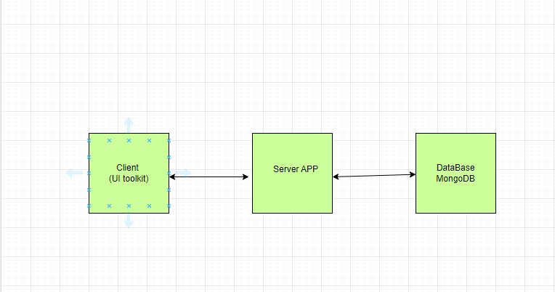

Health care module will take care of the user’s daily bases health by generating a form regarding the daily health issues.it will recommend the exercises or medication according to the problem

Chatbot analytics will check for the busiest period of the user .It will check when the user will be more active.

## 3. System overview

Below is the system architecture of our project:

### Architectural Design

The three-tier architecture will be used to construct the AI Chatbot System. The system's needs are met by this architecture. For the user interface, we need a database, a logic tier, and a client tier. The system will employ 3-tier architecture because it gives us these levels.

## 4. Design Models

**Activity Diagram:**

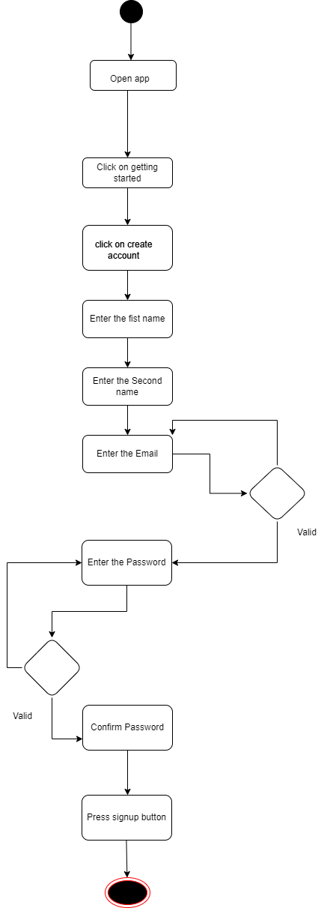

**Activity Diagram:**

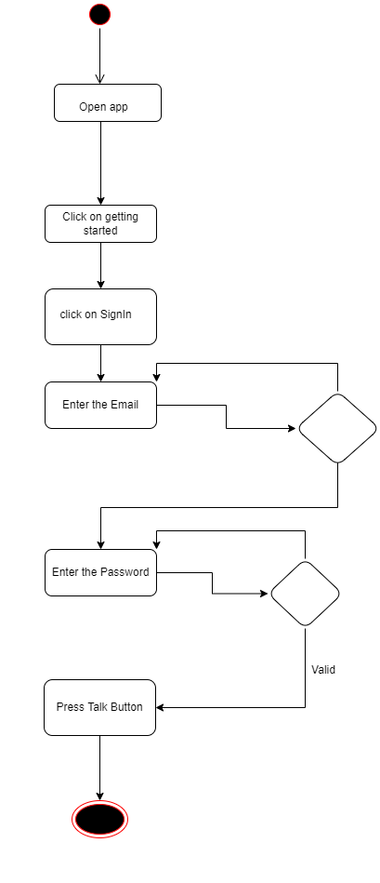

**Activity Diagram:**

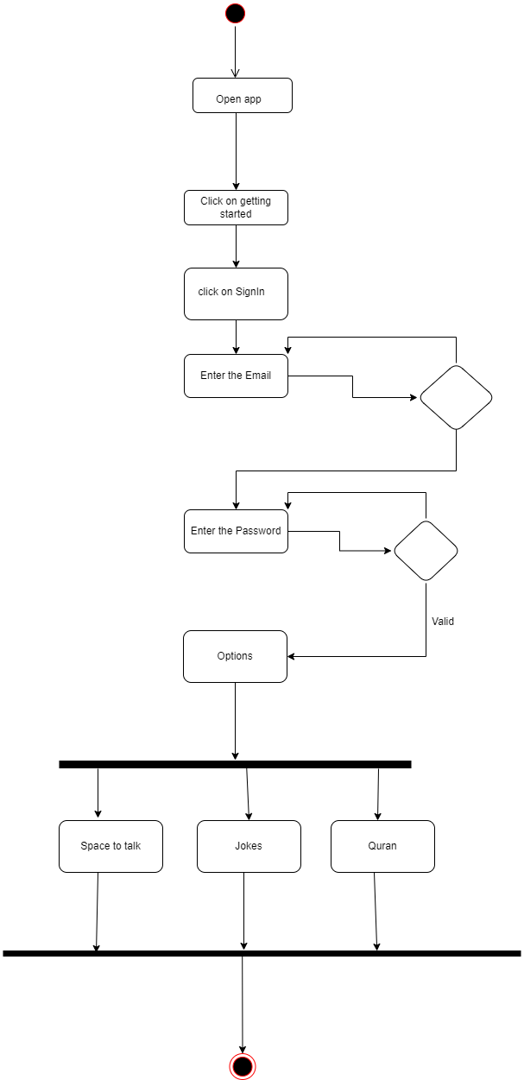

**Activity Diagram:**

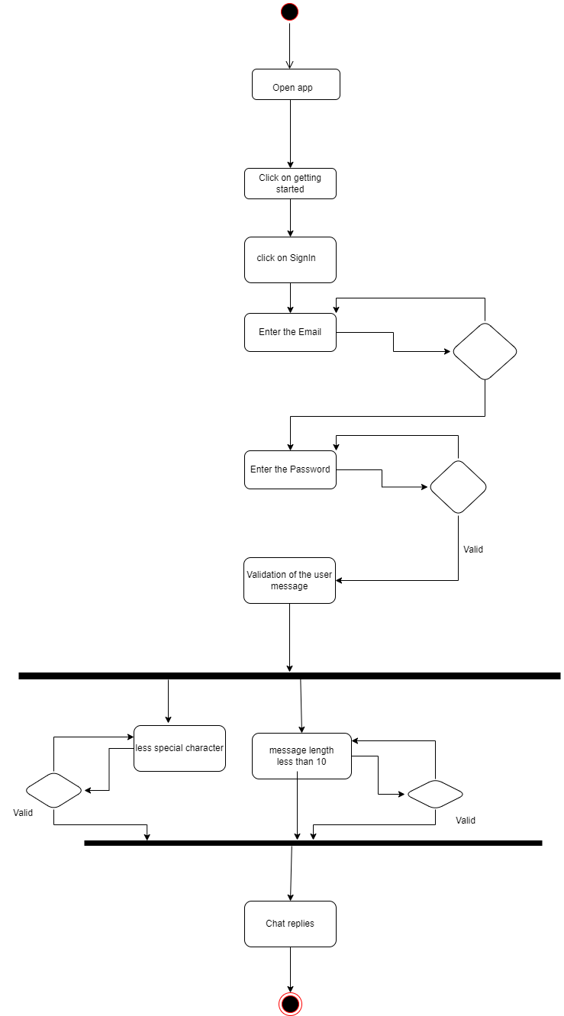

**Activity Diagram:**

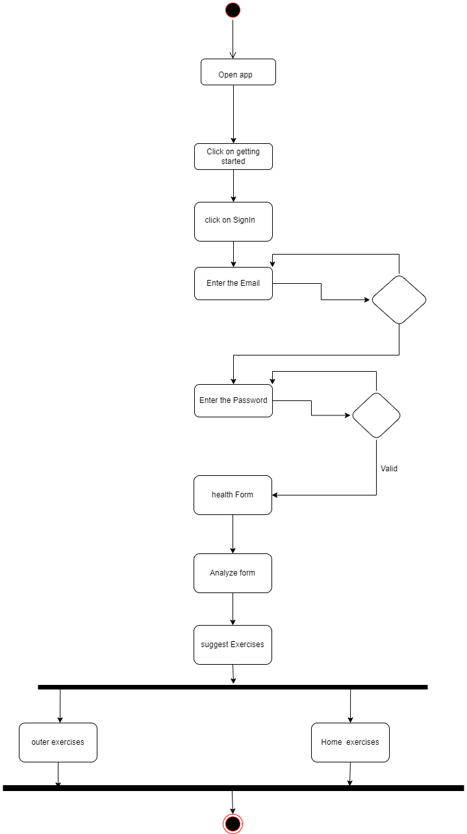

**4.6 Activity Diagram:**

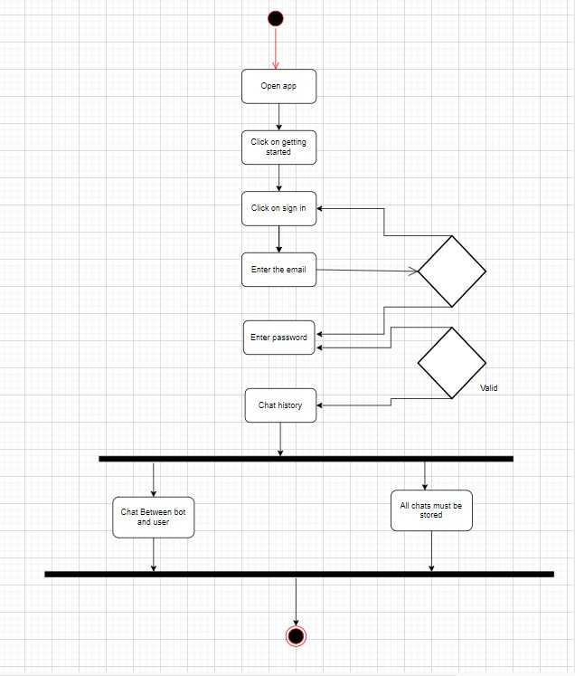

**4.7 Activity Diagram:**

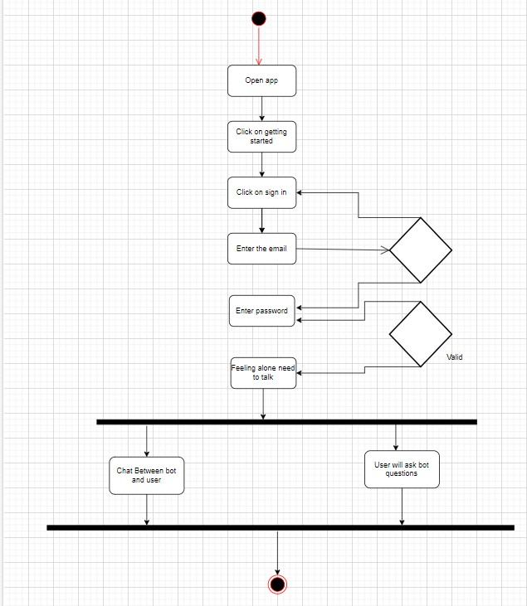

**4.8 Activity Diagram:**

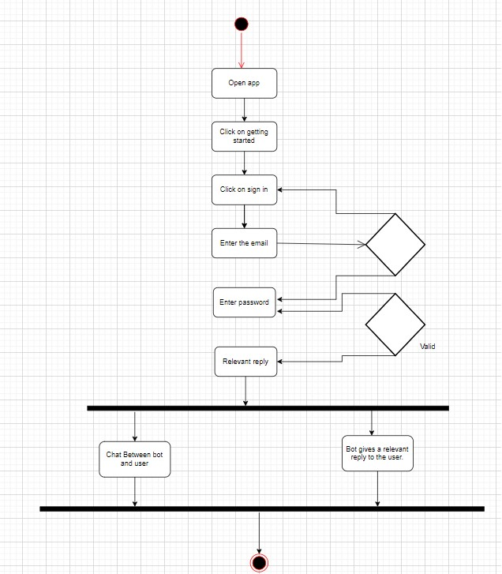

**4.9 Activity Diagram:**

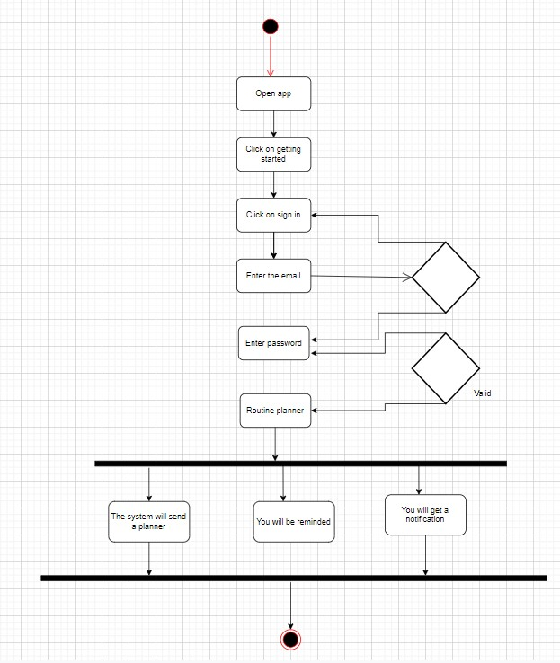

**4.10 Activity Diagram:**

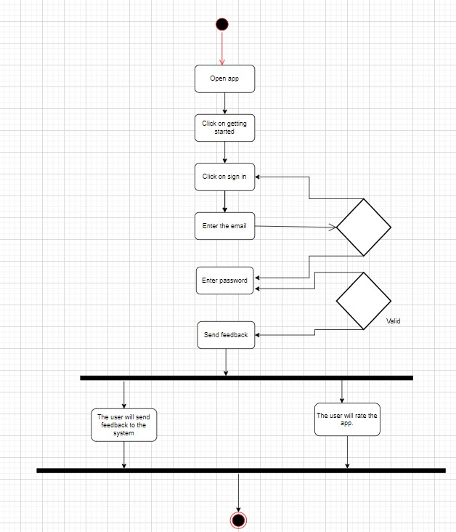

**4.6 Class Diagram:**

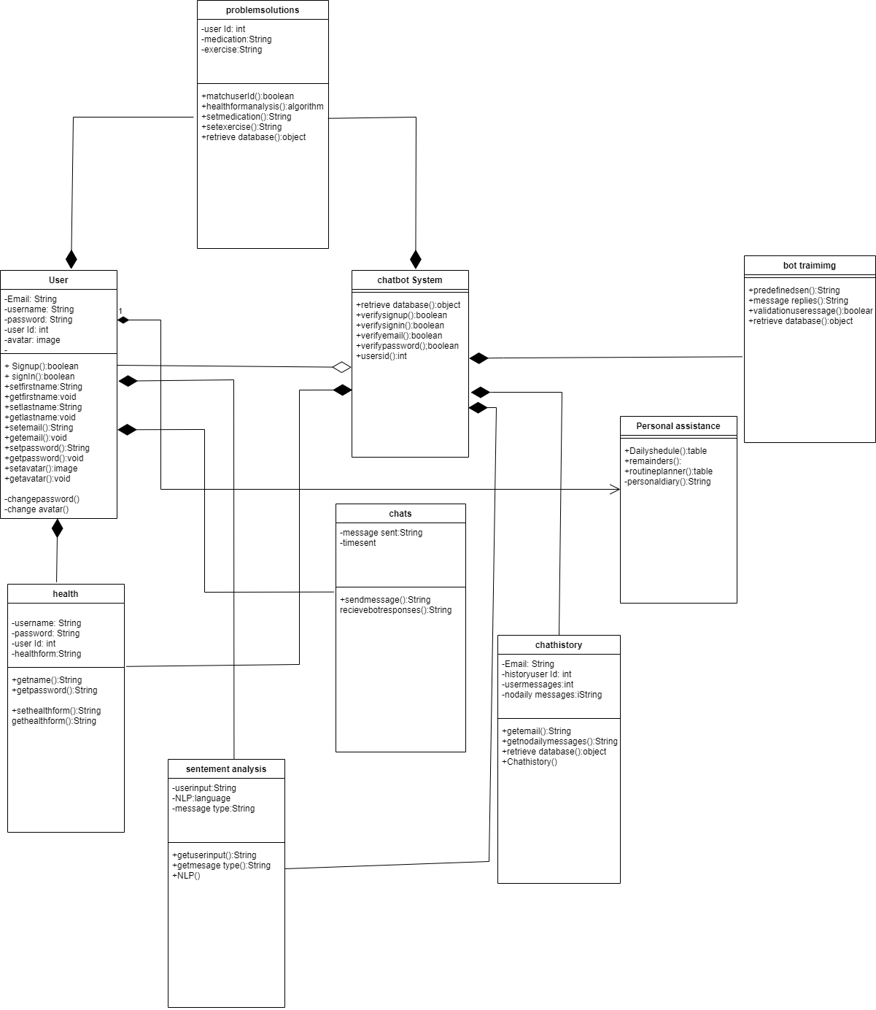

**4.7 Sequence Diagrams.**

**4.7.1 Sequence Diagram 1:**

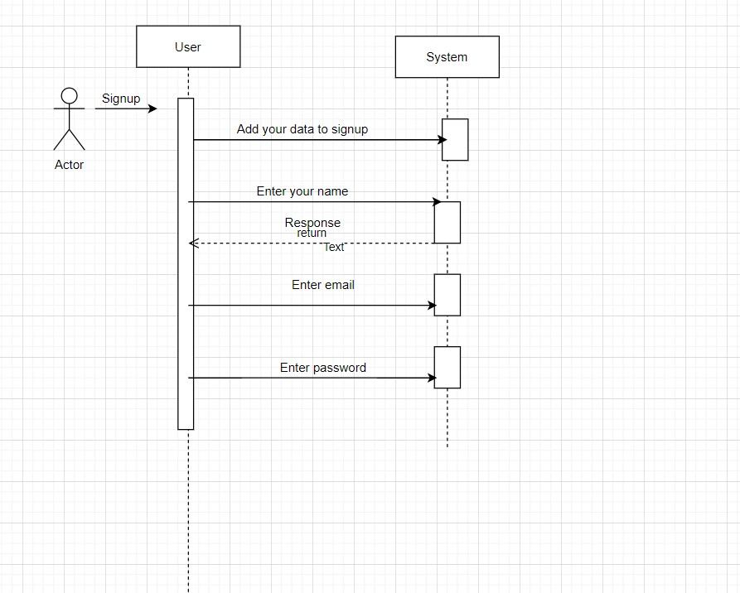

**4.7.2: Sequence Diagram 2:**

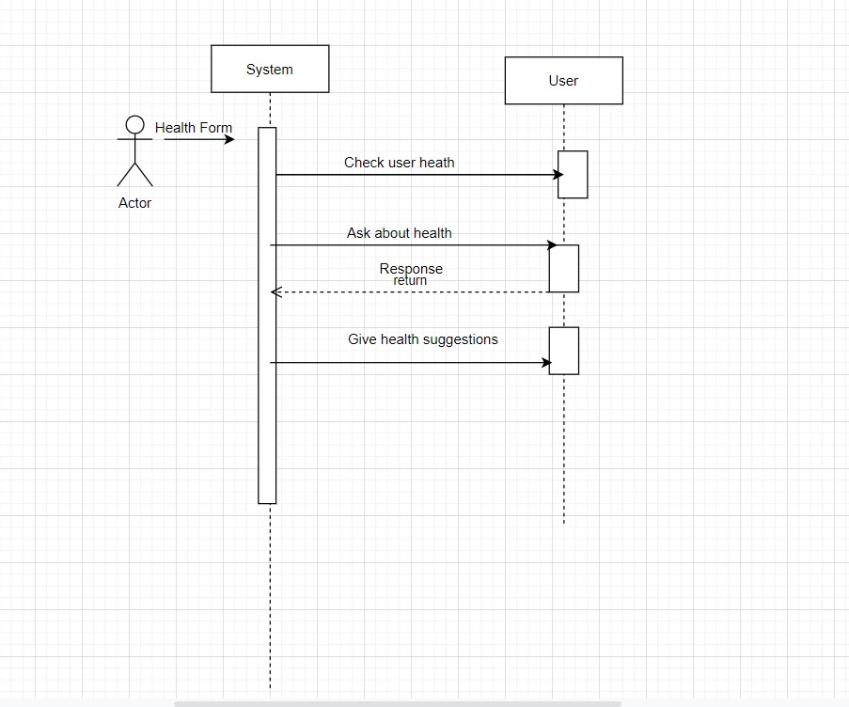

**4.7.3: Sequence Diagram 3:**

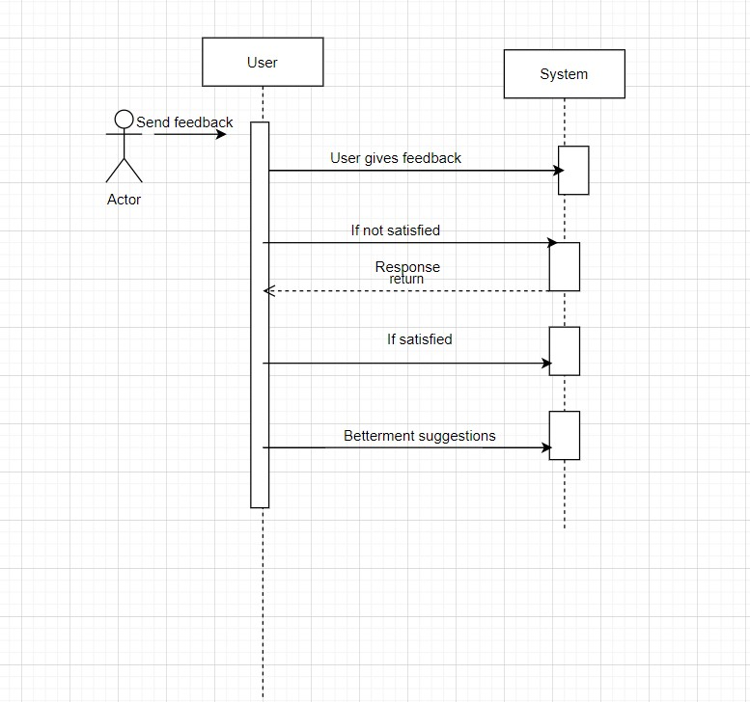

**4.7.4: Sequence Diagram 4:**

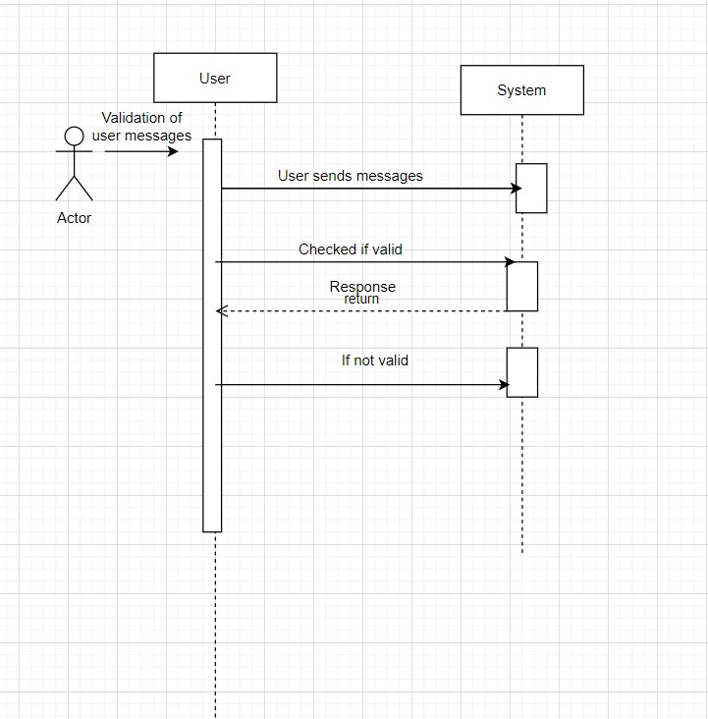

**4.7.5: Sequence Diagram 5:**

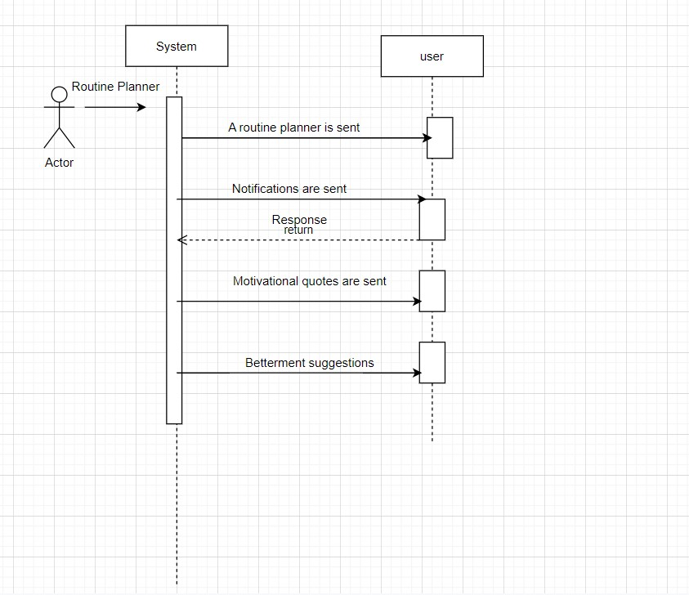

**4.7.6: Sequence Diagram 6:**

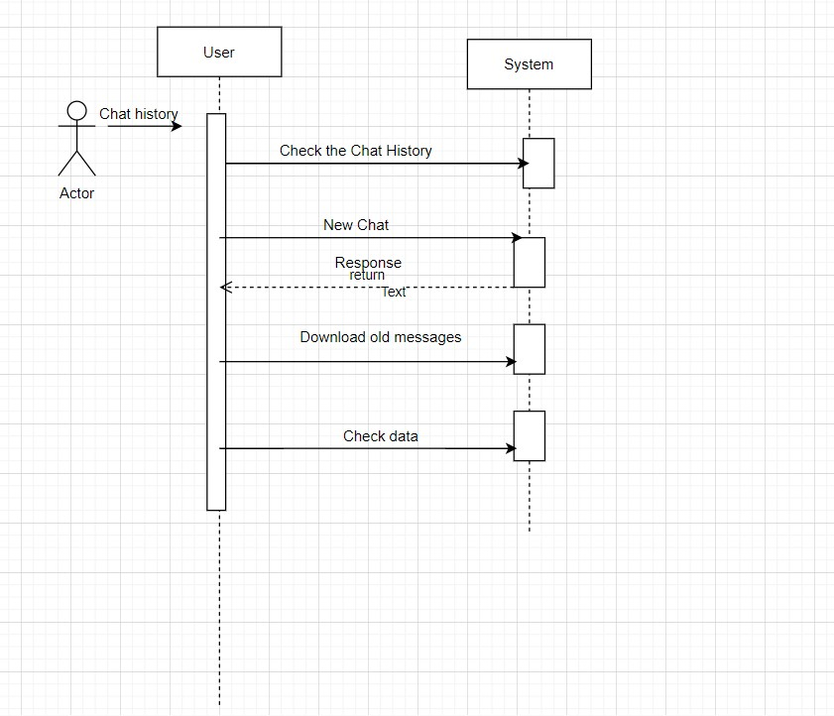

**4.7.7: Sequence Diagram 7:**

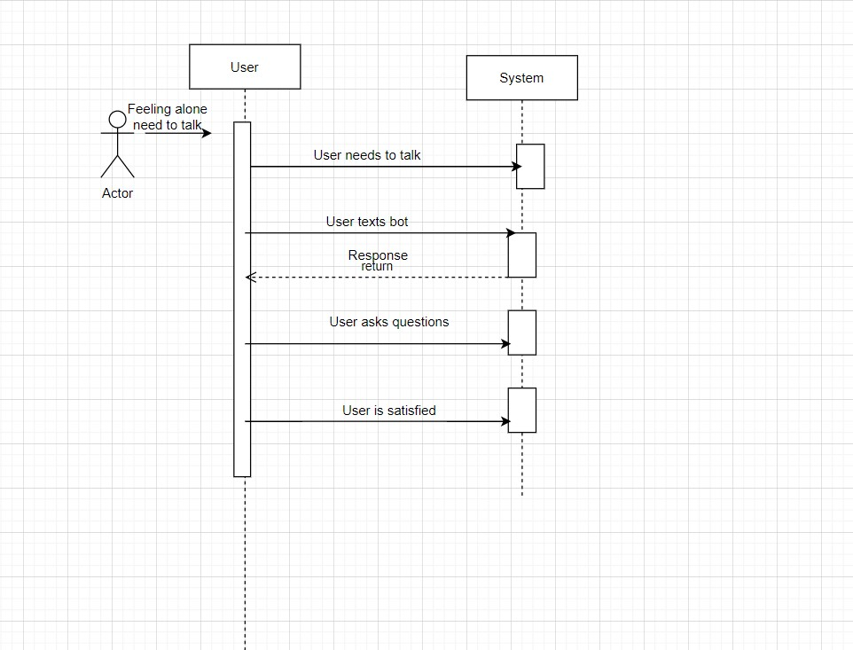

**4.8.8:**

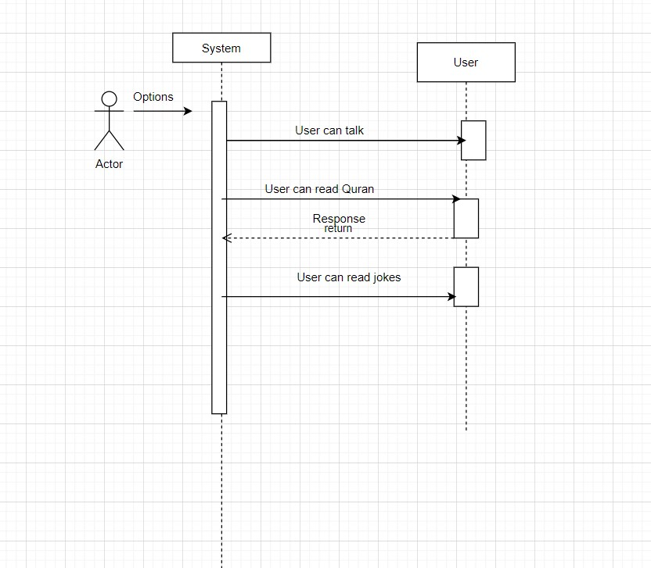

## 5. Data design

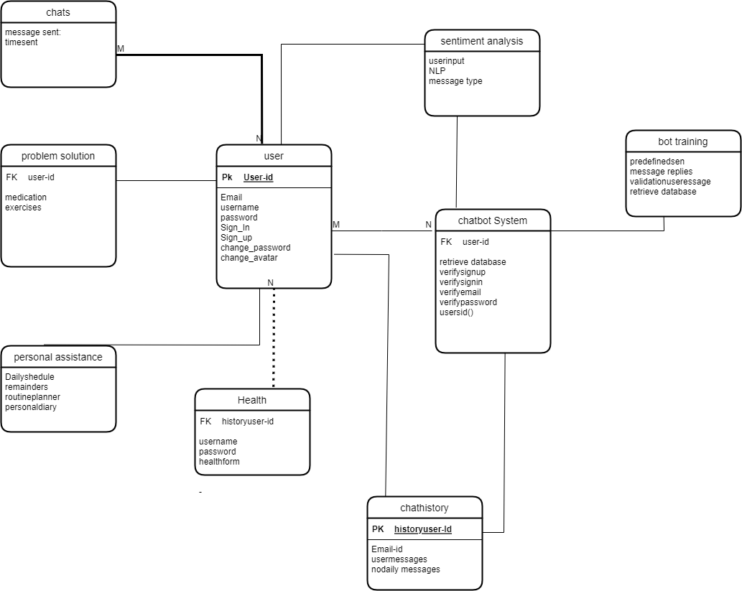

Following is the JSON schema of RPC [Renter-Proprietor Coordination ] System:

{

“title”: “Payment",

“type”: “object”,

“properties”: {

"Payment_ID”: { “type”: “String”,

“description”: “It will contain the ID of payment” },

“Payment_Method”: {

“type”: “String”,

“description”: “It will contain the method of online payment”. },

“Payment_Account_Number”: {

“type”: “int”,

“description”: “It will contain account number”. },

“CVV”: {

“type”: “int”,

“description”: “It will contain the CVV code of account”.

},

“Country”: {

“type”: “String”,

“description”: “It will contain the country of account holder”.

},

“Account_Expiry”: {

“type”: “Date”,

“description”: “It will contain the date of expiry of bank card”. },

“Billing_Address”: { “type”: “String”,

“description”: “It will contain the address of account holder”. },

“Date”: {

“type”: “Date”,

“description”: “It will contain the date of payment”. },

“Payment_Amount”: { “type”: “float”,

“description”: “It will contain the amount of payment”. },

}

{

“title”: “Complaint",

“type”: “object”,

“properties”: {

"Complaint_ID”: { “type”: “String”,

“description”: “It will contain the ID of complaint” },

“Type”: {

“type”: “String”,

“description”: “It will contain the type of complaint”. },

“Description”: {

“type”: “String”,

“description”: “It will contain description of complaint”. },

“Status”: {

“type”: “boolean”,

“description”: “It will contain the progress status of complaint”. },

“Date”: {

“type”: “Date”,

“description”: “It will contain the date of complaint”. },

“Time”: {

“type”: “Time”,

“description”: “It will contain the time of complaint”. },

}

{

“title”: “User",

“type”: “object”, “properties”: {

"ID”: {

“type”: “int”,

“description”: “It will contain the ID of user”

},

“Profile_Image”: {

“type”: “image”,

“description”: “It will contain the profile picture of user”.

},

“CNIC”: {

“type”: “String”,

“description”: “It will contain the CNIC of user”.

},

“First_Name”: {

“type”: “String”,

“description”: “It will contain the first name of user”.

},

“Last_Name”: {

“type”: “String”,

“description”: “It will contain the last name of user”.

},

“Contact”: {

“type”: “int”,

“description”: “It will contain the contact number of user”.

},

“Email”: {

“type”: “String”,

“description”: “It will contain the email of user”.

},

“Password”: {

“type”: “String”,

“description”: “It will contain the password of user”.

},

“isPremiumAccount”: {

“type”: “boolean”,

“description”: “It will contain whether account is premium or not.

},

“isRenter”: {

“type”: “boolean”,

“description”: “It will contain whether user is renter.

},

“isProprietor”: {

“type”: “boolean”,

“description”: “It will contain whether user is proprietor.

},

}

{

“title”: “Feedback",

“type”: “object”,

“properties”: {

" ID”: {

“type”: “String”,

“description”: “It will contain the ID of feedback”

},

“Description”: {

“type”: “String”,

“description”: “It will contain description of feedback”.

},

“Rating”: {

“type”: “int”,

“description”: “It will contain the rating from 1-5”.

},

“Date”: {

“type”: “Date”,

“description”: “It will contain the date of feedback”.

},

“Time”: {

“type”: “Time”,

“description”: “It will contain the time of feedback”.

},

}

{

“title”: “Notification",

“type”: “object”,

“properties”: {

"ID”: {

“type”: “String”,

“description”: “It will contain the ID of notification”

},

“Type”: {

“type”: “String”,

“description”: “It will contain the type of notification”.

},

“Message”: {

“type”: “String”,

“description”: “It will contain message of notification”.

},

“Title”: {

“type”: “String”,

“description”: “It will contain the Title of notification”.

},

}

{

“title”: “Notification_Settings",

“type”: “object”,

“properties”: {

"Chat_Notification_State”: {

“type”: “boolean”,

“description”: “It will contain whether chat notification is on or off”

},

"Rent_Notification_State”: {

“type”: “boolean”,

“description”: “It will contain whether rent notification is on or off”

},

“Ringtone”: {

“type”: “File”,

“description”: “It will contain the ringtone”.

},

“Intensity”: {

“type”: “int”,

“description”: “It will contain volume of notification”.

},

“Vibration_Frequency”: {

“type”: “float”,

“description”: “It will contain the frequency of vibration”.

},

}

{

“title”: “Rent",

“type”: “object”,

“properties”: { "ID”: {

“type”: “String”,

“description”: “It will contain the ID of rent”

},

“Due_Amount”: {

“type”: “float”,

“description”: “It will contain the amount of due rent”.

},

“Due_Date”: {

“type”: “Date”,

“description”: “It will contain Date of due rent”.

},

“Rent_Status”: {

“type”: “boolean”,

“description”: “It will contain the progress status of rent payment”.

},

}

{

“title”: “ChatBot",

“type”: “object”,

“properties”: {

"Message_Sent”: {

“type”: “String”,

“description”: “It will contain the message sent to bot”

},

“Time”: {

“type”: “Time”,

“description”: “It will contain the time of message sent to bot”.

},

}

{

“title”: “Lease",

“type”: “object”, “properties”: {

"ID”: {

“type”: “String”,

“description”: “It will contain the ID of lease”

},

“Description”: {

“type”: “String”,

“description”: “It will contain description of lease”.

},

“Renter_Signature”: {

“type”: “image”,

“description”: “It will contain the verification signature of renter”.

},

“Proprietor_Signature”: {

“type”: “image”,

“description”: “It will contain the verification signature of Proprietor”.

},

“Creation_Date”: {

“type”: “Date”,

“description”: “It will contain the date of lease finalization”.

},

}

{

“title”: “Property",

“type”: “object”,

“properties”: {

"ID”: {

“type”: “String”,

“description”: “It will contain the ID of property”

},

“Property_Name”: {

“type”: “String”,

“description”: “It will contain name of property”.

},

“Property_Address”: {

“type”: “String”,

“description”: “It will contain address of property”.

},

“Property_Rooms”: {

“type”: “int”,

“description”: “It will contain number of rooms in the property”.

},

“Property_Allocation_Area”: {

“type”: “float”,

“description”: “It will contain area of the property”.

},

“Property_Floors”: {

“type”: “int”,

“description”: “It will contain number of floors in the property”.

},

“Number_of_Renters”: {

“type”: “int”,

“description”: “It will contain number of renters allowed to rentthe property”. },

}

{

“title”: “Chat",

“type”: “object”,

“properties”: {

"Sender_ID”: { “type”: “String”,

“description”: “It will contain the ID of message sender” },

“Receiver_ID”: {

“type”: “String”,

“description”: “It will contain the ID of message receiver” },

“Sender_Message”: {

“type”: “String”,

“description”: “It will contain the sender message” },

“Receiver_Message”: {

“type”: “String”,

“description”: “It will contain the receiver message” },

“Date_Sent”: {

“type”: “Date”,

“description”: “It will contain the date of message sent”. },

“Time_Sent”: {

“type”: “Time”,

“description”: “It will contain the time of message sent”.

},

|  |  |  |  |
| --- | --- | --- | --- |
| **Collections** | **Properties** | **DataType** | **Description** |
| email | Address | String | will contain the email address of the user |
| chat history | history | String | will have the chat history of the user |
| daily routine | users | Table | will have the daily routine table |
| ID | User1 id | String | It will contain user1 ID |
| ID | user2id | String | It will contain users2 ID |
| ID | user3id | String | It will contain user3 ID |
| name | First name | String | It will contain first name of the user |
| name | Last name | String | It will contain last name of the user |
| Password1 | Password1 User1 | String | will contain the password of user1 |
| Password2 | Password2 User2 | String | will contain the password of user2 |
| Password3 | Password3 User3 | String | will contain the password of user3 |
| Health form | users health | algorithms | will contains an algo or table contai ing the information about user health |
| description | feedback Description | String | will contain the feedback description |
| description | complaint Description | String | will contain the complaint description |

}

**Data dictionary**

## 6. Algorithm & Implementation

**INPUT email**

**IF(verifyEmail NOT EQUAL true)**

### DISPLAY “Invalid Email”

**WHILE (verifyEmail EQUAL false)**

**INPUT password**

**IF(account NOT found)**

**DISPLAY “Invalid login credentials! Please try again!”**

**ELSE**

**DISPLAY “Successfully logged in!”**

**GENERATE ads**

**DISPLAY ads**

**IF(login)**

**DO**

**INPUT message**

**INPUT receiverID**

**WHILE(message NOT null OR valid receiverID)**

**SEND message request to receiver end**

**ELSE**

**DISPLAY “Please login”**

**Object Detection:**

**7. Software requirements traceability matrix**

## 8. Human Interface Design

### Screen images

FOR Mobile:

**MOCKUP 1:**

**Front page**

**MOCKUP 2:**

**Home Page**

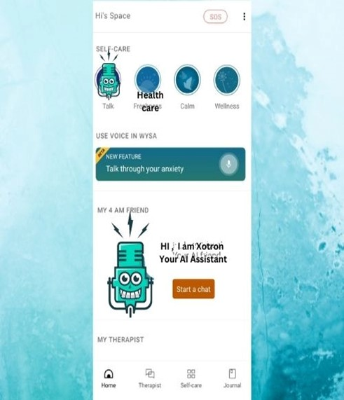

**Mockup 3:**

**Security**



**Mockup 4:**

**Choose from Options**



**FOR WEB**

**Mockup 5**

**Chat screen for Web**

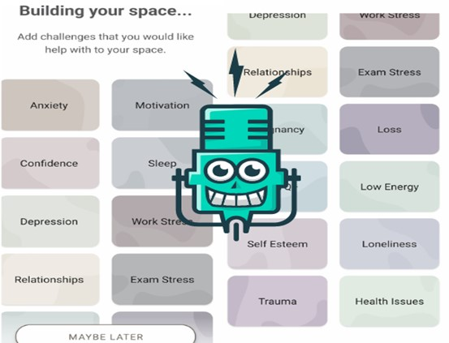

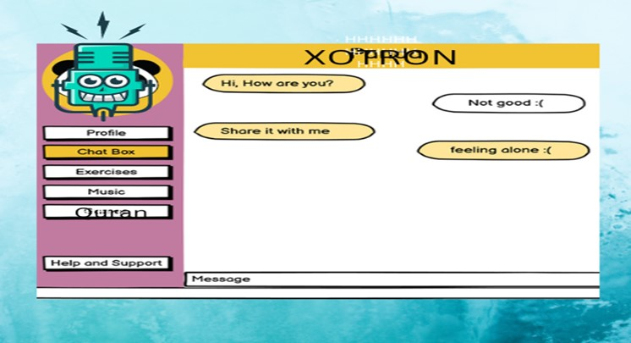

**MOCKUP 6**

**Chat analysis**

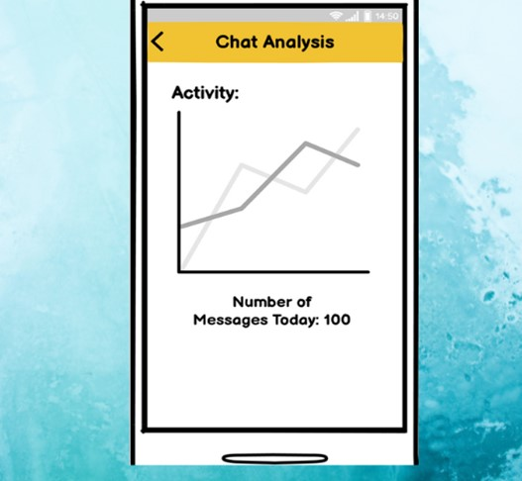

## 9. Conclusion

The system's design is fully described in this document. Additionally provided are the abstract implementation details and the logical flow. The user and system requirements have been met. This document will contain the application's design. How it operates and how it is put into practise. Additionally, the approaches necessary for the application to function correctly will be described.

## 10. References

* · [**https://ui8.net/the-madbrains/products/madbrainsui--chatbot--ai-startup-agencyux**](https://ui8.net/the-madbrains/products/madbrainsui--chatbot--ai-startup-agencyux)
* ·

[**https://www.analyticsvidhya.com/blog/2021/10/complete-guide-to-build-your-ai-chatbot-with-n lp-in-python/**](https://www.analyticsvidhya.com/blog/2021/10/complete-guide-to-build-your-ai-chatbot-with-nlp-in-python/)

* · [**https://vilmate.com/blog/how-to-develop-a-chatbot/**](https://vilmate.com/blog/how-to-develop-a-chatbot/)
* · [**https://youtu.be/1XHp8WrZzoc**](https://youtu.be/1XHp8WrZzoc)
* · [**https://www.ameyo.com/blog/key-advantages-and-use-cases-of-healthcare-chatbot/**](https://www.ameyo.com/blog/key-advantages-and-use-cases-of-healthcare-chatbot/)
* · [**https://geekflare.com/create-chatbot/**](https://geekflare.com/create-chatbot/)
* ·

[**https://www.tutorialspoint.com/artificial_intelligence/artificial_intelligence_natural_language_ procssing.htm**](https://www.tutorialspoint.com/artificial_intelligence/artificial_intelligence_natural_language_procssing.htm)

**11. Appendix I**

## 12. Plaragism Report

Attach the Plaragism report of your project requirement document from library staff of Turnitin tool ([http://turnitin.com](http://turnitin.com/))

