Skill Highlights

|  |  |
| --- | --- |
| * MS Word, Excel * Communication skills * Innovative * Service-focused * Strong decision maker * GitHub | * HTML5 * CSS3 * Bootstrap * jQuery * Python(basic) * JavaScript(basic) |

Work Experience

Six Month Worked in **Call Center**

Six Month Worked as a **Cashier** in Local Mall

One Year Worked as a **TM** in **Continental Pharmacuticals**

Three Month Internship as a **Frontend Web Developer** in **Muqit Services limited**

Education

Bachelor of Science: **Software Engineering** - 2020

**Virtual University of Pakistan**

**ICS (Physics)** BISELahore Board - 2015

**Matric (Science)** BISELahore Board - 2013

Hobbies

* Cricket
* History
* Collect Information
* Gaming

Languages

* Urdu – Native
* English – Medium
* Punjabi – Native

Contact

**Address:**

House No.30, Street No.5, Hakeem Park Chah Miran Shad Bagh, Lahore

**Phone:**

+92323 8840961

+92304 1249231

**Email:**

[mianarsal96@gmail.com](mailto:mianarsal96@gmail.com)

**Date of Birth:**

20-07-1996

**CNIC:**

35202-8304312-1

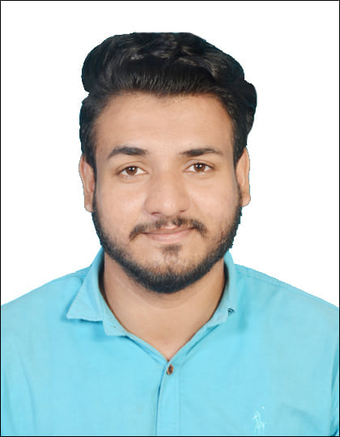

Arslan Ahmad