

APEX Port Scanner
Information Security

Assignment No 1

Group Members:
Arsal Hameed L22-6240
Taimoor Pasha L22-7791

National University Of Computer and Emerging Sciences
Department of Computer Science
Lahore, Pakistan

Abstract
A port scanner is a network tool used to detect open or filtered ports on a target system, helping assess connectivity and security. This report presents a Python-based port scanner that accepts hostnames or IP addresses, supports flexible port input formats, and performs TCP scanning with socket programming. Multi-threading enhances speed, while error handling ensures reliability. The scanner outputs open ports, detected services, and total scan time, offering a lightweight and practical solution for network analysis.

Introduction
A port scanner is a network utility that identifies open, closed, or filtered ports on a target system. It plays a key role in network administration and security testing by helping determine which services are accessible. This report presents the design and development of a custom Python-based TCP port scanner. The scanner accepts both hostnames and IP addresses, supports flexible port specifications, implements multi-threaded scanning for efficiency, and provides detailed results including open and filtered ports with their associated service names.

Methodology
The scanner was built using Python’s socket and threading libraries. The methodology involved:
- Host Resolution
Converting a hostname into its corresponding IP address with proper error handling.
- Port Specification Parsing
Supporting single ports, multiple ports, ranges, and mixed formats.
- TCP Port Scanning
Attempting TCP connections using socket.connect_ex to determine port states (open, closed, or filtered).
- Multi-threading
Using Python threads to scan multiple ports simultaneously, improving performance.
- Result Processing
Collecting and displaying open and filtered ports along with standard service names using socket.getservbyport.
- Time Measurement
Recording total scan duration for performance evaluation.

Implementation
The implementation consists of several modular functions:
- resolve_host(target)
Validates and resolves hostnames to IP addresses.
- parse_ports(port_spec)
Parses user input to generate a list of valid ports.
- tcp_scan(ip, port)
Performs TCP connection attempts and returns port status.
- scan_port_wrapper(args)
Wraps the scan and maps ports to service names.
- scan_target(target, port_spec)
Main function that manages threading, collects results, and measures scan time.
- display_results(...)
Outputs the scan summary, including target IP, open/filtered ports, services, and scan duration.
The code was tested against well-known test domains such as scanme.nmap.org and www.speedguide.net.

Team Contribution
This project was a joint effort by me (Arsal) and Taimoor, where both members divided responsibilities according to their strengths but collaborated throughout the development cycle.
- I focused on the technical core of scanning, including TCP connection setup, socket programming, and implementing multithreading for faster scanning. He ensured that the scanner could handle multiple ports concurrently while maintaining accuracy and efficiency.
- While Taimoor concentrated on the functional framework, including hostname/IP resolution, parsing and validating port specifications, and designing the result display methodology. He worked on presenting clear scan results and handling edge cases such as invalid inputs or unreachable hosts.

Results

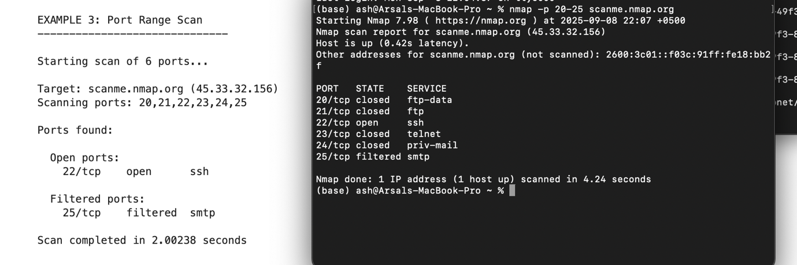

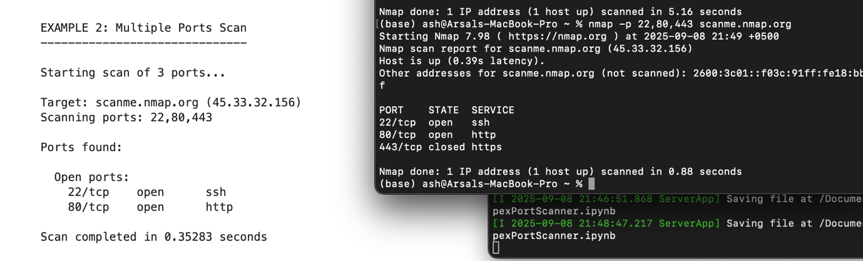

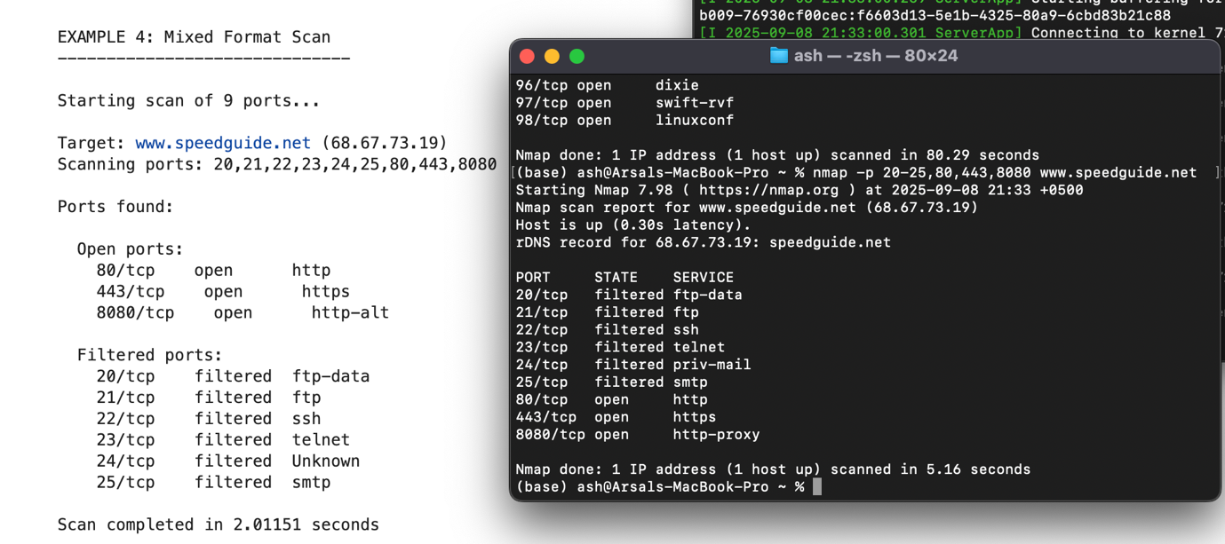

• Single Port Scan (www.speedguide.net, port 80): Successfully detected HTTP service as open.
• Multiple Ports Scan (scanme.nmap.org, ports 22, 80, 443): Correctly reported SSH (22), HTTP (80), and HTTPS (443) ports.
• Range Scan (speedguide.net, ports 20–25): Identified open and filtered ports within the given range.
• Mixed Format Scan (www.speedguide.net, ports 80,443,8080,20-25): Handled combined single, multiple, and ranged inputs without errors.

Conclusion
The custom Python port scanner successfully fulfills the core requirements of target input handling, port specification flexibility, TCP scanning, and results display. It also incorporates essential features such as hostname resolution, multi-threading, and service detection. While not as feature rich as professional tools like Nmap, this scanner provides a lightweight and educational solution for network analysis. Future improvements could include UDP scanning, OS fingerprinting, and integration with a graphical interface.

