**Table of Contents:**

1. Dataset: 1

2. Using_Word2Vec: 1

2.1. Source Code: 1

2.2. Output: 2

3. Using_TFIDF: 3

3.1. Source Code: 3

3.2. Outputs: 4

4. TPE_(Tree_structured_Parzen_Estimator) _optimization_algorithm 5

4.1. Source Code: 5

4.2. Outputs: 5

5. Using_Bert_Model: 7

5.1. Source Code: 7

5.2. Output: 7

# **Dataset:**

Here Huawei Mobile dataset 2021_2022 in excel file is attached:



# **Using_Word2Vec:**

I have applied **Word2Vec** algorithm on Huawei mobile dataset.

The output has following results:

* Test loss: 8.162650108337402
* Test accuracy: 0.3316666781902313

## **Source Code**:

Here source code file of this algorithm in ipynb file is attached:



## **Output:**

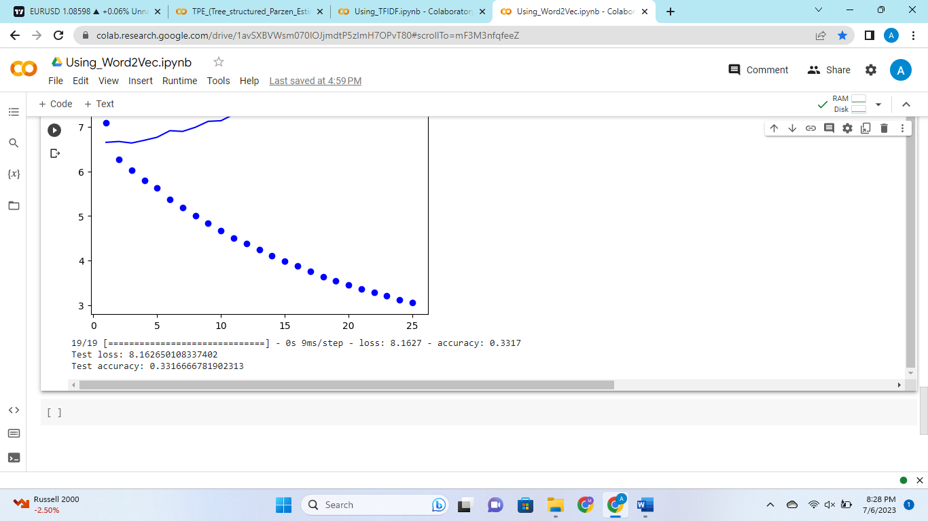

# **Using_****TFIDF:**

I have applied **TFIDF** algorithm on Huawei mobile dataset.

The output has following results:

* Test loss: 12.169648170471191
* Test accuracy: 0.3199999928474426

## **Source Code:**

Here source code file of this algorithm in ipynb file is attached:



## **Outputs:**

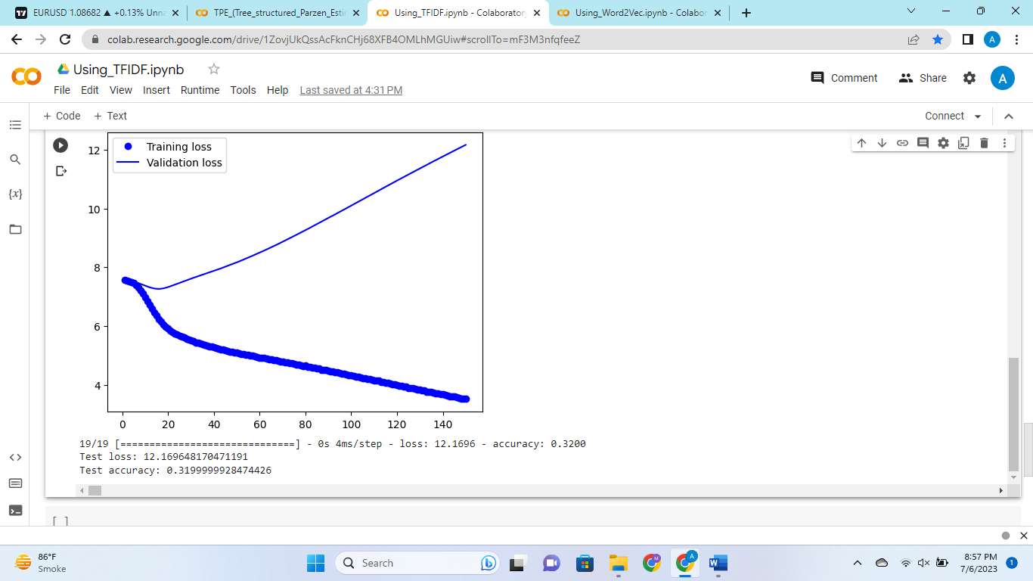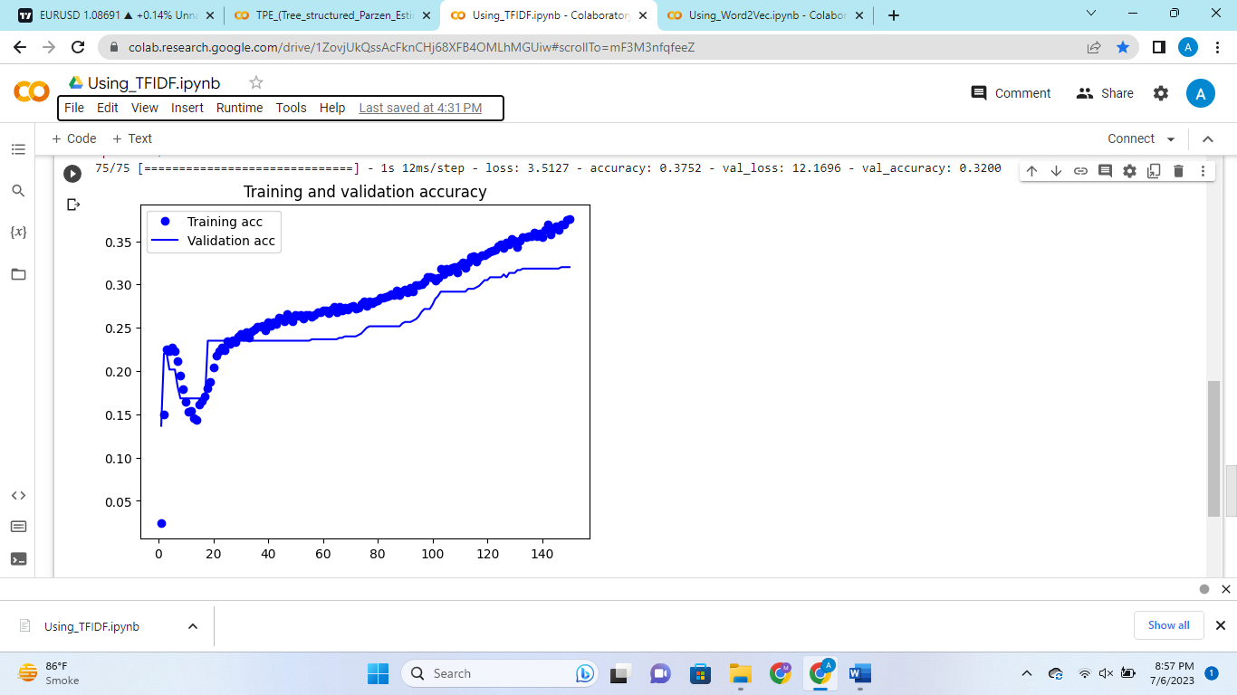

# **TPE_(Tree_structured_Parzen_Estimator) _optimization_algorithm**

I have applied **TPE_optimization_algorithm** on Huawei mobile dataset.

The output has following results:

* Best Hidden Units: 64
* Best Dropout Rate: 0.4420692871436659
* Best Loss: 8.366680145263672
* Best Validation Accuracy: 0.3050000071525574

## **Source Code:**

Here source code file of this algorithm in ipynb file is attached:



## **Outputs:**

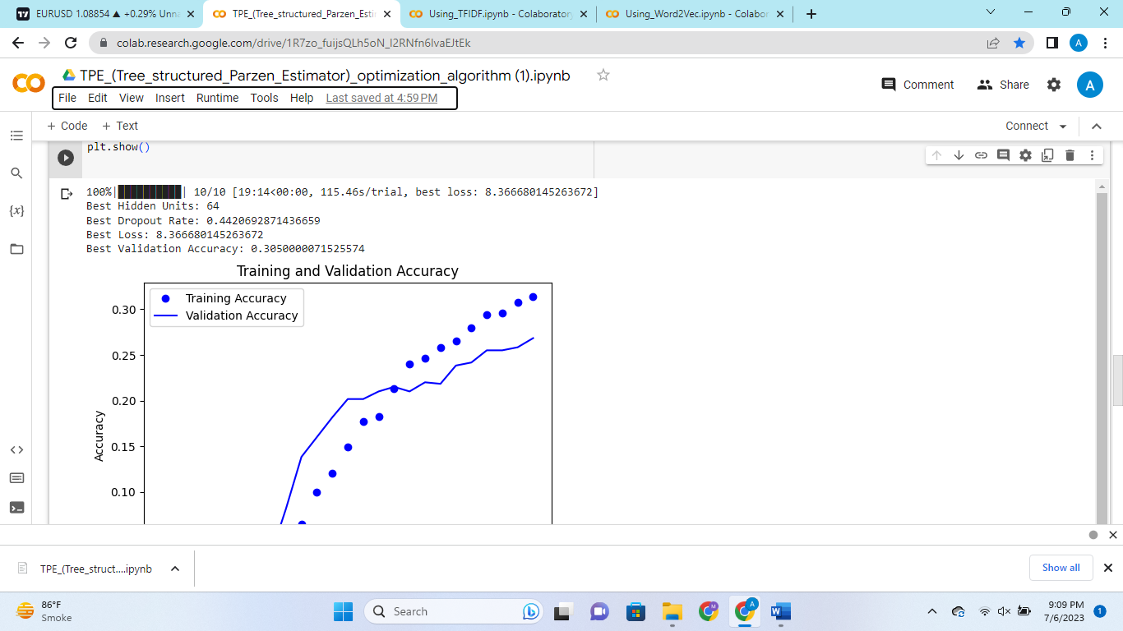

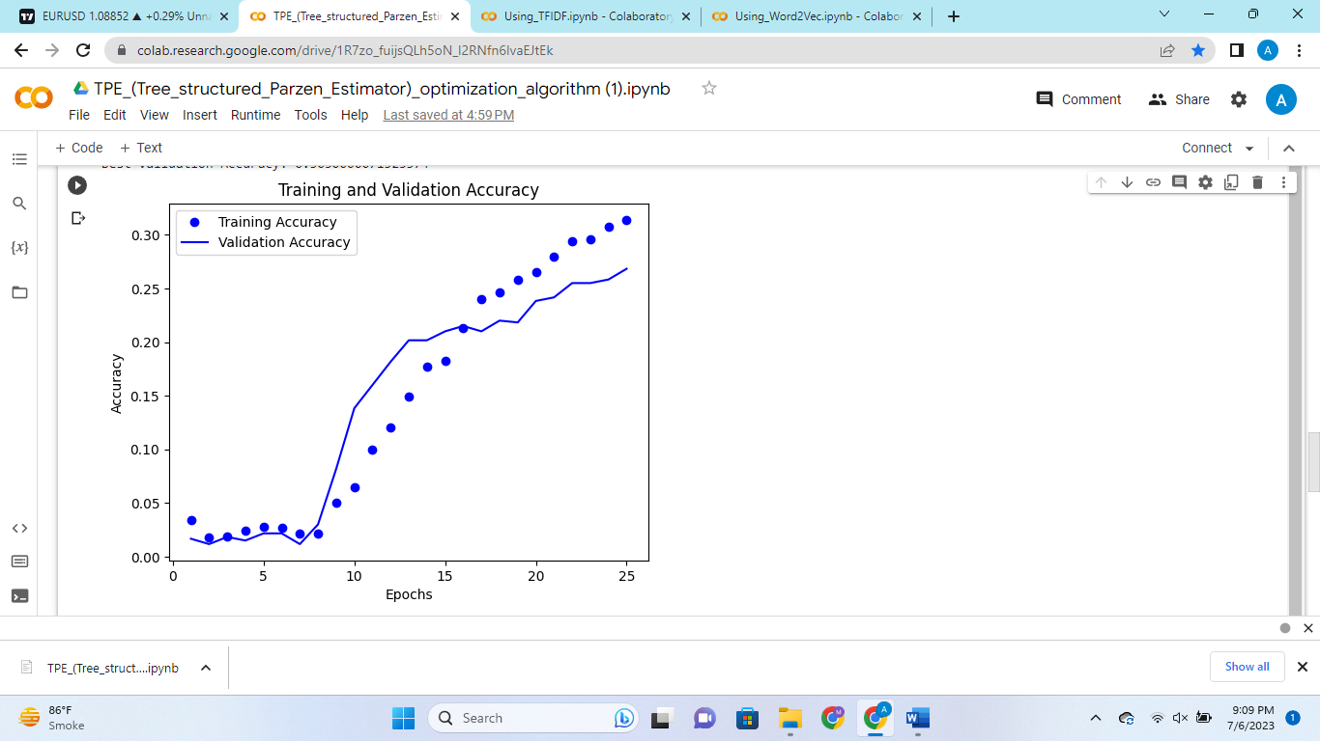

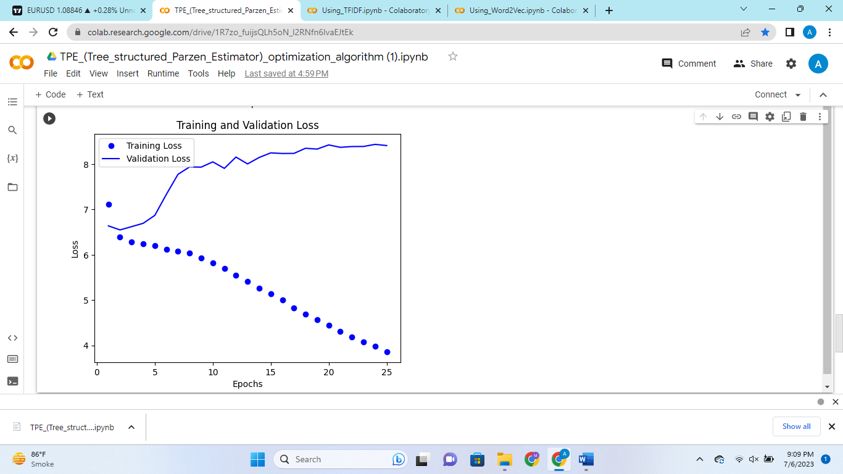

# **Using_Bert_Model:**

I have applied **Using_Bert_Model** on Huawei mobile dataset.

Which has following tokenizer and Bert model:

* Bert Tokenizer: bert_based_uncased
* Bert Model: TFBert_Model

The output has following results:

* Test loss: 7.469927787780762
* Test accuracy: 0.23499999940395355

## **Source Code:**

Here source code file of this algorithm in ipynb file is attached:



## **Output:**

