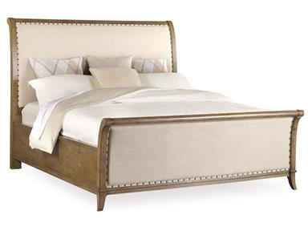

SHELBOURNE UPHOLSTERED

KING SLEIGH BED

MEASUREMENTS:

W71” D90” H60”

1

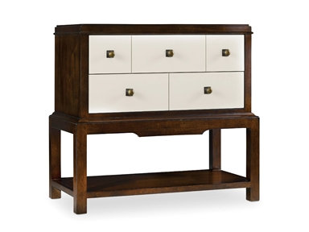

PALISADE TWO DRAWER NIGHT STAND

5 drawer partition (2 small 3 big)

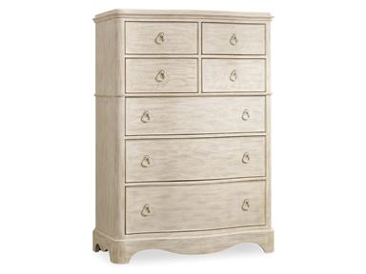

SUNSET POINT CHEST

7 drawer sections

4 small for little stuff

3 big as a dresser

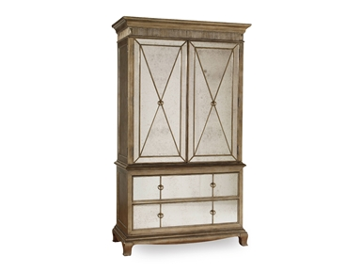

SANCTUARY ARMOIRE - VISAGE

2 horizontal sections for clothes

2 vertical drawers

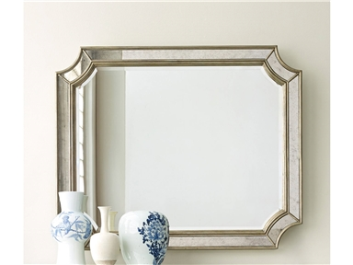

MONTAGE MIRROR

Framed mirror 18” × 18”

Small stand