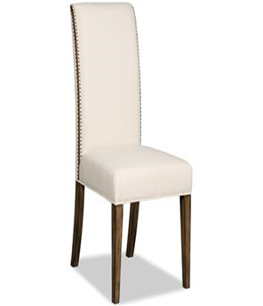

BAYEAUX NATURAL SIDE CHAIR

Chair covered with leather

Available colours: Brown, White, Black

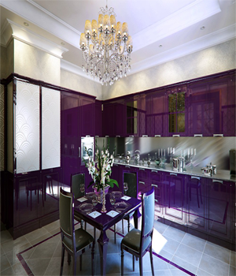

MAGENTO DINING + KITCHEN

Kitchen cabinets

Dining Table (Material Iron)

4 chairs (Material Iron)

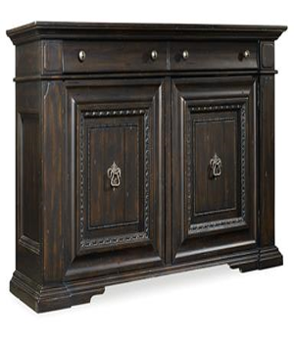

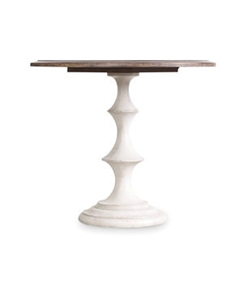

TREVISO SIDEBOARD

Wood Material

2 drawers

2 cupboards

BRYNLEE TABLE

42” Table

Glass top

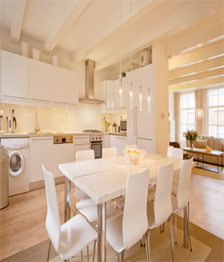

SOOTIHNG WHITE DINING

Rectangular Dining table

8 chairs available