TRAY COCKTAIL TABLE

Wood table with iron stands

3 sections of table

1

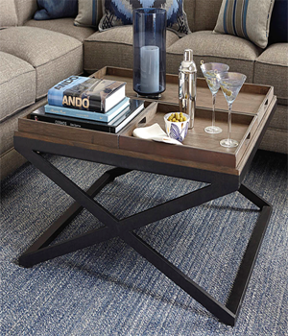

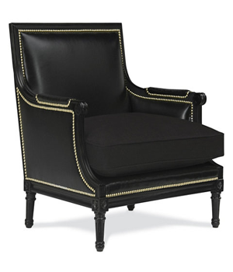

Duchess Chair

Wood Material with pure leather

Available colours: Brown, Maroon & Black

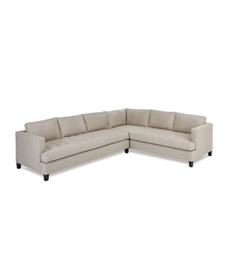

TEMPLE SECTIONAL SOFA

Available colours: Black, Off White, Brown

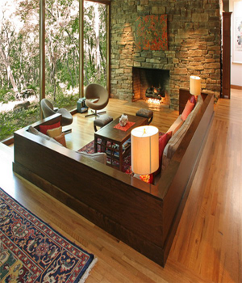

COMPLETE MODERN LIVING ROOM

Wood Material

Sectional Sofa set

Tea table

Side table

Ottoma

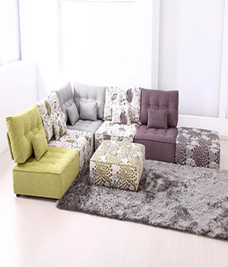

Cheap sofa set

Sectional sofa with a woody back

Ottoma

Small cushions