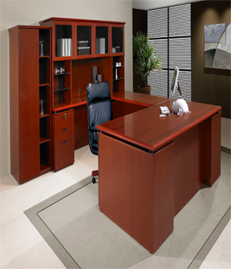

CLIFF OFFICE

Material: Wood

Computer table

Cupboard with shelves of different sizes

1

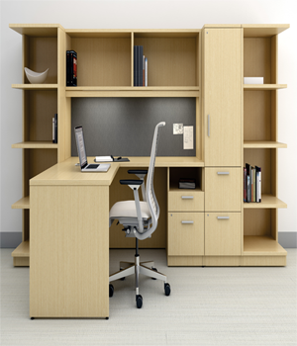

SUNSET OFFICE DESK

Material: Wood

Computer table

Cupboard with shelves of different sizes

1

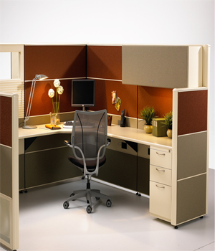

SUNSET OFFICE CABINET

Material: Wood

Cabinet with Shelves of different sizes

Chair of irony material

1

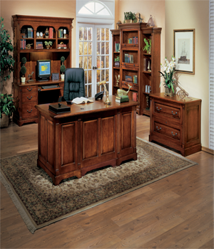

WOODEN OFFICE

Material: Wood

Office Desk

1 Computer table with drawers

1 Cupboard with shelves of different sizes

Side table

1

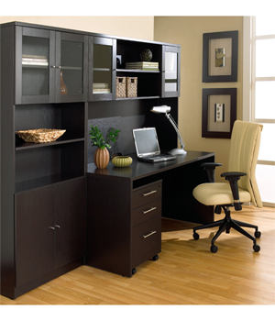

MONTAGE HOME OFFICE

Material: Black Wood

Computer table

Shelves of different sizes

3 Drawers

Anex Chair

1