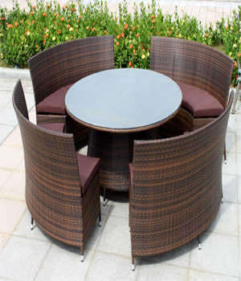

MAGENTA TWISTER

4 curved chairs

1 round tea table

1

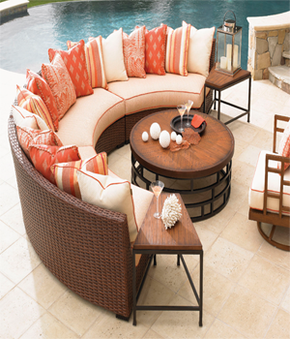

CRESCENT

1 moon shaped sofa with side tables on both sides

1 round tea table

1 moving chair

1

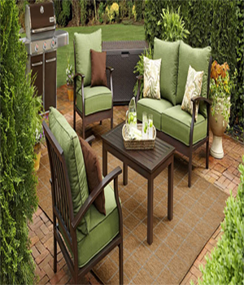

SUMMER WOODS

4 seats ( 2 single + 1 double)

1 rectangular shaped table

1

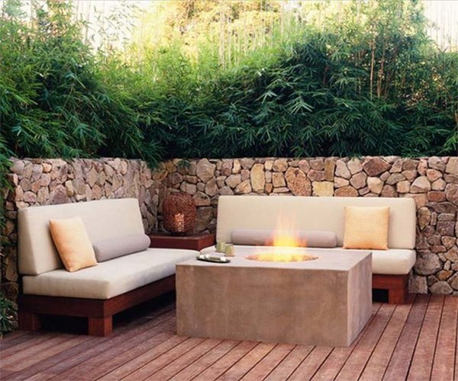

FLAT LOG

2 sofa sets double (6 seats)

1 side table

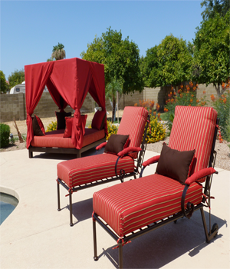

RED COUTURE

Innovative Patio Exquisite