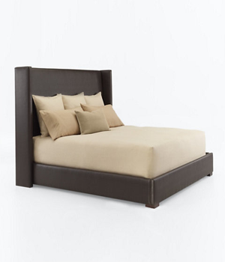

CLIFF HOUSE UPHOLSTERED BED

Weltless

MEASUREMENTS:

W71” D90” H60”

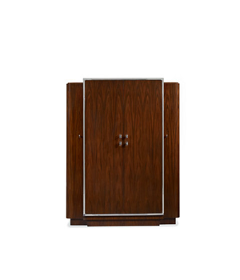

DUKE WARDROBE

Polished stainless steel and Lucite hardware

Full length indoor mirror

Right side five shelves

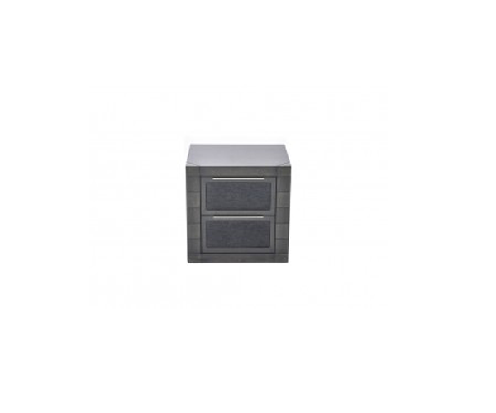

BOUTIQUE DRAWER BEDSIDE

Irony Material

2 horizontal drawers

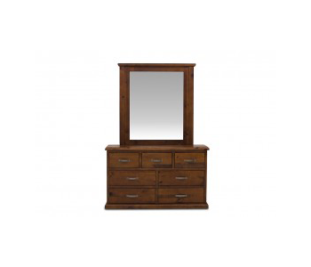

SETTLER WITH MIRROR

Woody Material

Mirror

3 small drawers

4 large drawers



WAKEFIELD ARCHED PANEL BED

Bed Measurement:

W80” D90” H70”

Side Table with drawers