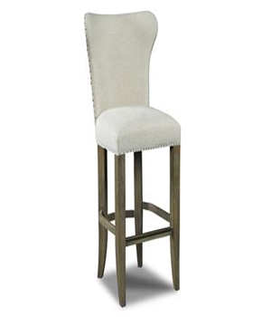

CLIFF

Wood + leather

Available colours: Black & White

1

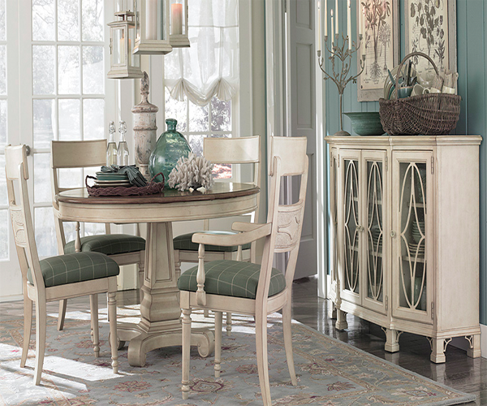

SUNSET PACKAGE

Round table

4 chairs

Cupboard for crockery

1

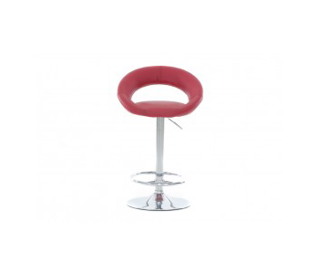

ASTRA

Moving chair

Available colours: Black , White, Blue & Brown

1

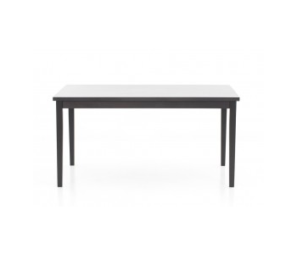

FULLERTON

Iron table

Available colours: Black & Grey

1

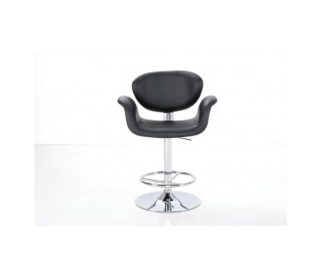

CAMARON

Moving chair with side take

Available colours: Black & Blue

1