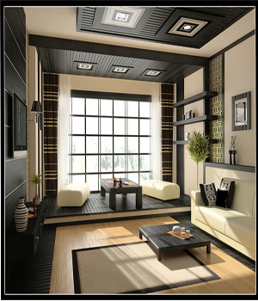

GODREJ LIVING ROOM SET

One sofa set

Narrow table

2 rectangular ottomas

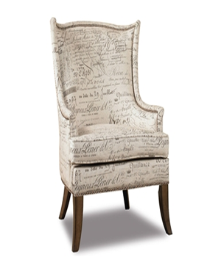

PARRIS ACCENT CHAIR

Material foamy with wood support

Available colours: Black, Brown & White

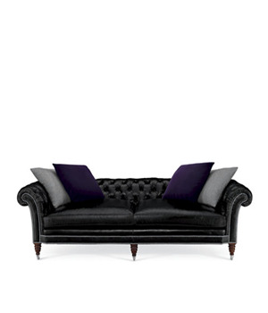

TUFTED SOFA

Sofa with 4 cushions of double colours

Colours Available: Black & Red

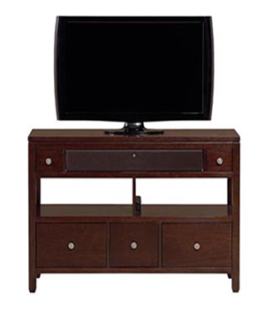

HOME ENTERTAINMENT

Wood Trolley for T.V

Drawers of different sizes

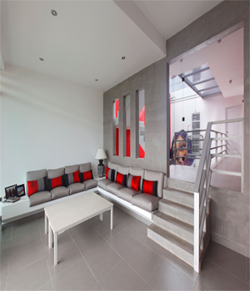

MODULAR SOFA SET

2 pair of sofa set

One tea table