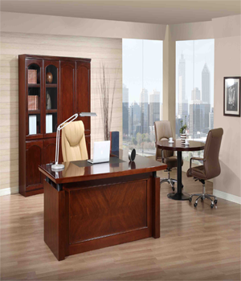

WOODEN SET

One office desk

One office Chair

One cupboard having partition of different sizes

One tea table with two irony chairs

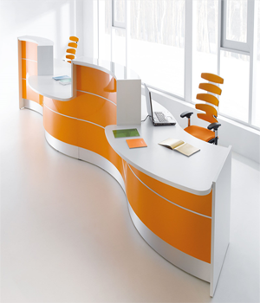

ORANGE DESK

Available colours: Orange, Blue & Green

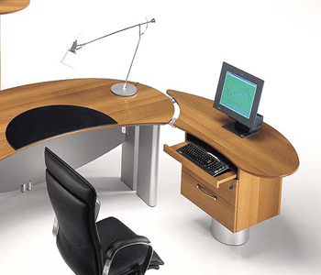

ART STYLE

Material Wood

Computer Trolley

Office Desk

Accent Chair

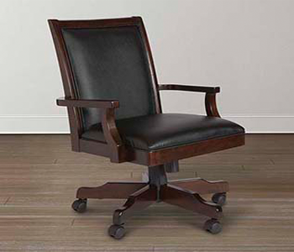

EOS OFFICE CHAIR

Material Wood and Leather

Revolving Chair

Available Colours: Black & Brown

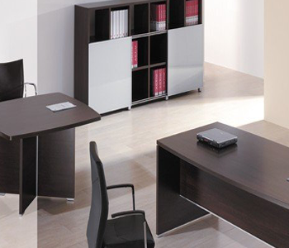

MANAGER ROOM SET

Two office tables

Four Chairs

Files Shelve