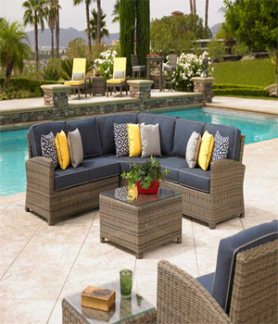

GRAY GALA

2 sectional Sofa set

One Tea table

One Side table

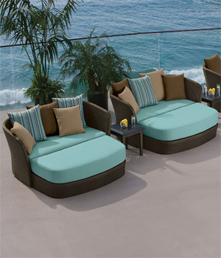

AUA BARS

Seat with small tea table

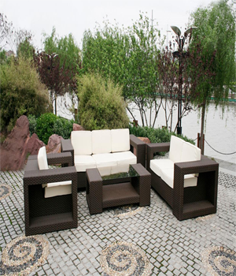

KIT KAT HOLIDAYS

3 Sofa sets

One Tea table

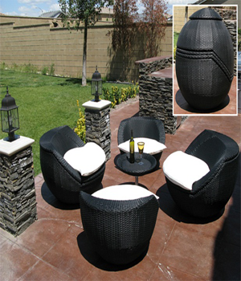

HAND GRENADE

Four seats

One round Tea Table

Best for camping purpose

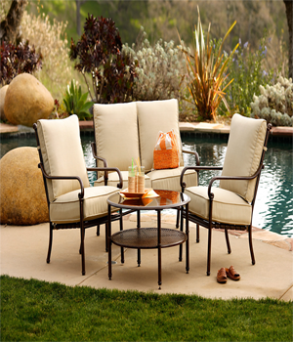

IRON EASE

Set of 4 chairs

Iron table with glass top