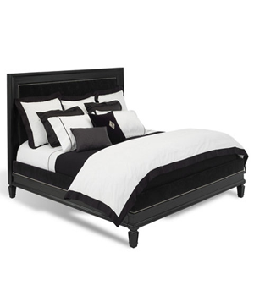

BROOK STREET TUFTED BED

MEASUREMENTS:

W75” D50” H70”

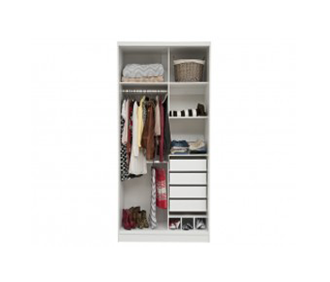

SPACEMASTER CUPBOARD

one big vertical section

4 small square shaped section

4 drawers

3 small partitions

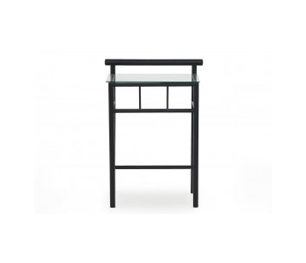

FERRIS BESIDE TABLE

Iron material

Glass top

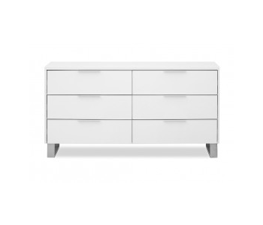

ICE DRESSER

6 drawers

Colours Available: Black, White & Brown



WAKEFIELD PANEL BED

MEASUREMENTS:

W75” D50” H70”