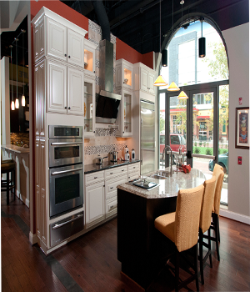

ELEGENT DINING ROOM

Curved dining table

4 chairs

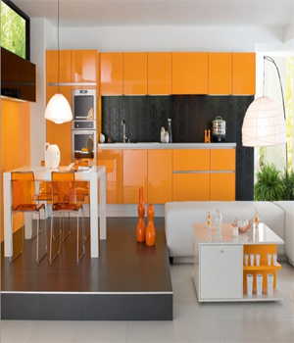

ORANGE BLACK MODULAR KITCHEN

White Dining table

4 Orange chairs

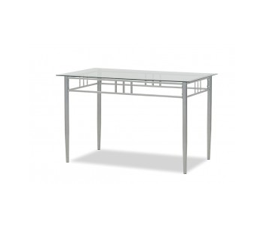

BERRICKTABLE

Iron table

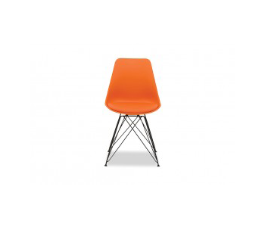

GLEBE

Plastic Chair with iron stand

Colours Available: Red, Orange, Black, Blue, Green & White

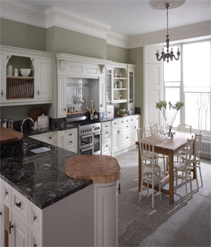

TRADITIONAL SMALL DINING

Brown Square shaped Dining table

6 White chairs