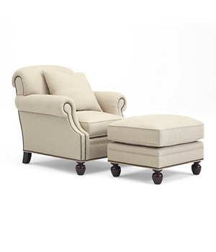

EDWARDIAN CLUB CHAIR AND OTTOMA

Elite spring down seat cushions

Tight back

Welted frame and seat cushion

1

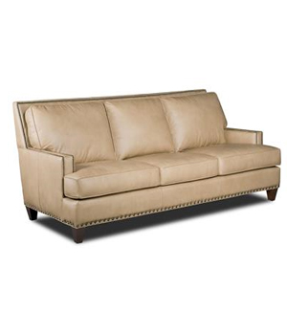

ASPEN REGIS STATIONARY SOFA

Tight back

Welted frame and seat cushion

1

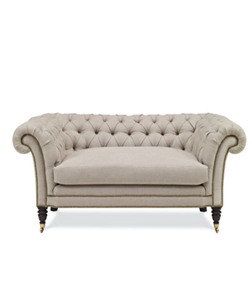

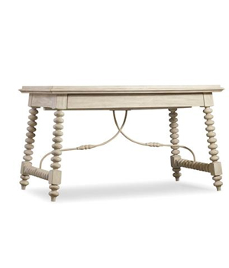

BROOK STREET LOVESEAT

Elite spring down seat cushions

Tufted Back And Arm

SUNSET POINT COCKTAIL TABLE

White ebony

W 84”

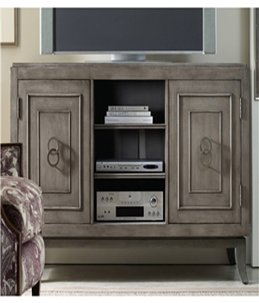

ACCENT TV STAND

Tv stand with 3 sections for DVD player & DVDs

2 chests