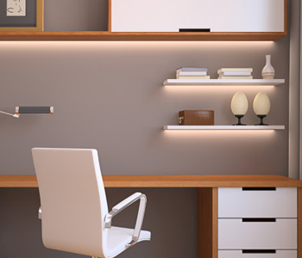

CLIFF OFFICE FURNITURE

Office desk with drawers

1 chair

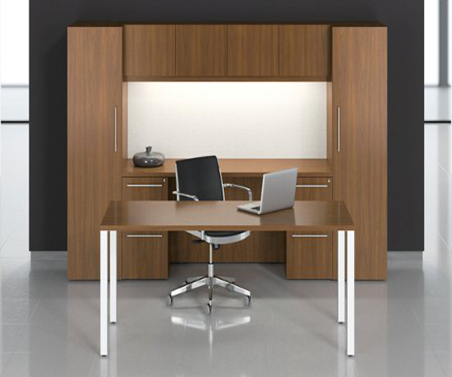

PANEL BASED OFFICE

Office desk

Cupboards with drawers

1 iron chair

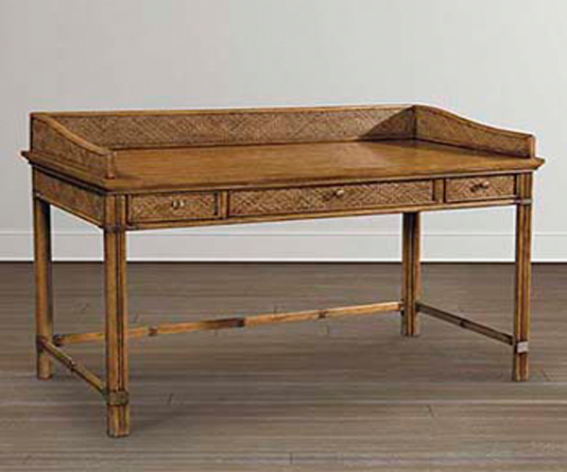

PELHAM BAY LEG DESK

Desk with 3 drawers

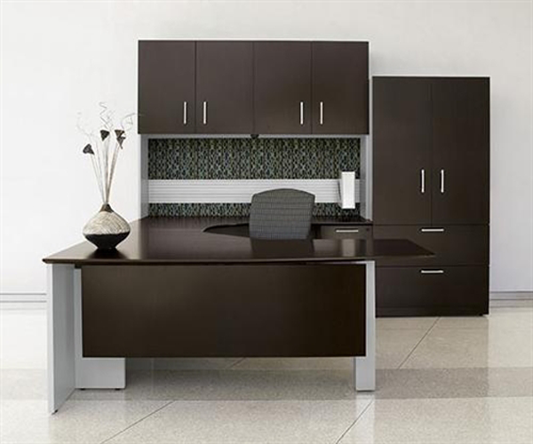

BLACK WOOD

Office desk with drawers

1 chair

4 Cabinets

1 cupboard

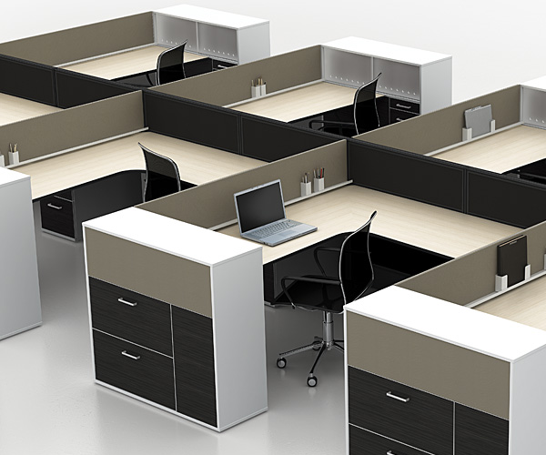

WATSON

Office Cabins