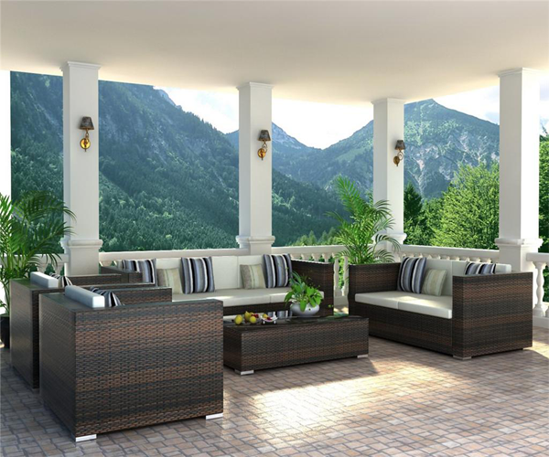

ALPINE WAFFERS

2 single sofa set

2 double sofa sets

Tea Table with glass top

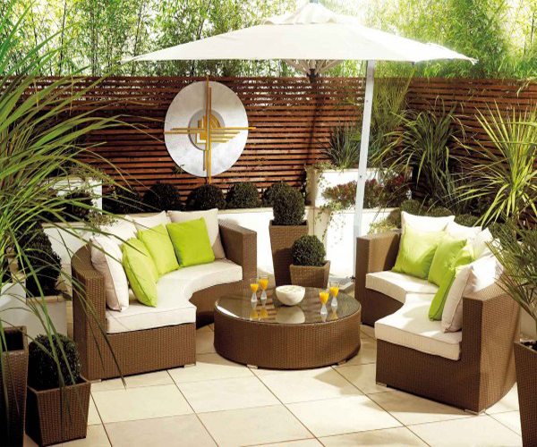

CRUNCHY LOUNGE SET

2 sofa sets

Round Tea Table with glass top

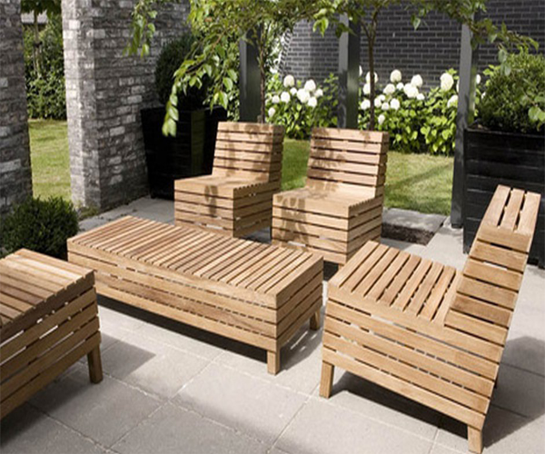

WOODEN IMPRESSION

4 Relaxing Seats

Tea Table

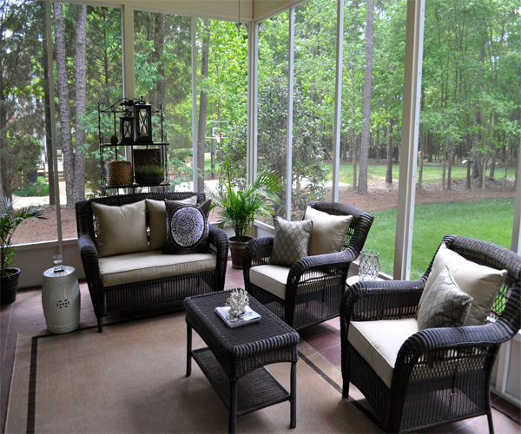

BLACKEES

2 single sofa set

1 double sofa sets

Tea Table with bottom section

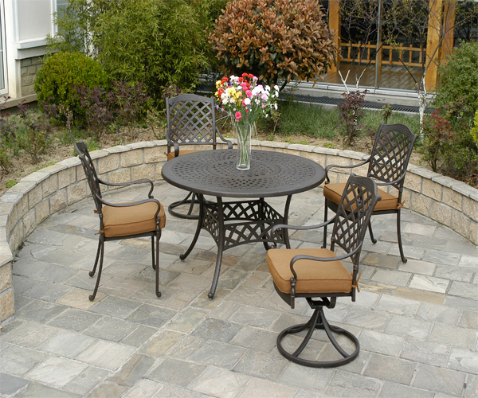

IRONY TRADES

Round Tea with bottom section

2 revolving chairs

2 simple chairs