Arsalaan Ansari (aaa2325)

ELENE4903 HW 3

Problem 1b)

Variance

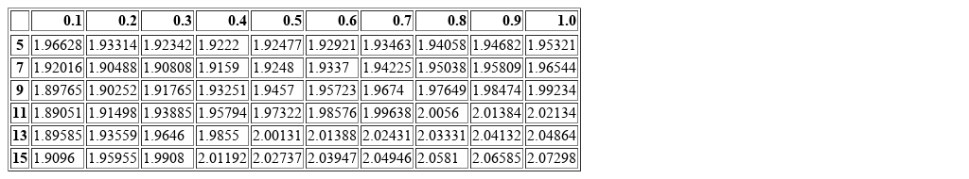

b value

*RSME for given b and variance value*

Problem 1c)

The RSME value 1.89051 for which b = 11 and the variance = 0.1 is the lowest RSME found in the table. The lowest RSME found in Homework 1 was around 2.2 which is considerably higher than the RSME value of 1.89051, and is larger than all of the values in the table as well.

There are a few disadvantages to using the Gaussian process method. First is that the Gaussian process method scales worse with larger data sets than ridge regression with a complexity of O(N^3), meaning that performance is impacted for large datasets. Second it is much more difficult to implement sparse feature selection in a Gaussian process compared to Ridge Regression.

Problem 1d)

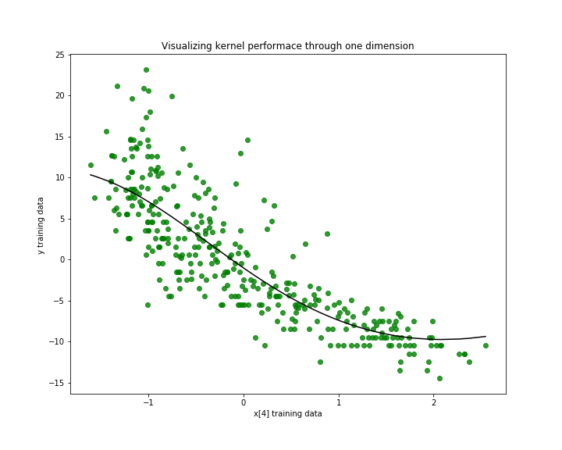

Problem 2a)

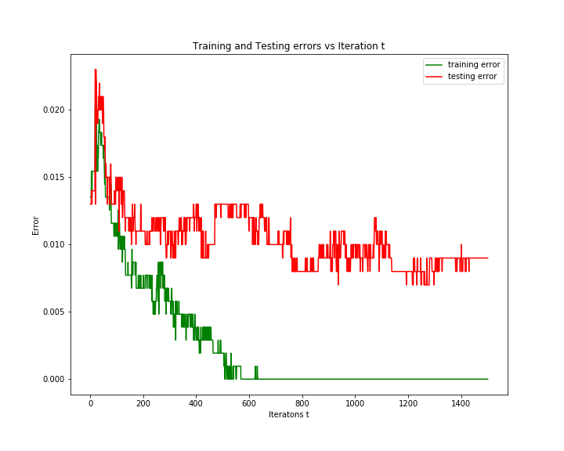

Problem 2b)

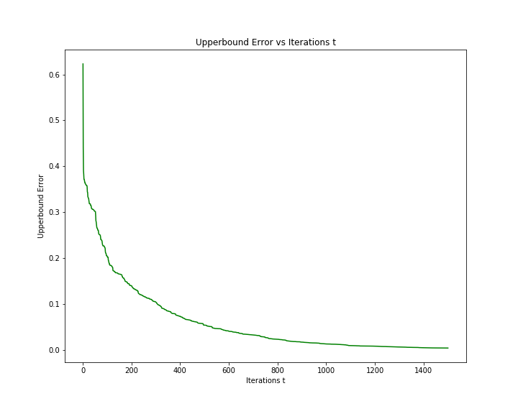

Problem 2c)

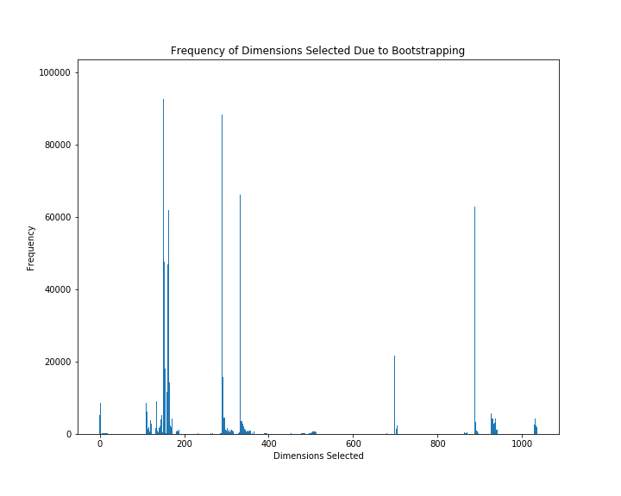

Problem 2d)

