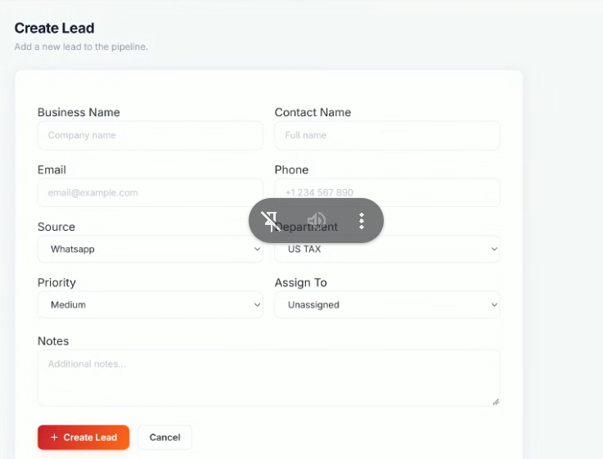
Leads mein campaign name ka naam add krna h
Departments
mein Legal- US
and Legal- UK
CSR
Pipeline number of clients
Clients with partially paid
Clients on fully-Paid
Clients on Quotation
Clients on invoice
Clients on Lost
Clients on Follow-up after contacted before Qualified
Converted mein Screenshot of payment will be must and for status
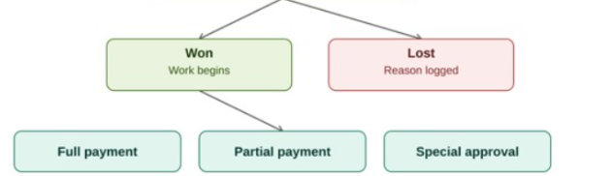
Full Payment mein bhi required kary payment ke details, Partial Payment mein bhi notfy kary payment ka , Special approval pay payment nhi mangy
Lost Reason of Client auto template and special note
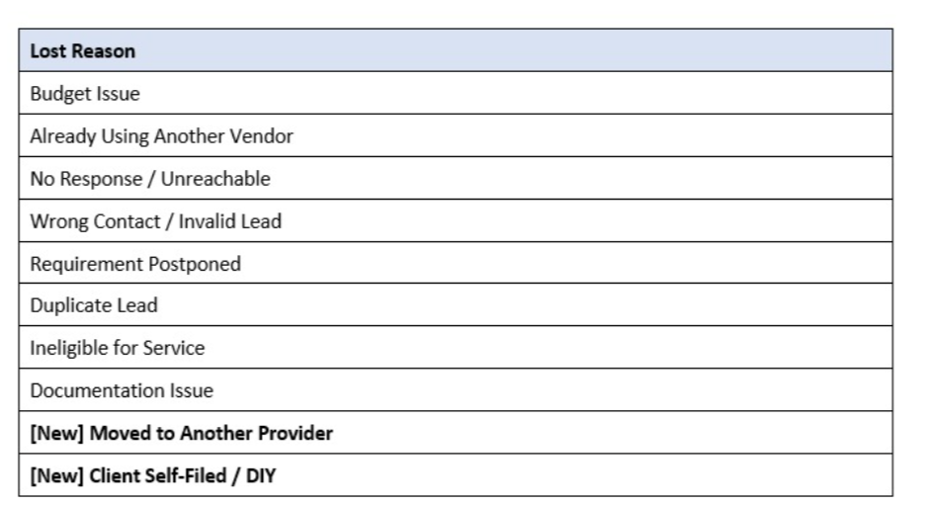
First check the portfolio
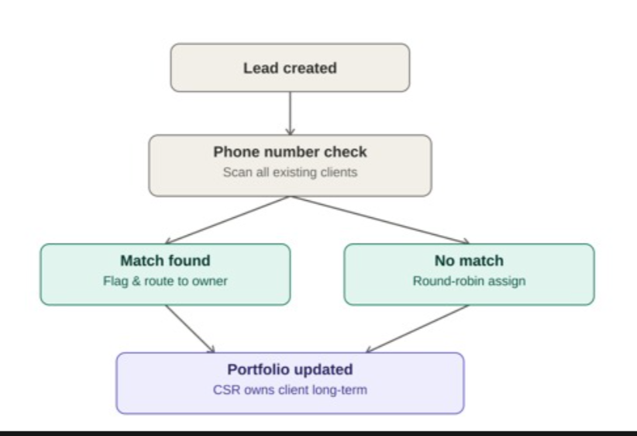
if repeated lead comes again to wo match kary again us say
usi csr ko assign hojay if agr nhi h to 1 2 3 random with calculated
equally divide ho
Client number +1 bhia ssign kardy or csr ko assign bhi kardy
Qutation and invoice pay email jay client ko
Duplicate Qutation mein quotation number same nhi rahy ga kbhi bhi naya generate hoga
duplicate chota sa side mein likha ay ga,
quotation email inv email to client and to admin.
can search according to the quotation or Client name or client company or client number
Sales Packages Templates
GBP,USD mostly
if Client pays us in different currency so we need to have a
exchange rate on qutation or in payment part we need exchange rate
finance module mein bhi rkhna h isko
and record the payment acknowledge button
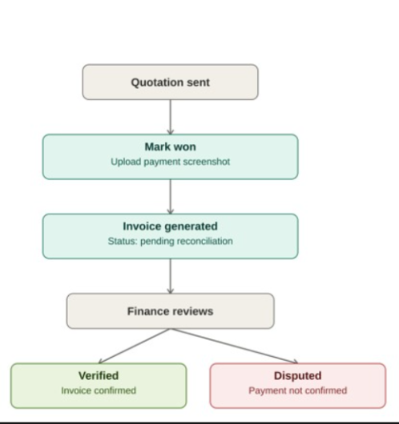
finance will get the csr details according to the payments and acknowledge it
csr will agree the client for the payment rate in quotation
super admin delete and reports option.

