Automated Classification of ANA Immunofluorescence Patterns Using Deep Learning
Final Year Project Proposal
Session Fall 2026
BS in Computer Science

Department of Computer Science
FAST School of Computing
FAST National University, Karachi Campus
1st September 2026
Project Registration
Project ID (for office use)
Type of project | ☐ Traditional ☒ Industrial ☐ Continuing
Nature of project | ☐ Development ☒ Research & Development ☐ Research
Sustainable Development Goals (SDGs) | ☒ Good Health and Well-Being ☐ Quality Education  ☒ Industry, Innovation, and Infrastructure ☐ Gender Equality  ☐ Decent Work and Economic Growth ☐ Climate Action
Area of specialization | ☒ Artificial Intelligence (AI) ☒ Data Science and Analytics  ☐ Internet of Things (IoT) ☐ Blockchain ☐ Mobile App Development  ☒ Web Development ☐ Cybersecurity ☐ Game Development  ☐ Natural Language Processing (NLP) ☐ Other

Supervisor Details
Supervisor Name | Ubaid Chawla
Supervisor Signature

Project Group Members
Sr. # | Reg. # | Student Name | CGPA | Email ID | Phone #
(i) Leader | 23K-0690 | Muhammad Yousuf |  | k230690@nu.edu.pk
(ii) | 23K-0536 | Arsalan Ahmed |  | k230536@nu.edu.pk
(iii) | 23K-0627 | Muhammad Huzaifa Altaf |  | k230627@nu.edu.pk
Declaration: FYP group members have cleared all prerequisite courses.

1. Project Abstract
Antinuclear antibody (ANA) testing by indirect immunofluorescence (IIF) on HEp-2 cells is the first-line screening test for autoimmune diseases such as systemic lupus erythematosus, systemic sclerosis and Sjögren’s syndrome. When autoantibodies in a patient’s serum bind structures inside the cell, a characteristic fluorescent staining pattern appears. That pattern tells the clinician which antigens are likely involved and which confirmatory test to order next. Reading the slide is still done by hand. A technologist looks at each field under a microscope and decides the result by eye, which is slow, tiring and open to disagreement, because several patterns look very similar.
This project builds and evaluates a deep learning system that classifies ANA-IIF staining patterns from HEp-2 cell images. Two public datasets have already been obtained: the AIDA public dataset, which is the only widely available collection that contains negative as well as positive specimens, and the I3A Task-1 cell-level dataset. Further public datasets will be added as access is granted. Alongside these, an anonymised routine clinical dataset will be collected from Indus Laboratory, Karachi, under institutional ethical approval, so that the system is tested on the kind of slides a working laboratory actually produces.
Work will begin with the patterns seen most often in local practice, namely the homogeneous pattern (AC-1), the speckled group and the nucleolar group. The remaining ICAP patterns will be added in later stages once the frequent classes are working reliably. Two architectures will be built and compared on the same data: a single flat multi-class classifier, and a staged pipeline that first screens positive against negative, then assigns a broad group, then picks the specific pattern within that group. Because one patient sample produces several microscopy images, image-level predictions are combined into one sample-level result to match how laboratories report.
Performance will be reported using precision, recall, F1 and specificity together with Cohen’s kappa against expert reporting, since plain accuracy is misleading when some classes are far more common than others. The expected contribution is a validated classification model, measured evidence on which architecture suits this task, and a web application demonstrating end-to-end use. The system reports a fluorescence pattern as decision support. It does not diagnose disease.

2. Introduction

2.1 Research Domain
The research domain is medical image analysis using deep learning, applied to clinical immunology diagnostics. Autoimmune diseases arise when the immune system produces autoantibodies that attack the body’s own cells. Finding those autoantibodies is central to diagnosis, and the standard screening test is the antinuclear antibody (ANA) test performed by indirect immunofluorescence on HEp-2 cells, a standardised human epithelial cell line used as a substrate.
Patient serum is applied to a slide of these cells. Autoantibodies in the serum bind to particular structures inside the cell, and a fluorescent conjugate makes them visible under a microscope. Different autoantibodies target different structures, so each one produces a visually distinct staining pattern that reflects what is present in the sample [1], [2].
These patterns are standardised internationally by the International Consensus on ANA Patterns (ICAP), which gives each one an alphanumeric anti-cell (AC) code [1]. The classification originally covered 28 positive patterns, AC-1 to AC-28 [1]. AC-0, denoting a negative result, and AC-29 were added later, and AC-30 and AC-31 were introduced after the seventh ICAP workshop, so the scheme now runs from AC-0 to AC-31 [3], [4]. The patterns are split into competent-level patterns, which a routine laboratory is expected to recognise and report, and expert-level patterns, which are harder to tell apart. The classification tree defines eleven competent-level reportable groups [1], [4].
Not all of these patterns are seen equally often. At the collaborating laboratory the common findings are the homogeneous pattern (AC-1), the speckled group (AC-2, AC-4 and AC-5) and the nucleolar group (AC-8, AC-9 and AC-10), while the centromere pattern (AC-3) is rare. This project therefore starts with the frequent patterns, because those are the classes for which enough labelled examples can realistically be collected and validated. Once they are classified reliably, the less common patterns will be brought in as further data accumulates. The pipeline is designed so that new groups and their classifiers can be attached without rebuilding the parts that already work, which makes the staged extension practical rather than a second project.

2.2 Importance of the Domain
The reported pattern is not a cosmetic detail. It indicates which antigens the autoantibodies are likely targeting, and therefore decides which confirmatory antibody test the clinician orders next. A wrongly reported pattern can send the diagnostic pathway in the wrong direction and delay diagnosis in conditions where early treatment changes the outcome. ANA testing is also high volume, used as a first-line screen across rheumatology and general medicine, so the reading step sits on a busy critical path.

2.3 Current Situation
Even though the naming is standardised internationally, the reading itself is still entirely manual. A trained technologist examines each slide and judges, by eye, whether the sample is positive, at what titre, and which pattern is present. The result therefore depends on who is reading. Published work reports that two experienced readers agree closely, with a Cohen’s kappa of 0.849, but agreement between an experienced reader and a novice drops to 0.528 [5]. The same slide can be reported differently depending on the reader and the laboratory.

2.4 Relevance of Computational Research
Recognising patterns in images is exactly what convolutional neural networks are good at, and a large body of work has already applied deep learning to HEp-2 images with encouraging results on research datasets [6]. Two findings from that literature shape this project. First, performance on unselected routine clinical samples remains more challenging than the figures reported on curated benchmark datasets [7]. Second, visually similar patterns are difficult for machines and for human readers alike [7], [8]. The case for a computational approach is not that it replaces the expert. It is that a trained model applies the same decision to every slide, which is the one property manual reading cannot offer.

3. Problem Statement
Visual interpretation of ANA-IIF slides is subjective, labour-intensive and inconsistent between observers and between laboratories. Several patterns look very similar, so two qualified readers can examine the same slide and report different results. As test volumes grow, this manual step becomes a bottleneck in the diagnostic pathway.
The gap this project addresses is methodological and applied rather than a simple absence of software. Specifically:
- Performance gap on realistic data. Accuracies reported on curated public benchmarks do not transfer reliably to unselected routine clinical samples, and the size of that drop has not been characterised for local case mix and imaging conditions [7].
- Methodological gap in architecture. Breaking ANA classification into clinically meaningful stages has already been shown to help. Jain et al. reported 92.27% accuracy for a staged pipeline against 87.16% for a flat classifier on the same data, a gain of roughly 5.1 percentage points [8]. That result, however, came from a single curated dataset covering five patterns, using a split on metaphase-plate staining that does not extend naturally to the wider ICAP set. Whether the same advantage holds on routine local material, and on a class set fixed by local pattern frequency rather than by dataset availability, has not been tested.
- Generalisation gap. Many published systems are developed and evaluated on data from a single centre or a small number of datasets, which leaves cross-centre generalisation an open challenge [5], [6], [8].
- Application gap. Reported systems are largely research artefacts rather than tools a laboratory can run on its own slides.
The project therefore investigates how a deep learning system for ANA pattern classification should be structured and evaluated so that its measured performance means something on routine clinical material, not only on curated benchmarks.

4. Motivation
The motivation behind this project is to build a practical and clinically grounded solution for ANA-IIF pattern interpretation. The project aims to:
- Cut the manual effort needed to read ANA slides, particularly the repeated field-by-field examination of every specimen.
- Improve consistency by applying the same learned decision to every slide, which removes the reader-to-reader variation that characterises manual reading.
- Automate the first-pass screening step so that clearly negative samples take less manual work and expert attention goes to the positive and ambiguous cases.
- Give clinicians a simple interface where an image can be submitted and a predicted pattern returned with a confidence score.
- Support laboratories where experienced ANA readers are scarce, by offering standardised interpretation as decision support.
- Produce measured evidence on how architectural choices affect performance on this task, using local clinical data rather than curated benchmarks alone.

4.1 Aims and Objectives
The aim of this project is to develop and evaluate a deep learning system that classifies ANA immunofluorescence patterns from HEp-2 cell images, giving laboratories a consistent and reproducible aid to interpretation. The specific objectives are listed in Table 1.
Table 1. Project objectives.
No. | Objective
O1 | To build a labelled image dataset for ANA pattern classification by combining public HEp-2 benchmark datasets with anonymised routine clinical samples from the collaborating laboratory.
O2 | To develop a model that reliably determines, at image level, whether a sample is ANA positive or negative, for later aggregation to a sample-level result.
O3 | To develop a model that classifies the ANA staining pattern, starting with the patterns most frequently encountered in local clinical practice and extending to the remaining patterns in later stages.
O4 | To compare a single flat classifier against a staged pipeline on the same data, and to adopt whichever performs better.
O5 | To aggregate predictions across the several images belonging to one patient sample, producing a single result per sample as reported clinically.
O6 | To evaluate the system using metrics appropriate to imbalanced clinical data, and to measure its agreement with expert reporting.
O7 | To deploy the validated model behind a web application through which a clinician can upload an image and receive a predicted pattern with a confidence score.

4.2 Scope of the Project

4.2.1 In Scope
- Acquisition and preparation of a labelled ANA-IIF image dataset from public benchmark sources and from an anonymised routine clinical dataset obtained under institutional ethical approval.
- Development of an image-level classifier for ANA positive versus negative status.
- Development of a pattern classifier covering the ANA patterns most frequently encountered in local clinical practice, with the initial class set fixed in consultation with the clinical collaborator, and with provision for extending to further patterns.
- Implementation and comparative evaluation of both a flat classifier and a staged pipeline on the same data.
- Aggregation of image-level predictions into one sample-level result.
- Evaluation using precision, recall, F1, specificity, confusion matrices and Cohen’s kappa against expert reporting.
- Development of a web application supporting image upload and return of the predicted pattern with a confidence score.

4.2.2 Out of Scope
- Prediction of ANA titre. The system reports patterns only. Titre determination requires serial dilution, which is a physical laboratory procedure rather than something visible in a single image.
- Diagnosis of disease. The system outputs a fluorescence pattern, which is one input to a clinical decision made by a qualified clinician.
- Simultaneous reporting of multiple co-occurring patterns. The initial system treats classification as single-label. Extension to mixed patterns may be considered in later work.
- Coverage of the complete ICAP set within this project. The initial class set is deliberately restricted to the most frequent patterns, with the architecture built so that further groups can be added afterwards.
- Regulatory certification. The deliverable is a functional research prototype, not a certified diagnostic device.

5. Proposed Methodology
The methodology set out here reflects the current design and will be refined as data arrives and initial experiments are run. Data acquisition is settled. The architectural choice is deliberately left open and will be decided on measured performance.

5.1 Overview of the Two Candidate Designs
Two designs are under consideration. The first is a single flat multi-class classifier that separates all classes in one step, shown in Fig. 1. The second is a staged pipeline that breaks the task into a sequence of simpler decisions, broadly mirroring how an experienced reader works through a slide, shown in Fig. 2. Published work reports that the staged approach can beat a flat classifier on the same data because each stage faces a narrower problem, with one study recording an improvement from 87.16% to 92.27% purely from this restructuring [8]. Both designs will be implemented here and compared on our own data, and the final choice made on the measured result rather than on the published one.
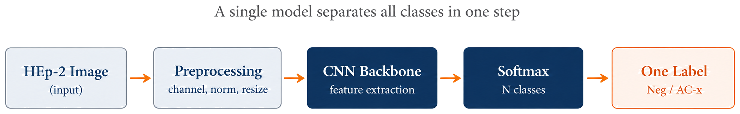
Fig. 1. Single flat classifier, the baseline design against which the staged pipeline is compared.
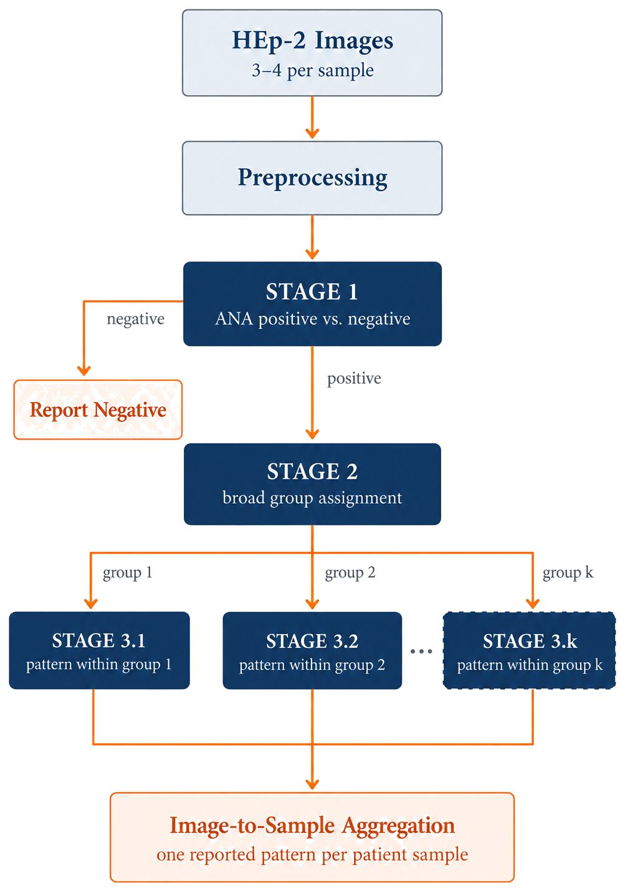
Fig. 2. Staged pipeline in general form. The task is split into a positive/negative screen, assignment to one of k broad groups, and a specialised classifier per group. Predictions from a sample’s images are aggregated into one reported result.

5.2 Data Acquisition
Two complementary sources will be used: public benchmark datasets and a local clinical dataset.
Public datasets already obtained. The AIDA public dataset contains 2,080 specimen images, of which 1,498 are positive and 582 negative, annotated at specimen level across 22 antinuclear antibody patterns [9]. It is the only widely available HEp-2 collection that includes negative specimens, which makes it directly useful for the positive-versus-negative stage, since the other public sets contain positive material only. The I3A Task-1 dataset contains 13,596 cell-level images across six pattern classes, extracted from 83 specimens, and is the benchmark most often used for comparison in published work [6], [10].
Further public datasets. Access to the ICPR 2012 / MIVIA dataset and to SNPHEp-2 is being arranged, and these will be added to the training pool once available [10], [11]. Together the public sets give enough volume to train deep networks from the outset and provide a comparison point against published results.
Local clinical dataset. Anonymised routine samples will be collected from Indus Laboratory, Karachi, where Dr. Sabiha Anis, Consultant in Clinical Immunology, is collaborating on the project. Samples are reported by qualified staff according to the ICAP standard, and each patient sample yields roughly three to four microscopy images. The laboratory processes approximately 480 images per month, and will also supply the observed frequency of each pattern in local practice so that the initial class set can be fixed to the patterns that actually occur.
Using both sources is a deliberate decision. Public datasets are curated and therefore cleaner than routine practice, while the local dataset is smaller but reflects genuine local case mix, staining conditions and pattern frequencies. Together they allow the system to be trained at scale and then tested on the kind of cases a working laboratory really sees. Beyond Indus Laboratory, further data may be collected from other hospitals and diagnostic centres where this can be arranged. Slides prepared at different sites vary in staining intensity, imaging equipment and patient mix, so training and validating across more than one centre would improve generalisation and reduce the risk of a system that only works well at a single site.

5.3 Image Preprocessing
- Channel selection. The fluorescence signal sits mainly in the green channel, so the other channels contribute little and may be discarded.
- Intensity normalisation. Staining intensity varies between batches and laboratories, so pixel intensities will be normalised to a common range to reduce this source of variation.
- Resizing. Images will be resized to a fixed input resolution suited to the chosen architectures.
- Data augmentation. Rotation, flipping and mirroring will be applied. Rotation matters here because a cell under a microscope has no fixed orientation. Augmentation will be class-aware, with rarer patterns augmented more heavily to offset imbalance, as recommended in the review literature [6].

5.4 Candidate Staged Pipeline
Following the structure in Fig. 2, this design breaks the task into the stages listed in Table 2, each a separate and independently trained model. The design is general on purpose. The initial class set covers the patterns seen most often locally, but the same three-stage structure scales to a wider set of ICAP patterns by adding groups at Stage 2 and their classifiers at Stage 3. Exact group boundaries will be fixed once the pattern distribution in the local data is known. A flat classifier over the same classes will be trained as the baseline for comparison.
Table 2. Stages of the candidate pipeline.
Stage | Decision | Type
Stage 1 | Is the sample ANA positive or negative? | Binary
Stage 2 | If positive, which broad group does the pattern belong to? Candidate groupings include the top level of the ICAP classification tree, namely nuclear, cytoplasmic and mitotic [1], or a split on an intermediate visual feature such as metaphase plate staining [8]. The grouping will be agreed with the clinical collaborator. | k-class
Stage 3 | Which specific pattern within the assigned group? One specialised classifier is trained per group, so adding patterns later means extending or adding a group-level classifier rather than redesigning the pipeline. | Multi-class

5.5 Model Development and Transfer Learning
Several convolutional architectures will be trained and compared at each stage rather than committing to one in advance, since published results show that the choice of architecture can matter a great deal on this task. Differences of over thirty percentage points between architectures have been reported on the hardest pattern pairs [8]. Each architecture will be trained in two configurations, one initialised randomly and one initialised from ImageNet pretrained weights and fine-tuned, and the two compared. Transfer learning is expected to help most at the harder fine-grained stages, where labelled data is scarcest.

5.6 Image-to-Sample Aggregation
A clinical result is reported per sample, not per image, so the predictions from the three to four images belonging to one sample have to be combined into a single output. A rule-based aggregation scheme will be developed with the clinical collaborator. For example, a pattern might be required to appear in more than one image before it is reported, with defined exceptions where a diagnostic feature can legitimately show up in only one field.

5.7 Evaluation Protocol
Data will be divided into training, validation and test sets, with stratified k-fold cross-validation inside the training set so that class proportions are preserved across folds. Where sample identifiers are available, splits will be made at sample level rather than image level, so that images from the same patient never appear in both training and test data. Overall accuracy is misleading when some classes are far more common than others, so performance will be reported using the measures listed in Table 3.
Table 3. Evaluation metrics and their interpretation.
Metric | What it tells us
Sensitivity (recall) | Of the truly positive samples, how many the system correctly detects. This matters most in a screening role, where a missed positive is the costlier error.
Precision | When the system reports a pattern, how often that report is correct.
F1 score | The balance between precision and recall, reported per pattern as well as overall.
Specificity | Of the truly negative samples, how many are correctly identified as negative.
Cohen’s kappa | Agreement with expert reporting, corrected for the agreement expected by chance. This is the same statistic used to compare two human readers [5], [7].
Confusion matrix | Which patterns are being mistaken for which, so that failure modes can be identified rather than averaged away.

5.8 Ethical Considerations
- Institutional Review Board approval will be obtained before any clinical data is accessed or used. A formal proposal stating the study objective and methodology will be submitted to Indus Laboratory.
- All images will be anonymised. No patient-identifying information will be collected, stored or processed.
- Data will be handled under agreed access controls on secured machines, in line with the laboratory’s confidentiality requirements. Cloud compute will be used with public datasets only, unless explicitly permitted under the approved data-sharing arrangement.

6. Functional and Non-Functional Requirements

6.1 Functional Requirements
Table 4. Functional requirements.
ID | Requirement
FR-1 | The system shall accept one or more HEp-2 microscopy images belonging to a single patient sample.
FR-2 | The system shall validate the uploaded file format and reject unsupported or corrupted files with a clear message.
FR-3 | The system shall apply the defined preprocessing pipeline to every uploaded image before inference.
FR-4 | The system shall classify each image as ANA positive or negative.
FR-5 | The system shall classify the ANA staining pattern of images identified as positive.
FR-6 | The system shall aggregate image-level predictions belonging to one sample into a single sample-level result.
FR-7 | The system shall display the predicted pattern together with an associated confidence score.
FR-8 | The system shall store predictions and associated metadata for later review.
FR-9 | The system shall allow a user to review previously submitted samples and their results.
FR-10 | The system shall present a clear statement that the output is decision support and not a diagnosis.

6.2 Non-Functional Requirements
Table 5. Non-functional requirements.
ID | Requirement
NFR-1 | Accuracy. The system shall achieve performance competitive with published results on comparable data, measured by agreement with expert reporting.
NFR-2 | Reliability. Predictions shall be reproducible for identical inputs.
NFR-3 | Performance. Inference on a single uploaded image shall complete within a few seconds on the target hardware.
NFR-4 | Security and privacy. Clinical images shall be processed on secured machines under agreed access controls, with no patient-identifying information stored.
NFR-5 | Usability. The interface shall be operable by a clinician without technical training.
NFR-6 | Maintainability. Model weights shall be versioned so that any reported result can be traced to the model that produced it.
NFR-7 | Extensibility. The classification pipeline shall permit additional pattern classes to be added without redesigning the architecture.
NFR-8 | Portability. The trained model and serving layer shall be deployable on a local machine without dependence on external services.

7. System Architecture
The proposed system follows a three-tier architecture, shown in Fig. 3. The major layers and components are described below.

7.1 Presentation Layer
The clinician-facing web interface. It provides image upload, submits the request to the backend service, and presents the predicted pattern with its confidence score.

7.2 Application Layer
The backend service handling requests, the preprocessing module applying channel selection, normalisation and resizing, and the inference engine running the trained models and producing predictions. Image-to-sample aggregation is applied at this layer.

7.3 Data Layer
Persistent storage for uploaded and training images, the model registry holding trained weights and their versions, and the results store holding predictions and processing logs.
The overall workflow is: user → web interface → backend service → preprocessing → inference engine → results store → results returned to the interface.
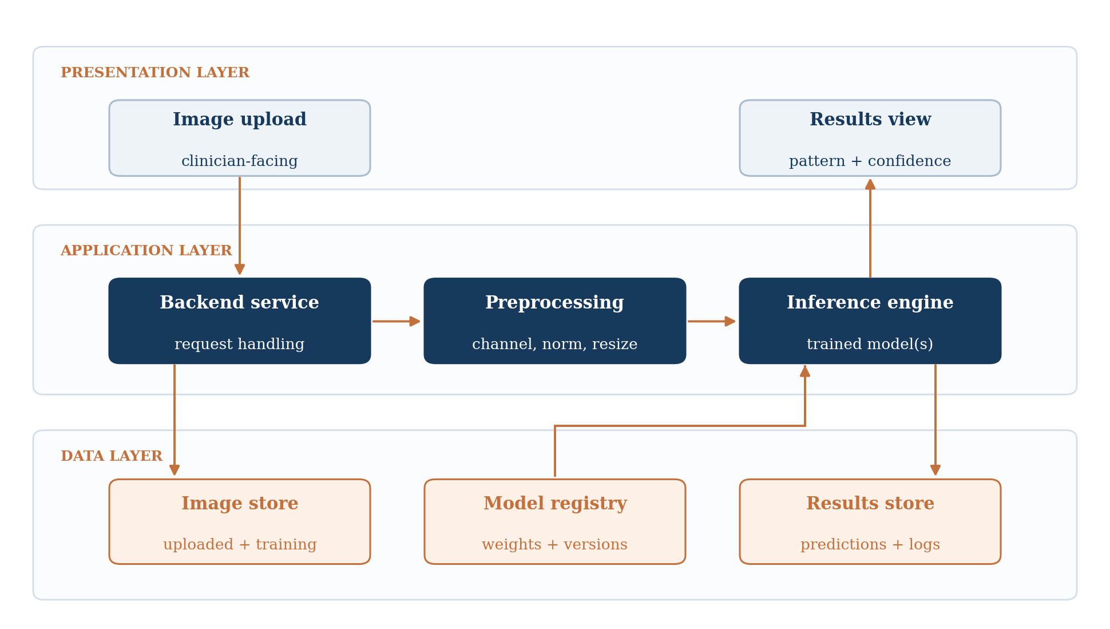
Fig. 3. Three-tier system architecture.

8. Individual Tasks
The distribution of work across the group is given in Table 6. Tasks are allocated so that each member carries an identifiable stream of work across the full year, while the comparative evaluation, which is the central research contribution, is undertaken jointly.
Table 6. Individual task allocation.
Team Member | Activity | Tentative Date
Muhammad Yousuf  (Group Leader) | Literature review and clinical domain study | Sep – Oct 2026
 | Preparation and submission of the IRB proposal | Oct – Nov 2026
 | Design and implementation of the staged pipeline | Feb – Mar 2027
 | Comparative evaluation of flat versus staged designs | Apr – May 2027
 | Final report and documentation | May – Jun 2027
Arsalan Ahmed | Acquisition and organisation of public benchmark datasets (AIDA, I3A Task-1 and further sets) | Oct – Nov 2026
 | Implementation of the image preprocessing and augmentation pipeline | Nov – Dec 2026
 | Baseline model: ANA positive versus negative classification | Dec 2026 – Jan 2027
 | Implementation of the flat multi-class classifier | Jan – Feb 2027
 | Architecture comparison and hyper-parameter tuning | Mar – Apr 2027
Muhammad Huzaifa Altaf | Clinical dataset integration and annotation alignment | Feb – Apr 2027
 | Image-to-sample aggregation logic | Mar – Apr 2027
 | Validation against expert reporting and error analysis | May – Jun 2027
 | Web application development and model deployment | Apr – Jun 2027
 | User interface testing and integration | Jun 2027

9. Gantt Chart
The project schedule is shown in Fig. 4. Tasks that depend on the outcome of an earlier task run in series, while independent streams run in parallel. The IRB proposal is prepared alongside public dataset work so that model development is not blocked while approval is pending. Clinical dataset integration begins only once approval is granted. The flat and staged designs are implemented one after the other by the same stream to keep the comparison controlled, and the web application is developed in parallel with the final evaluation.
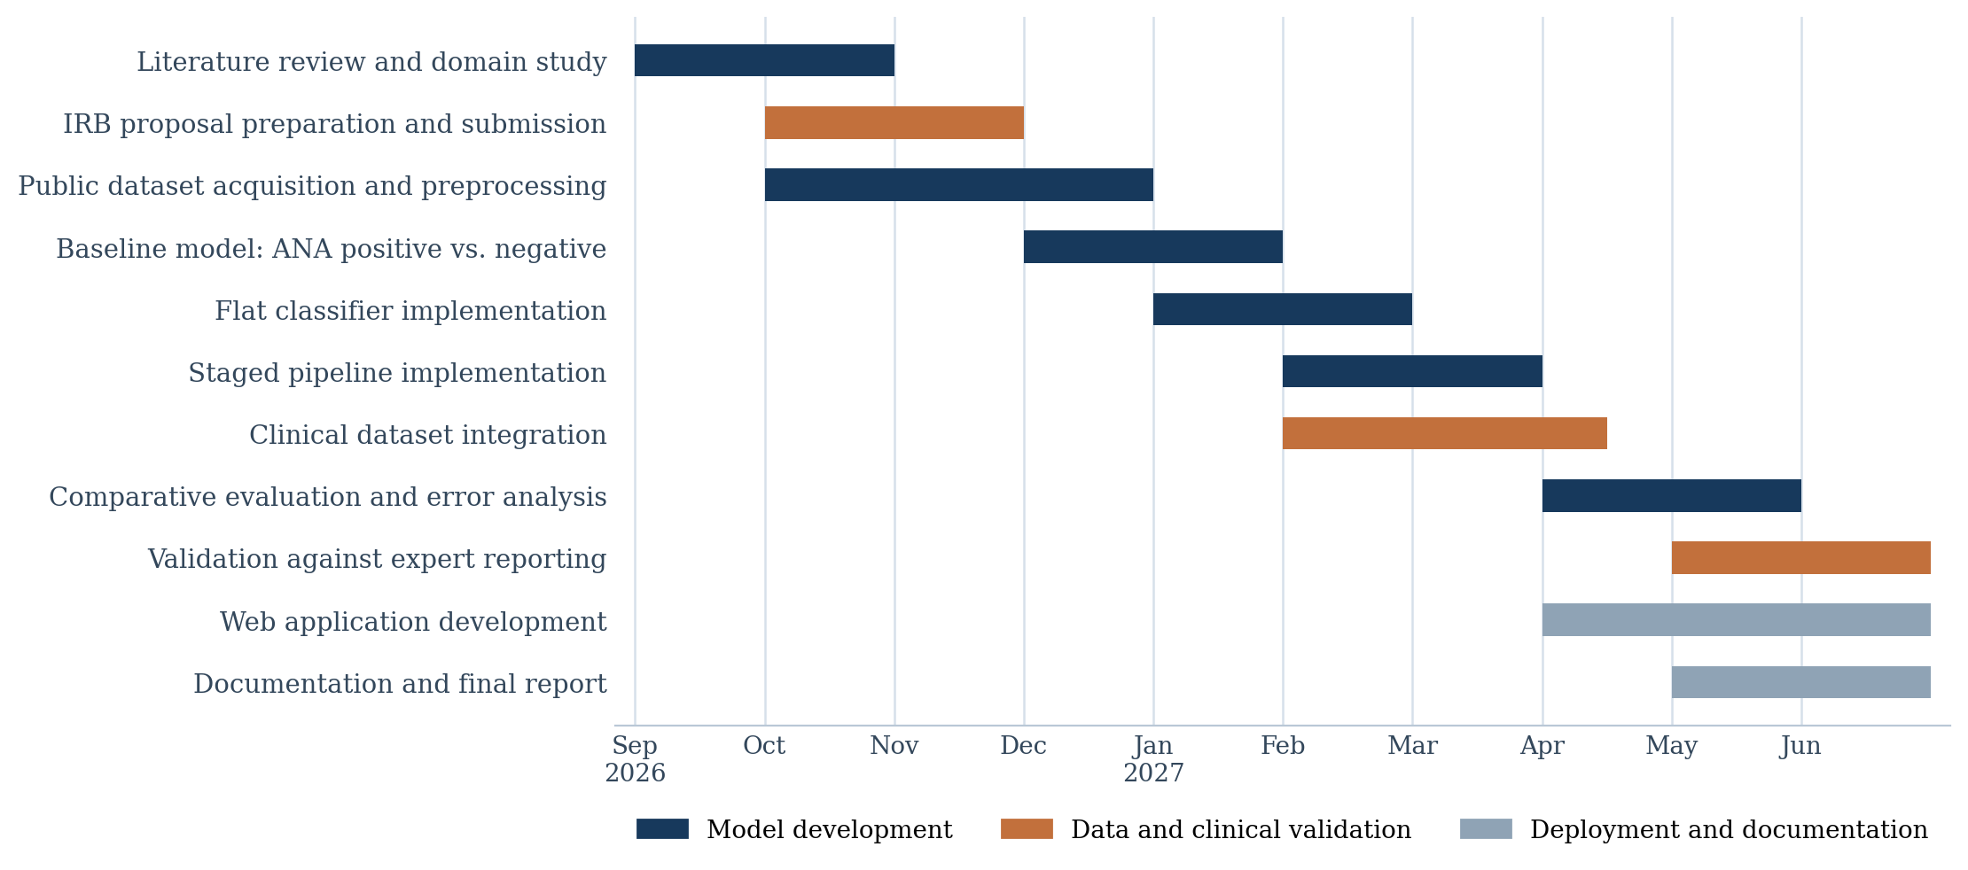
Fig. 4. Project Gantt chart, September 2026 to June 2027.

10. Tools and Technologies
The stack listed in Table 7 is tentative and reflects current planning. Specific libraries and frameworks will be confirmed during implementation as the design settles.
Table 7. Tentative tools and technologies.
Category | Tools and Technologies
Programming language | Python
Deep learning | PyTorch or TensorFlow with Keras; pretrained model libraries for transfer learning
Image processing | OpenCV, Pillow, scikit-image
Data handling | NumPy, Pandas
Evaluation and analysis | scikit-learn for metrics and cross-validation; Matplotlib and Seaborn for visualisation
Backend | FastAPI
Front end | Web client for image upload and results display
Development environment | Jupyter Notebook, Visual Studio Code
Version control | Git and GitHub
Compute | NVIDIA GPU workstation (12–16 GB VRAM); cloud GPU such as Google Colab or Kaggle for public datasets only

11. Expected Deliverables
The project runs across two semesters. FYP-I covers dataset preparation, the preprocessing pipeline and the positive-versus-negative baseline, so that by the end of semester seven there is a working model and a dataset to build on. FYP-II covers pattern classification, the architectural comparison, clinical validation and deployment.

11.1 FYP-I Deliverables (Semester 7)
- A consolidated literature review covering the current state of deep learning for HEp-2 image classification, together with the clinical domain study of ICAP patterns.
- A prepared and organised public dataset combining AIDA and I3A Task-1, with any further public sets obtained during the semester, cleaned and split at sample level where identifiers allow.
- The IRB proposal prepared and submitted to the collaborating laboratory, together with the agreed data-sharing arrangement.
- An implemented image preprocessing and augmentation pipeline covering channel selection, intensity normalisation, resizing and class-aware augmentation.
- A trained and evaluated model for ANA positive versus negative classification, with results reported on public data.
- An initial architecture comparison across candidate convolutional backbones for the positive-versus-negative stage, including randomly initialised and ImageNet-pretrained configurations.
- Software requirements specification and initial design documentation, along with the FYP-I report.

11.2 FYP-II Deliverables (Semester 8)
- The anonymised local clinical dataset from the collaborating laboratory, integrated and aligned with the public data under a common labelling scheme.
- A trained and validated model for ANA pattern classification across the prioritised class set, with a defined route for adding the remaining patterns.
- Both architectures implemented and compared on the same data, with a per-pattern breakdown showing where the system succeeds and where it fails.
- The image-to-sample aggregation scheme, developed with the clinical collaborator and evaluated at sample level.
- A measure of agreement between the system and expert reporting, benchmarked the same way two human readers would be compared.
- A web application demonstrating end-to-end use, from image upload through to predicted pattern with a confidence score.
- Test reports, complete project documentation and the final report, suitable as the basis of a publication.
The system classifies fluorescence patterns. It does not diagnose disease. Its role is decision support, standardising interpretation and reducing manual workload, with the final interpretation remaining with the reporting clinician.

12. References
[1] E. K. L. Chan et al., “Report of the first international consensus on standardized nomenclature of antinuclear antibody HEp-2 cell patterns 2014–2015,” Frontiers in Immunology, vol. 6, art. 412, 2015.
[2] J. Damoiseaux et al., “Clinical relevance of HEp-2 indirect immunofluorescent patterns: the International Consensus on ANA Patterns (ICAP) perspective,” Annals of the Rheumatic Diseases, vol. 78, no. 7, pp. 879–889, 2019.
[3] L. E. C. Andrade et al., “Reflecting on a decade of the International Consensus on ANA Patterns (ICAP): accomplishments and challenges from the perspective of the 7th ICAP workshop,” Autoimmunity Reviews, vol. 23, art. 103608, 2024.
[4] International Consensus on ANA Patterns (ICAP), “Nomenclature and classification tree.” [Online]. Available: www.anapatterns.org. [Accessed: 18 September 2026].
[5] Y.-D. Wu et al., “Application of supervised machine learning to recognize competent level and mixed antinuclear antibody patterns based on ICAP international consensus,” Diagnostics, vol. 11, no. 4, art. 642, 2021.
[6] S. Rahman, L. Wang, C. Sun, and L. Zhou, “Deep learning based HEp-2 image classification: a comprehensive review,” Medical Image Analysis, vol. 65, art. 101764, 2020.
[7] S. Mayr et al., “Pilot study of AI-assisted ANA immunofluorescence reading — comparison with classical visual interpretation,” Journal of Clinical Medicine, vol. 14, no. 19, art. 6924, 2025.
[8] H. Jain et al., “Artificial intelligence for automated classification of antinuclear-antibody indirect immunofluorescence patterns,” EULAR Rheumatology Open, vol. 2, no. 1, pp. 111–118, 2026.
[9] A. Benammar Elgaaied et al., “Computer-assisted classification patterns in autoimmune diagnostics: the AIDA project,” BioMed Research International, vol. 2016, art. 2073076, 2016.
[10] P. Foggia, G. Percannella, P. Soda, and M. Vento, “Benchmarking HEp-2 cells classification methods,” IEEE Transactions on Medical Imaging, vol. 32, no. 10, pp. 1878–1889, 2013.
[11] P. Hobson, B. C. Lovell, G. Percannella, M. Vento, and A. Wiliem, “Benchmarking human epithelial type 2 interphase cells classification methods on a very large dataset,” Artificial Intelligence in Medicine, vol. 65, no. 3, pp. 239–250, 2015.

