**HIBERNATE**

# Fetch Technique Theory | Lazy Loading | Eager Loading

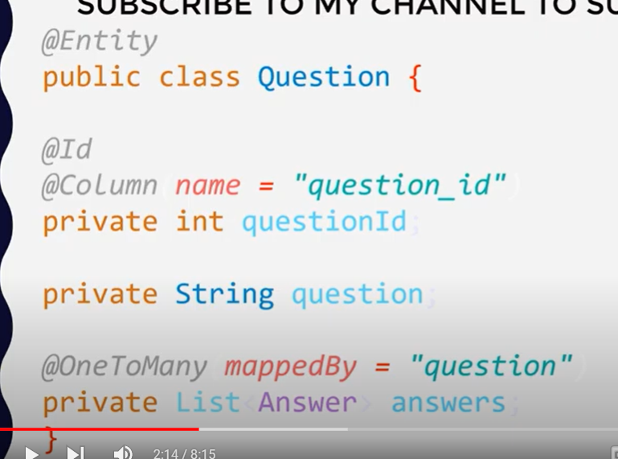

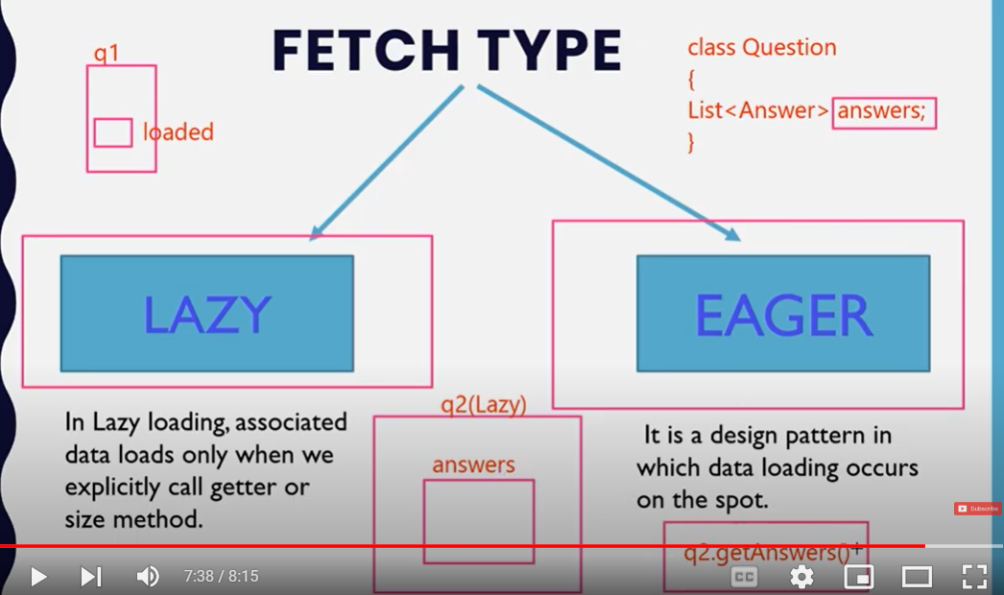

For ex: Question Answers ki example hai hamaray pass tw Eager mai question nikaltay hoa waqt ki saray answers load hojayengay eager mai answer get k time hi ayega answer.

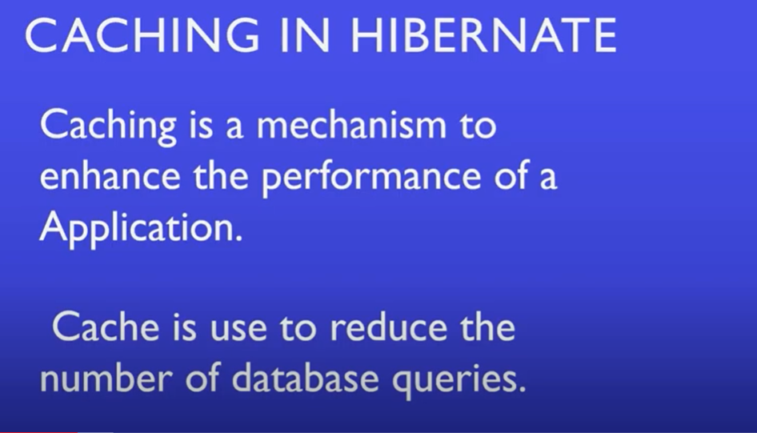

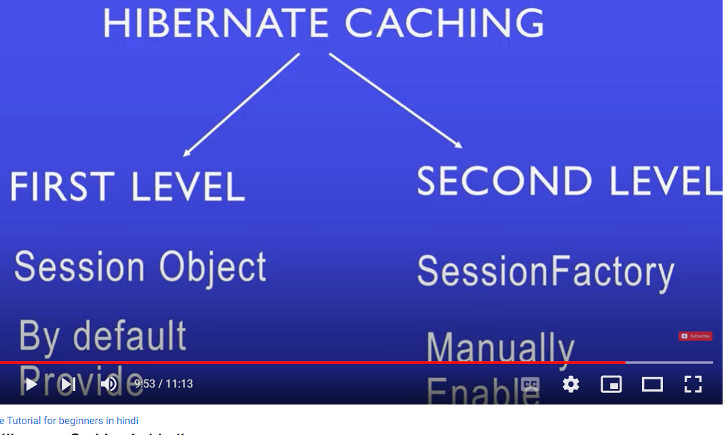

**First Level Cache**

Is mai first time wo query chalayega us k baad wo data session mai store hojayega next time phr wo session sai fetch karay ga same data session agar close kardia tw phr dobara query sai fetch hoga

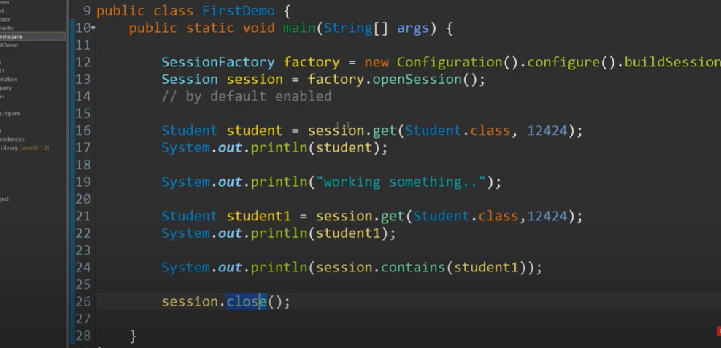

# Second Level Cache