DAY -1 May -14 2025

Mohammed Arsalain

Employee ID: 109890529

mobarsal@amazon.com

SDLC: Software Development life cycle

Task 1

**What is SDLC**: SDLC is a process that helps the production of software … SDLC is a Structured framework for a software development which will help in software product development from Scratch

Task 2

**WHY is SDLC**: It provides proper Framework of Stages, it helps in looking for project requirements, pre-requisites, planning, developing and releasing of software timely

Taking feedbacks as per client and making improvements to product

It helps in releasing software timely and cost can be reduced by following the Traditional/conventional Frameworks.

What are the stages of SDLC ?

**Stages** :

Planning & Requirement

Development (Coding/building phase)

Testing phase

Deployment

Maintenance

Task 4:

SDLC Models:

**SDLC Models :**

1. **Waterfall-** this is the Traditional and old model each phases will run sequentially one after other … less scope for changes ,less flexibility.

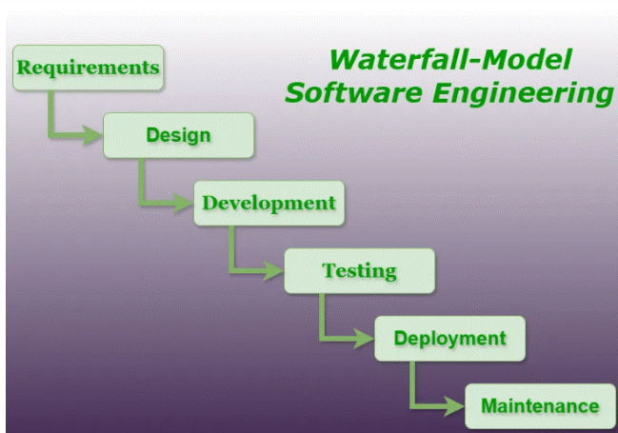

1. **Iterative-** This model works in iterative software development

Every iteration will add more software requirement . software will be built in smaller versions.

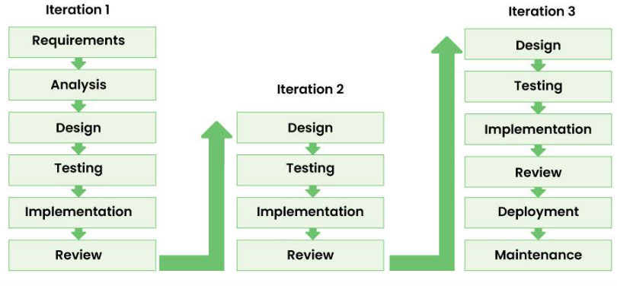

1. **Spiral --**It is based on the concept of a spiral, with each loop representing a phase in the software development process. The model is risk-driven, where the risk are addressed continousely.

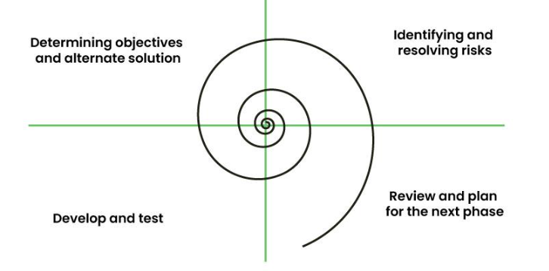

1. **V-Shaped –** In this model verification and validation phases run In parallel each phase of development has a testing .. model runs in V-shape

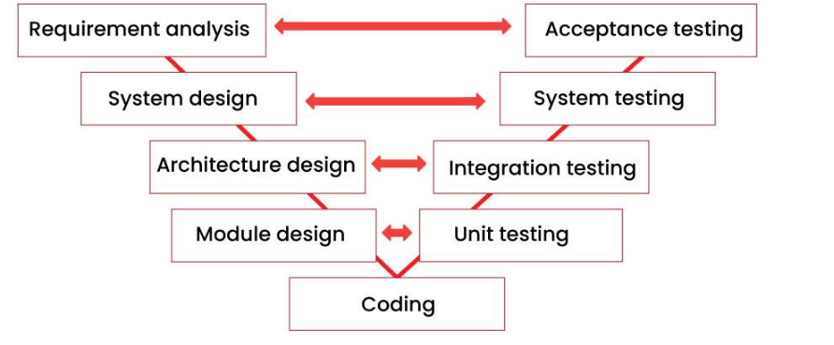

1. **Incremental—**This model divides the project into smaller and managebale parts  In these each part will goes through Requirement, Design, Testing phases and Implementation phase. The overall process continue until we got the complete System.

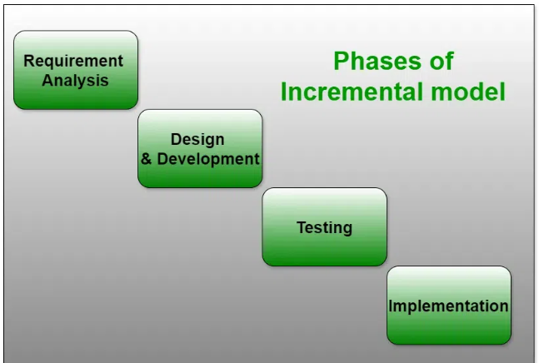

1. **Agile--**The agile methodology produces ongoing release cycles, each featuring small, incremental changes from the previous release. At each iteration, the product is tested. The agile model helps teams identify and address small issues in projects before they evolve into more significant problems. Teams can also engage business stakeholders and get their feedback throughout the development process.

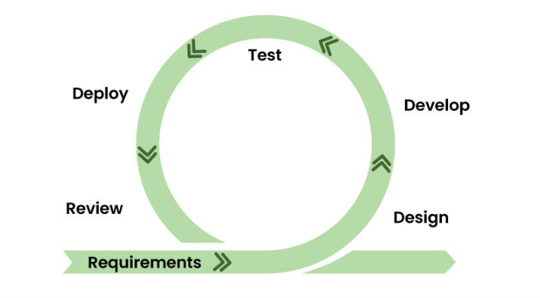

1. **RAD model--**Rapid Application Development is an iterative and incremental model that prioritizes quick development and iteration cycles. It places a strong emphasis on user feedback and involvement throughout the development process.

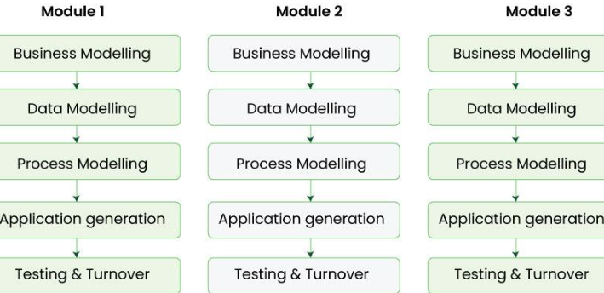

1. **Prototype model** – This model is used when the customers do not know the exact project requirements beforehand.In this model, a prototype of the end product is first developed, tested, and refined as per customer feedback repeatedly till a final acceptable prototype is achieved which forms the basis for developing the final product

* **LLT (Low-Level Testing):** Tests individual components, modules, or functionalities of the software.
* **HLT (High-Level Testing):** Tests the entire software application or product as a whole, verifying its overall functionality

Networking Concepts

Task 5:

What are the different Network types?

**Types of Netwrok :**

**1 PAN**

**2 LAN**

**3CAN**

**4 MAN**

**5 WAN**

Task 6:

What are the types of servers ?

**WHAT ARE THE TYPES OF SERVERS**

**1 Web servers:** Mail servers handle email communication, including sending, receiving, and storing emails.

**2 :Mail servers :** Mail servers handle email communication, including sending, receiving, and storing emails.

**3 : File servers:** File servers store and manage files for multiple users, making it easier to share and access data.

4: **Database servers:** These servers manage and store data in databases, allowing applications to access and process information.

5: **Application servers:** Application servers host and manage software applications, enabling users to access them remotely.

**6:** **Proxy servers:** Proxy servers act as intermediaries between clients and other servers, often filtering requests and improving security.

7: **Virtual servers:** These servers, such as virtual machines, are created within specialized software and offer flexibility and resource management.

Task 7:

This is Verbal task

What do you know about DNS? Domain Name System

8 : DNS server : These servers transform readable computer domain names into computer language IP addresses. The DNS server takes search data from a user and finds the requested address to deliver to the client device.

**Dns domain name system:**

**DNS translates domain name to IP address**

The Domain Name System (DNS) translates human-readable domain names (e.g., www.google.com) into machine-readable IP addresses (e.g., 142.250.190.14), enabling internet communication

* It enables computers to locate and communicate with each other on the internet.

Task 8

Task 8: what is TCP and UDP? What is the difference?

**What is TCP and UDP**

Transmission Control Protocol (TCP) is a connection-oriented protocol for communications that helps in the exchange of messages between different devices over a network. It is one of the main protocols of the TCP/IP suite. In OSI model, it operates at the transport layer(Layer 4). It lies between the Application and Network Layers which are used in providing reliable delivery services. The Internet Protocol (IP), which establishes the technique for sending data packets between computers, works with TCP.

**UDP**: User Datagram Protocol (UDP) is a Transport Layer protocol. UDP is a part of the Internet Protocol suite, referred to as UDP/IP suite. Unlike TCP, it is an unreliable and connectionless protocol. So, there is no need to establish a connection before data transfer. The UDP helps to establish low-latency and loss-tolerating connections over the network. The UDP enables process-to-process communication.

Task 9: What do you know about mac address ? What is the difference between Mac address and IP address.

Task 9: What do you know about mac address ? What is the difference between Mac address and IP address.

**MAC :** The MAC address is a device's physical address, which uniquely identifies it on a specific network. MAC is short for Media Access Control and is also referred to as a hardware address, physical address, or burned-in address (BIA). The MAC address works on the OSI model's data link layer. The Address Resolution Protocol (ARP), a layer 2 communication protocol, maps the MAC addresses to the IP (Internet Protocol) address.

The MAC is assigned to the Network Interface Card (NIC) of any device that can connect to the Internet. The vendor provides the number at the time of the device's manufacturer, and it's embedded in its NIC (hence the "burned in" description), which typically cannot be changed.

Task 10

**What is OSI: Open systems interconnections**

The OSI model is a set of rules that explains how different computer systems communicate over a network.

The layers of the Open Systems Interconnection (OSI) model encapsulate every type of network communication across both software and hardware components.

There are 7 layers in the OSI Model and each layer has its specific role

Physical Layer

Data Link Layer

Network Layer

Transport Layer

Session Layer

Presentation Layer

Application Layer

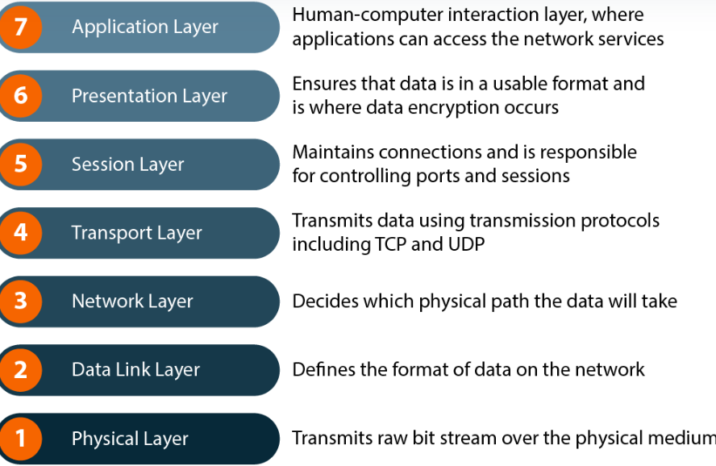

**Physical Layer** -- The physical layer refers to the physical communication medium and the technologies to transmit data across that medium

**Data Link Layer** --The data link layer refers to the technologies used to connect two machines across a network where the physical layer already exists. It manages data frames, which are digital signals encapsulated into data packets

**Network Layer** -- The network layer is concerned with concepts such as routing, forwarding, and addressing across a dispersed network or multiple connected networks of nodes or machines.

**Transport Layer** -- The primary focus of the transport layer is to ensure that data packets arrive in the right order, without losses or errors, or can be seamlessly recovered if required.

**Session Layer** -- The session layer is responsible for network coordination between two separate applications in a session. A session manages the beginning and ending of a one-to-one application connection and synchronization conflicts

**Presentation Layer** -- The presentation layer is primarily concerned with the syntax of the data itself for applications to send and consume. For example, Hypertext Markup Language (HTML), JavaScipt Object Notation (JSON), and Comma Separated Values (CSV) are all modeling languages to describe the structure of data at the presentation layer.

**Application Layer** --- The application layer is concerned with the specific type of application itself and its standardized communication methods. For example, browsers can communicate using HyperText Transfer Protocol Secure (HTTPS), and HTTP and email clients can communicate using POP3 (Post Office Protocol version 3) and SMTP (Simple Mail Transfer Protocol)

Task 11:

What is an IPv4 address? What are the different classes of IPv4?

An IPv4 address is a 32-bit numerical address used to identify devices on a network. These addresses are typically represented in a dotted decimal format, like 192.168.1.1, where each number represents a group of 8 bits (an octet). IPv4 addresses are divided into five classes (A, B, C, D, and E) based on their first octet, with each class having a different default subnet mask and intended usage.

An IPv4 address is 32-bits (232) in size. It was decided to split all of the available addresses into groups called classes. The idea was to make address allocation scalable.

IP address is divided into 5 classes -  class A, class B, and class C. Class D and E.

Classes of IPv4 Addresses:

**Class A**

IP addresses belonging to class A are assigned to the networks that contain a large number of hosts.

* The network ID is 8 bits long.
* The host ID is 24 bits long.

### Class B

IP address belonging to class B is assigned to networks that range from medium-sized to large-sized networks.

* The network ID is 16 bits long.
* The host ID is 16 bits long.

### Class C

IP addresses belonging to class C are assigned to small-sized networks.

* The network ID is 24 bits long.
* The host ID is 8 bits long.

### Class D

IP address belonging to class D is reserved for [multi-casting](https://www.geeksforgeeks.org/multicasting-in-computer-network/). The higher-order bits of the first octet of IP addresses belonging to class D is always set to 1110. The remaining bits are for the address that interested hosts recognize.

Class D does not possess any subnet mask. IP addresses belonging to class D range from 224.0.0.0 – 239.255.255.255

In simpler terms:

* **A, B, and C:** These are the most common classes used for public and private IP addresses, with A being the largest and C the smallest.
* **D:** Used for sending the same information to multiple computers on a network simultaneously.
* **E:** Reserved for experimental use

Task 13:

**What are the advantages of using VPN**

VPN primarily focused on privacy, security, and access to restricted content. It encrypts your internet traffic, masks your IP address, and can bypass geo-restrictions, all while enhancing your online safety.

### 1. Enhanced privacy

### 2. Improved security

### 5. Reduced activity-based bandwidth throttling

Different type of VPNs

Access VPN :

VPNs allow you to securely connect to a corporate network from anywhere, as if you were in the office

 site-to-site virtual private network (VPN) refers to a connection set up between multiple networks. This could be a corporate network where multiple offices work in conjunction with each other or a branch office network with a central office and multiple branch locations.

An intranet is a private computer network that uses Internet protocols, network connectivity to securely share part of an organization's information or operations with its employees. Sometimes the term refers only to the most visible service, the internal website.

An extranet is an organization's private network and its available only for selected users. It’s a way to connect to third parties like vendors, customers, and partners in a secure and controlled way. The users typically have a login mechanism such as username and password to access the network. Extranet in simple terms provides a secure network for an organization to share information with relevant people outside the organization. It is part of an organization's intranet divided via a firewall.

Task 14 👍

Node and link

a node represents a device or point within a network that can transmit, receive, or store data, while a link refers to the physical or virtual connection between two nodes.

Task 15:

Topology means

topology refers to the physical or logical arrangement of devices, nodes, and connections within a network. It describes how these components are interconnected and how data is transmitted between them

Task 16:

### different types of network topology

Netwrok topology is the way devices are connected in a network it defines how devices are connected and how data transferes between network

There are two major network topology

Physical ---- Physical Network Topology refers to the actual structure of the physical medium for the transmission of data

and Netwrok topology :

Logical network Topology refers to the transmission of data between devices present in the network irrespective of the way devices are connected

Types of Network topology :

**Point to Point Topology**

Point-to-point topology is a type of topology that works on the functionality of the sender and receiver.

**Mesh Topology mesh topology**

In a mesh topology, every device is connected to another device via a particular channel. Every device is connected to another via dedicated channels. These channels are known as links. In Mesh Topology, the protocols used are AHCP (Ad Hoc Configuration Protocols), [DHCP](https://www.geeksforgeeks.org/dynamic-host-configuration-protocol-dhcp/)(Dynamic Host Configuration Protocol), etc.

Star Topology star topology –

In Star Topology, all the devices are connected to a single hub through a cable. This hub is the central node and all other nodes are connected to the central node.

Bus Topology BUS topology

Bus Topology is a network type in which every computer and network device is connected to a single cable

Ring Topology Ring topology

In a Ring Topology, it forms a ring connecting devices with exactly two neighboring devices. A number of repeaters are used for Ring topology with a large number of nodes,

Tree Topology Tree topology

Tree topology is the variation of the Star topology. This topology has a hierarchical flow of data. In Tree Topology, protocols like [DHCP](https://www.geeksforgeeks.org/dynamic-host-configuration-protocol-dhcp/) and **SAC (Standard Automatic Configuration)**are used.

Hybrid Topology Hybrid topology

Hybrid topology is the combination of all the othe types of topologies

Hybrib topology is used when the nodes are free to take nay form

Task 17:

What is extended bus topology ? its Tree Topology.

What is the router and gateway

Task 18:

What is the use of a router and how is it different from a gateway?

A router is a device that forwards packets from one netwron to another when a packet comes in through one port , the router reads the address information on the packet and determines the right destination.

Gateway

A gateway is a device or hardware acts like a gate among the netwroks thus it can also be defined as node that acts as an entrance for the other nodes in the network . gateway is a device that is used for communication among the networks that have a different set of protocols and is responsible for the conversion of one protocol into the other

A router and a gateway are both network devices that facilitate communication between different parts of a network, but they have distinct roles. A router primarily handles data within similar networks, choosing the best path for data packets to travel. A gateway, on the other hand, connects dissimilar networks, often acting as a bridge between different protocols or formats.

Task 19

SMTP stands for Simple Mail Transfer Protocol.

SMTP stands for Simple Mail Transfer Protocol. It is a communication protocol used for sending and receiving email messages over the Internet. Mail servers and other message transfer agents (MTAs) use SMTP to send, receive and relay mail messages.

In the Simple Mail Transfer Protocol (SMTP) model, the sender's email client or server acts as the SMTP client, and the sender’s email server acts as the SMTP server. This client initiates a connection to the server and transmits the email, complete with recipient details, subject, and body. The server processes this email and determines the suitable next server based on the recipient's address. This next server could either be another SMTP server in the transmission route or the final destination, i.e., the recipient's email server. Once the message arrives at the recipient's server, it's delivered to the recipient's inbox using a different protocol, such as POP or IMAP.

Task 20:

# Difference Between OSI Model and TCP/IP Model

TCP/IP Model is a communication protocols suite using which network devices can be connected to the Internet. On the other hand, the OSI Model is a conceptual framework using which the functioning of a network can be described.

There is a separate layer for Data Link and Physical in the OSI Model, whereas the TCP/IP has a single Network Interface layer for the same. Similarly, there are Application, Presentation and Session layers in OSI, which are combined into one layer (Application) for TCP/IP

**TCP/ip**

The full form of TCP/IP is Transmission Control Protocol/ Internet Protocol.

It is a communication protocol that is based on standard protocols and allows the connection of hosts over a network.

It comprises of four layers:

Network Interface

Internet

Transport

Application

The TCP/IP is the implementation of the OSI Model.

It is protocol-dependent.

It follows a horizontal approach.

**OSI model**

The full form of OSI is Open Systems Interconnection.

It is a structured model which deals which the functioning of a network.

It comprises seven layers:

Physical

Data Link

Network

Transport

Session

Presentation

Application

It follows a vertical approach.

An OSI Model is a reference model, based on which a network is created.

It is protocol-independent.

**What is SRS (What is SRS (Software Requirement Specification)**

A software requirement specifications (SRS) document lists the requirements, expectations, design, and standards for a future project. These include the high-level business requirements dictating the goal of the project, end-user requirements and needs, and the product’s functionality in technical terms. To put it simply, an SRS provides a detailed description of how a software product should work and how your development team should make it work.

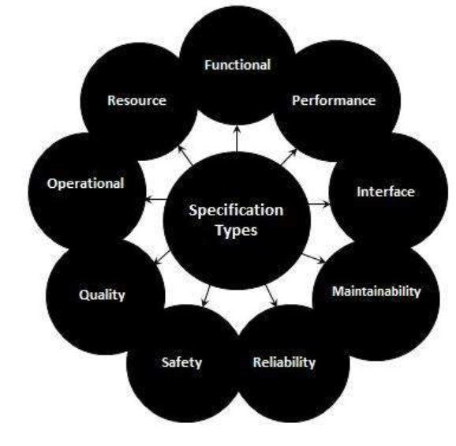

List Top SDLC tools.

Jira: This software is intended to make workflow management easier for a wide range of groups. Jira was created with the intention of being a simple system for recording tasks and errors. However, it has since matured into a robust workflow management solution.

Git is a distributed version management system that is open-source. Developers aiming to examine changes and contributions to the overall code might considerably benefit from a version control system or VCS. This software customisation management tool is an important part of the SDLC.

Confluence: During this stage, Confluence is a wonderful tool for developing product research docs and sharing design assets.

Asana: From daily activities to larger projects, Asana assists teams in orchestrating their work. Teams are more confident, move faster, and accomplish more with less when they use Asana, regardless of where they are based.

Git Hub Accounts

9pax have

27 pax have account as of now..

Add ons-

7. What is Software Configuration Management, and how does it work?

The process of tracking and regulating changes that occur during the software development lifecycle is known as software configuration management. Any modification made during the development of software must be tracked using a well-defined and controlled process. Any modifications performed during software development are regulated through a well-defined process, thanks to configuration management. Revision control and the establishment of baselines are two SCM procedures.

8. What do a Software Project Manager's responsibilities entail?

The Software Project Manager is in charge of seeing the project through to completion. The Software Project Manager is responsible for ensuring that the entire team follows a methodical and well-defined approach to software development. They also handle project planning, tracking project status, resource management, and risk management.

9. What do you know about Scrum impediments?

Obstacles or challenges that the scrum team faces slow down their work speed are referred to as impediments. An obstacle is anything that tries to prevent the scrum team from getting work "Done." Impediments can take many different forms. Some of the roadblocks include resource shortages or sick team members, technical, operational, and organisational issues, a lack of management support systems, and business issues.

10. Briefly explain Scrum methodology in the Agile model.

Scrum is an agile development approach based on iterative and incremental procedures that are used in the creation of software. It's an agile structure that's adaptable, rapid, flexible, and excellent at delivering value to customers throughout the project's development. Companies of all sizes employ the Agile Scrum technique because of its ability to provide high-end cooperation and efficiency for project-based work. Scrum is a sort of agile approach that breaks projects down into manageable parts known as "sprints." The Agile Scrum methodology is ideal for companies who need to complete projects fast.

11. What are Capability Maturity Model(CMM) levels?

Following are the five Capability Maturity Model Levels:

Initial: The first step is to create an unstable process environment. The software development process is considered haphazard and even chaotic at times. There are few methods that have been specified, and success is based on individual effort and heroism.

Repeatable: Work is planned and monitored, making it repeatable. To track cost, schedule, and functionality, basic project management techniques are implemented.

Defined: This level encompasses written and defined standards that evolve over time and support consistent performance. The work is well defined at this point.

Managed: Extensive data on the software development process and product quality are gathered. Both the software development process and the end products are quantified and managed.

Optimized: Work is based on continuous improvement (optimization). The focus on continuously improving process performance is a significant feature of this level.

12. What is Capability Maturity Model?

The Capability Maturity Model (CMM) is a cross-discipline and technical paradigm for facilitating and refining software development processes and system improvement. This methodology is at the heart of most management systems that aim to improve the quality of all product and service development and delivery.

13. What is Level-0 DFD?

Context Diagram is another name for DFD Level 0. It's a high-level overview of the entire system or process that's being studied or modelled. It's meant to be a quick peek into the system, displaying it as a single high-level process with its connections to external entities. Stakeholders, business analysts, data analysts, and developers should all be able to understand it readily.

14. How can DDLC and SDLC work together?

The DDLC (Documentation Development Life Cycle) is a software documentation development life cycle used by technical documenters to prepare software documentation. The life cycle is followed in tandem with the SDLC, as testers and developers work on the programme at the same time. Because the documentation requires input and feedback from the various phases of the SDLC, the DDLC has stages that are comparable to the SDLC.

15. What are different types of prototype model?

There are four types of Prototyping models:

Rapid Throwaway prototypes.

Evolutionary prototype.

Incremental prototype.

Extreme prototype.

16. What is FRS document?

This document captures the user's voice from the outside, or the end user's perspective. A Business System Analyst creates it (BSA). This paper demonstrates how a system will react when a user interacts with it in order to meet the BRD and SRD standards. The key area of interest for software experts is the Functional Requirement Specification (FRS). An FRS is useful for software testers to learn the situations in which the product is intended to be tested, just as it is for developers to understand what product they are planning to produce. An FRS's ultimate purpose is to meet all of the requirements outlined in the SRS and BRS regulations.

17. What is the Software release process?

The Software Development Life Cycle (SDLC) release phase is historically connected with production, deployment, and post-production operations, which generally include software maintenance and support. So, release management is the process of managing, planning, scheduling, and controlling a full software development at every stage and environment, including testing and releasing software releases.

18. What is the use of JAD session?

JAD is a strategy for defining business system requirements that are commonly utilised in the early phases of a systems development project. JAD's goal is to bring MIS and end-users together in a structured workshop setting in order to extract outcome system needs. It allows clients and developers to swiftly agree on a project's fundamental scope, objectives, and specifications

SDLC MCQ

1.

A feasibility study using the SDLC model is conducted to

determine whether or not the project is technically possible

determine whether the proposal is financially viable

Both a and b

None of the above

2.

A well-documented life cycle model aids in the detection of what during the development phase?

Inconsistencies

Redundancies

Omission

All of the above

3.

How many lines of code does the Build & Fix Model suit for programming exercises?

100-200

300-400

600-700

Above 800+

4.

In which life cycle does regression testing play a significant role?

Waterfall model

V model

Iterative model

All of the above

5.

What determines if the project should go forward?

feasibility assessment

opportunity identification

system evaluation

program specification

6.

What is the most significant disadvantage of employing the RAD Model?

Developers/designers that are highly specialized and skilled are required.

Component reusability is improved.

Encourages client/customer input.

Increases component reusability.

7.

Which of the following developmental models is incremental?

Prototyping, V model, Agile

Prototyping, RAD, Agile, RUP

Prototyping, V model, RAD, Agile, RUP

All of the above

8.

Which of the following is an Agile development characteristic?

Shared code ownership

Test-Driven Development

Implement the simplest solution to meet today's problem

Continual feedback from customer

All of the above

9.

Which of the following steps in the SDLC framework are valid?

Requirement Gathering

Software Design

System Analysis

All of the above

10.

Who is in charge of system development, staffing, budgeting, and reporting, as well as ensuring that deadlines are met?

Project managers

Network engineers

Graphic designers

Systems analysts