Day 5 - 28th May 2025

Mohammed Arsalain

Employee ID: 109890529

Email id : mobarsal@amazon.com

Operating System Fundamentals

Linux

Linux Fundamentals

Linux Basics , Introduction to System Access and File System, Linux Command Syntax, Files and Directory Permissions (chmod), File Permissions Using Numeric Mode, File Ownership Commands (chown, chgrp), Access Control List (ACL), Help Commands, TAB Completion and Up Arrow Keys, Adding Text to Files, Input and Output Redirects (>, >>, <, stdin, stdout and stderr), Standard Output to a File (tee command), Pipes ( | ), File Maintenance Commands (cp, rm, mv, mkdir, rmdir), File Display Commands (cat, less, more, head, tail), Filters / Text Processing Commands, cut - Text Processors Commands, awk - Text Processors Commands, grep/egrep - Text Processors Commands, sort/uniq - Text Processors Commands, wc - Text Processors Commands, Compare Files (diff and cmp), Compress and uncompress (tar, gzip, gunzip), Truncate File Size (truncate), Combining and Splitting Files, Basics of System Administration & Networking

To check if linux is installed in your windows 👍

Go to cmd and type  wsl –version

Plz check power shell type

Wsl –version

If not installed try to use below linux..

In cmd:

wsl

Install linux

<https://learn.microsoft.com/en-us/linux/install>

Task 1:

Create a Directory with the Name Linux Practice.

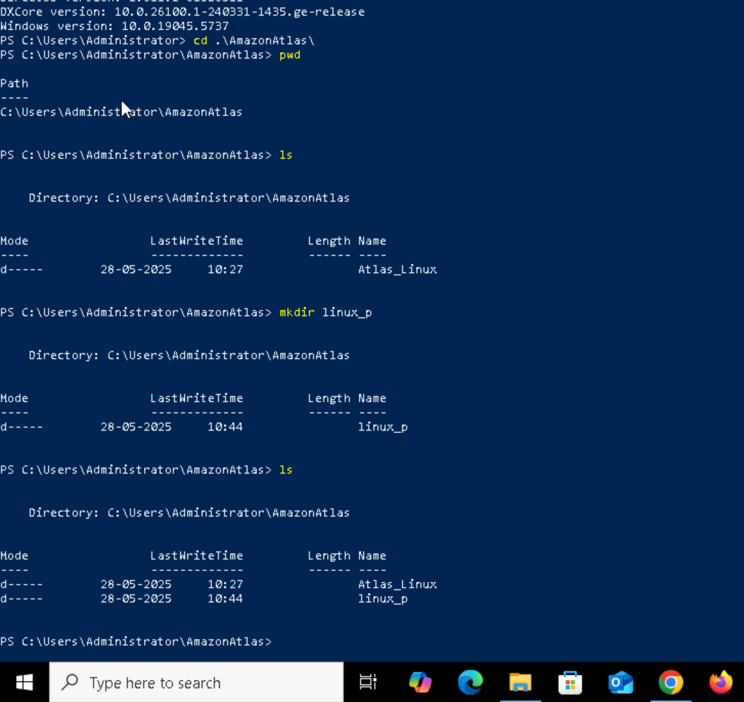

Task2:

Change to the directory

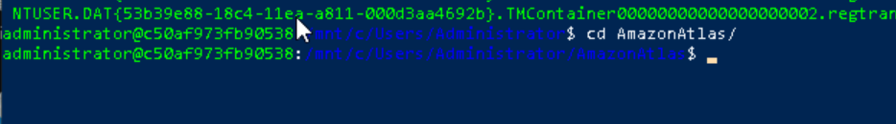

2 min

Task 3:

Create a file names TestFile1.txt and add the content to it.



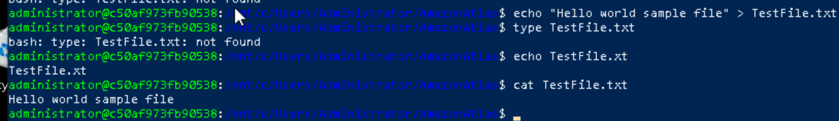

5 min

x

Task 4:

Create a Folder named Dummy and try to delete it.

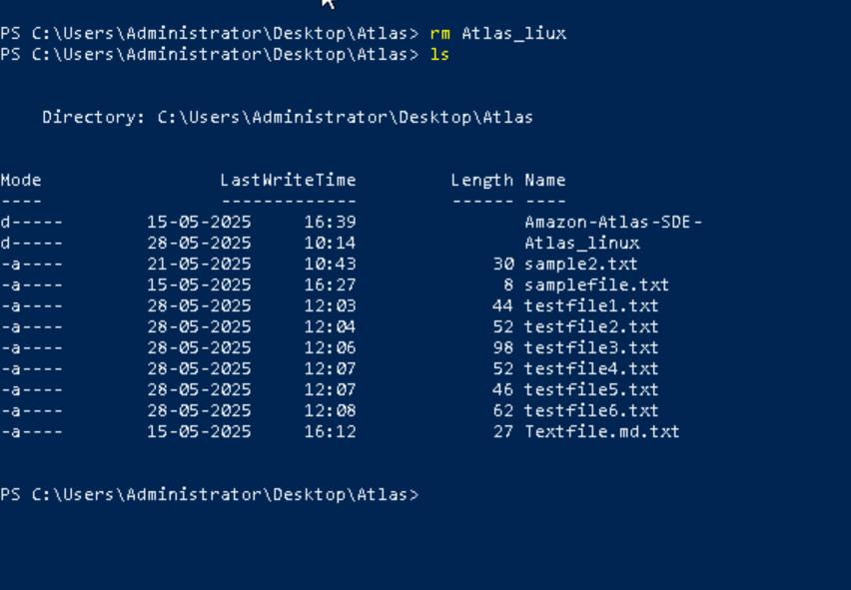

Task 5: Plz check the working directory (Hint : pwd)

2 mi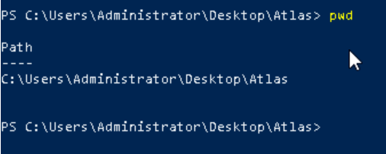n

Task 6:

How do you check all the files and directories in the directory you are in?

& Task 7:

Create five files named TestFile2.txt.. TestFile3.txt… and so on

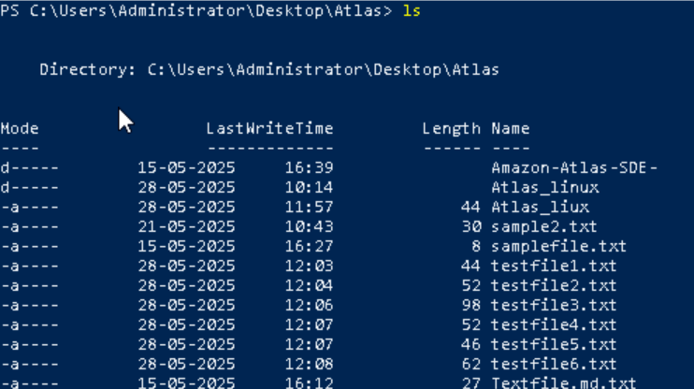

Task 8:

Copy all files from Dir 1 ti Dir 2



Task 10 : Can you plz show me the diff between **rm** and **rmdir** commands with screen shots ?

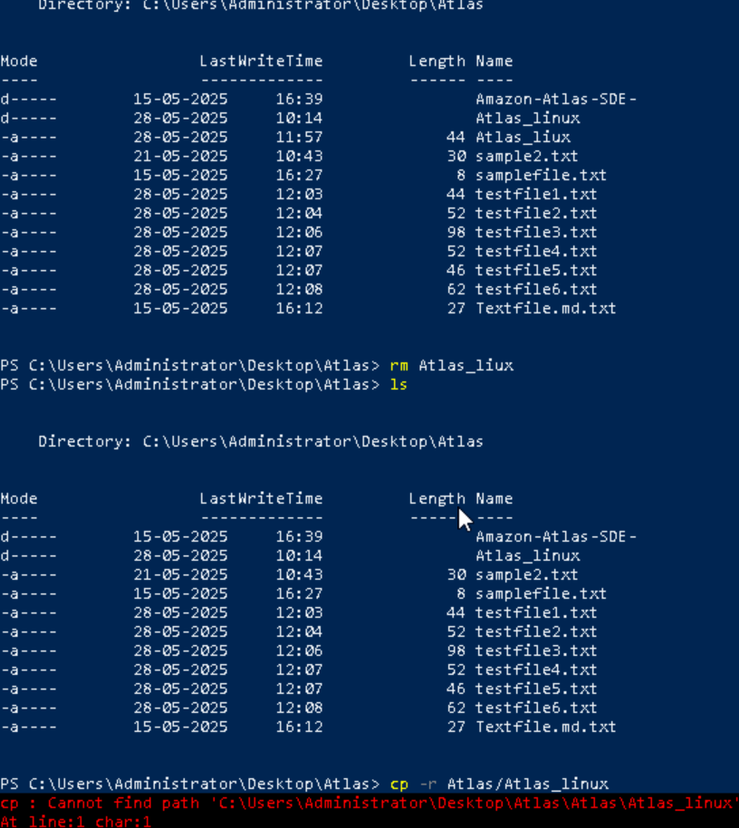

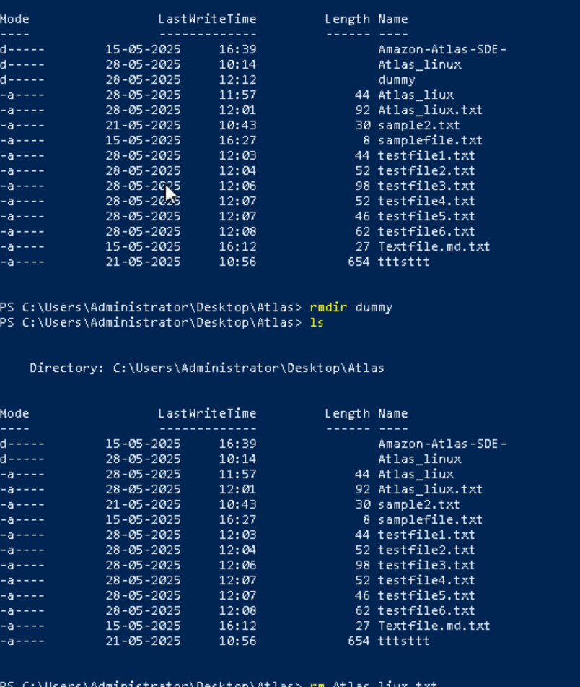

—------------------------------------------commands  to work in linux —----------------------------------------

Now use specifically use cat command to create a file  


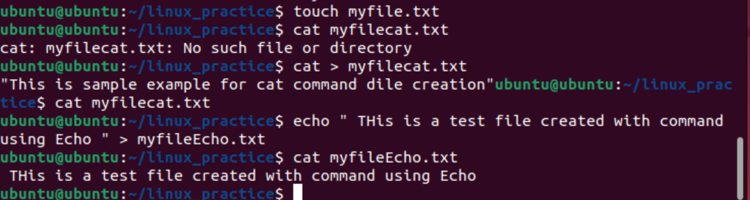

How to get only Top part of the file

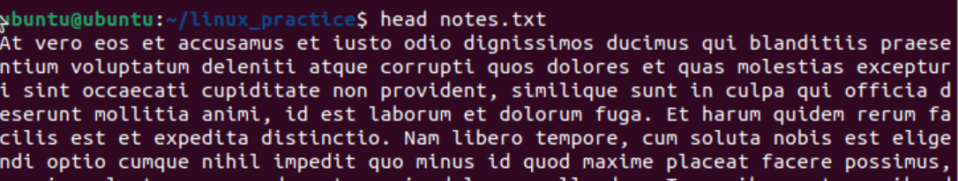

How to get tail of the file

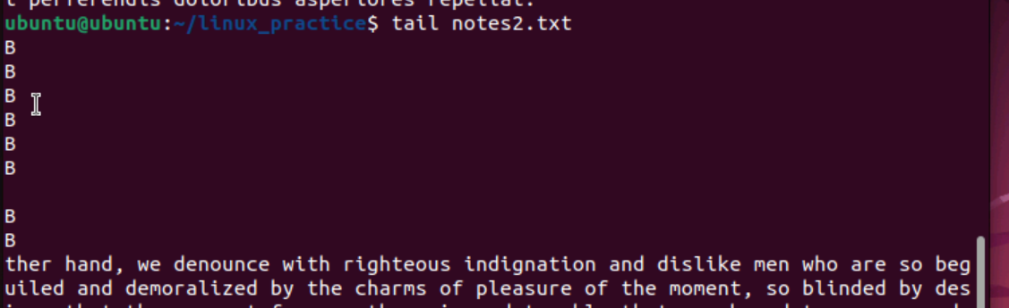

Task 14:

Plz add dummy text of 5 to 6 pages in to the same file

And

Now show the file in page by page

Task 15:

Use more command on the above file and find out the diff between less command and more command.

In Linux, both more and less are used to display text files, especially large ones, one screen at a time. However, less offers more features than more. Specifically, less allows both forward and backward scrolling, searching within the file, and jumping to the beginning or end of the file, while more only allows forward scrolling and limited backward navigation. Additionally, less does not load the entire file into memory before displaying it, making it faster to start up with large files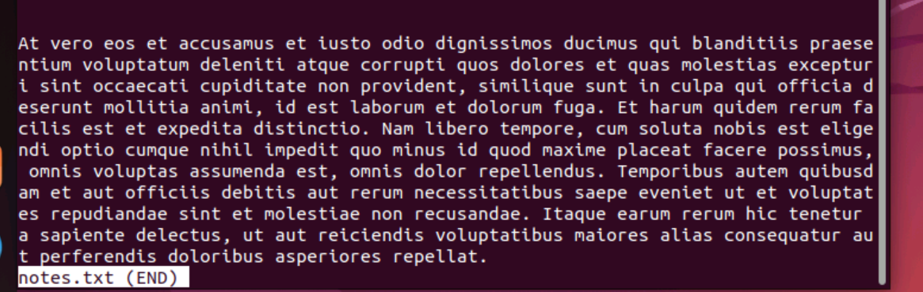

Can you use echo command with -e and see the diff.. Also take a ss and paste .

The e in the echo command is an option that enables the interpretation of backslash escape sequences. These sequences allow you to insert special characters and formatting into the output.

Whith echo -e the line will break \n

Withut echo -e \n will be considered as plain text

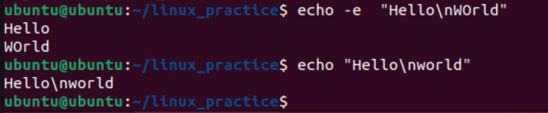

What is diff between ls and ls -l command ..

Ls – list all the documents

Ls-l list all the documents with detailed info like permisisions , number of links owners , last modified date and file size file directory name ,

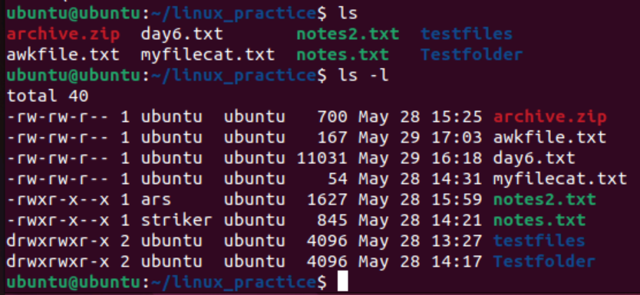

Create  a file using **touch** command , **cat** command and **echo** command and take ss (screen shot)..



Touch : create a empty file

Cat : first creates a file then we can enter the text manually after that ctr+d to save file

Echo : we can create file and write date in one line

Task 19:

Can you guys try to display the calendar by using a command..

Hint: use cal

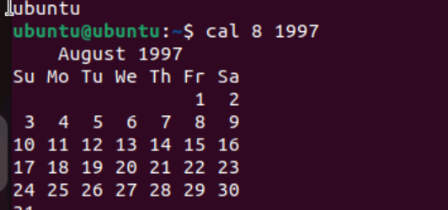

Task 20:

Can you go back to 1 directory .. at a time  whats the command

Cd . .

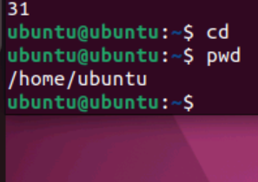

Task 21:

How to know whose user u are working on ?

Hint: use whoami command

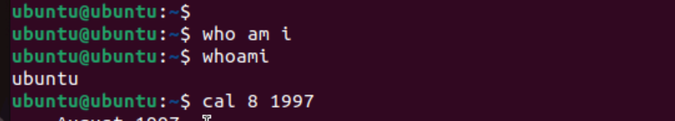

Task 22:

Try to find out who is peeping into your system..

Use users, who and w commands with ss

Try to find out who is peeping into your system..

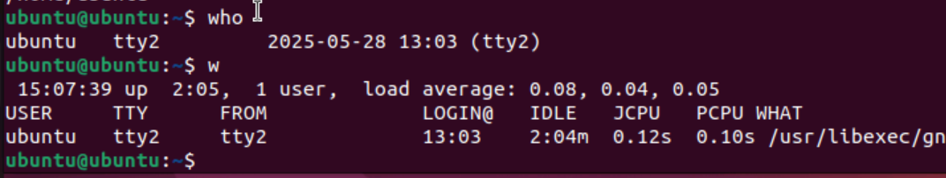

Task 24:

Can you plz try using the below commands

|  |  |
| --- | --- |
| **Prefix** | **Description** |
| **-** | **Regular file**, such as an ASCII text file, binary executable, or hard link. |
| **b** | **Block special file**. Block input/output device file such as a physical hard drive. |
| **c** | **Character special file**. Raw input/output device file such as a physical hard drive. |
| **d** | **Directory** which contains a listing of other files and directories. |
| **l** | **Symbolic link file**. Links on any regular file. |
| **p** | **Named pipe**. A mechanism for interprocess communications. |
| **s** | **Socket** which is used for interprocess communication. |

Disc space

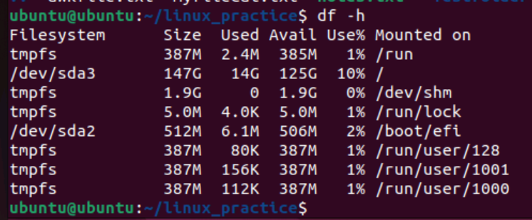

Task 25:

Find the list pf all files ending with .txt

Hint : use * in ls

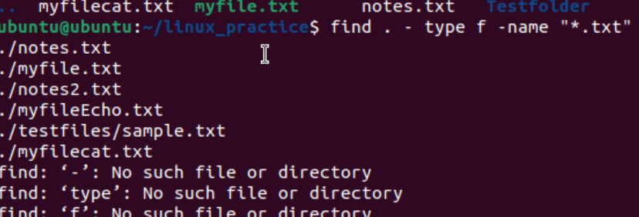

Task 26:

In Linux all the hidden files starts with . (period)

How to check all the hidden files in Linux..

Hint : use  ls -a

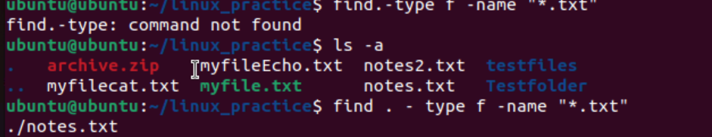

What is the difference between . and .. in linux

. represents the present directory

While .. represenst the parent directory

Eg cd . : present working directory

Cd .. : parent directory of the present working directory

How to find the no of words in the file

Hint: use wc

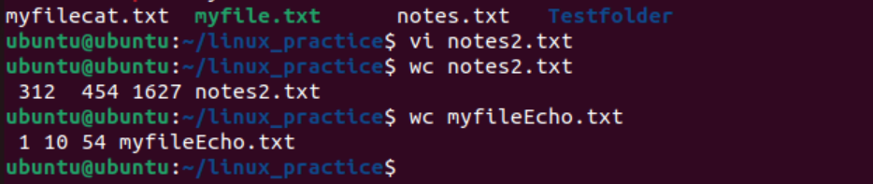

What is the use of cat -b myfilename.txt command?

cat -b displays the contents of a file with line numbers, but only for non-empty lines. This means that blank lines will not be numbered. The cat command is a versatile tool for viewing, combining, and manipulating file contents

Can I use the wc with 2 or more files? Yes

How to copy content of one file to another file

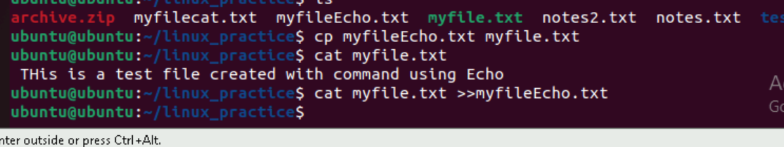

Now I want to rename my file with MYFILENEW can i do that if so how ?

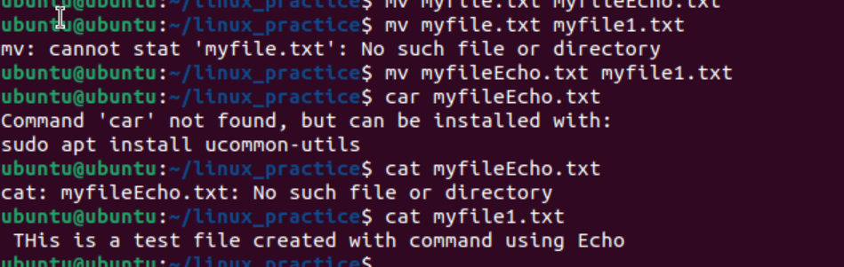

Task 34:

Can i remove or delete multiple files in linux..? How?

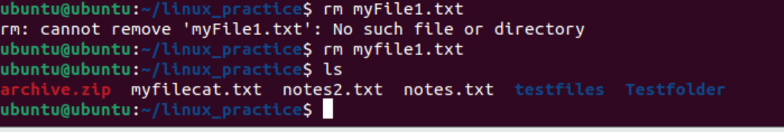

What is the way go go to home directory ?

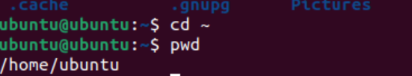

Task 37:

If i want to move to different users home directory

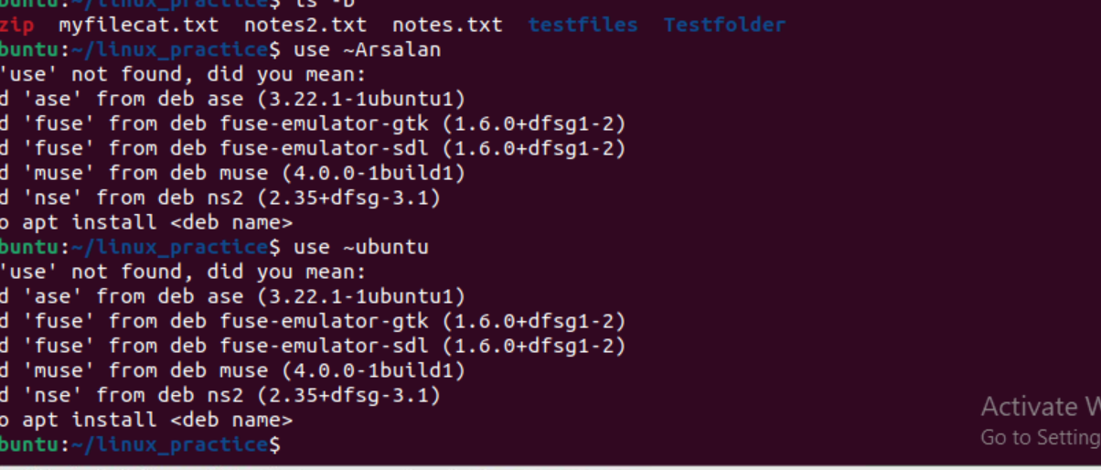

Basic Navigation & File Operations:

* cd: Change directory.
* pwd: Print working directory.
* ls: List directory contents.
* mkdir: Create a new directory.
* rmdir: Remove an empty directory.
* rm: Remove files or directories.
* cp: Copy files or directories.
* mv: Move or rename files or directories.
* touch: Create an empty file.

File Content Management:

* cat: Concatenate and display the contents of a file.
* head: Display the first part of a file.
* tail: Display the last part of a file.
* less: Display file contents, page by page.
* more: Display file contents, page by page.

System Information & Utility:

* uname: Print system information.
* whoami: Display the current user's name.
* date: Display the current date and time.
* cal: Display the calendar for a specified month or year.
* df: Display disk space usage.
* du: Display disk space usage for a specific directory.
* top: Display real-time processor activity.
* man: Access the command manual.
* grep: Search for patterns within files.
* echo: Print text to the terminal.

Other Useful Commands:

* sudo: Execute a command with superuser privileges.
* chmod: Change file permissions.
* chown: Change file ownership.
* tar: Create archives.
* gzip: Compress or decompress files.
* unzip: Unzip archives.
* zip: Create zip archives.