Day 12 -25th June
Mohammed Arsalain
mobarsal@amazon.com
Data Structures

Data structures in Java.docx in docs to study

A ===> how the character A is stored?

A ====> ASCII = American Standard code for information interchange value 65 ====> binary code

ASCII values are given === by ASNI === American Standard National Institute

Special before 65

A ===> 65 …. 66 = B…..

Small characters … 97 = a. 98 = b

A
65 ===> binary code?

65 / 2 == 1
32 / 2 == 0
16 / 2 == 0
8 / 2 == 0
4 / 2 == 0
2 / 2 == 0
1 / 2 == 1
What is the binary 8 bit representation of A?
2 min

The binary representation of the decimal number 65 is 1000001.

Task 2:
What is the binary value of a?
2min

Hint ascii value is 97..

Task 3

Types of Computer memory with examples.. Explain ..

Types of Computer Memory
Cache Memory: This temporary storage area, known as a cache, is more readily available to the processor than the computer's main memory source. It is also called CPU memory because it is typically integrated directly into the CPU chip or placed on a separate chip with a bus interconnect with the CPU.
RAM: It is one of the parts of the Main memory, also famously known as Read Write Memory. Random Access memory is present on the motherboard and the computer’s data is temporarily stored in RAM. As the name says, RAM can help in both Read and write.
D RAM (Dynamic RAM): D RAM uses capacitors and transistors and stores the data as a charge on the capacitors. They contain thousands of memory cells. It needs refreshing of charge on capacitor after a few milliseconds. This memory is slower than S RAM.
S RAM (Static RAM): S RAM uses transistors and the circuits of this memory are capable of retaining their state as long as the power is applied. This memory consists of the number of flip flops with each flip flop storing 1 bit. It has less access time and hence, it is faster.
ROM: ROM full form is Read Only Memory. ROM is a non volatile memory and it is used to store important information which is used to operate the system. We can only read the programs and data stored on it and can not modify of delete it.
MROM(Masked ROM): Hard-wired devices with a pre-programmed collection of data or instructions were the first ROMs. Masked ROMs are a type of low-cost ROM that works in this way.
PROM (Programmable Read Only Memory): This read-only memory is modifiable once by the user. The user purchases a blank PROM and uses a PROM program to put the required contents into the PROM. Its content can’t be erased once written.
EPROM (Erasable Programmable Read Only Memory): EPROM is an extension to PROM where you can erase the content of ROM by exposing it to Ultraviolet rays for nearly 40 minutes.
EEPROM (Electrically Erasable Programmable Read Only Memory): Here the written contents can be erased electrically. You can delete and reprogram EEPROM up to 10,000 times. Erasing and programming take very little time, i.e., nearly 4 -10ms(milliseconds). Any area in an EEPROM can be wiped and programmed selectively.
Virtual memory: A memory management technique where secondary memory can be used as if it were a part of the main memory. Virtual memory uses hardware and software to enable a computer to compensate for physical memory shortages by temporarily transferring data from RAM to disk storage.

Task 4:

What you do understand by data structures..?

Data structure is a way to store and organize the data so that it can be used efficiently
Data structure is a way of organizing all data items and relationship to each other

Task 5:

What are the operations on data structures ?

Data structure operations :

- Insertaion
- Deleting
- Sorting
- Searching
- Merging
- Traversing

Task 6:

What are static and dynamic arrays key points summarize in a table
Static array Dynamic array
1 Fixed size at creation 1 can resize( increment or decrement) dynamically
2 Contagious memory at compile 2 Allocated heam memory at runtime
Time
Int [] arr = new int[] ArrayList<Integer> list = new ArrayList<>();
Support primitive data type object supports objects only (Integer not int)
0(1) for index access
Manual efforts for changing wasy with add(), remove()
Fixed size flexible size , easier to manage and modify data

Task 7:

Reverse an array. write a code.

11.59 to 12.02

Hint : take a list of nos and display in reverse order..

Task 8:

Reverse a string .. write a code.

12.03 to 12.06

Hint: take a name from the user and display the name in reverse order..

Task 9:

Leetcode and Hackerrank … accounts ..

By Zain – link given for practice

AlgoMaster.io - Master Software Engineering Interviews

10 pax have the above accounts … out of 25 pax..

Task 10:

public class Example {
public static void main (String[] args) {
int[] arr1 = {11, 34, 66, 75};
int n1 = arr1.length;
int[] arr2 = {1, 5, 19, 50, 89, 100};
int n2 = arr2.length;
int[] merge = new int[n1 + n2];
int i = 0, j = 0, k = 0, x;
System.out.print("Array 1: ");
for (x = 0; x < n1; x++)
System.out.print(arr1[x] + " ");
System.out.print("\nArray 2: ");
for (x = 0; x < n2; x++)
System.out.print(arr2[x] + " ");
while (i < n1 && j < n2) {
if (arr1[i] < arr2[j])
merge[k++] = arr1[i++];
else
merge[k++] = arr2[j++];
}
while (i < n1)
merge[k++] = arr1[i++];
while (j < n2)
merge[k++] = arr2[j++];
System.out.print("\nArray after merging: ");
for (x = 0; x < n1 + n2; x++)
System.out.print(merge[x] + " ");
}
}

12.11 to 12.15 to 12.17

This code is merging two sorted arrays into a single sorted array
Task 11:

What do you know about hash table?

12. 18 to 12. 22

Task 12:

Wap to create a hash table and display them..

Hint 👍

Import java.util.Hashtable;
Import java.util.Map;

12.39 to 12.44

import java.util.Hashtable;
import java.util.Map;

public class Task012_DS_HashTable {
public static void main(String[] args) {
Hashtable<String, Integer> ht = new Hashtable<>();
ht.put("Anitha", 101);
ht.put("Kavitha", 102);
ht.put("Meera", 103);

for (Map.Entry<String, Integer> e : ht.entrySet())
System.out.println(e.getKey() + " " + e.getValue());
}
}

// Map is an interface

// hash table --> slower , sync , thread safe, no null value accepted

// hash map --> faster while retrieving, asynchro , only one null key and multiple null values..

Task 16:

Methods of Hash table plz list them..

==================================================

hsjh
- put(K key, V value): Inserts a key-value mapping into the Hashtable. If the key already exists, the old value is replaced with the new one.

- get(Object key): Returns the value associated with the specified key. Returns null if the key is not found.

- remove(Object key): Removes the key-value mapping for the specified key from the Hashtable.

- containsKey(Object key): Returns true if the Hashtable contains a mapping for the specified key, otherwise returns false.

- containsValue(Object value): Returns true if the Hashtable maps one or more keys to the specified value, otherwise returns false.

- isEmpty(): Returns true if the Hashtable contains no key-value mappings, otherwise returns false.

- size(): Returns the number of key-value mappings in the Hashtable.

- clear(): Removes all key-value mappings from the Hashtable.

- keySet(): Returns a Set view of the keys contained in the Hashtable.

- values(): Returns a Collection view of the values contained in the Hashtable.

- entrySet(): Returns a Set view of the key-value mappings contained in the Hashtable.

- rehash(): Increases the size of the Hashtable and rehashes all of its keys. This method is protected and typically handled internally by the Hashtable for performance optimization.

- clone(): Returns a shallow copy of the Hashtable instance.

Explain the internal working of a HashMap. With diagram..
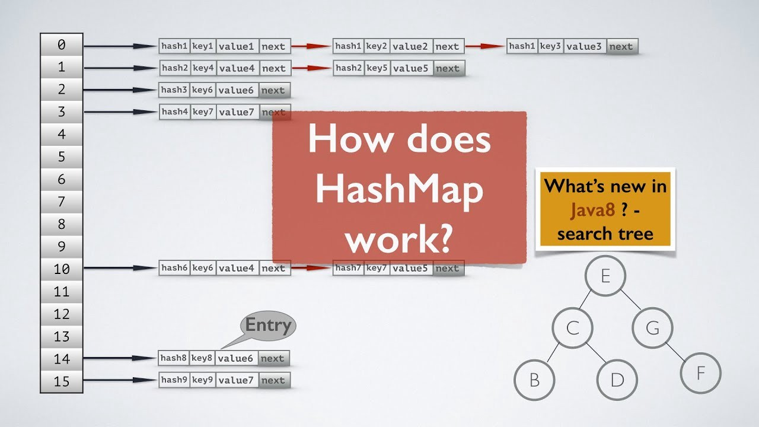

A hashmap uses a hashtable, however, it is internally implemented using two data structures namely an array and a linked list
Whenever you declare a hashmap, internally, it will create an array of buckets. The buckets are referred to as nodes or you can say a linked list. A node can represent :
- Hashcode
- Key
- Value
- Address of the next node
Now, when you insert values in a key using put() method of the HashMap class, the hashcode will be generated by the put() method. Hashcode makes the process of receiving values faster and easier. And this hashcode is further computed and it will generate the index for storing the value.

The value of our key will be stored at the index given by the hashcode in the form of a Linked list.

To make retrieval of the key-value pairs more efficient,

- hashCode():
This method, part of the Object class (and overridden by many classes, including String), is crucial for HashMap. It generates an integer value (hash code) from a key object. This hash code is used to determine which "bucket" in the HashMap's internal array the key-value pair will be stored in.
- key:
The key is the unique identifier you use to store and retrieve values in the HashMap. It must be an object, and it's important that the hashCode() and equals() methods are properly implemented for the key's class. If two keys are considered equal (using the equals() method), their hashCode() values should also be equal. This ensures consistent behavior when retrieving values.
- value:
The value is the data you want to store and retrieve. It can be any object type, including primitives (using their wrapper classes, like Integer for int). A HashMap can hold null keys (only one) and multiple null values.
- next:
In case of a collision (where two different keys produce the same hash code), the HashMap uses a linked list to store multiple key-value pairs in the same bucket. The next field in each Entry (representing a key-value pair) points to the next Entry in the linked list. This allows the HashMap to efficiently handle collisions and maintain its performance.

Home task:

Do hash table have linked list internally? yes

Do collisions occur in hash Maps? What are they?

Collision in a HashMap :

A Hash Collision is a situation where for two or more distinct records, the hash function returns the same bucket position in the HashTable. This is the main disadvantage of using hashmap.

HashMap uses these two methods to handle collision:

Separate Chaining
Open Addressing

Data Structures used for Separate Chaining are -

Linked List
Self Balancing Binary Search Tree
Dynamic Sized Array

In chaining, all key-value pairs mapping to the same index will be stored in the linked list of that index. Similarly, binary search trees can also be used for chaining.

Task 20:

How many methods are there to create a hash Map?

Task020_DS_HashMapCreateMethods:

Different methods to create a hashmap in java :
1) Constructing a hashmap with default capacity

ex:
HashMap<String, Integer> hm1 = new HashMap<String, Integer>();

2) Constructing a hashmap with a capacity 10

ex:
HashMap<String, Integer> hm2 = new HashMap<String, Integer>(10);

3)copy one map to another map

ex:
HashMap<String, Integer> hm3 = new HashMap<String, Integer>( hm2);

4)
Specifying load factor along with the capacity

ex:
HashMap<String, Integer> hm4= new HashMap<String, Integer>(10, 0.75f);
Initial capacity ===10
Load factor === 0.75f

Task 21:

Wap to make a Hashmap synchronized..

Plz note : Hash Map are - asynchronous in nature..

import java.util.Collections;
import java.util.HashMap;
import java.util.Map;

public class task021_DS_HashMap_SyncMap {
public static void main(String[] args) {
HashMap<String, Integer> Hm1 = new HashMap<String, Integer>();
Map<String, Integer> syncMap = Collections.synchronizedMap(Hm1);
}
}

$$$$$$$$$$$$$$$$$$$$$$$$$$$$$$$$$$$$$$$$$$$$$$$$$$$$$$$$$$$$$$$$$$$$$$$$$$$$
Home Tasks:
$$$$$$$$$$$$$$$$$$$$$$$$$$$$$$$$$$$$$$$$$$$$$$$$$$$$$$$$$$$$$$$$$$$$$$$$$$$$

Do hash table have linked list internally?

Do collisions occur in hash Maps? What are they?

What is load factor and how the capacity increases?

Slide 21 ppt – plz work on it..

Map and set

https://leetcode.com/problems/design-hashmap/description/
Leet code :

Add on:

Hash Table - Linear Probing

import java.util.Scanner;
class LinearProbingHashTable {
private int currentSize, maxSize;
private String[] keys;
private String[] vals;

public LinearProbingHashTable(int capacity) {
currentSize = 0;
maxSize = capacity;
keys = new String[maxSize];
vals = new String[maxSize];
}

public void makeEmpty() {
currentSize = 0;
keys = new String[maxSize];
vals = new String[maxSize];
}

public int getSize() {
return currentSize;
}

public boolean isFull() {
return currentSize == maxSize;
}

public boolean isEmpty() {
return getSize() == 0;
}

public boolean contains(String key) {
return get(key) != null;
}

private int hash(String key) {
return key.hashCode() % maxSize;
}

public void insert(String key, String val) {
int tmp = hash(key);
int i = tmp;
do {
if (keys[i] == null) {
keys[i] = key;
vals[i] = val;
currentSize++;
return;
}
if (keys[i].equals(key)) {
vals[i] = val;
return;
}
i = (i + 1) % maxSize;
} while (i != tmp);
}

public String get(String key) {
int i = hash(key);
while (keys[i] != null)
{
if (keys[i].equals(key))
return vals[i];
i = (i + 1) % maxSize;
}
return null;
}

public void remove(String key) {
if (!contains(key))
return;

int i = hash(key);
while (!key.equals(keys[i]))
i = (i + 1) % maxSize;
keys[i] = vals[i] = null;

for (i = (i + 1) % maxSize; keys[i] != null; i = (i + 1) % maxSize) {
String tmp1 = keys[i], tmp2 = vals[i];
keys[i] = vals[i] = null;
currentSize--;
insert(tmp1, tmp2);
}
currentSize--;
}

public void printHashTable() {
System.out.println("\nHash Table: ");
for (int i = 0; i < maxSize; i++)
if (keys[i] != null)
System.out.println(keys[i] +" "+ vals[i]);
System.out.println();
}
}

public class LinearProbingHashTableTest {
public static void main(String[] args) {
Scanner scan = new Scanner(System.in);
System.out.println("Hash Table Test\n\n");
System.out.println("Enter size");

LinearProbingHashTable lpht = new LinearProbingHashTable(scan.nextInt() );

char ch;

do {
System.out.println("\nHash Table Operations\n");
System.out.println("1. insert ");
System.out.println("2. remove");
System.out.println("3. get");
System.out.println("4. clear");
System.out.println("5. size");

int choice = scan.nextInt();
switch (choice) {
case 1 :
System.out.println("Enter key and value");
lpht.insert(scan.next(), scan.next() );
break;
case 2 :
System.out.println("Enter key");
lpht.remove( scan.next() );
break;
case 3 :
System.out.println("Enter key");
System.out.println("Value = "+ lpht.get( scan.next() ));
break;
case 4 :
lpht.makeEmpty();
System.out.println("Hash Table Cleared\n");
break;
case 5 :
System.out.println("Size = "+ lpht.getSize() );
break;
default :
System.out.println("Wrong Entry \n ");
break;
}

lpht.printHashTable();

System.out.println("\nDo you want to continue (Type y or n) \n");
ch = scan.next().charAt(0);
} while (ch == 'Y'|| ch == 'y');
}
}

