Day15
3rd July 2025
Mohammed Arsalain
mobarsal@amazon.com
Task 1:

Create a node for a tree and include a constructor (empty)

Hint 👍
A node which consists of 1 data part and 2 refs ( 1 Left ref and another right ref)

Solution:

class TreeNode {
int value;
TreeNode left, right;

TreeNode(int item) {
value = item;
left = right = null;
}
}

Task 2:

Create a class named Binarty Search tree in which you have 2 insert operations

1 insert —----> for inserting if the tree is empty
1 insert —----> for inserting if the tree has 1 or more nodes

11.40 to 11.45

TreeNode insertVal(TreeNode node, int value) {
if (node == null) {
node = new TreeNode(value);
return node;
}
if (value < node.value) {
node.left = insertVal(node.left, value);
} else if (value > node.value) {
node.right = insertVal(node.right, value);
}
return node;
}

HOme Tasks:
Status update : 5pm

Task 4:

Create a main method Task 1, 2 and 3

And run the code..
12.04 to 12.09 to 12.09

Solution for Task 1 to task 4
In order Binary Search tree..

class TreeNode {
int value;
TreeNode left, right;

TreeNode(int item) {
value = item;
left = right = null;
}
}
class BinarySearchTreeOp {
TreeNode root;

void insert(int value) {
root = insertVal(root, value);
}
TreeNode insertVal(TreeNode node, int value) {
if (node == null) {
node = new TreeNode(value);
return node;
}
if (value < node.value) {
node.left = insertVal(node.left, value);
} else if (value > node.value) {
node.right = insertVal(node.right, value);
}
return node;
}

void inorder() {
inorderVal(root);
}

void inorderVal(TreeNode node) {
if (node != null) {
inorderVal(node.left);
System.out.print(node.value + " ");
inorderVal(node.right);
}
}
}

public class BinarySearchTree {
public static void main(String[] args) {
BinarySearchTreeOp bstobj = new BinarySearchTreeOp();
bstobj.insert(10);
bstobj.insert(50);
bstobj.insert(40);
bstobj.insert(70);
bstobj.insert(5);
Sytem.out.println("here is the code for in order traversal of Binary search tree ");
bstobj.inorder();
}
}

Task 5:

Applications of Trees

Task 6:

Create a binary search operation on tree

Hint:

Create a node

Class for binary search

Task 7:
15.20 to 15.28

Solution 👍
class TreeNode {
int item;
TreeNode left, right;

TreeNode(int item) {
item = item;
left = right = null;
}
}
class BinarySearchTreeOp02 {
TreeNode root;

public BinarySearchTreeOp02() {
this.root = null;
}

public TreeNode search(int key) {
TreeNode current = root;
while (current != null) { // key 30 current 50 == root
if (key == current.item) {
return current;
} else if (key < current.item) { // key 80 current 50 == root
current = current.left;
} else {
current = current.right;
}
}
return null;
}
}

Task 8:

Types of binary trees:

===============================================================================================================================================
Graphs

===============================================================================================================================================

Task 9:

Applications of Graphs
4 min 17.04 to 17.08

Task 10:

Types of Graphs:

17.09 to 17.12

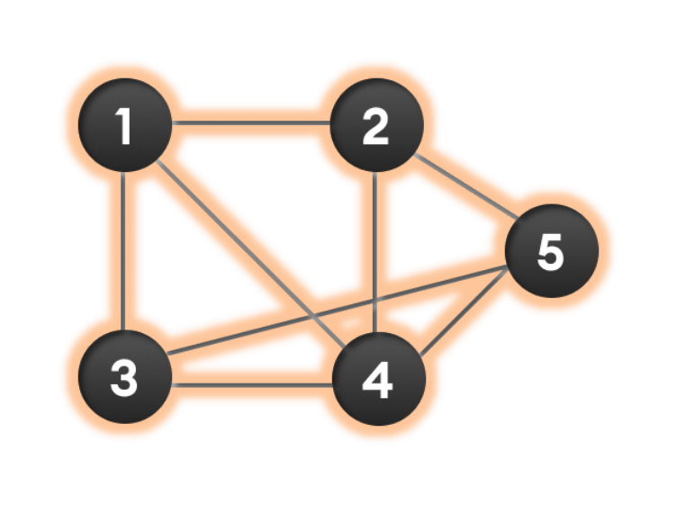

Wap to display a graph edges .in the below order no od edges 8 and no of vertex 5

1 - 2
1 - 3
1 - 4
2 - 4
2 - 5
3 - 4
3 - 5
4 - 5

Hint:

Class Graph{

Class Edge{
Int start/src;
Int end/dest;
}

Int vertex;
Int edge;

}

Solution:

class Graph01 {
class Edge {
int src, dest;
}
int vertices, edges;

Edge[] edge;

Graph(int vertices, int eges) {
this.vertices = vertices;
this.edges = edges;

edge = new Edge[edges];
for(int i = 0; i < edges; i++) {
edge[i] = new Edge();
}
}

public static void main(String[] args) {
int noVertices = 5;
int noEdges = 8;
Graph gObj = new Graph(noVertices, noEdges);

gObj.edge[0].src = 1;
gObj.edge[0].dest = 2;
gObj.edge[1].src = 1;
gObj.edge[1].dest = 3;
gObj.edge[2].src = 1;
gObj.edge[2].dest = 4;
gObj.edge[3].src = 2;
gObj.edge[3].dest = 4;
gObj.edge[4].src = 2;
gObj.edge[4].dest = 5;
gObj.edge[5].src = 3;
gObj.edge[5].dest = 4;
gObj.edge[6].src = 3;
gObj.edge[6].dest = 5;
gObj.edge[7].src = 4;
gObj.edge[7].dest = 5;

for(int i =0; i < noEdges; i++) {
System.out.println(gObj.edge[i].src+ " - " + gObj.edge[i].dest);
}
}
}

================================================================================================================================================
Home Task 👍
Pre order and post order traversal..

Home Tasks:

Recursion: assigned on Day 14th 02nd July 2025..

Wap to find the factorial of a number

Wap to find the Fibonacci series of a number

What is the difference between recursion and iteration

Wap to reverse a string using recursion..

*****************************************************************************************************************************************************************************************************************
info box

&&&&&&&&&&&&&&&&&&&&&&&&&&&&&&&&&&&&&&&&&&&&&&&&&&&&&&&&&&&&&&&&&&&&&&&&&&&&&&&&&&&&&&&&&&&&&&&&&&&&&&&&&&&&&&&&

https://drive.google.com/drive/folders/1LwhNov1s1-vHzF9GPAObLSnP9kAvipmw?usp=drive_link

Binary tree delete op ..along with insertion and traversal inorder …

https://www.codecademy.com/learn/graph-data-structures-java/modules/graphs-java/cheatsheet

Graphs in data structures.. Along with code – juz for reference..

**************************************************************************************************************************************

