Day23
Day 23 - 31st July 2025
Mohammed Arsalain
mobarsal@amazon.com

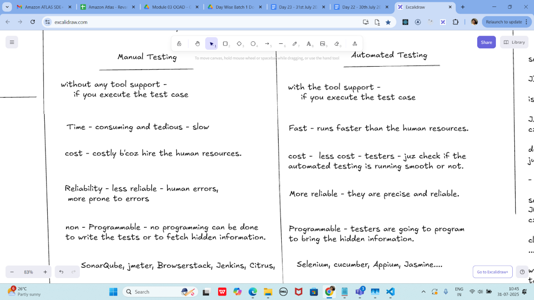

Junit

setup - environmental

JDk 1.5 or above

is java installed in your system

JAVA_HOME = "...path "
c:\programfiles\Java\jdk...

download JUnit archive
junit.org/junit5/

- .jar file ==> junit4.11.jar

set environmental variables
JUNIT_HOME = "Path.."
c:\programfile\junit

classpath ==> junit jar
..... \junit4.11.jar

write the code: -
testcase write
see the result pass or fail

cmd:
javac TestJnuit.java TestRunner.java
java TestRunner

TestJunit --> @test...... cases
TestRunner --> psvm ( ==> driver class for Junittest

=========================================================
Task 01

TestJunit.java

import org.junit.Test;
import static org.junit.Assert.assertEquals;

public class TestJunit {
@Test
public void testSubtract() {
int num1 = 10;
int num2 = 5;
int res = num1 - num2;
assertEquals(5 , res);
}
}

TestRunner.java

import org.junit.runner.JUnitCore;
import org.junit.runner.Result;
import org.junit.runner.notification.Failure;

public class TestRunner {
public static void main(String[] args) {
Result resobj = JUnitCore.runClasses(TestJunit.class);
for (Failure fobj : resobj.getFailures()) {
Sout(fobj.toString());
}
sout(resobj.wasSuccessful()); //--> true
}
}
===================================================================

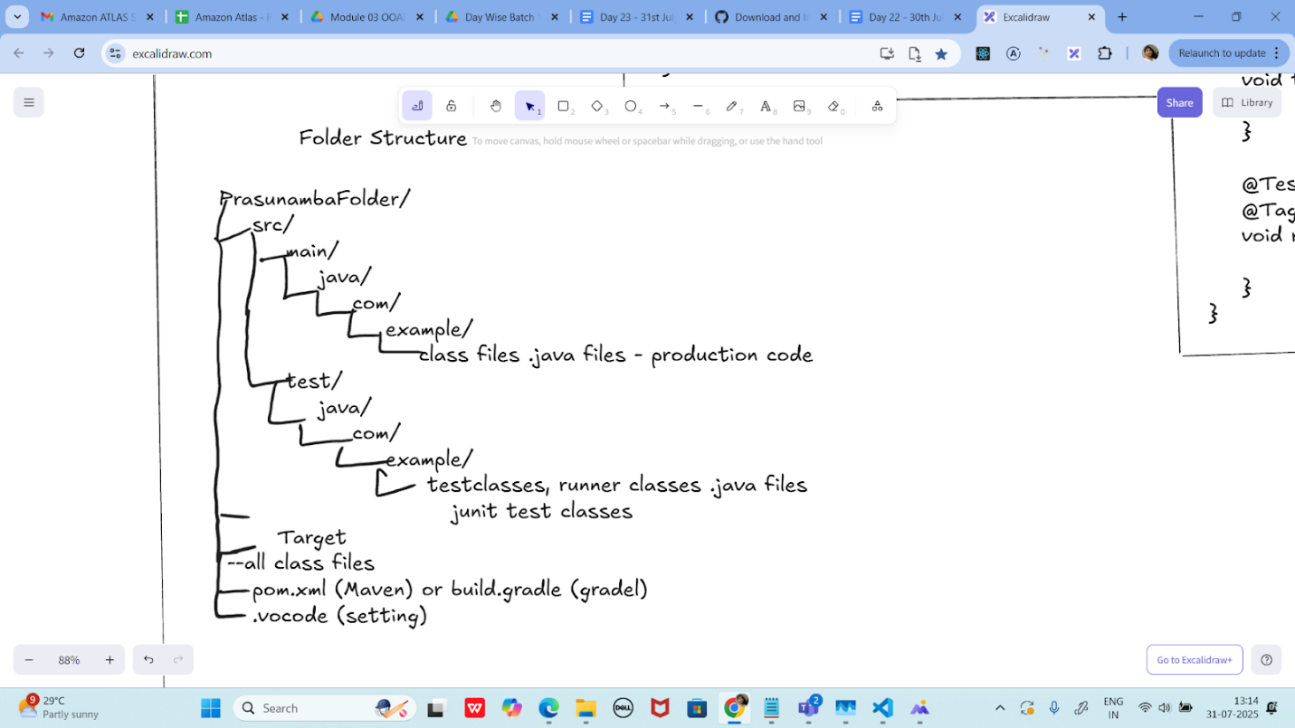

Junit test Framework

Regression Testing framework.

- Junit - unit Testing in java
- Junit - it will increase the programming speed, quality of my code will increase.

Junit - integrated with

Maven
Eclipse
Ant

features of Junit Test
Framework

JUnit classes - TestResult
- Assert
- TestCase
Test runners
Test suites
Fixtures

Fixtures

-fixed state of set of objects
- use for baseline for running tests
- why ? they ensure that
- the test cases will run in
fixed environment
- repeatedly.. test cases.

few methods:
tearDown() : - if you want you
to run after each and every test method
setUp(): if you want you
to run before each and every test method

Fixtures sample code:

import junit.framework.*;
public class FixturesDemo extends TestCase {
protected int num1,num2;

protected void setUp() {
num1 = 100;
num2 = 200;
}
//test method to multiply numbers
public void testMultiply() {
int res = num1 * num2;
assertTrue(res == 20000);
}
}

Test Suite:

- its a bundle of unit test cases and run them
all together.
@Suite
@RunWith

TestSuite Demo

import org.junit.runner.RunWith;
import org.junit.runners.Suite;

@RunWith(Suite.class)

@Suite.SuiteClasses( {
JunitTest01.class,
JunitTest02.class,
JunitTest03.class
})

public class TestSuiteDemo {

}

JunitTest01.java

import org,junit.Test;
import static org.junit.Assert.assetEquals;
import org.junit.Igore;
public class junitTest01 {

String msg = "running test01 ";

MessageUtil msgUtilobj = new MessageUtil(msg);
//MessageUtil is a utility class
//store a message
@Test
public void msgTest() {
sout("we are inside the msgtest()");

assertEquals(msg, msgUtilobj.printMessage());
}
}

junitTest02.java

test Runner

Test 02:

Implement the above code also add one more test case and test runner.. And execute the test suite.
14.38 to 14.46 8 min..

++++++++++++++++++++++++++++++++++++++++++++++++++++++++++++++++++++++++++++++++++++++++++++++++++++++++++++++++++++++++++++++++++++++++++++++++
Home Task:

Task 01:

List down the methods of Assertion class in Junit

Task 02:

Implement

assertNotSame
assetSame
assertArrayEquals()

Methods in your codes..

Task 03:
Ignore Test

Add @Ignore to your one of the test case and check if thet case is ignored or not

Task 04:

Time Test

In one the tests pass the timeout parameter with value and check if the test case fails if the time is out

@Test(timeout = 1000)

Task 05:

Exception test

In one of your tests check for arithmetic exceptions and see if it works..

@Test(expected = ArithmeticException.class)

++++++++++++++++++++++++++++++++++++++++++++++++++++++++++++++++++++++++++++++++++++++++++++++++++++++++++++++++++++++++++++++++++++++++++++++++

Info box:

https://junit.org/junit4/

Junit4 archive.

https://excalidraw.com/#json=5q1SN8_NqZBXvnbebkWY1,RyZBHBZmLIcetkhuIxVImg

Updated canvas link as of 13.13 IST.

Codes for reference link → for uml codes
https://drive.google.com/drive/folders/1LwhNov1s1-vHzF9GPAObLSnP9kAvipmw?usp=sharing

Plz go through uml diagrams in page nos:
Docs 04 OOAD UML in doc to study

8 to 16
12
18 to 39
57 to 58
97
118
123
136
154 to 160

Plantuml site juz found .. plz check for reference

https://plantuml.com/use-case-diagram

