Day25
mobarsal@amazon.com
Mohammed Arsalain
Task 01:

Builder

Task 02:

Adaptor

public interface Iphone {
public void onCharge();
public void offCharge();
}

public class Iphone16Charger implements Charger{
Iphone16Charger() {......};

public void charge() {
sout(" i m acharging Iphone 16");
}

interface Charger {
void charge();
void removeCharge();
}

class Iphone16Adapter implements Charger {
Iphone16Charger iphone16Charger;

Iphone16Adapter() {
iphone16Charger = new Iphone16Charger();
}
@Override
void charge() {
iphone16Charger.charge();
}

@Override
void charge() {
iphone16Charger.charge();
}
}

class Iphone16 implements Iphone {
Charger Iphone16Adapter;

Iphone16( Charge iphone16Adapter) {
this.iphone16Adapter= iphone16Adapter;
}

@Override
void onChrage() {
Iphone16Adapter.charge();
}

@Override
void offChrage() {
Iphone16Adapter.removecharge();
}

}

ClientAdapterDpMain {
psvm () {
Iphone16 iphoneobj = new Iphone16(new Iphone16Adapter());
iphoneobj.onCharge();
iphoneobj.offCharge();
}
}

1.10 to 1.20

Builder code 👍 by Ahmed ..
Builder Example — Codefile

Verified .. rated..

Adaptor code Ahmed..
Adapter Task02 — Codefile

Facade 👍

Code by Vivek: need to verify
compsite: https://codefile.io/f/2WmAlULYgy

Task03:

Create a class diagram in uml..

Task 04:

What are the commonly used visibility Notations in class diagrams?

Eg: =,-, ~, #,

Task 05:

What do you know about Parameter Directionality?

List them

Task 06:

Class Diagram Relationships

Task 07:

Package notation

Task 08:

what is state notation .. initial and final ?

================================

Home task:
Home task01:

Facade code:

class BankFacade {
//list of all services
private FdService fdService;

//constructor
this.fdService = new FdService();

void getfdServiceDetails(String ...) {
fdservice.getfdServiceDetails(accoundno);
}
}

Home task 02:

Composite Method Design Patteren:

interface Component {
void brandName();
}

class leaf implements Component {
// declare variables

construtor

@Override
brandName()

}
class Composite implements Component {
//variable declaration

Composite() {
}
Composite(...params) { }

@Override
brandName () {
for each loop - for all components {
compobj.brandName();
}
}
add(Component subComponent) {
componets.add(subComponent);
}

}

Home Task 03:

Proxy:

interface DBExecutor {
abstract void runQuery(String Type);
}
class DB{
DB(){ }
void runIt(String Type , String id) {
sout("we are running a query "+ Type);
}
}
class DBProxy implements DBExecutor {
String id;
DB db;
//constructor default
public DBProxy(String id) {
this.id = id;
db = new DB();
}
@Override
public void runQuery (String Type) {
if (Type.equals("Delete") && (!Objects.equals(this.id, "ADMIN")) {
sout("sorry access denied");
return;
}
db.runIt(Type, this.id);
}
}
class ClientProxyDP {
psvm(...) {
DBExecutor obj1 = new DBProxy("ADMIN");
obj1.runIt("READ");
obj1.runIt("UPDATE");
obj1.runIt("DELETE");

DBExecutor obj2 = new DBProxy("MANAGER");
obj2.runIt("READ");
obj2.runIt("UPDATE");
obj2.runIt("DELETE");

}
}

Hmotask 04:

Flyweight

HomeTask 05:

Bridge

Home Task 06:

Develop the below prototype method DP..

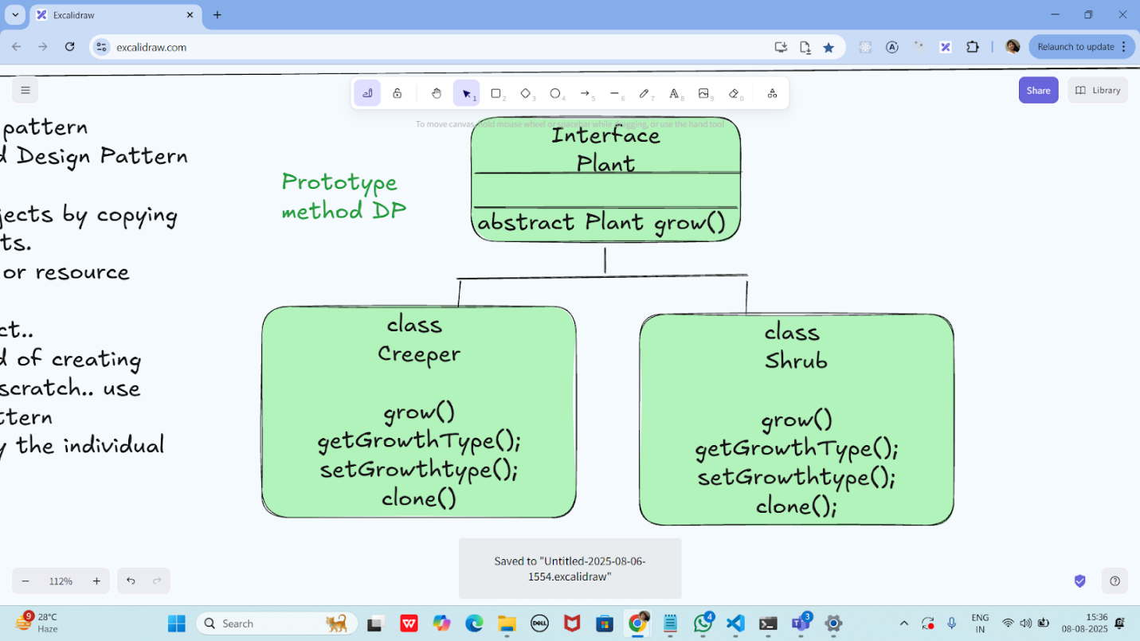

Excalidraw link updated at 11.00

https://excalidraw.com/#json=suv0yH5AB-GjV4ZQdPKo1,xOzVuTY2l6HZ08vr3p6nuQ

Excalidraw updated at 13.08
https://excalidraw.com/#json=QURJ6oE0ck3nlsez82HVI,qiWEIN4OR56V2751XiD8TA

Git hub links will be checked on sunday 10th aug evening after 6pm

Excalidraw updated at 17.08:

https://excalidraw.com/#json=vc4FTtHNUf8rUYzdF4Kng,JQLY2aD4fRzDFyBm4yW2WA

