Day 26 - 13th Aug 2025

Mohammed Arsalain
mobarsal@amazon.com

Creational
Structural DP
Behavioural

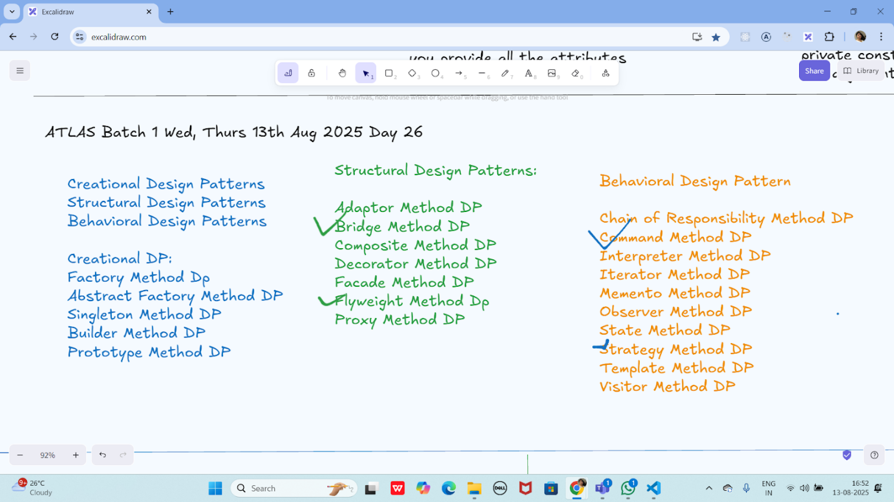

Strategy Method
Method Dp → Behavioral

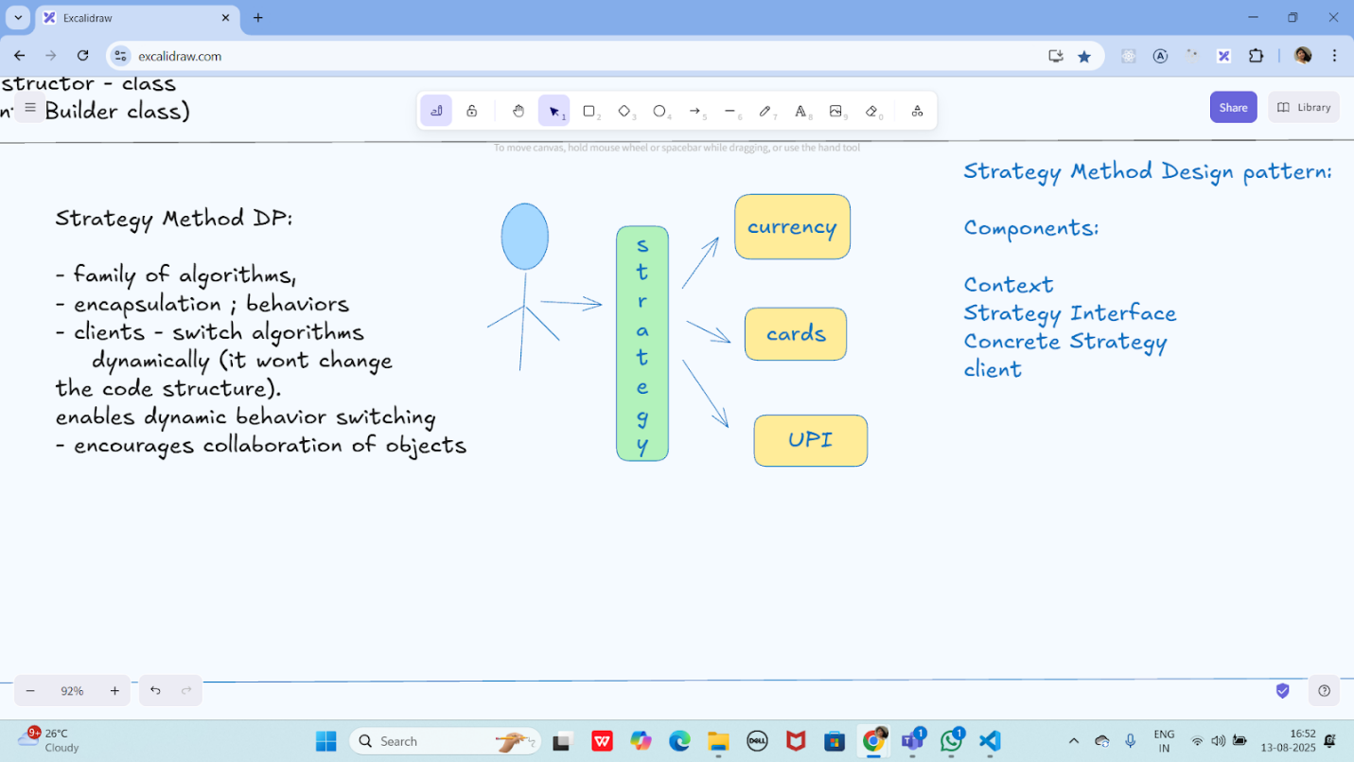

Command method DP → Behavioural
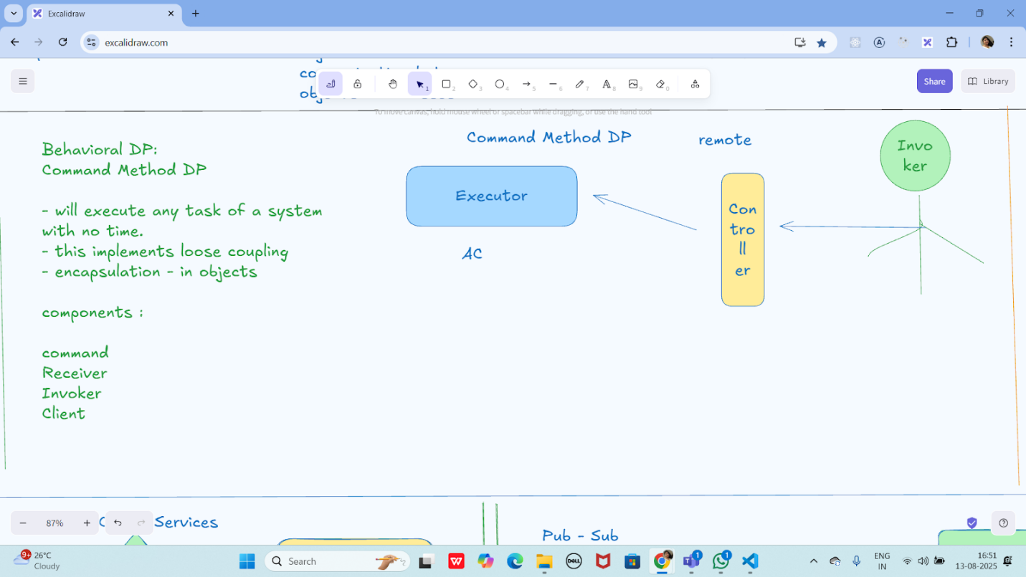

Microservices:
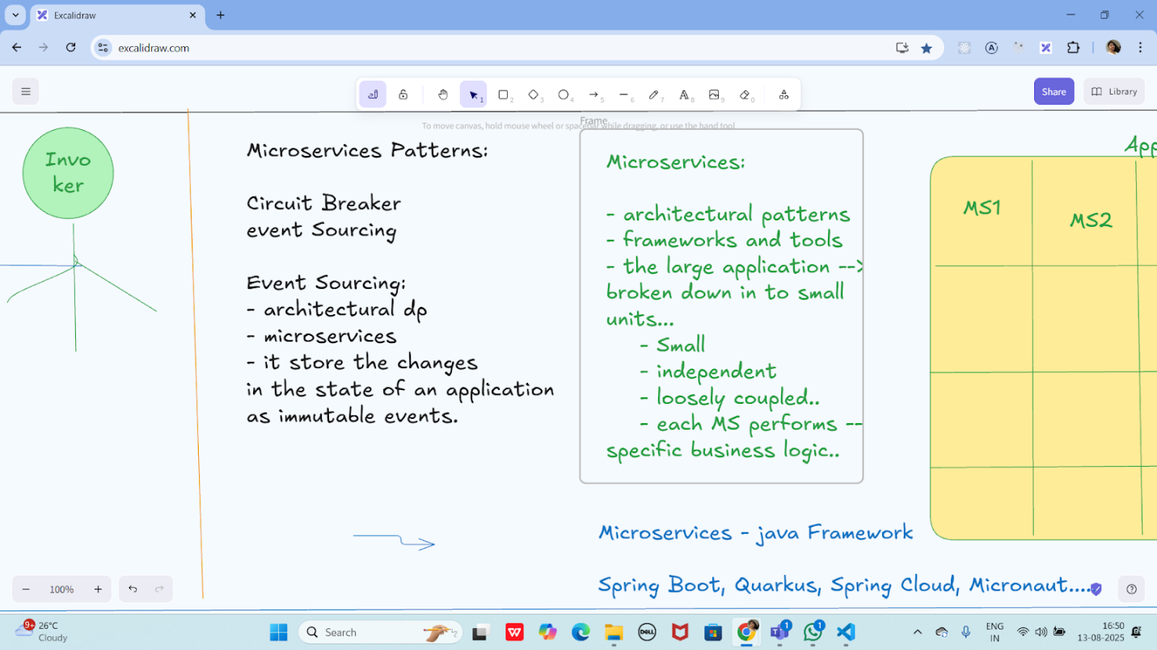

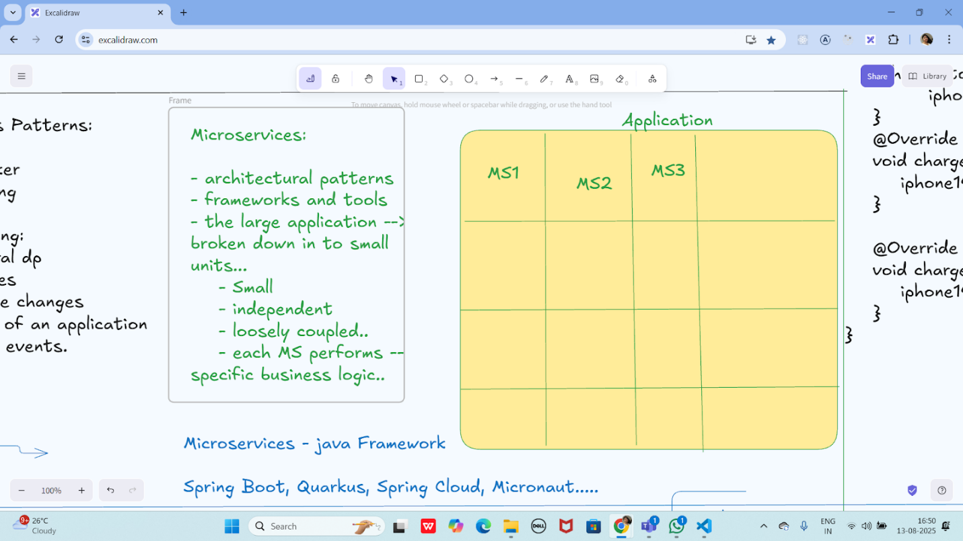
:

Event source Pattern


Microservices:




Event source Pattern

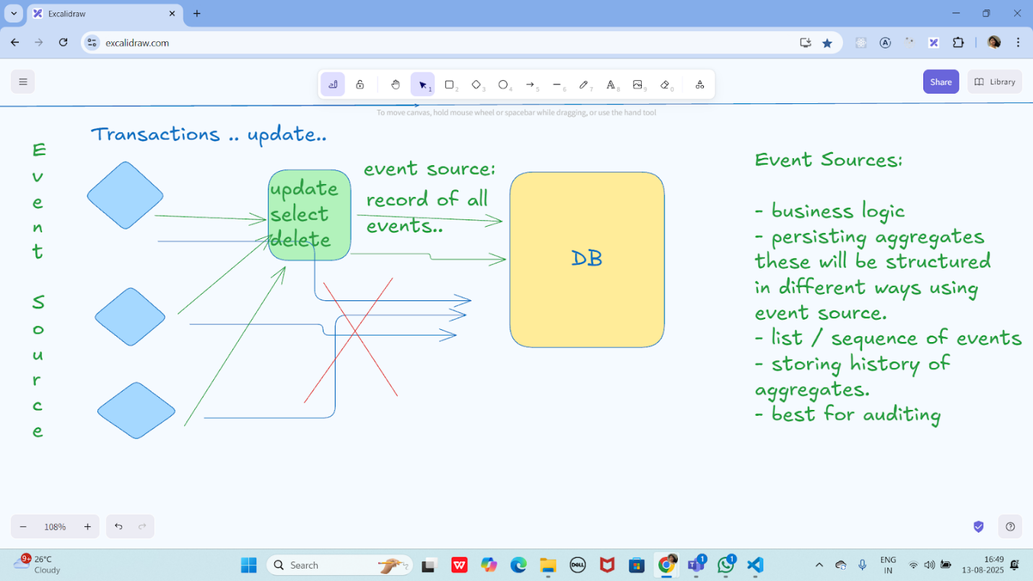

Circuit Breaker Pattern
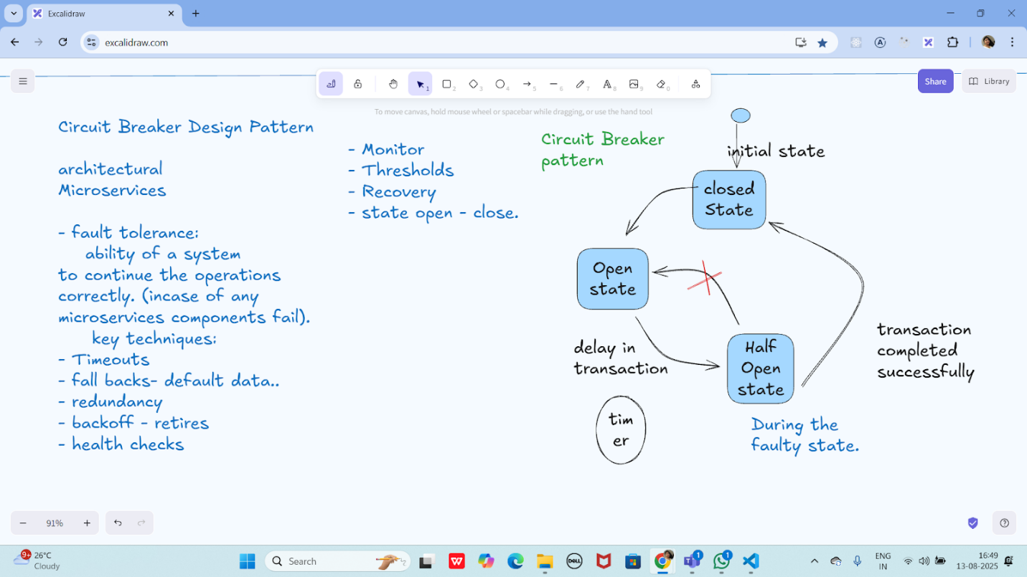



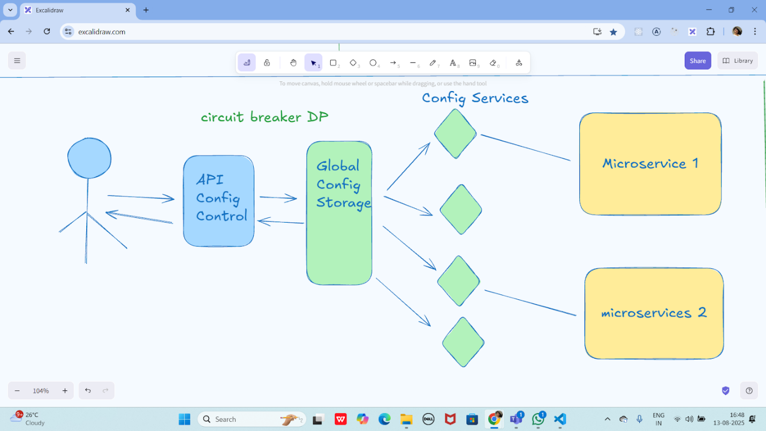

Pub sub Pattern:

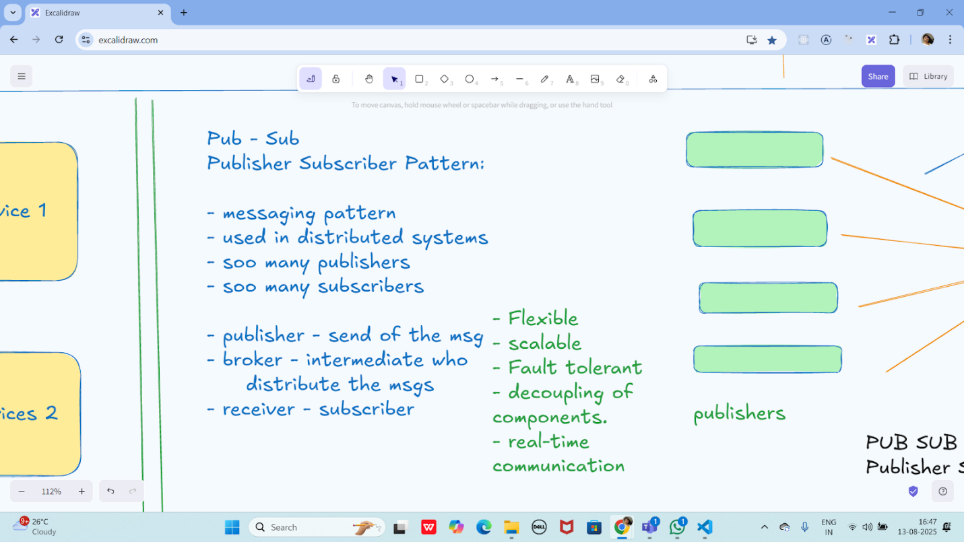



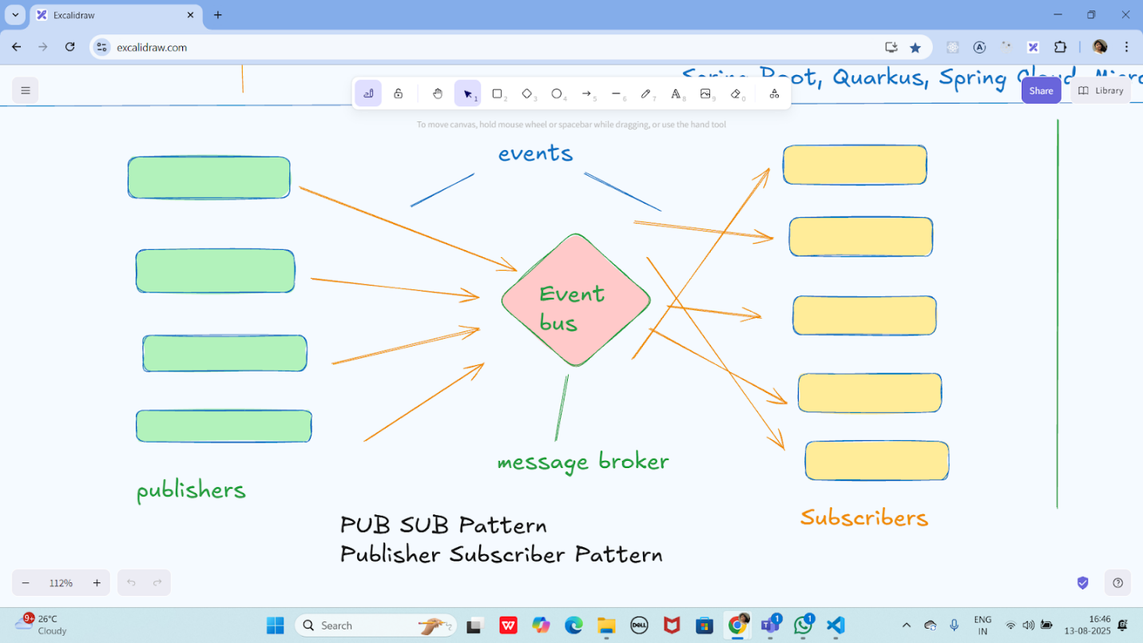

Three tier Architecture

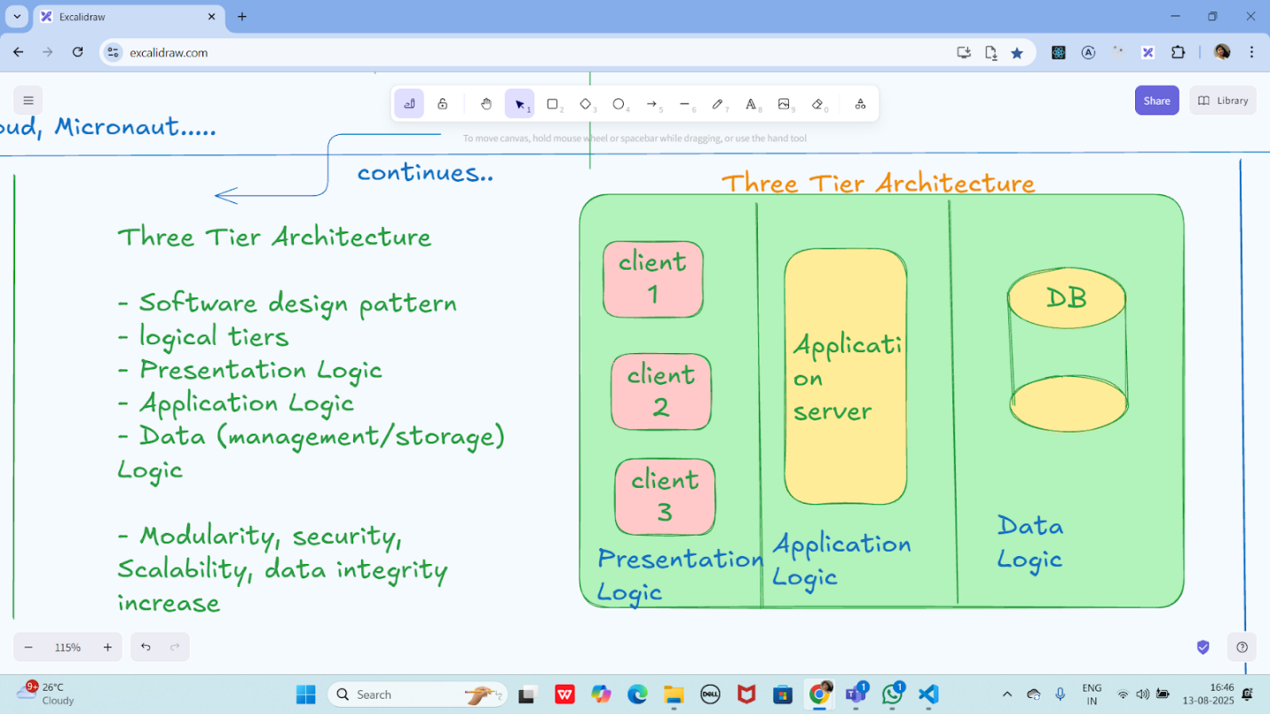

Multi tier Architecture

Multi Tier Architecture
=> client - server architecture

- improved scalability

Multi tier Architecture

Multi Tier Architecture
=> client - server architecture

- improved scalability
-

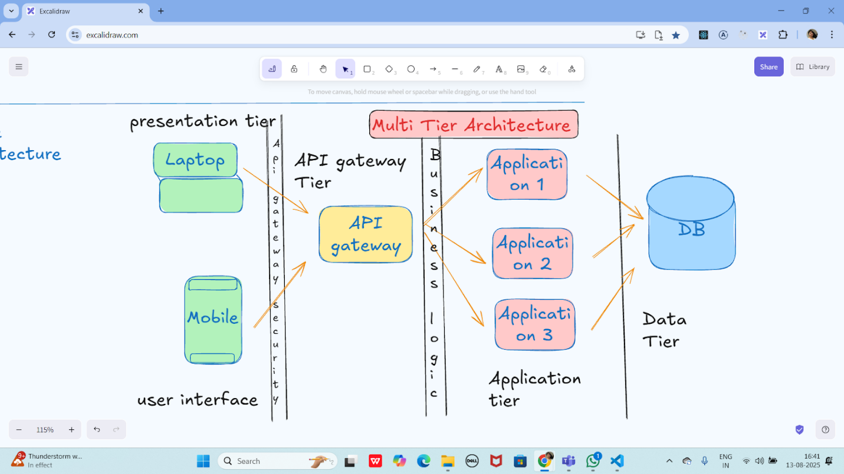

-

Task 01:
What are the Advantages of Multi tier Architecture?

The primary advantages of multi-tier architecture include enhanced scalability, where individual tiers can be scaled independently, and improved security, as direct access between the client and data tiers is prevented. Other benefits are increased maintainability due to modular components, faster development as teams can work in parallel, and improved reliability because an issue in one tier is less likely to affect the others

By Vivek Persistent Object

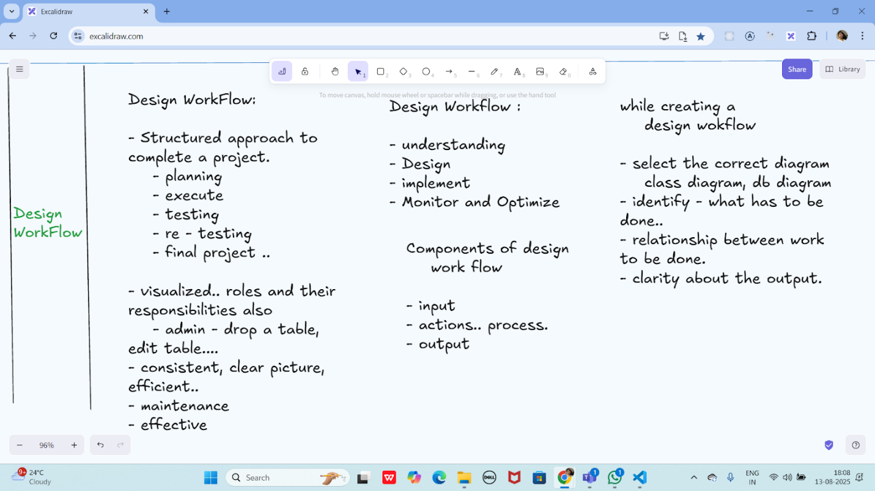

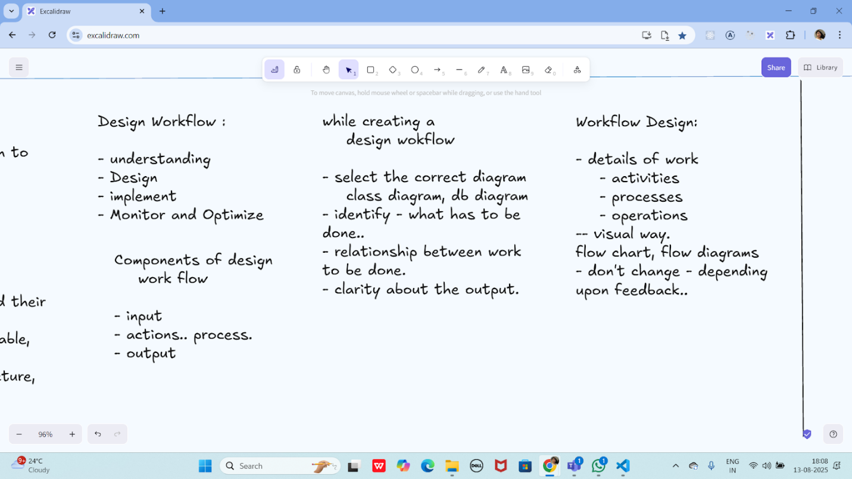
Multi tier Architecture

Multi Tier Architecture
=> client - server architecture

- improved scalability
-



Task 01:
What are the Advantages of Multi tier Architecture?





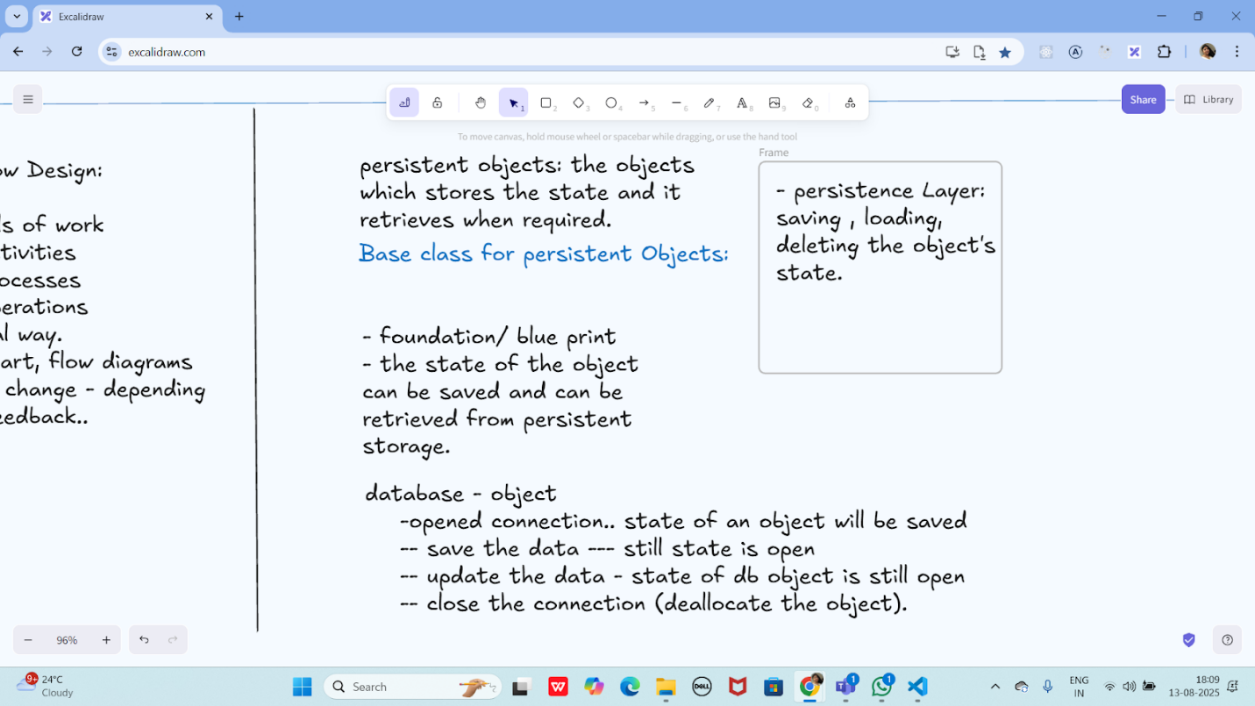
Multi tier Architecture

Multi Tier Architecture
=> client - server architecture

- improved scalability
-



Task 01:
What are the Advantages of Multi tier Architecture?







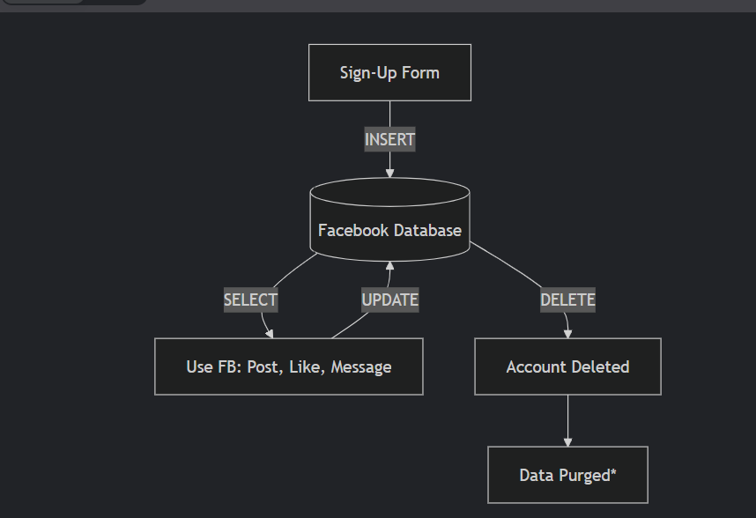

++++++++++++++++++++++++++++++++++++++++++++++++++++++++++++++++++++++++++++++++++++++++++++++++++++++++++++++++++++++++++++++++++++++++++++++++

Home Tasks:

Behavioral Dp: 1 . Strategy and 2. command method complete the code..

Task 03:
Multi tier Architecture

Multi Tier Architecture
=> client - server architecture

- improved scalability
-



Task 01:
What are the Advantages of Multi tier Architecture?









By Vivek Persistent Object

++++++++++++++++++++++++++++++++++++++++++++++++++++++++++++++++++++++++++++++++++++++++++++++++++++++++++++++++++++++++++++++++++++++++++++++++

Home Tasks:

Behavioral Dp: 1 . Strategy and 2. command method complete the code..

Task 03:

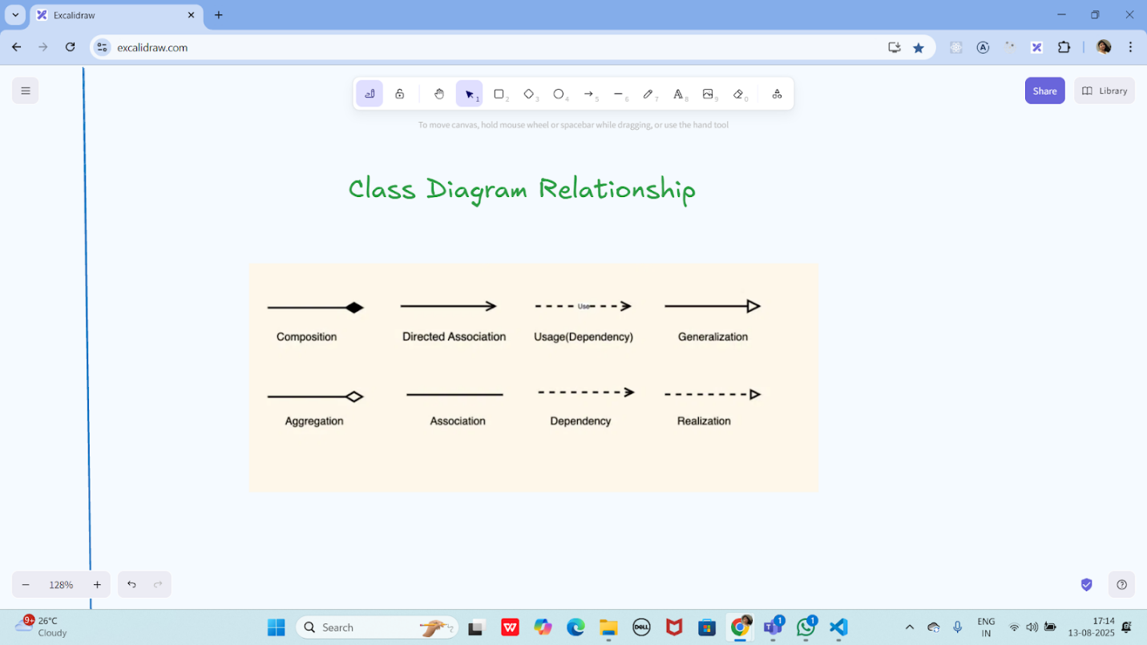

Task 04:

Multi tier Architecture

Multi Tier Architecture
=> client - server architecture

- improved scalability
-



Task 01:
What are the Advantages of Multi tier Architecture?









By Vivek Persistent Object

++++++++++++++++++++++++++++++++++++++++++++++++++++++++++++++++++++++++++++++++++++++++++++++++++++++++++++++++++++++++++++++++++++++++++++++++

Home Tasks:

Behavioral Dp: 1 . Strategy and 2. command method complete the code..

Task 03:



Task 04:

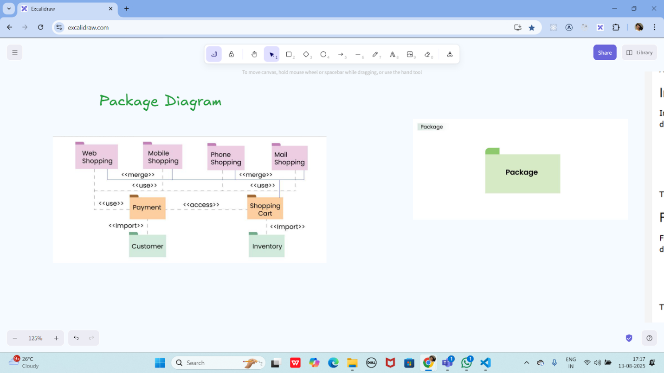

Create a package diagram representation of Command Design Pattern code..

Create uml diagrams to represent different kinds of relation ships

Task 05:

Info 👍

Understand diff between

Rating Qns:

3. Which of the following components is not typically part of the Command pattern?
a) Invoker
b) Receiver
c) Abstract Factory
d) Command (interface/abstract class)

What role does the Invoker play in the Command pattern?
a) It knows how to perform the operations associated with a request.
b) It encapsulates the request as an object.
c) It asks the command to carry out the request.
d) It defines the interface for executing an operation.

A key benefit of using the Command pattern is its ability to support:
a) Lazy initialization
b) Undo/Redo functionality
c) Singleton instance creation
d) Compile-time polymorphism

In the Strategy pattern, what role does the "Context" play?
A. It defines the interface for the algorithms.
B. It implements a specific algorithm.
C. It maintains a reference to a Strategy object and delegates the task to it.
D. It creates the Concrete Strategy objects.

**************************************************************************************************************************************************************************************************************************

Info Box:

Strategy Method DP:

Codes for reference link is below

https://drive.google.com/drive/folders/1LwhNov1s1-vHzF9GPAObLSnP9kAvipmw?usp=sharing

Code can be found in → Codes for reference → OOAD → Strategy Method DP.

Command Method DP code in Codes for reference

Excalidraw link updated at 11.50:

https://excalidraw.com/#json=ApYmKVfT4c0BbWs8y2EOe,UpLAw9RgWj4HgxdaMOC0xQ

Excalidraw link updated at 13.23

https://excalidraw.com/#json=mftMxEg5jjIXA5eVC7b-i,DVNKX2PvMsB8ZVkKc0CNuQ
Publisher Subscriber Pattern code in code for reference

Excalidraw link updated at 16.44

https://excalidraw.com/#json=aV6jajpxgU0LHxFWvmRy1,2HM5gvVCmTa5_wGXMTZc2A

Exca;lidraw link updated at 18.05

https://excalidraw.com/#json=4WkZ9xQ3_vqnQxofqOAGs,18EhyeE8wgYKq-kWm2xjmA

**************************************************************************************************************************************************************************************************************************

