Day32

03rd Sept 2025
Mohammed Arsalain
mobarsal@amazon.com

Hope you have received Credentials for accessing AWS cloud

Login to cloud environment

Change region to Asia - Mumbai

Search for DynamoDB

Task 1:

Create a table with few attributes..
Also add some records..
Take a ss of it and paste it

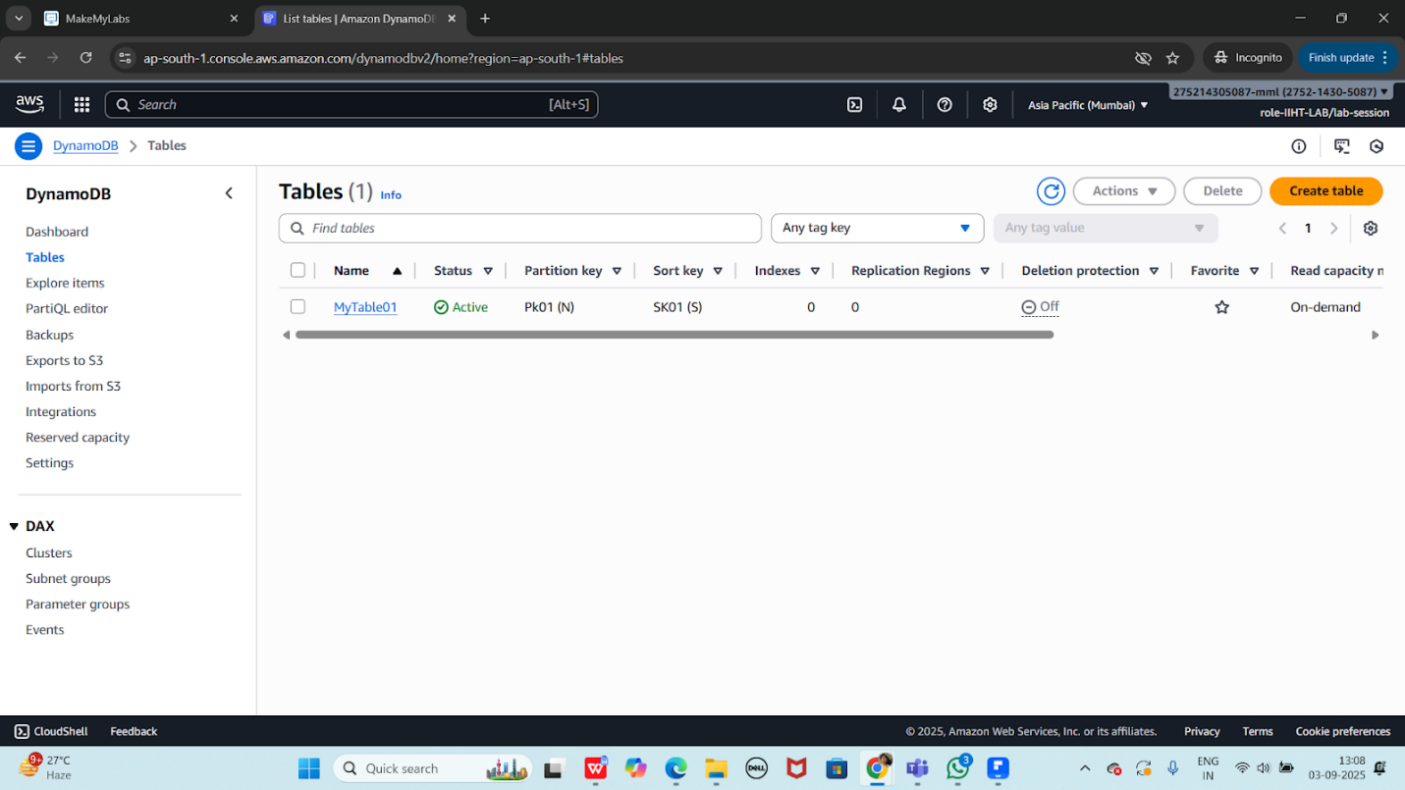

Task 2:

Create a table and do the crud operations on the table ..

CRUD operations in AWS Dynamodb CLI:

Creating a table

aws dynamodb create-table --table-name Employee --attribute-definitions AttributeName=ID,AttributeType=N AttributeName=EmpName,AttributeType=S --key-schema AttributeName=ID,KeyType=HASH AttributeName=EmpName,KeyType=RANGE --provisioned-throughput ReadCapacityUnits=5,WriteCapacityUnits=5

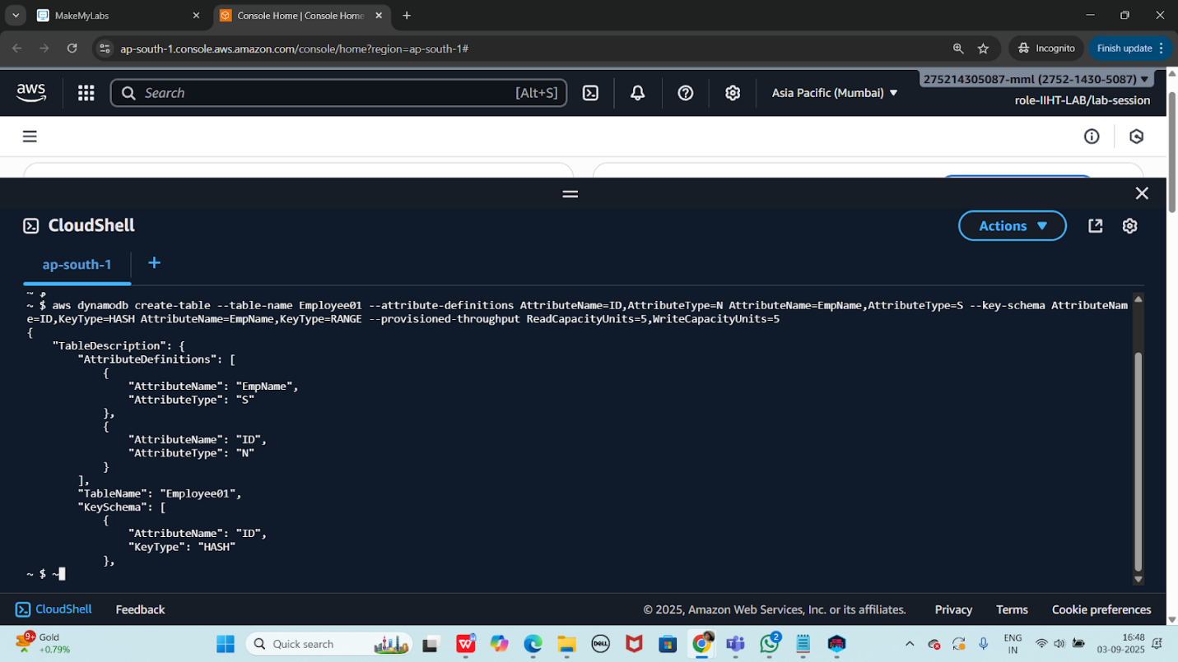

configuring AWS CLI
install aws cli - aws cli
configure aws cli
aws configure

aws access key
secret key
region and output format

IAM permissions:

IAM user or role

CreateTable
PutItems
Getitems
Query
UpdateItems
DeleteItems
DeleteTable
---------------------------------------------------------------
Add custom IAM policy

aws iam create policy \
--policy-name
DynamoDBManagementPolicy \
--policy-document '{"Version" : "2025-05-20",
"Statement" :
[ {"Effect": "Allow", "Action" :
["dynamodb: CreateTable",
"dynamodb: Query", .......],
"Resource": "*" } ] }'

the above policy lets give to a role/user

aws iam attach-user-policy --policy-arn arn:aws:iam:: DynamoDBManagementPolicy
--user-name emp(here give the username for whom your want to attach the above policy)

create table
insert data
crud operAtions

---- GUI , CLI, SDK...

insert into table

aws dynamodb put-item --table-name Employee --item '{"ID": {"N": "1001"},
"EmpName": {"S": "Prasunamba"} }'

aws dynamodb put-item --table-name Employee --item '{"ID": {"N": "1001"},
"EmpName": {"S": "Prasunamba"} }'
.....

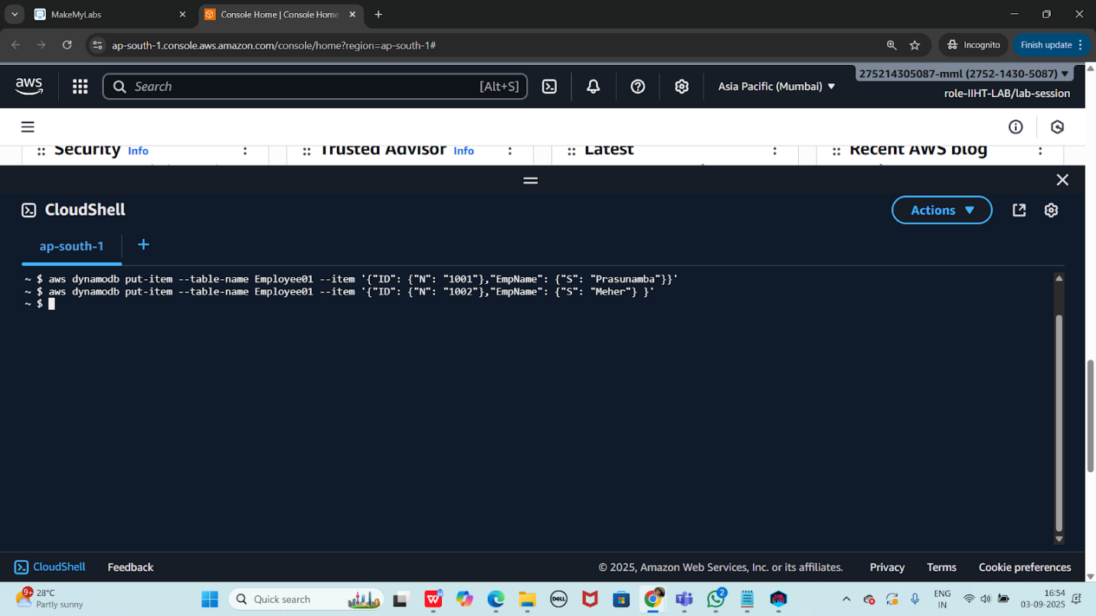

Query:
aws dynamodb query --table-name Employee
--key-condition-expression "ID = :ID"
--expression-attribute-values '{":ID":{"N":"1001"}}'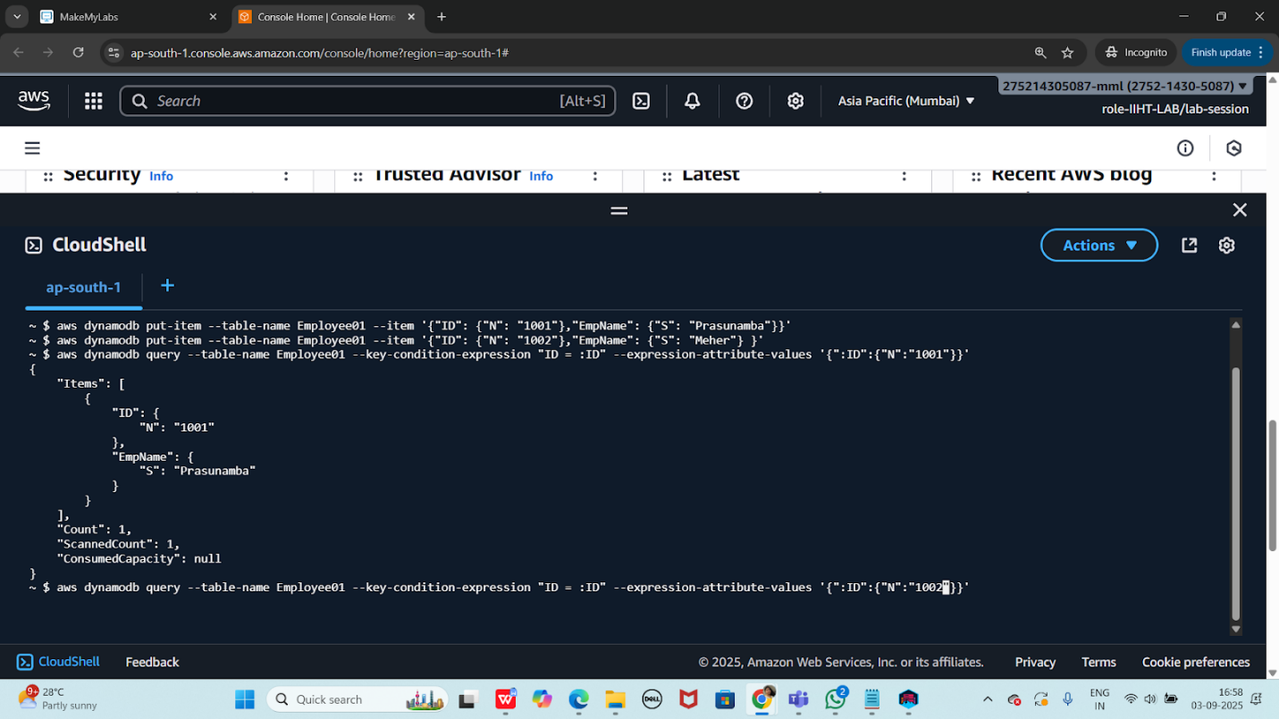

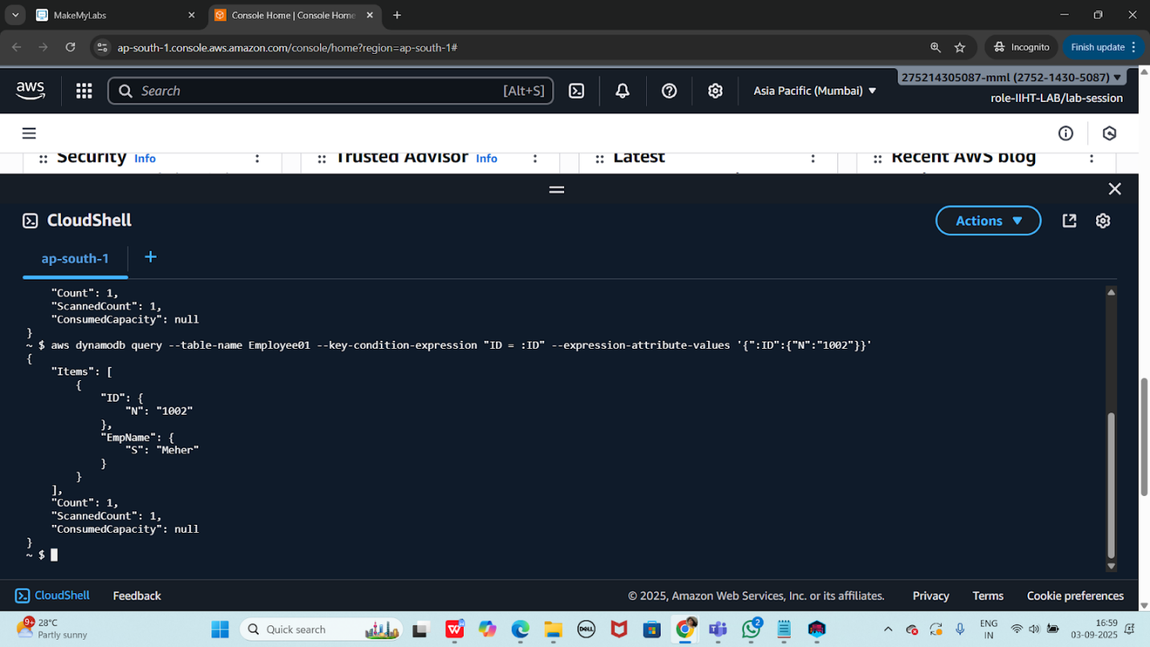

Update:
Updating a new column/ attribute
aws dynamodb update-item --table-name Employee
--key '{"ID": {"N": "1001"} , "EmpName": {"S": "Prasunamba"} }'
--update-expression "set info = :info"
--expression-attribute-values '{":info": {"S": "MK"}}'

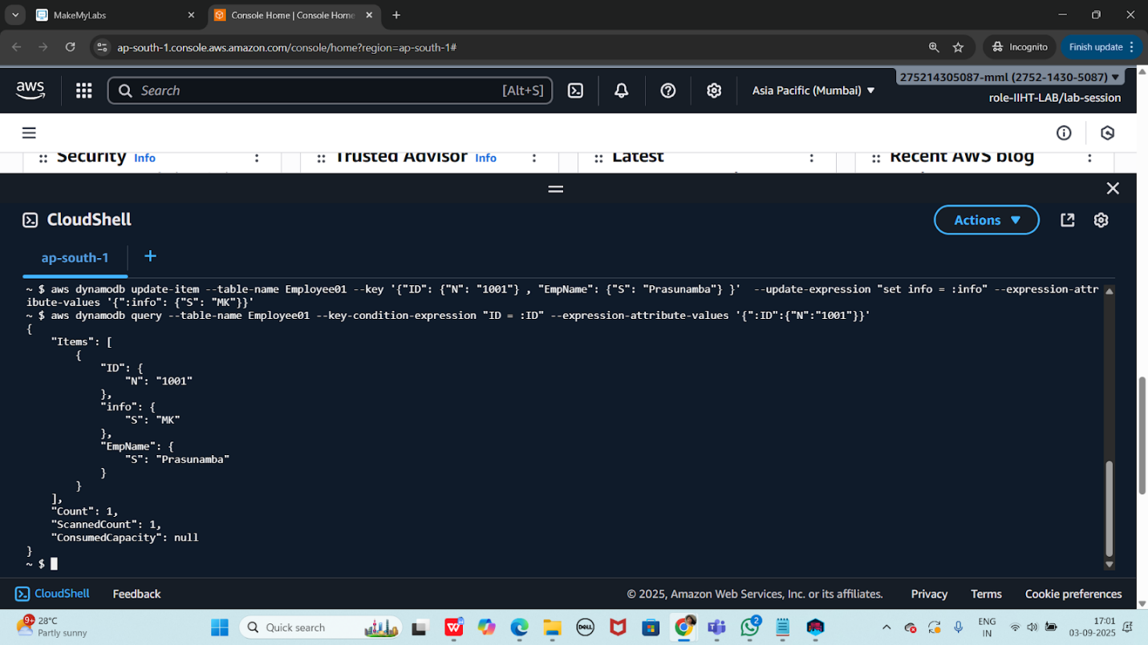

Delete :

aws dynamodb delete-item --table-name Employee
--key '{"ID": {"N": "1001"}, "EmpName":{"S": "Prasunamba"} }'

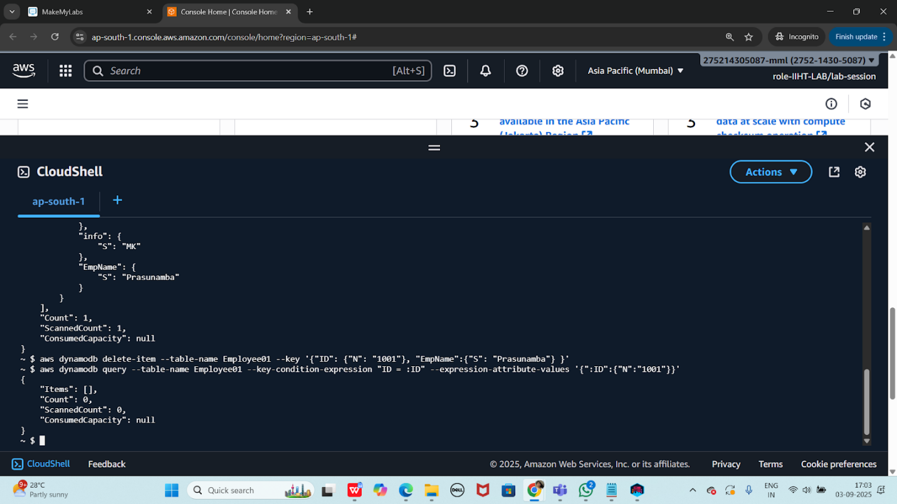

List the tables

Aws dynamodb list-tables

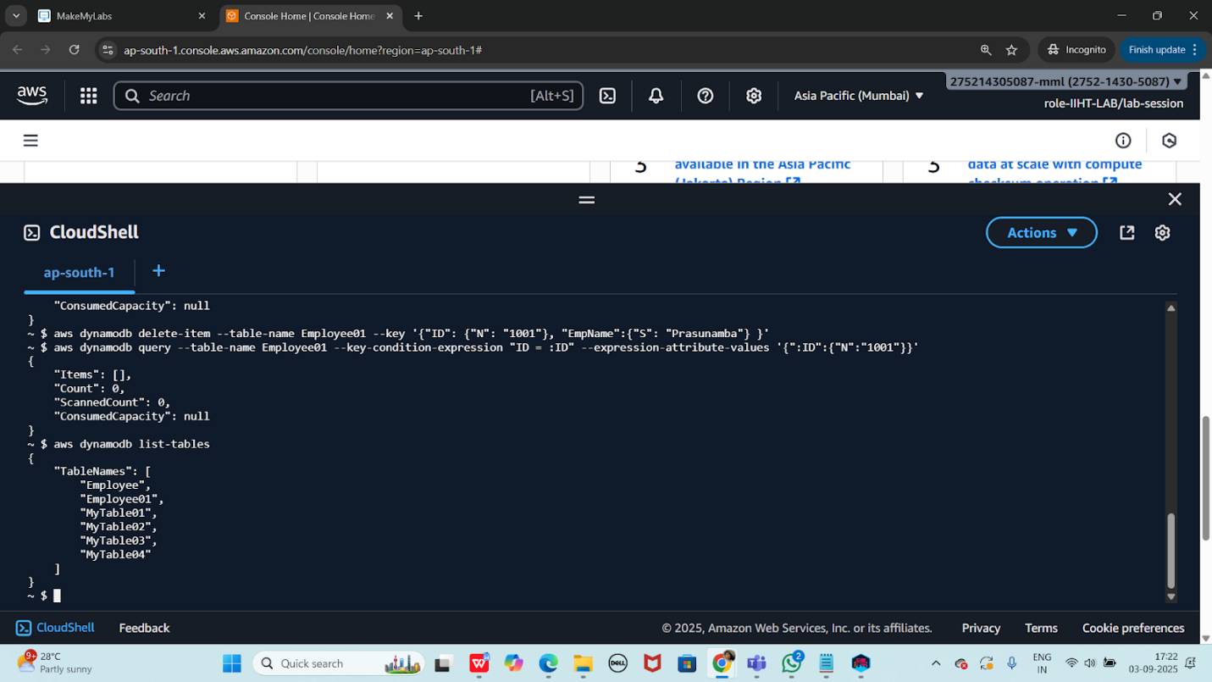

detailed info about our table
aws dynamodb describe-table --table-name Employee01

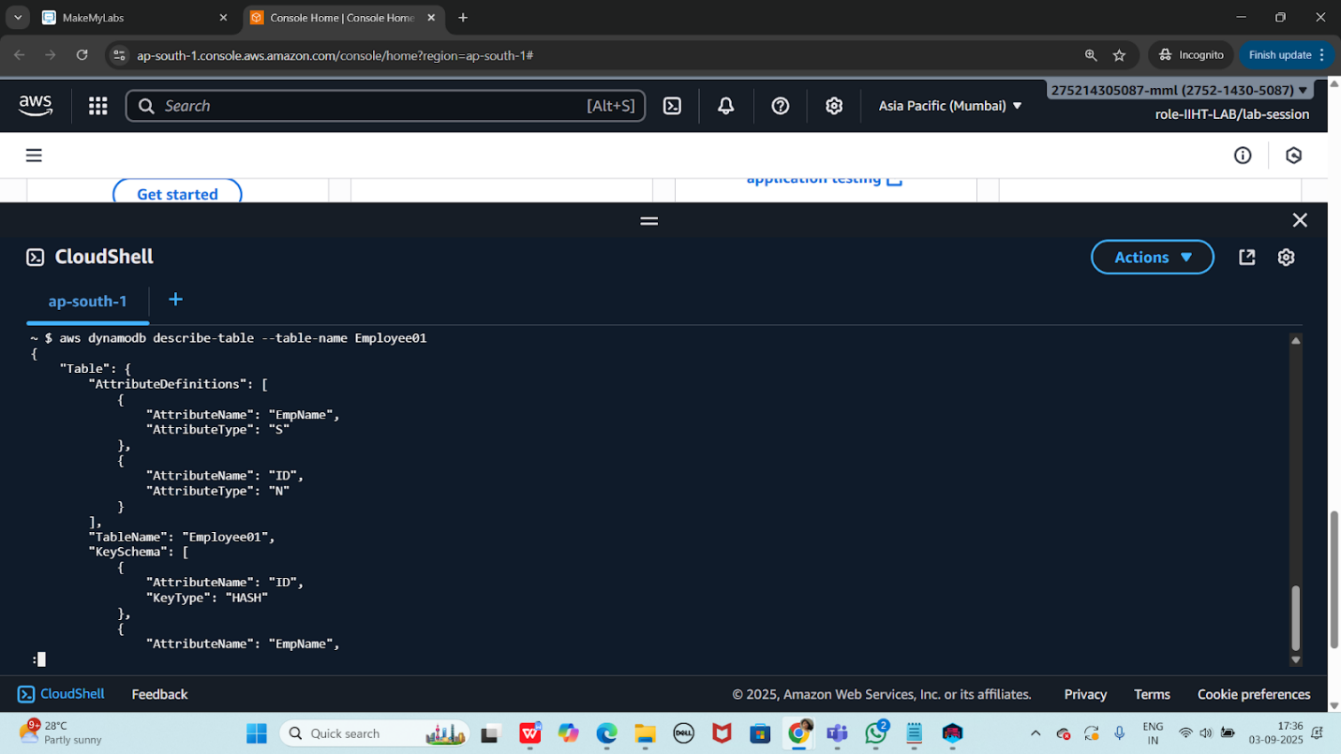

Scan the table
aws dynamodb scan --table-name Employee01

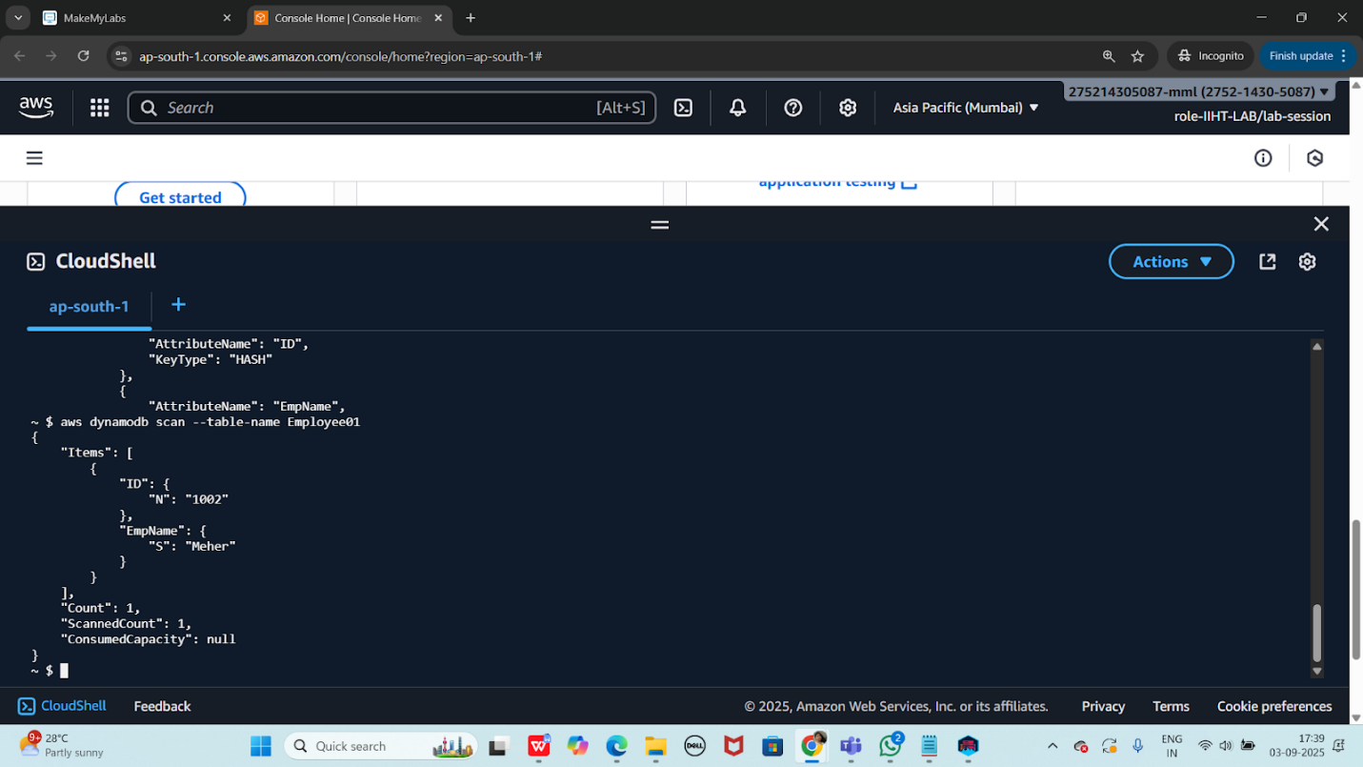

Aws - - version

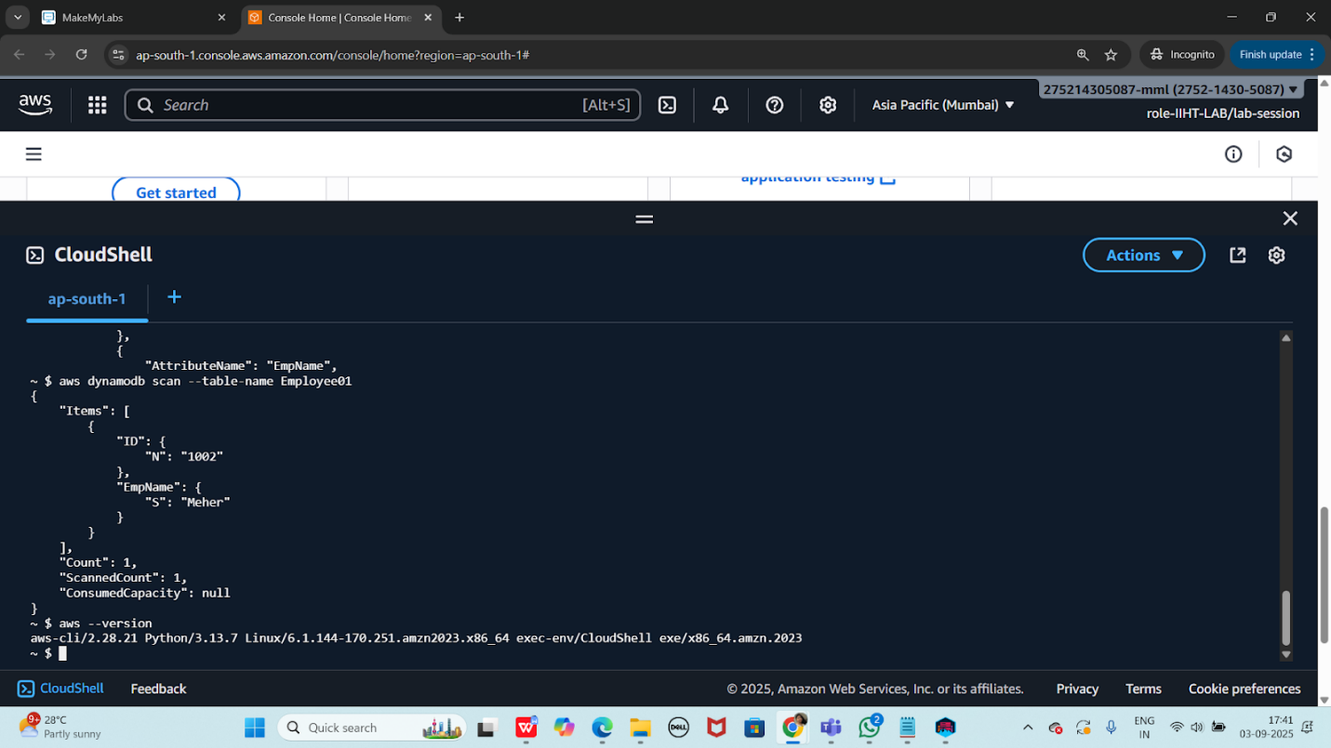

identity details of the user
aws sts get-caller-identity

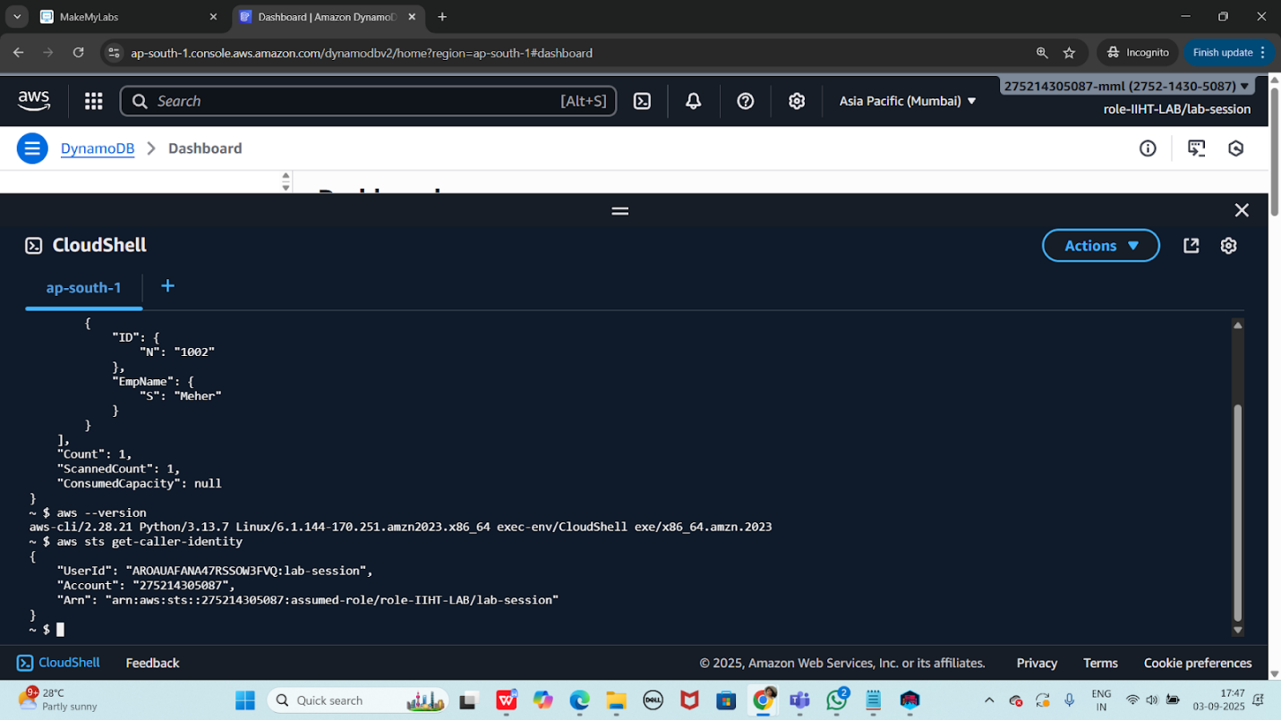
Creayting a table using wizard

Aws dynamodb wizard new-table

Fill the blanks
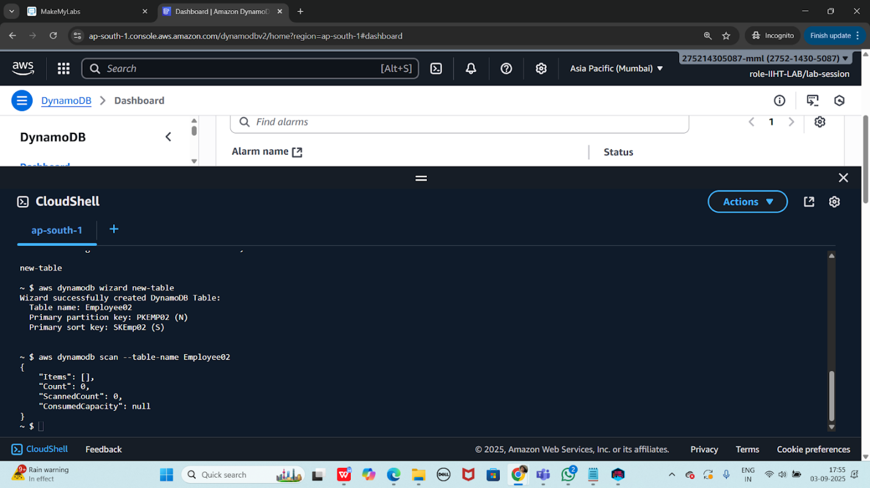

taking backup of a table

aws dynamodb create-backup
--table-name Employee01
--backup-name MyEmployee01backup

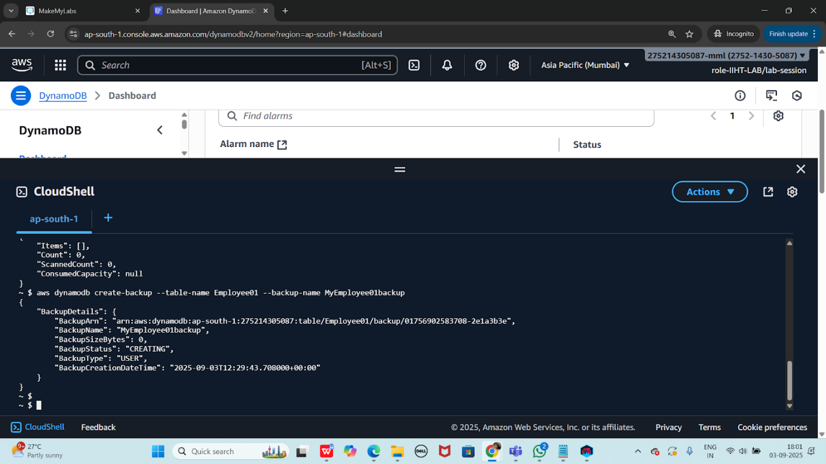

Listing all the backup files

Aws dynamodb list-backups

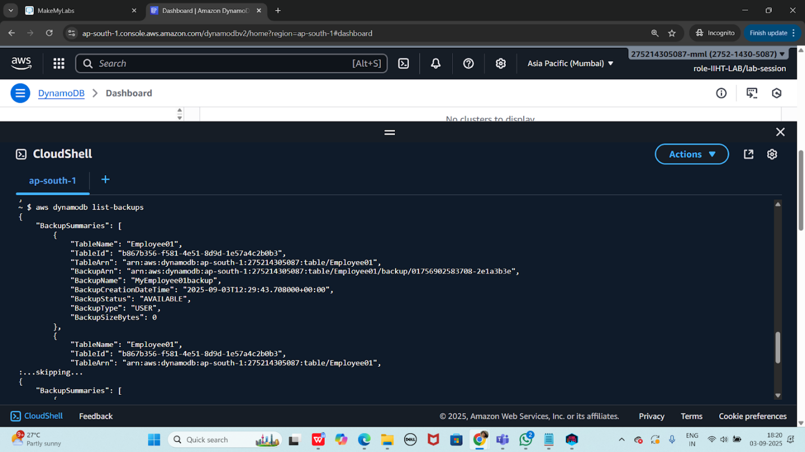
Output that i got 👍

"BackupSummaries": [
{
"TableName": "Employee01",
"TableId": "b867b356-f581-4e51-8d9d-1e57a4c2b0b3",
"TableArn": "arn:aws:dynamodb:ap-south-1:275214305087:table/Employee01",
"BackupArn": "arn:aws:dynamodb:ap-south-1:275214305087:table/Employee01/backup/01756902583708-2e1a3b3e",
"BackupName": "MyEmployee01backup",
"BackupCreationDateTime": "2025-09-03T12:29:43.708000+00:00",
"BackupStatus": "AVAILABLE",
"BackupType": "USER",
"BackupSizeBytes": 0
},
{
"TableName": "Employee01",
"TableId": "b867b356-f581-4e51-8d9d-1e57a4c2b0b3",
"TableArn": "arn:aws:dynamodb:ap-south-1:275214305087:table/Employee01",
:...skipping...
{
"BackupSummaries": [
{
"TableName": "Employee01",
"TableId": "b867b356-f581-4e51-8d9d-1e57a4c2b0b3",
"TableArn": "arn:aws:dynamodb:ap-south-1:275214305087:table/Employee01",
"BackupArn": "arn:aws:dynamodb:ap-south-1:275214305087:table/Employee01/backup/01756902583708-2e1a3b3e",
"BackupName": "MyEmployee01backup",
"BackupCreationDateTime": "2025-09-03T12:29:43.708000+00:00",
"BackupStatus": "AVAILABLE",
"BackupType": "USER",
"BackupSizeBytes": 0
},
{
"TableName": "Employee01",
"TableId": "b867b356-f581-4e51-8d9d-1e57a4c2b0b3",
"TableArn": "arn:aws:dynamodb:ap-south-1:275214305087:table/Employee01",
"BackupArn": "arn:aws:dynamodb:ap-south-1:275214305087:table/Employee01/backup/01756903439441-1a6b9bc1",
"BackupName": "MyEmployee01backup",
"BackupCreationDateTime": "2025-09-03T12:43:59.441000+00:00",
:

Describing back up table

aws dynamodb describe-backup --backup-arn arn:aws:dynamodb:ap-south-1:275214305087:table/Employee01/backup/01756902583708-2e1a3b3e

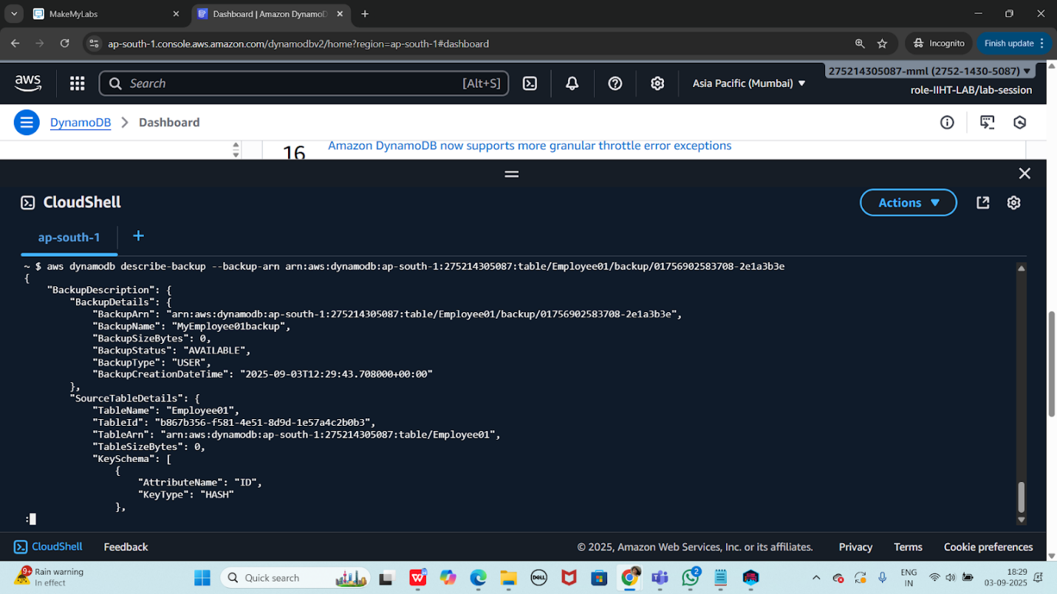

Restoring table from back up file

Using ARN

aws dynamodb restore-table-from-backup --target-table-name restoreEmpoloyee01 --backup-arn arn:aws:dynamodb:ap-south-1:275214305087:table/Employee01/backup/01756902583708-2e1a3b3e

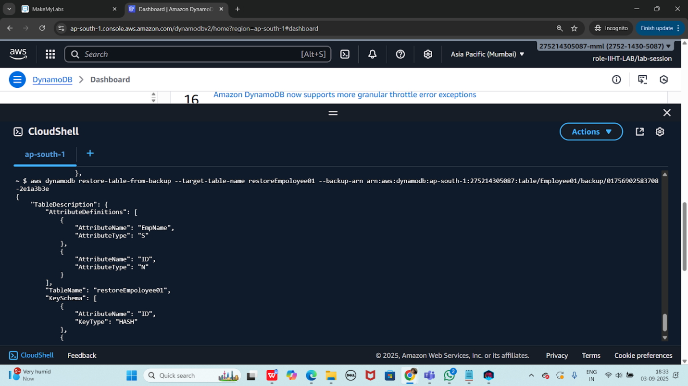

Check for the restore file… using list-tables command
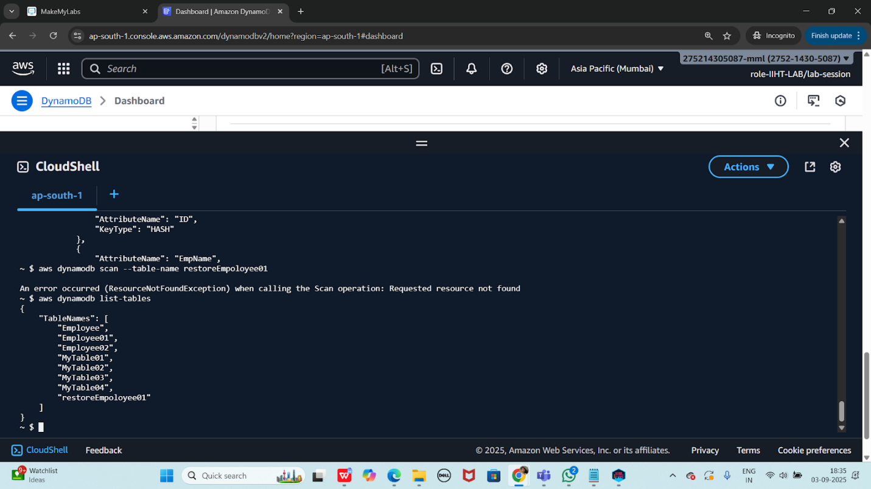

=============================================================

Home Task

Use the same crud operations to create a table of your choice with 4 columns and 5 records..

—--------------------------------------------------------------------------------------------------------------------
HINT:

Creating a table

aws dynamodb create-table --table-name Employee --attribute-definitions AttributeName=ID,AttributeType=N attributeName=EmpName,AttributeType=S --key-schema AttributeName=ID,KeyType=HASH AttributeName=EmpName,KeyType=RANGE --provisioned-throughput ReadCapacityUnits=5,WriteCapacityUnits=5

insert into table

aws dynamodb put-item --table-name Employee01 --item '{"ID": {"N": "1001"},"EmpName": {"S": "Prasunamba"}}'

aws dynamodb put-item --table-name Employee01 --item '{"ID": {"N": "1002"},"EmpName": {"S": "Meher"} }'
.....

Query:

aws dynamodb query --table-name Employee01 --key-condition-expression "ID = :ID" --expression-attribute-values '{":ID":{"N":"1001"}}'

Update:

aws dynamodb update-item --table-name Employee01 --key '{"ID": {"N": "1001"} , "EmpName": {"S": "Prasunamba"} }' --update-expression "set info = :info" --expression-attribute-values '{":info": {"S": "MK"}}'

Delete :

aws dynamodb delete-item --table-name Employee01 --key '{"ID": {"N": "1001"}, "EmpName":{"S": "Prasunamba"} }'

—------------------------------------------------------------------------------------------------------------------

Info Box:

Projects doc link.. ALL Projects 10 Day plan

https://docs.google.com/document/d/1gOzEONAVHm-DifF-RhEy_PwsdjCnkLzi/edit?usp=sharing&ouid=103020917863623365252&rtpof=true&sd=true

Batch 1 projects

https://docs.google.com/spreadsheets/d/16Ia3jG_uJtTPvpDQTv-XW3-0OE1qagjD5pgB9TYcKDc/edit?usp=sharing

