Day33
mobarsal@amazon.com
Mohammed Arsalain

Day 33 - 04th Sept 2025

As we have learnt about the DynamoDb Architecture..

Task 01👍

What do you understand by DynamoDb Architecture.. ? explain using a diagram.

Rating qn.. Plz

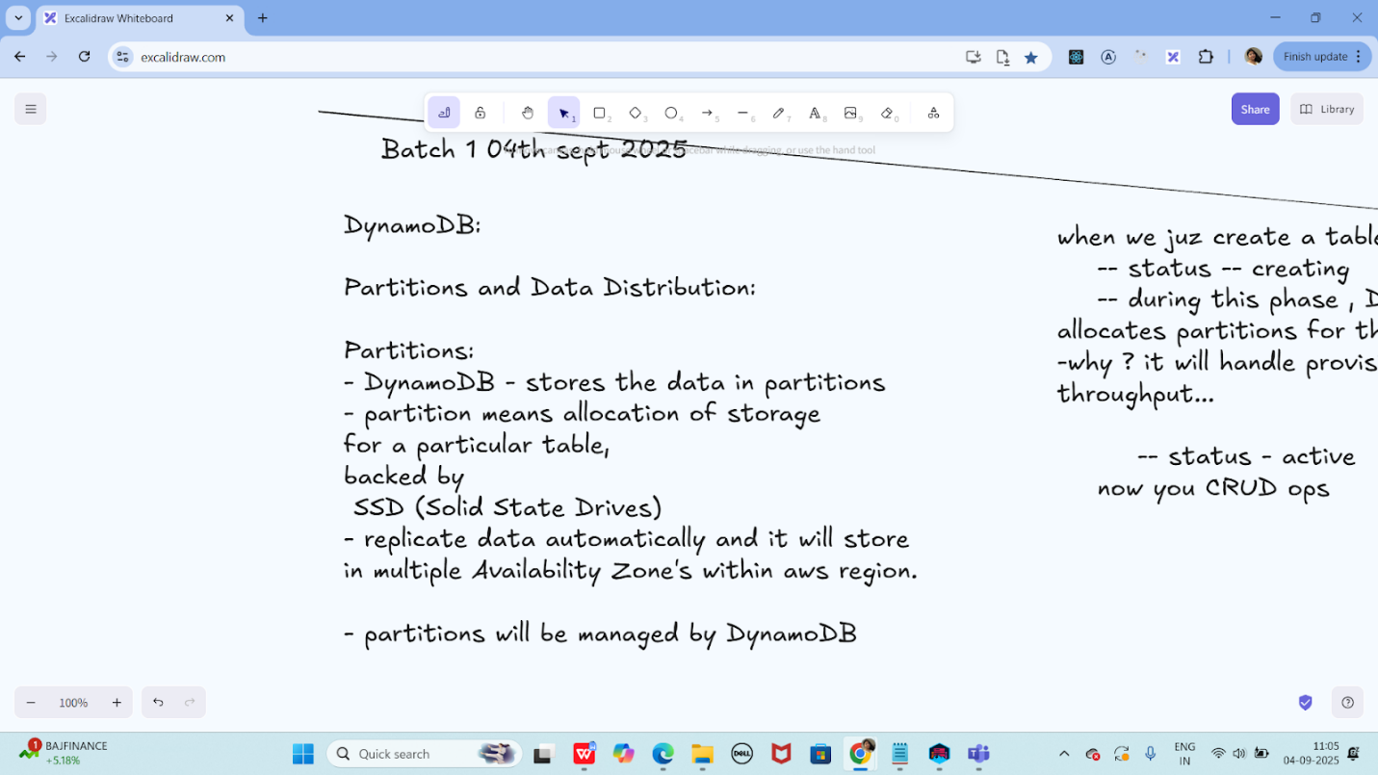

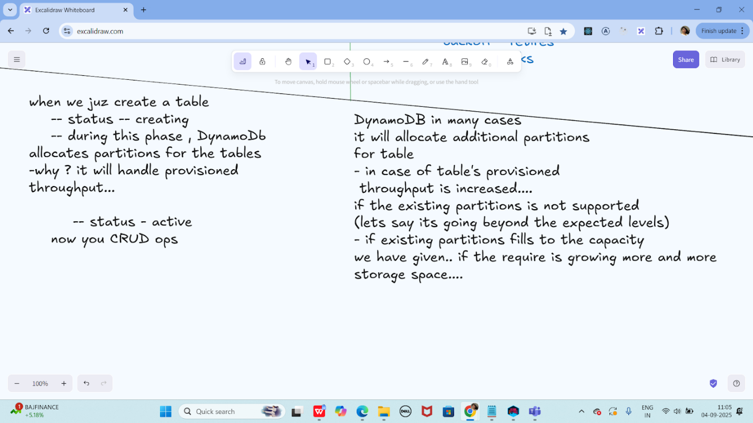

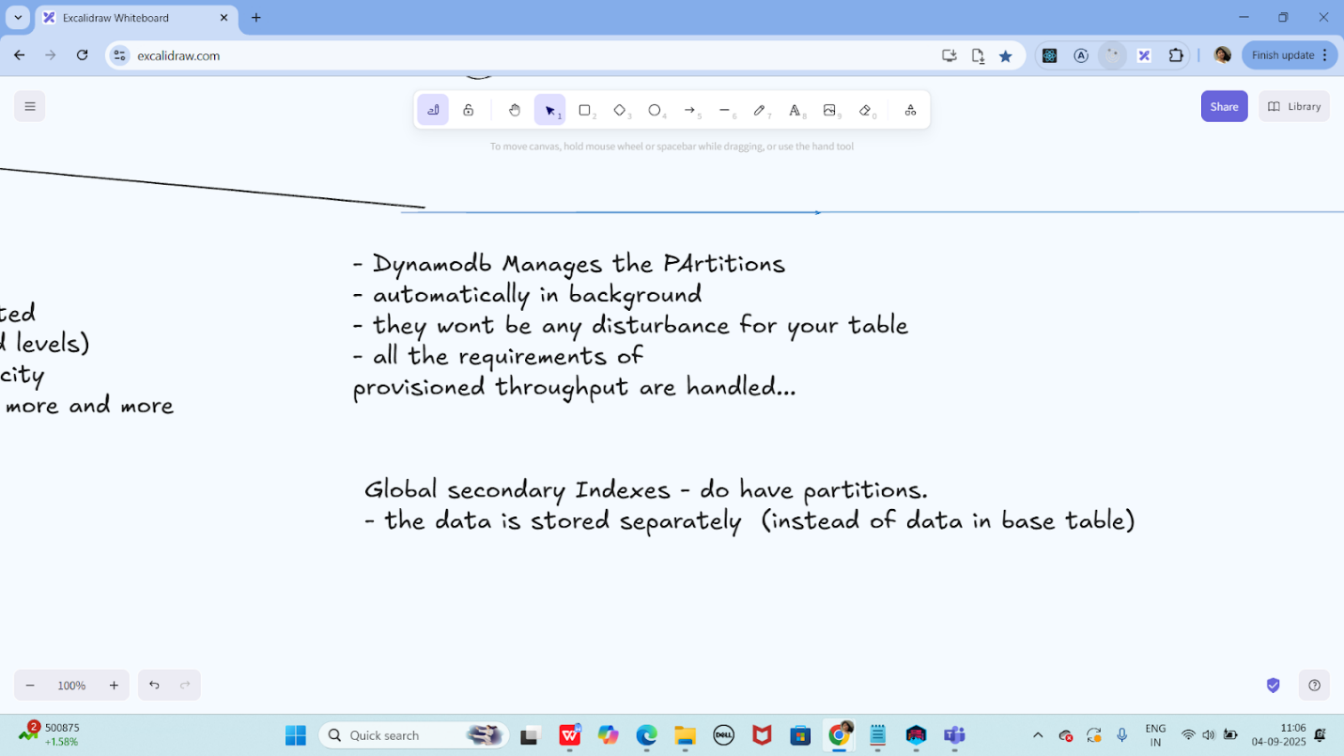

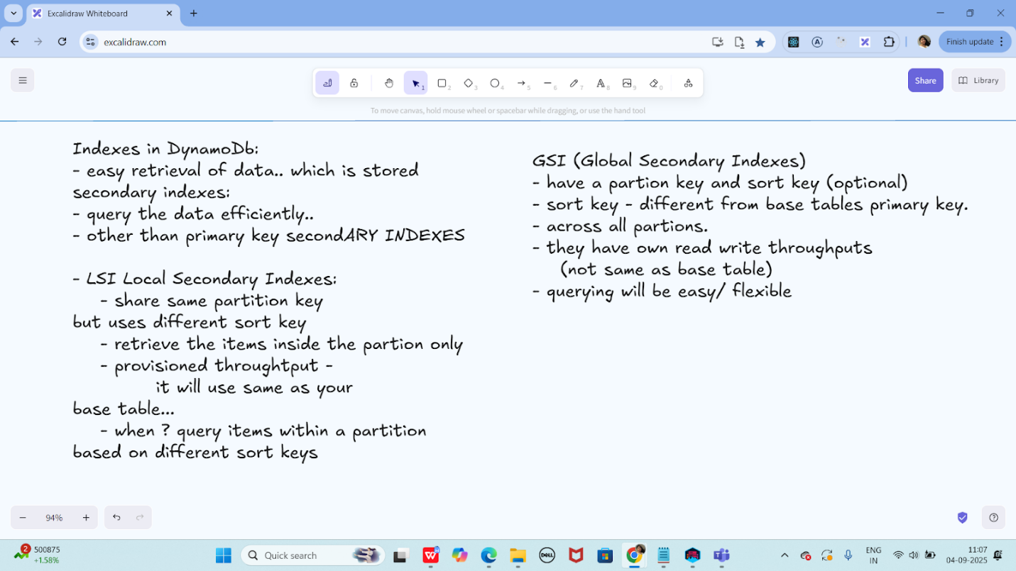

Efficient Key Design:

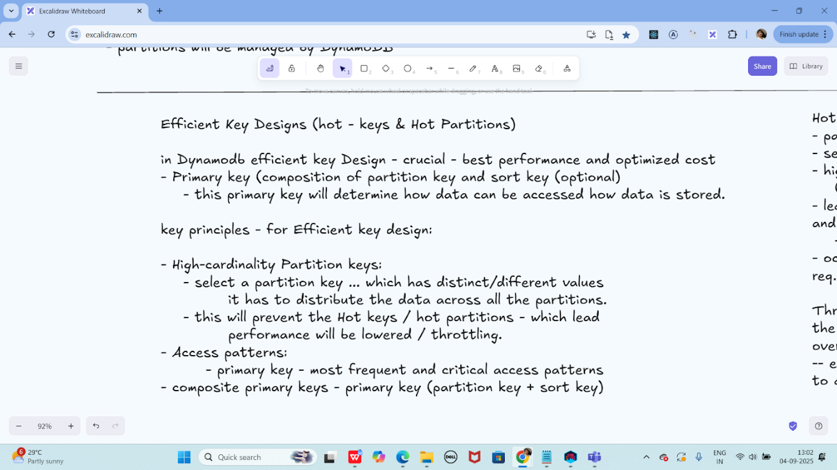

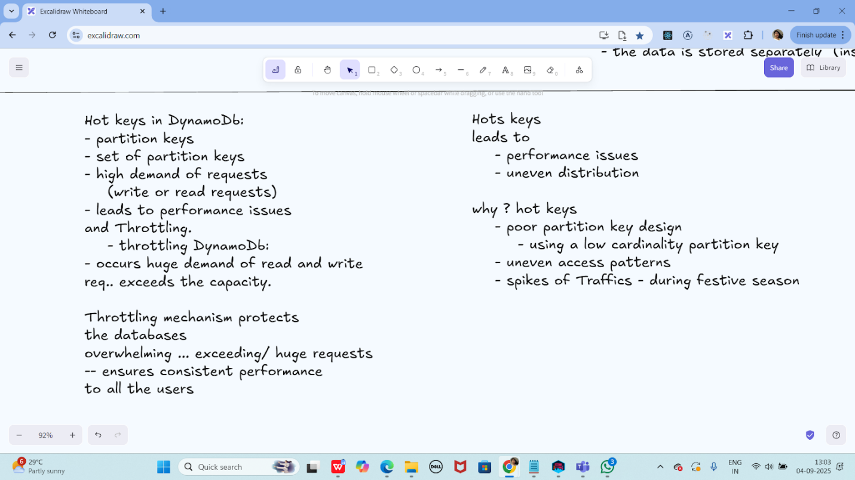

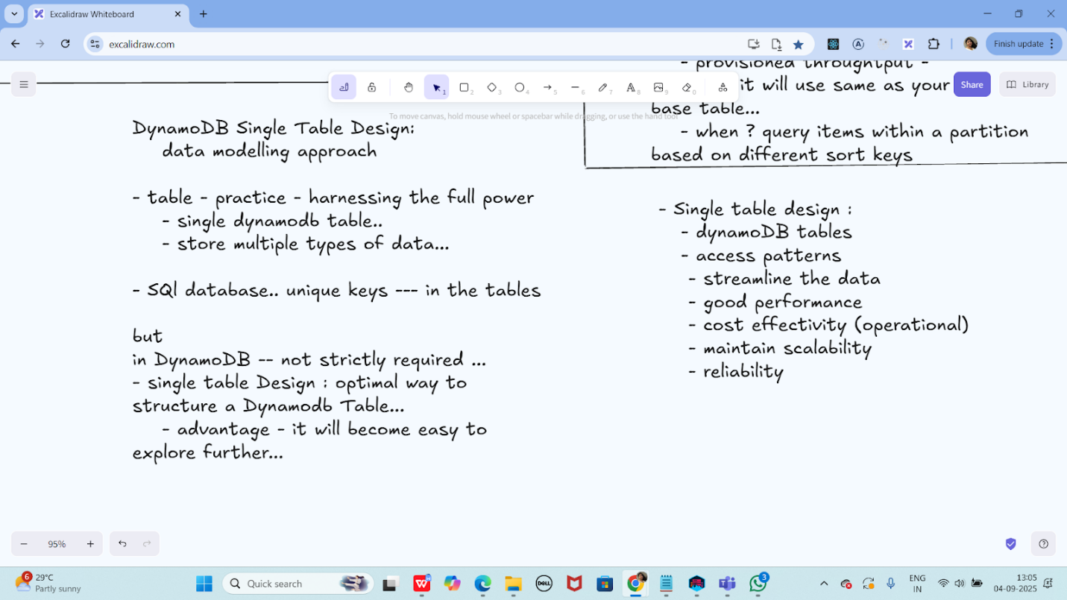

Task 02:

What are multivalue sorts or filters..? Explain briefly..

A multivalue sort involves using conditions on the sort key to retrieve items that match a range or pattern of values.
Definition:
A way to retrieve multiple sorted items by specifying a range (BETWEEN), prefix (BEGINS_WITH), or comparison (e.g., >=, <) on the sort key during a Query.

🔹 Multivalue Filter:
A multivalue filter allows you to retrieve items where an attribute matches one of several values using the IN operator or similar conditions.
Definition:
A filtering technique that returns items whose non-key attribute matches one or more specified values, typically using IN, contains, or logical operators in a FilterExpression.

Task 03:

How do you lower the cost of DynomaDB..explain ways to do so…

Ways to Lower DynamoDB Costs (Short Summary)
- Choose Right Capacity Mode
  - Use On-Demand for unpredictable traffic.
  - Use Provisioned for steady workloads.
- Enable Auto Scaling
  - Automatically adjusts capacity — avoids overprovisioning.
- Avoid Scans, Use Queries
  - Queries are targeted and cheaper than full-table Scans.
- Use TTL (Time to Live)
  - Automatically deletes old data — reduces storage cost.
- Fetch Only Needed Attributes
  - Smaller item size = fewer RCUs/WCUs used.
- Use DAX (Caching)
  - Reduces read costs by caching frequent reads.
- Reserve Capacity (if provisioned)
  - Prepay and save up to 70% for steady workloads.
- Optimize Table Design
  - Avoid hot partitions and redundant writes.

=======================================================================================================================================================================

Info box:

Excalidraw updated at 11.05

https://excalidraw.com/#json=QkKS8kaMr61IO2OuVmyy5,UGs5LYSkL0C5LM1eFOTffQ

Excalidraw updated at 13.01

https://excalidraw.com/#json=M67BNiIL9iNISXSRzaZpW,mfnzHw8ap2eEWQ57QEM0_w

Ways to reduce code - dynamodb — doc in Module 4 Dynamodb folder

https://drive.google.com/drive/folders/19jURMCjQRnl-j56VLupBhuCgkSr7oLrf?usp=sharing

Amazon AWS dynamoDb doc for reference…

https://docs.aws.amazon.com/amazondynamodb/latest/developerguide

CPS-user-stories link – asked by Priya

https://docs.google.com/document/d/1cHdvgX-qlfIHPl4ryMtQOcfcSWZw7Dqv/edit?usp=sharing&ouid=103020917863623365252&rtpof=true&sd=true

Project doc link..

https://drive.google.com/drive/folders/1JxEfQiKEiW9hq1YyCkpbGxXkkfoO2PjQ?usp=sharing

