Day34
Mohammed Arsalain
mobarsal@amazon.com
Day 34 - 10th Sept 2025

Task 01:

Create a java program to retrieve dynamodb table records and display..
Done

TASK 02:

Create a java program to create a table and insert 2 items .. the NOSQl workbench we should be able to see the table updated.

Done

Task 03:

Key Features of DynamoDB
- Fully Managed
  - No servers to manage — AWS handles scaling, replication, and availability.
- High Performance at Scale
  - Millisecond latency at any scale (up to millions of requests/sec).
- Flexible Data Model
  - Supports key-value and document data types (JSON-like).
- Automatic Scaling
  - Adjusts capacity based on traffic (with Auto Scaling).
- On-Demand or Provisioned Capacity
  - Choose cost model based on workload needs.
- Built-in Security
  - Integration with IAM, encryption at rest, and VPC endpoints.
- Global Tables
  - Multi-region, active-active replication for low-latency global apps.
- Time to Live (TTL)
  - Automatically delete expired items to save storage.
- DAX (DynamoDB Accelerator)
  - In-memory caching for faster read performance.
- Streams
- Capture real-time changes to items for event-driven applications.

Task 04:

Advantages of DynamoDB
- Fully Managed
  - No need to manage servers, backups, or replication.
- High Performance
  - Low-latency reads and writes at scale (milliseconds).
- Scalable
  - Automatically scales to handle millions of requests per second.
- Flexible Schema
  - No fixed schema; supports key-value and document data.
- High Availability & Durability
  - Data is replicated across multiple Availability Zones.
- Built-in Security
  - Encryption, fine-grained access control, and VPC support.
- Global Tables
  - Multi-region replication for global applications.
- TTL & Streams
  - Automatically delete old data and react to changes in real time.
Disadvantages of DynamoDB
- Complex Querying
  - Limited query capabilities (no joins, limited filtering).
- Cost Management
  - Can get expensive if not optimized (especially with On-Demand).
- Item Size Limit
  - Max item size is 400 KB.
- Eventually Consistent Reads (by default)
  - Strong consistency must be explicitly requested.
- Learning Curve
  - Requires careful data modeling (e.g., single-table design for efficiency).
- No Native Full-Text Search
  - Requires integration with tools like OpenSearch for advanced searches.

Task 05:

Where do we use DynamoDB (use cases of DynamoDB)

Use Cases of DynamoDB
- User Profiles & Authentication
  - Store user accounts, preferences, login sessions.
  - Example: Social media or mobile apps.
- Real-Time Gaming
  - Track player sessions, scores, and game state instantly.
- IoT Data Storage
  - Collect and store telemetry data from devices at high speed.
- E-commerce Applications
  - Shopping carts, product catalogs, inventory tracking.
- Content Management Systems (CMS)
  - Store articles, comments, metadata, tags, etc.
- Leaderboards & Rankings
  - Real-time updates of top users or scores.
- Chat Applications
  - Store chat history, messages, and user presence.
- Event Logging & Audit Trails
  - Scalable, time-stamped storage for logs and events.
- Serverless Backends
  - Used with AWS Lambda for fully serverless apps.
- Session Management
- Manage active sessions with TTL (auto-expiry).

Task 06:

What is DynamoDBMapper?
DynamoDBMapper is a high-level Java library provided by AWS SDK that makes it easier to interact with Amazon DynamoDB by mapping Java objects (POJOs) to DynamoDB tables.
• Automatically maps Java classes to DynamoDB tables and attributes using annotations.
• Supports CRUD operations easily: save(), load(), delete(), query(), scan().
• Handles data type conversion automatically.

Task 07:

What are DynamoDb Projections?

In DynamoDB, a projection refers to the set of attributes that are copied from a table into a secondary index (Global Secondary Index or Local Secondary Index).
Type | Description
ALL | Includes all attributes from the table in the index.
KEYS_ONLY | Includes only the partition and sort keys (primary keys).
INCLUDE | Includes specific attributes that you choose.

Task 08:

How can you say that DYnamoDB prevents data loss?

How DynamoDB Prevents Data Loss
- Data Replication Across Multiple Availability Zones (AZs)
  - DynamoDB automatically replicates your data synchronously across at least three geographically separated AZs within an AWS Region.
  - This ensures durability and fault tolerance—even if one AZ fails, your data is safe in others.
- Durable Storage on SSDs
  - Data is stored on highly durable solid-state drives (SSDs) designed for 99.999999999% (11 nines) durability.
- Automatic Backups and Point-in-Time Recovery (PITR)
  - You can enable automatic backups or create manual backups anytime.
  - PITR allows restoring your table to any second in the last 35 days, protecting against accidental writes or deletes.
- Atomic Writes and Conditional Updates
  - Ensures consistency during write operations, preventing partial writes or data corruption.
- Fault-Tolerant Architecture
  - DynamoDB’s distributed design handles hardware or software failures without losing data.

Task 09:

What is in-place atomic updates means ? does dynamoaDB supports?

Yes! DynamoDB supports in-place atomic updates through its UpdateItem API with atomic update operators such as:
- ADD — increment/decrement numbers or add elements to sets
- SET — modify or add attributes
- REMOVE — delete attributes

Why is this Important?
- Ensures data consistency in concurrent environments.
- Improves performance by reducing read-before-write operations.
- Prevents race conditions when multiple clients update the same item.

Task 10:

What are Streams in DynamoDB?

DynamoDB Streams is a feature that captures a time-ordered sequence of item-level changes (like inserts, updates, and deletes) in a DynamoDB table.

Key Points:
- Records changes to items in the table.
- Stores these changes as stream records for up to 24 hours.
- Enables event-driven architectures by reacting to data changes.

Task 11:
What are DynamoDb Pricing Tiers?

Capacity Modes (Pricing Models)
- On-Demand Capacity
Pay per request (read/write) without provisioning capacity.
Good for unpredictable workloads.
- Provisioned Capacity
Pay for a set number of Read Capacity Units (RCUs) and Write Capacity Units (WCUs).
Cheaper for steady, predictable workloads.
Can use Auto Scaling to adjust capacity automatically

Task 12:

Do you have any max limit for Item Size in DynamoDb? If so what is it?

- The maximum size of a single item (including all attribute names and values) is 400 KB.

Task 13:

At a max of how many GSI’s Global Secondary Indexes can you create in a table?
You can create up to 20 Global Secondary Indexes (GSIs) per DynamoDB table.

Task 14:

What is DynamoDb Accelarator?

DynamoDB Accelerator (DAX) is a fully managed, in-memory caching service for DynamoDB that improves read performance by providing microsecond latency for eventually consistent reads.

Tsk 15:

What are DynamoDB Global tables?

Global Tables are a DynamoDB feature that provides multi-region, fully replicated tables, allowing you to build globally distributed applications with low-latency access to data anywhere in the world.

Task 16:

What are indexes and Secondary indexes in DynamoDB?

• Index in DynamoDB: A data structure that lets you query the table using attributes other than the primary key.
• Secondary Indexes: Additional indexes you create to enable queries on different keys.
- Global Secondary Index (GSI):
  - Can have different partition and sort keys from the main table.
  - Supports queries across all partitions.
  - Eventually consistent reads.
- Local Secondary Index (LSI):
  - Uses the same partition key as the main table but a different sort key.
  - Created only at table creation.
  - Supports strongly consistent reads.

Task 17:

What are Hot Keys and Hot Partitions?

- Hot Keys:
Specific partition key values that receive a disproportionately high amount of traffic (reads or writes), causing uneven load.
- Hot Partitions:
Partitions in DynamoDB that store those hot keys, resulting in throttling or degraded performance because the traffic is too concentrated on a small subset of partitions.
Why it matters:
DynamoDB partitions capacity across partition keys, so if a few keys get heavy traffic, they become “hot,” leading to performance bottlenecks.

Task 18:

What are Table level operations and Item level operations in DynamoDB?

able-level operations:
- Actions that affect the entire table or its structure.
- Examples:
  - Creating or deleting a table
  - Updating table settings (like throughput capacity)
  - Describing table metadata
  - Listing tables

Item-level operations:
- Actions that operate on individual items (rows) in the table.
- Examples:
  - PutItem (add or replace an item)
  - GetItem (read an item)
  - UpdateItem (modify attributes)
  - DeleteItem (remove an item)
  - Query and Scan (retrieve multiple items based on criteria)

===========================================

Pending Tasks:

Task 06:

What is DynamoDBMapper?
12.03 to 12.08

INfo Box:

<!-- SLF4J Simple Logger -->
<dependency>
<groupId>org.slf4j</groupId>
<artifactId>slf4j-simple</artifactId>
<version>2.0.16</version>
</dependency>

By Sudipto to remove errors.. SLF4J logger error

DynamoDBMapper classes

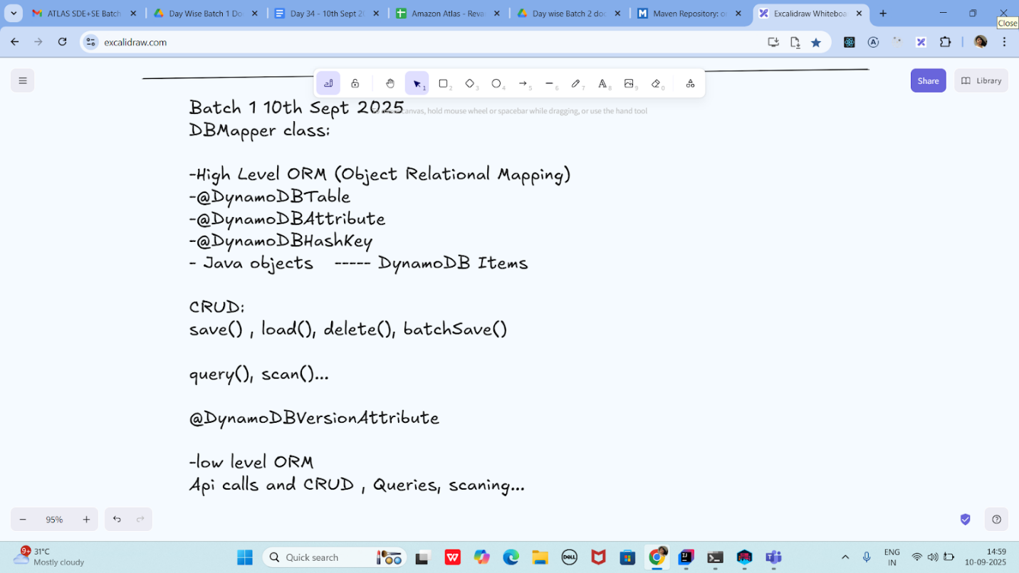

package org.example;
import lombok.Data;

import java.sql.Struct;
import java.util.List;

@Data
@DynamoDBTable(tableName="Students")
class Students {
@DynamoDBHashKay(attributeName="ID")
private String ID;

@DynamoDBAttribute(attributeName="SName")
private String Name;
}
//DynamoDB Access
class DynamoDBAccess {
private DynamoDBMapper Mapper = new DynamoDBMapper((AmazonDynamoDB) AmazonDynamoDBClientBuilder.standard().build());

public Students getItem(Students item) {
return Mapper.load(Students.class, item.getID());
}

public void saveItem(Students item) {
Mapper.save(Item);
}

public List<Students> getItems(Students item) {
return Mapper.query(Students.class, new DynamoDBQueryExpression().withHashKeyValues(item));
}

}
public class DynamoDBMapperClass {

public static void main(String[] args) {

}
}

Lombok dependency
<dependency>
<groupId>org.projectlombok</groupId>
<artifactId>lombok</artifactId>
<version>1.18.20</version>
<scope>provided</scope>
</dependency>

—--------------------------------------------------------------

For Kinnera:

https://docs.aws.amazon.com/amazondynamodb/latest/developerguide/DynamoDBLocal.DownloadingAndRunning.html

Download the zip file .. for DynamoDBlocar.jar file..

Then extract it…

Open the cmd from the extracted location and then type the below command.

java -Djava.library.path=./DynamoDBLocal_lib -jar DynamoDBLocal.jar -sharedDb

Once the above cpmmand is running

Check for the list

aws dynamodb list-tables --endpoint-url http://localhost:8000

==========================================================================================================================
Delete operation - for ref – Kinnera,,,

package org.example;

import software.amazon.awssdk.auth.credentials.AwsBasicCredentials;
import software.amazon.awssdk.auth.credentials.StaticCredentialsProvider;
import software.amazon.awssdk.regions.Region;
import software.amazon.awssdk.services.dynamodb.DynamoDbClient;
import software.amazon.awssdk.services.dynamodb.model.AttributeValue;
import software.amazon.awssdk.services.dynamodb.model.GetItemResponse;
import software.amazon.awssdk.services.dynamodb.model.ScanRequest;
import software.amazon.awssdk.services.dynamodb.model.ScanResponse;

import java.net.URI;
import java.util.HashMap;
import java.util.Map;

public class DeleteItem {
public static void main(String[] args) {
System.out.println("hello Delete item by id from table in DynamoDB");
AwsBasicCredentials awsCreds = AwsBasicCredentials.create("fakeAccesskey","fakeSecretKey");

DynamoDbClient client = DynamoDbClient.builder()
.endpointOverride(URI.create("http://localhost:8001"))
.region(Region.AP_SOUTH_1)
.credentialsProvider(StaticCredentialsProvider.create(awsCreds))
.build();

String tableName = "Employees01";
int delId = 1002;

Map<String, AttributeValue> item = new HashMap<>();
item.put("ID", AttributeValue.builder().n(String.valueOf(delId)).build());

GetItemResponse getResponse =client.getItem(builder -> builder.tableName(tableName).key(item));
client.deleteItem(builder -> builder.tableName(tableName).key(item));

System.out.println("items after deletion");
ScanRequest req = ScanRequest.builder().tableName(tableName).build();
ScanResponse resp = client.scan(req);

for(Map<String, AttributeValue> dbitem : resp.items()) {
System.out.println(dbitem);
}
client.close();

}
}

—-- for reference

Check codes for reference → Dynamodb folder .. for CRUD operations…

