NED University of Engineering and Technology, Karachi
Computer Science and Information Technology
COMPLEX COMPUTING PROBLEM (CCP)
PROJECT SUBMISSION

Knowledge-Based Systems (CT-359)
Project Title | Intelligent Knowledge-Based System for Industrial Equipment Fault Diagnosis and Maintenance Decision Support  Case study: Centrifugal Pump Knowledge-Based System
Submission Date

Student Details
Sr. No. | Student Name | Roll No.
1 | Arsalna Sheikh | CT-24159
2 | Amna Faisal | CT-24013
3 | Kashan Baig | CT-24178
4 | Saad Baig | CT-24184
5 | Syed Azan | CT-24193

Table of Contents
1. Project Instructions 3
2. Problem Statement 3
3. Problem Description / Project Context 3
4. Problem Analysis 4
4.1 Problem Understanding 4
4.2 Stakeholders and Their Requirements 4
4.3 Constraints and Conflicting Requirements 5
4.4 Root Cause / Requirement Identification 5
4.5 Assumptions 6
5. Knowledge Representation and KBS Design 6
5.1 Selected Knowledge Representation Formalism 6
5.2 Knowledge Base / Ontology / Rule Base 7
5.3 Inference Mechanism 9
5.4 Conflict Resolution Strategy 10
5.5 Explanation Facility 11
5.6 System Architecture 12
6. Dataset / Knowledge Sources 13
6. Implementation 15
6.1 Software / Tools / Libraries 15
6.2 Modules and Components 15
6.3 Code Structure 16
6.4 User Inputs and Outputs 16
7. Testing and Results 18
8. Evaluation, Limitations and Conclusion 20
8.1 Evaluation of the Proposed Approach 20
8.2 Limitations 21
8.3 Future Improvements 21
8.4 Conclusion 21
9. References 22

1. Project Instructions
- Complete all sections using the prescribed template. Replace bracketed placeholders with project-specific information.
- Submit the complete source code, dataset / knowledge base files, project report, and presentation according to the submission instructions.
- The implementation must be executable and demonstrable during the viva.
- Any assumptions made to complete the problem must be clearly stated and justified.
- All external datasets, knowledge sources, libraries, tools, or publications used in the project must be cited.
- The report and presentation must follow the prescribed template and be submitted on time.
This report follows the prescribed template [C-2]. Assumptions are stated in Section 4.5, and all sources, the dataset and the software tools are cited in Sections 6 and 9.

2. Problem Statement
- Explain how a Knowledge-Based System can represent industrial equipment knowledge, including equipment, components, symptoms, faults, causes, and maintenance actions, using an appropriate knowledge representation formalism. (CLO 1)
- Analyze the given industrial equipment fault-diagnosis problem by identifying incomplete requirements, stakeholder needs, relationships, constraints, and suitable knowledge-based approaches for developing an effective solution. (CLO 2)
- Evaluate suitable knowledge representation methods and inference algorithms for diagnosing equipment faults and recommending maintenance actions, and justify the selected approach based on accuracy, explainability, safety, cost, and system requirements. (CLO 3)
Table 1: Where each part of the problem statement [C-1] is answered
Element | Sections | Answer in brief
Knowledge representation (CLO 1) | 5.1, 5.2 | Production rules over a typed relationship graph of equipment, components, symptoms, faults, causes, tests, actions and safety rules, with provenance on every record
Problem analysis (CLO 2) | 4.1-4.5 | Stakeholders, requirements, constraints, conflicts and the incomplete requirements of the brief, each resolved by a recorded decision
Method evaluation (CLO 3) | 5.1, 5.3, 8.1 | Seven approaches compared on accuracy, explainability, safety, cost and system requirements; stratified forward chaining selected

3. Problem Description / Project Context
A process plant operates a fleet of centrifugal pump sets: each comprises the pump, its electric motor, coupling, baseplate, and the suction and discharge piping with their valves. The knowledge needed to diagnose a misbehaving pump is heterogeneous and scattered across manufacturers' manuals and troubleshooting lists, operator observations (noise, leakage, loss of prime), maintenance records, expert experience and condition-monitoring sensors (vibration, temperatures, pressures, flow and motor current). Faults share symptoms: low flow, for example, can result from impeller blockage, discharge restriction, worn wear rings, air ingress or cavitation, and each fault has several possible root causes. The available information is frequently incomplete, because observations go unrecorded or sensors are missing, and it can be contradictory, as when an operator report disagrees with a sensor or two pressure readings are physically inconsistent.
The stakeholders' requirements conflict. Operations wants equipment availability and production continuity; maintenance wants the most probable fault, its cause and the cheapest effective action; and safety requires dangerous states such as dry running to be flagged regardless of cost. The organisation therefore needs a Knowledge-Based System that represents this knowledge in a traceable form, infers possible faults and root causes from whatever evidence is available, states clearly what is unknown or contradictory, recommends maintenance actions with safety precautions, priority, cost and downtime, and explains every conclusion. This project designs, implements and evaluates such a system for centrifugal pump sets, using a synthetic dataset and knowledge from published engineering sources.

4. Problem Analysis

4.1 Problem Understanding
Fault diagnosis here is abductive: from observed effects, the system must propose the faults and root causes that best explain them. A knowledge-based approach suits the problem for three reasons:
- the engineering sources state the knowledge explicitly and causally, so it can be represented directly and cited;
- no real labelled plant data is available to train or validate a statistical model;
- users must see why a fault is suggested, and what is still unknown, before they stop a pump or open its casing.
The problem has three levels:
- evidence: readings and observations become symptom states;
- diagnosis: symptoms lead to faults, and faults to root causes and fault chains;
- decision support: tests, actions, safety warnings, priority, cost and downtime.
One equipment class, the centrifugal pump set, is modelled in depth. Pump sets have hydraulic, mechanical, sealing and electrical subsystems with overlapping but explainable symptoms, and an independent engineering literature exists for them [S-01]. The brief mentions "different types of industrial equipment"; the knowledge-base schema is equipment-generic, but only this class is populated (Section 8.2).

4.2 Stakeholders and Their Requirements
Table 2: Stakeholders, needs and how the system meets them
Stakeholder | Needs | How the KBS meets them
Operator | Simple entry; immediate warning of danger | Present / absent / unknown observations; safety warnings shown first
Maintenance technician | Likely fault, cause, first steps, precautions | Ranked hypotheses; candidate causes with confirming tests; prioritised actions with precautions
Reliability engineer | Traceable reasoning; editable knowledge | Rule-by-rule explanation with sources; knowledge stored as validated data
Safety officer | Conservative handling of hazards | Safety rules checked against every hypothesis, including pending ones
Production manager / management | Availability; cost and downtime visibility | Qualitative cost and downtime classes; Unknown outcome instead of a shutdown on weak evidence
Knowledge engineer | Maintainable, reproducible knowledge | Source register, support levels, validator, automated tests

Table 3: Requirements derived from the stakeholder needs
Functional requirements | Non-functional requirements
FR1 accept equipment data, measurements, three-state observations and test results  FR2 derive symptoms with equipment-specific thresholds  FR3 infer faults, causes and chains by rules; keep competing hypotheses  FR4 handle missing and conflicting evidence explicitly  FR5 safety warnings independent of ranking  FR6 actions with precautions, priority, cost and downtime  FR7 request discriminating tests and missing observations  FR8 explain every conclusion with evidence, rules and sources | NFR1 traceability: every knowledge item cites a source and support level  NFR2 maintainability: knowledge stored as data, not code  NFR3 honest uncertainty: likelihood and knowledge support kept separate; no forced diagnosis  NFR4 interactive response on a laptop  NFR5 reproducibility: fixed seed, scripted pipeline, automated tests  NFR6 robustness: invalid inputs rejected before any diagnosis

4.3 Constraints and Conflicting Requirements
The main constraints were:
- no real plant data and no access to a plant expert;
- no access to the numeric values in ISO 10816-7 [S-14] and ANSI/HI 9.6.1 [S-15], so no threshold could be validated;
- academic time and resources, which favoured a transparent, testable design over a complex probabilistic model.
Table 4 lists the conflicting requirements and how the design resolves each.
Table 4: Conflicting requirements and their resolution
Conflict | Resolution
Safety vs production continuity | Safety rules are checked against every hypothesis and are never suppressed by ranking, cost or downtime; the stop-pump action is recommended only when dry running is at least possible
Cost vs certainty | Discriminating and confirming tests are requested before invasive work; opening the pump carries the isolation precaution SAF-03
Completeness vs honesty | Explicit Unknown outcome and pending hypotheses with information requests; unknown is never treated as absent
Absolute vs equipment-relative limits | Flow, head and current are judged as % of the rated or healthy-baseline value; absolute fallback limits only as an explicit option
Conflicting sources | Two relationships linking blockage and discharge restriction to high motor current are contradicted for radial pumps by [S-01] (p.17); they are kept as Disputed (MA-23, MA-53), and rule N-01 lowers those faults when current is high on a radial pump
Hazard vs priority vs cost | Kept as separate attributes; none of them changes the diagnosis

4.4 Root Cause / Requirement Identification
The brief is deliberately incomplete (CPA-9 [C-3]). Knowledge acquisition also recorded 13 knowledge conflicts and 17 knowledge gaps, such as the absence of equipment context, root-cause knowledge, provenance, negative evidence and an "unknown" state; each became an explicit design requirement. Table 5 shows how the unclear requirements of the brief were resolved.
Table 5: Unclear requirements of the brief and the decision taken
Requirement | Issue | Decision
"different types of equipment" | Credible knowledge only for a well-documented class | One class in depth; generic schema
"historical records" | No real records | Synthetic, deliberately dirty dataset, used for consistency testing only
"expert experience" | No access to an expert | Published sources with evidence grading; unsupported knowledge marked Unvalidated
"incomplete and conflicting information" | Undefined | Three-state observations; five conflict types (Section 5.4)
"cost", "downtime", "priorities" | No data or definition | Qualitative classes and a three-level priority policy, all Unvalidated
Diagnostic thresholds | Not specified; standards not readable | Stored as data with provenance; all provisional; site limits allowed where no value is sourced
"explanation" | Depth undefined | Rule-by-rule trace with evidence, limits, sources and assumptions

4.5 Assumptions
- A1 The equipment is a centrifugal pump set. Pump design (radial / mixed / axial) is entered when a rule depends on it; otherwise those rules stay unused.
- A2 All numeric thresholds are provisional. Each records its support level, and site values can be supplied where the knowledge base has none.
- A3 The dataset is synthetic (seed 359) and is not evidence of real-world accuracy.
- A4 Independent sources give Strong support, manufacturer or trade sources Moderate, project-authored knowledge Unvalidated.
- A5 User observations are trusted unless they conflict with a sensor or another observation; conflicting evidence becomes unknown.
- A6 Project-assigned qualitative cost and downtime classes are acceptable placeholders until site data exists.
- A7 A case is a snapshot; trends such as "rapid temperature rise" are entered as observations.
- A8 Site safety procedures take precedence over the system's messages.

5. Knowledge Representation and KBS Design

5.1 Selected Knowledge Representation Formalism
The formalism is hybrid:
- frame-like records: entities with typed attributes, each attribute with its own provenance;
- typed relationships: 15 relationship types forming a lightweight ontology / knowledge graph (Figure 1);
- production rules: IF-THEN rules that reference the graph.
Every record, relationship and rule carries source_ids, a source_locator and a support level. Rules match the way troubleshooting sources state their knowledge and are easy to explain. The graph keeps the structure fault → cause → test → action reusable without writing a rule for each link, and the provenance separates what the system concludes from how well the knowledge behind it is supported.
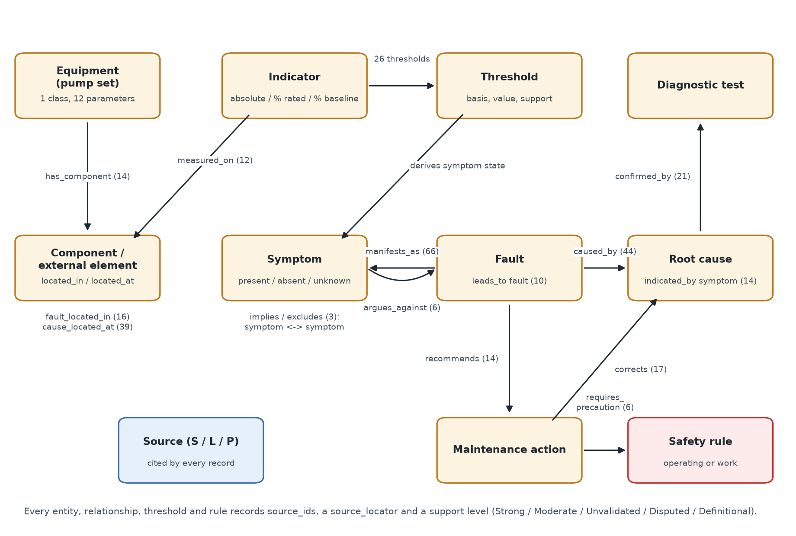
Figure 1: Knowledge model: entity types and typed relationships (counts from the validated knowledge base)
Method assessment (CLO 3). Table 6 compares the alternatives qualitatively; it is a design assessment, not an empirical benchmark.
Table 6: Assessment of representation and inference alternatives
Approach | Accuracy (given the knowledge and data) | Explainability | Safety | Cost / effort | Fit
Stratified forward chaining (selected) | Limited by rule coverage and provisional thresholds; no training data needed | High | Safety rules checked for every hypothesis | Moderate | Good: evidence arrives first; many hypotheses open at once
Backward chaining | Similar | High | Only for pursued goals | Moderate | Suits questioning one goal, not screening all faults
Weighted evidence scoring | Depends on unsourced weights | Medium; scores look like probabilities | Typically top fault only | Low | Poor: no unknown state or root causes
Bayesian network | Potentially high with good probabilities | Medium | Possible | High: probabilities unavailable | Poor: would require invented numbers
Case-based reasoning | Depends on a case library | Medium | Indirect | High: needs real cases | Poor: no case base
Ontology reasoning (OWL) | Good for classification | Medium | Indirect | High tooling cost | Partial: structure adopted without a reasoner
Machine-learning classifier | Unknown on real pumps | Low to medium | Not inherent | Low on synthetic data | Poor: would learn the generator's assumptions

Decision. Forward chaining was selected because diagnosis is data-driven, and a dangerous hypothesis must trigger its warning even when it is not ranked first. A limited goal-directed element is added: a partly satisfied rule makes its fault pending and requests the missing evidence.

5.2 Knowledge Base / Ontology / Rule Base
The knowledge base (knowledge_base/) consists of CSV and JSON files loaded read-only by kbs_engine/knowledge.py (Table 7).
Table 7: Knowledge-base contents (validated)
File | Records | Content
sources.csv | 24 | 16 external engineering sources, 3 research leads, and entries for project-authored knowledge
equipment / equipment_parameters | 1 / 12 | Pump-set class; rated, healthy-baseline and design parameters
components.csv | 14 | Pump, motor, coupling, baseplate, piping and external elements
indicators / thresholds | 12 / 26 | Measured quantities; thresholds with basis (absolute, % rated, % baseline) and support level
symptoms.csv | 23 | 14 sensor-derived, 7 observed, 2 trend
faults.csv | 14 | 12 faults and 2 outcomes (Normal, Unknown) with hazard, cost and downtime classes
root_causes / diagnostic_tests | 39 / 12 | Causes in 13 categories; tests with result values
maintenance_actions / safety_rules | 17 / 4 | Actions with purpose, competence, cost and downtime; safety rules
relationships.csv | 282 | 15 relationship types (Figure 1)
diagnostic_rules.json | 36 | 19 fault, 3 negative-evidence, 9 cause, 2 chain and 3 test-request rules
kb_meta.json | - | Vocabularies (support levels, statuses, bases, cost/downtime classes, priorities) and policies

Knowledge quality. Each item is graded by its best supporting source:
- Strong: independently supported, i.e. stated by an independent source that was read, mainly the DOE / Hydraulic Institute sourcebook [S-01];
- Moderate: manufacturer- or trade-supported only [S-04]-[S-13];
- Definitional: true by definition or design decision;
- Unvalidated: project-authored knowledge without an external source;
- Disputed: contradicted by an independent source in the stated context.
Table 8: Support levels across the knowledge base
Item | Strong | Moderate | Definitional | Unvalidated | Disputed
Relationships (282) | 91 | 55 | 38 | 96 | 2
Rules (36) | 15 | 11 | 4 | 6 | -
Thresholds (26) | - | - | 1 | 25 | -

5 thresholds have no sourced value (THR-03, THR-14, THR-22, THR-23, THR-25); they are used only when the user enters a site limit (Section 6.4). The validator validate_kb.py checks the schema, unique IDs, references, provenance (every item must cite a known source, and support levels must match the source type), vocabularies and rule structure.
Representative rules. Table 9 shows rules from each layer. Condition types are symptoms_all, symptoms_any, symptoms_absent, tests, context (e.g. pump design) and earlier conclusions.
Table 9: Representative rules (from diagnostic_rules.json)
Rule | Layer | IF | THEN | Support | Sources
R-CAV-1 | L2 fault | Crackling / popping noise; (Low suction pressure or Low pump head (differential pressure)) | fault: Cavitation (likely) | Strong | S-01, S-04
R-CAV-2 | L2 fault | NPSH margin check = NPSHA_below_NPSH3_plus_margin | fault: Cavitation (confirmed) | Strong | S-02
R-DRY-1 | L2 fault | No / near-zero flow + Pump fails to prime / loses prime | fault: Dry running / loss of prime (likely) | Moderate | S-01, S-11
R-AIR-1 | L2 fault | Pump fails to prime / loses prime; (Low flow or Low pump head (differential pressure)); NOT No / near-zero flow | fault: Air / gas ingress (likely) | Strong | S-01, S-03, S-11
R-BRG-1 | L2 fault | High overall vibration + High bearing temperature | fault: Bearing failure (likely) | Strong | S-01
R-DIS-2 | L2 fault | Low flow + Low motor current; pump design = radial | fault: Discharge restriction / low-flow operation (possible) | Strong | S-01, S-02
R-WR-1 | L2 fault | Sustained decline in pump performance; NOT High overall vibration | fault: Wear-ring wear (possible) | Unvalidated | S-01
N-02 | L2 negative | NOT Pump fails to prime / loses prime / Low flow | block: Dry running / loss of prime | Definitional | project
R-C-01 | L3 cause | Liquid temperature above design value; Cavitation ≥ possible | cause: Liquid temperature above design (likely) | Strong | S-01
R-C-07 | L3 chain | Impeller damage ≥ likely; Cavitation ≥ possible | chain: Cavitation → Impeller damage | Strong | S-01, S-04
R-T-01 | L4 test request | Cavitation ≥ possible; Air / gas ingress ≥ possible | request: NPSH margin check, Suction-line leak test, Liquid level / submergence check | Definitional | project

Faults. The 12 faults are cavitation, dry running / loss of prime, air / gas ingress, bearing failure, shaft misalignment, mechanical seal failure, impeller damage, impeller blockage / fouling, discharge restriction / low-flow operation, wear-ring wear, motor fault, coupling damage, plus the outcomes Normal and Unknown. Each fault carries a hazard class: CRITICAL: FLT-02; HIGH: FLT-01, FLT-03, FLT-04, FLT-05, FLT-06, FLT-07, FLT-09, FLT-11, FLT-12; MEDIUM: FLT-08; UNASSIGNED: FLT-10. Only the CRITICAL class of dry running is manufacturer-supported [S-06]; the others are Unvalidated.
Cost, downtime and priority. Faults and actions carry qualitative cost_class and downtime_class:
- Values: LOW, MEDIUM or HIGH, or a range such as MEDIUM-HIGH where an action covers steps of different cost.
- Source: project-assigned, with no external source.
- Missing values: UNKNOWN where no value was assigned (ACT-05, ACT-06, ACT-13, ACT-17, FLT-10).
- Status: all Unvalidated. No monetary or time figures are given.
Maintenance priority is a project policy declared in kb_meta.json, also Unvalidated:
- P1-immediate: a make-safe action, or one for a fault with an active safety warning;
- P2-high: an action for a likely or confirmed fault or cause;
- P3-planned: everything else.
Priority ignores hazard, cost and downtime, and never changes a diagnosis. The four safety rules are:
- SAF-01 Dry running stop: Stop or secure the pump according to site procedure; do not continue dry operation (Moderate)
- SAF-02 No continuous zero-flow operation: Do not run continuously at or near zero flow; restore flow to at least Qmin (Moderate)
- SAF-03 Isolate before opening: Isolate the pump before opening it (Unvalidated)
- SAF-04 Qualified electrical personnel: Electrical checks only by qualified electrical personnel (Unvalidated)

5.3 Inference Mechanism
kbs_engine/engine.py performs stratified forward chaining over a working memory (Figure 2). Each layer runs to a fixed point before the next one starts, because later layers use earlier conclusions: for example, cause rule R-C-01 needs cavitation to have been concluded first.
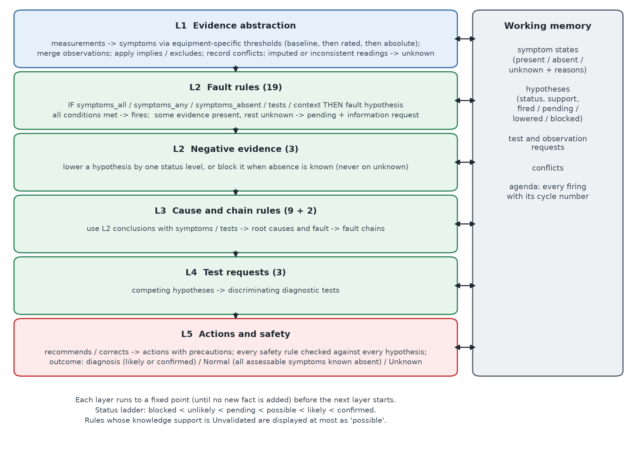
Figure 2: Stratified forward-chaining layers and the working memory
- L1 Evidence abstraction. Each reading is compared with the threshold of the most specific basis available: healthy baseline, then % of rated, then absolute. A user-supplied site limit can stand in for a threshold with no sourced value. Missing, estimated or physically inconsistent readings give unknown, never absent.
- L2 Faults. A rule fires when all its conditions hold. When none fails, some is unknown and some positive evidence is present, the fault becomes pending and the missing items are requested.
- L2 Negative evidence. Lowers a hypothesis by one status level, or blocks it, but only on known absence.
- L3 Causes and chains. Combines fault conclusions with symptoms or test results to conclude root causes and fault chains (e.g. cavitation leading to impeller damage).
- L4 Test requests. Requests discriminating tests when specific hypotheses compete.
- L5 Actions and safety. Recommends actions with their precautions; every safety rule is checked against every hypothesis, regardless of rank.
Status ladder. Each hypothesis has a status (blocked < unlikely < pending < possible < likely < confirmed) and, separately, the support of its best rule. Rules with Unvalidated support are shown at most as possible.
Outcome. The case outcome is one of three:
- Diagnosis: at least one fault is likely or confirmed;
- Normal: nothing is present and every assessable symptom is known to be absent;
- Unknown: anything else. Further investigation is recommended and confirming tests are requested.

5.4 Conflict Resolution Strategy
Table 10: Conflict types and resolution (every detected conflict is reported)
Level | Conflict | Resolution
Data | Sensor state differs from an entered observation of the same symptom | Symptom set to unknown; sensor_vs_observation recorded
Data | Mutually exclusive symptoms present (low/high head SR-02; low/high current SR-03) | Both unknown; mutually_exclusive recorded
Data | No flow present but low flow known absent (SR-01) | Both unknown; implication_violated recorded
Data | Discharge pressure below suction pressure | Both readings and the derived head unknown; inconsistent_measurements; Normal impossible
Data | Value marked as estimated | No evidence derived; reading shown as NOT USED
Rule | Several rules for one hypothesis; evidence against it | Best status kept; negative rules lower or block it (blocking only on known absence)
Hypothesis | Several faults plausible | No forced answer; competing_hypotheses recorded; discriminating tests requested
Knowledge / decision | Sources disagree; safety vs ranking or cost | Support level per item, Disputed links kept, Unvalidated capped; safety independent of ranking

Ranking (status, then support, then number of fired rules, then hazard class) only orders the display. Ruled-out and argued-against hypotheses stay visible with their reasons.

5.5 Explanation Facility
Each hypothesis panel shows the following:
- diagnostic status and knowledge support, side by side;
- hazard class, and cost and downtime, each with its support level;
- a labelled evidence list (Table 11);
- a rule-by-rule "why": the reasoning, stored likelihood, display cap, sources and assumptions.
Readings show the measured value, the value compared, the limit and its support. A user-supplied limit is shown as "site limit entered by the user". A short guide on the page explains outcome, status, support, hazard, cost, downtime and priority. The engine's agenda records every firing, and the full report can be downloaded as text. Figure 3 shows a likely and a pending hypothesis.
Table 11: Evidence labels in the diagnosis panels
Label | Meaning
Present (green) | Observed or measured, and used by a rule that fired (a used test result is labelled Test result)
Absent (grey) | Checked and not found, e.g. an expected symptom that is known to be absent
Unknown (amber) | Not yet known; a pending rule is waiting for it
Not used (muted grey) | Present, but its rule still needs other evidence, so it does not count yet

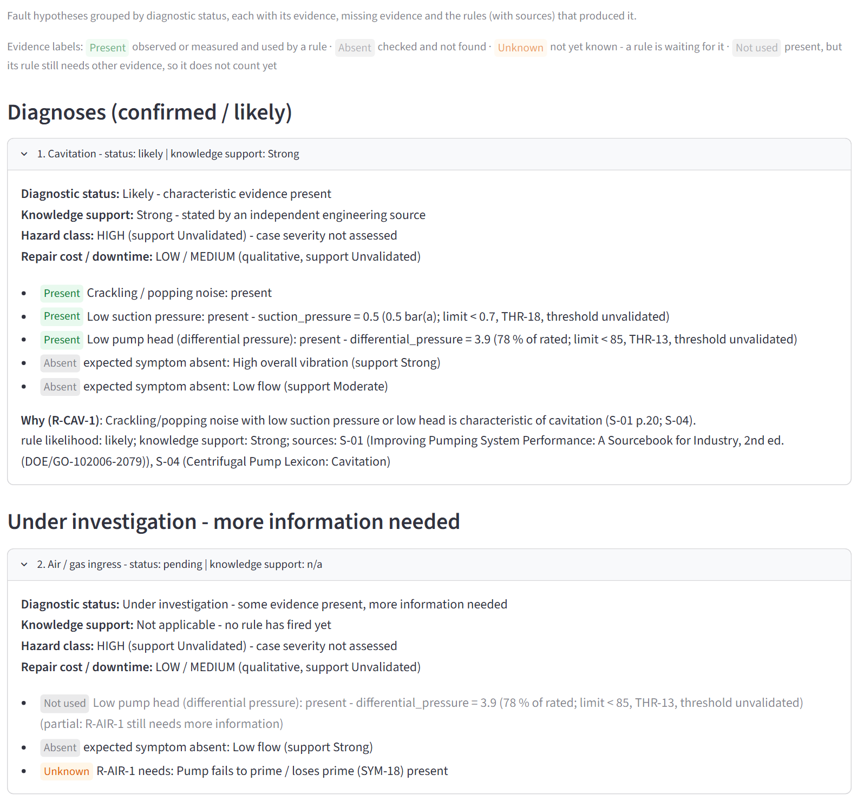
Figure 3: Diagnosis panels for the cavitation example: cavitation likely (Present / Absent evidence) and air ingress pending (Not used / Absent / Unknown evidence)

5.6 System Architecture
Figure 4 shows the layers:
- the Streamlit page collects inputs;
- the UI adapter validates them and builds a Case;
- the inference engine reasons over the knowledge base, which is pure data;
- the decision-support layer produces the report.
Knowledge acquisition populates the knowledge base offline, and the synthetic dataset supplies test cases.
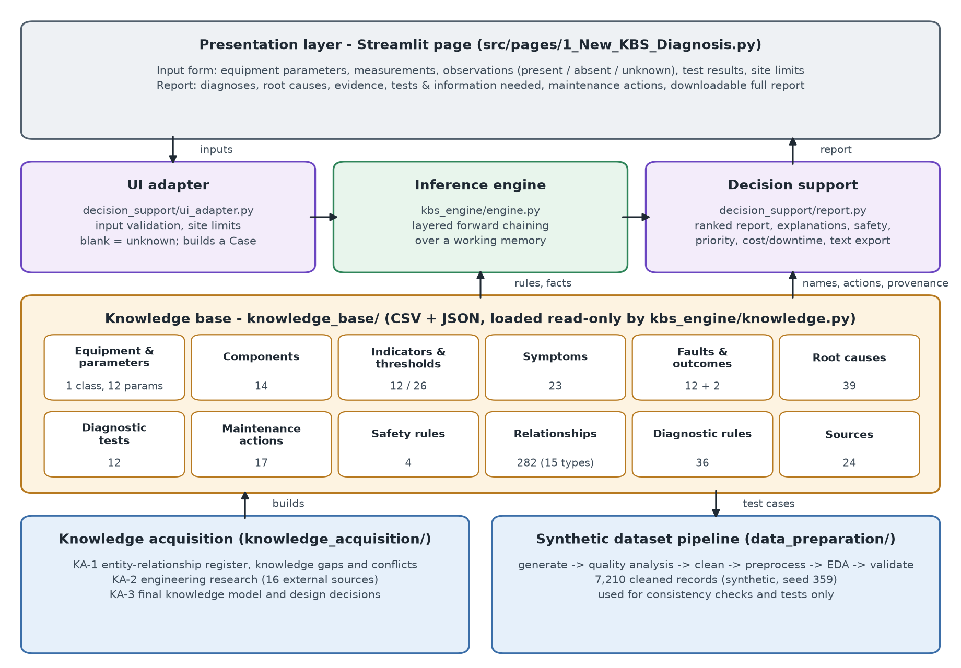
Figure 4: System architecture of the KBS

6. Dataset / Knowledge Sources

Knowledge acquisition
Knowledge was acquired in three documented stages (knowledge_acquisition/):
- KA-1 built an entity-relationship register (81 items) and recorded 13 knowledge conflicts and 17 gaps;
- KA-2 researched 16 external sources, graded each finding as independent, manufacturer or unvalidated, and resolved conflicts such as the direction of motor-current change at low flow [S-01, p.17];
- KA-3 fixed the final model in seven design decisions: fault granularity, faults vs causes, threshold reference, symptom vocabulary, equipment boundary, outstanding sources, and qualitative uncertainty without probabilities.
Implementation added four refinements:
- flow fluctuation and pressure fluctuation kept as separate symptoms;
- motor faults merged into one fault, with electrical supply imbalance kept as a cause;
- support for rated- and baseline-relative measurements;
- knowledge support kept separate from diagnostic likelihood.
No domain expert was interviewed; expert experience is represented only through published sources.

Synthetic dataset
The dataset was generated by the project (data_preparation/, seed 359) and is synthetic: it is not real industrial data and is not independent ground truth. It models:
- 40 pumps of four types over 2023-2025;
- simplified physics: a generic pump curve, load-dependent current, fault signatures, wear increasing with operating hours;
- 19 kinds of data-quality problem, injected so the cleaning stage has realistic work.
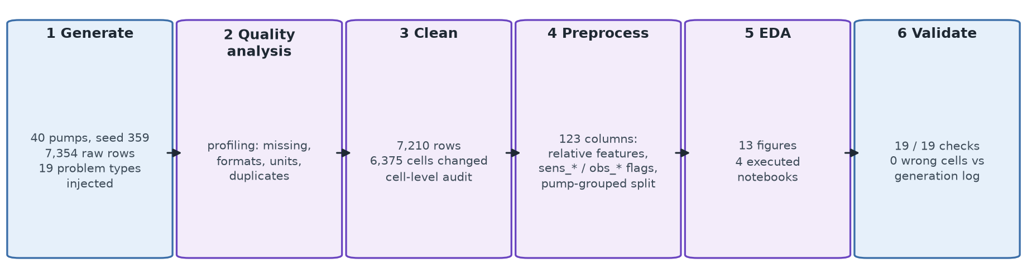
Figure 5: Reproducible data-preparation pipeline
Pipeline results:
- Cleaning: 7,354 raw rows became 7,210; 6,375 cells changed, all logged.
- Preprocessing: 123 columns, including relative features, symptom flags and a split grouped by pump.
- EDA: 13 figures and 4 executed notebooks.
- Validation: 19 of 19 checks pass; 0 of 7,602 corrupted cells were mishandled.
The same project wrote both the corruption and the cleaning rules, so this demonstrates only that the catalogued problems are handled. Generated relationships are simplified, and the costs and downtimes in the data are assumptions. The cleaned records are used only to test the engine (Section 7).

Source and dataset register
Table 12: Dataset and knowledge sources (size of a document = number of KB records citing it; full citations in Section 9)
Source / Dataset | Type | Size / No. of Records | Purpose | Citation / URL
Raw / cleaned / preprocessed pump dataset | Synthetic (project, seed 359) | 7,354 / 7,210 / 7,210 rows | Pipeline input; engine test cases | data_preparation/data/
Pump asset register | Synthetic | 40 pumps | Rated values for relative features | data_preparation/data/raw/
Improving Pumping System Performance: A Sourcebook for Industry, 2nd ed. (DOE/GO-102006-2079) | independent, consulted | cited by 116 KB records | Pages cited as printed page numbers; text machine-extracted in KA-2 (verify wording before publication) | [S-01]
The Basics of NPSH & Pump Operating Regions | independent, consulted | cited by 13 KB records | No numeric POR/AOR or margin values | [S-02]
The Effects of Gas & Liquid Mixtures on Rotodynamic Pumps & Water Hammer Basics | independent, consulted | cited by 4 KB records | No gas-volume percentage limit | [S-03]
Centrifugal Pump Lexicon: Cavitation | manufacturer, consulted | cited by 8 KB records | Fault, symptom and action knowledge | [S-04]
Centrifugal Pump Lexicon: NPSH | manufacturer, consulted | cited by 1 KB records | Formulas are images (not read) | [S-05]
Centrifugal Pump Lexicon: Dry running | manufacturer, consulted | cited by 11 KB records | Re-verified in KA-2 | [S-06]
Centrifugal Pump Lexicon: Operating behaviour | manufacturer, consulted | cited by 10 KB records | Re-verified in KA-2 | [S-07]
Centrifugal Pump Lexicon: Shaft seal | manufacturer, consulted | cited by 9 KB records | Fault, symptom and action knowledge | [S-08]
Centrifugal Pump Lexicon: Flow rate | manufacturer, consulted | cited by 2 KB records | Definition of Qmin/Qmax only | [S-09]
FAQ: What is cavitation? | manufacturer, consulted | cited by 2 KB records | Fault, symptom and action knowledge | [S-10]
Model 3408A Installation Operation and Maintenance manual (6/08) - troubleshooting printed pp. 23-24 | manufacturer, consulted | cited by 54 KB records | Model-specific (split-case pump); items numbered 1-41; third-party host | [S-11]
Bearing damage analysis (ISO 15243) e-learning transcript R32 | manufacturer, consulted | cited by 9 KB records | Describes ISO 15243:2004; cause statistics are SKF experience | [S-12]
Pump Alignment: Just the Facts | trade, consulted | cited by 6 KB records | Single practitioner article; numbers uncited | [S-13]
ISO 10816-7:2009 Mechanical vibration - Part 7: Rotodynamic pumps for industrial applications | independent, scope only | cited by 1 KB records | Scope seen via catalogue listings only; Annex A zone values not obtained; ISO/AWI 20816-7 planned replacement | [S-14]
ANSI/HI 9.6.1-2017 Rotodynamic Pumps Guideline for NPSH Margin | independent, not read (lead) | - | Scanned PDF - no text layer; margin tables not read | [S-15]
ISO 15243:2017 Rolling bearings - Damage and failures | independent, not read (lead) | - | HTTP 403; known only through S-12 | [S-16]
Vibration Signature of Misaligned Rotors of Centrifugal Pump | peer_reviewed, not read (lead) | - | Lead only (site unreachable) | [L-01]
Self-Diagnose the Root Causes to Your Mechanical Seal Failure | manufacturer, not read (lead) | - | Lead only (file too large to read) | [L-02]
Pump Handbook (Karassik et al.); Centrifugal Pumps (Guelich) | textbook, not read (lead) | - | Lead only - recommended for later validation | [L-03]

6. Implementation

6.1 Software / Tools / Libraries
Table 13: Software, tools and libraries
Tool | Version | Use and reason
Python + standard library [T-1] | 3.11.9 | The engine, knowledge loader and validator use only the standard library: no dependency in the reasoning core
Streamlit [T-2] | 1.66.1 | Interactive user interface with little code; headless AppTest for UI tests
pandas [T-3] | 3.1.0 | Result tables and data preparation
NumPy / scikit-learn [T-4] | 2.4.6 / 1.9.1 | Synthetic data generation; leakage-free grouped split
Matplotlib / seaborn [T-5] | 3.11.2 / 0.13.2 | EDA figures and diagrams
pytest + unittest [T-6] | 9.2.0 | Automated tests

6.2 Modules and Components
Table 14: Main modules
Module | File | Lines | Responsibility
Knowledge loader | kbs_engine/knowledge.py | 84 | Read-only loading and indexing of the knowledge base
Inference engine | kbs_engine/engine.py | 476 | Evidence abstraction, stratified forward chaining, safety, actions, outcome
Decision support | decision_support/report.py | 424 | Report, explanations, priority, cost/downtime, text rendering
UI adapter | decision_support/ui_adapter.py | 303 | Input validation, site limits, help texts generated from the knowledge base
User interface | src/pages/1_New_KBS_Diagnosis.py | 379 | Input form, example cases, report tabs
KB validator | knowledge_base/validate_kb.py | 537 | Schema, reference, provenance and vocabulary checks
Data preparation | data_preparation/scripts/ | 2,940 | Generation, cleaning, preprocessing, EDA, validation

6.3 Code Structure
knowledge_base/ knowledge (CSV + JSON), validate_kb.py
kbs_engine/ knowledge.py, engine.py, explain.py, dataset_cases.py, dataset_consistency.py, tests/
decision_support/ report.py, ui_adapter.py, tests/
src/pages/ 1_New_KBS_Diagnosis.py (Streamlit user interface)
knowledge_acquisition/ KA-1 register, KA-2 research, KA-3 knowledge model
data_preparation/ scripts, data (raw, interim, processed), notebooks, reports
Knowledge, reasoning, decision support and presentation are separate packages. The engine does not import Streamlit, so the reasoning can be tested without the interface. To run and verify:
streamlit run src/pages/1_New_KBS_Diagnosis.py # user interface
python knowledge_base/validate_kb.py # knowledge-base validator
python -m pytest kbs_engine/tests decision_support/tests # automated tests
python -m kbs_engine.dataset_consistency # synthetic consistency table

6.4 User Inputs and Outputs
Every input reaches the engine and has a help text, generated from the knowledge base, that states which symptom and limit it drives (Table 15, Figure 6). Blank inputs are unknown, never zero. Values outside physical input ranges stop the diagnosis with a message, and no earlier result is shown.
Table 15: User inputs
Section | Inputs and effect
1 Equipment | Pump design (enables the radial-pump rules R-DIS-2 and N-01); rated flow, differential pressure and motor current; healthy-baseline flow, differential pressure, current and vibration; design liquid temperature
2 Measurements | Vibration, bearing / seal-area / motor temperature, flow, suction and discharge pressure, motor current, pressure and flow fluctuation, liquid temperature; values can be marked as estimated (their evidence becomes unknown)
3 Observations | Nine observed or trend symptoms, each unknown (default), present or absent
4 Test results | The 6 tests that a rule interprets (TST-01, TST-02, TST-04, TST-08, TST-11, TST-12); the report states which rule used each result
5 Site-specific limits | Optional user values for the 5 thresholds with no sourced value (vibration, head and current as % of baseline; low current as % of rated; flow fluctuation); labelled as user-supplied; a warning appears when a baseline is entered without its limit
Option | Allow the knowledge base's non-default absolute limits (head via discharge pressure 4.2 / 6.0 bar; current 38 A, all Unvalidated) when no rated or baseline value is given

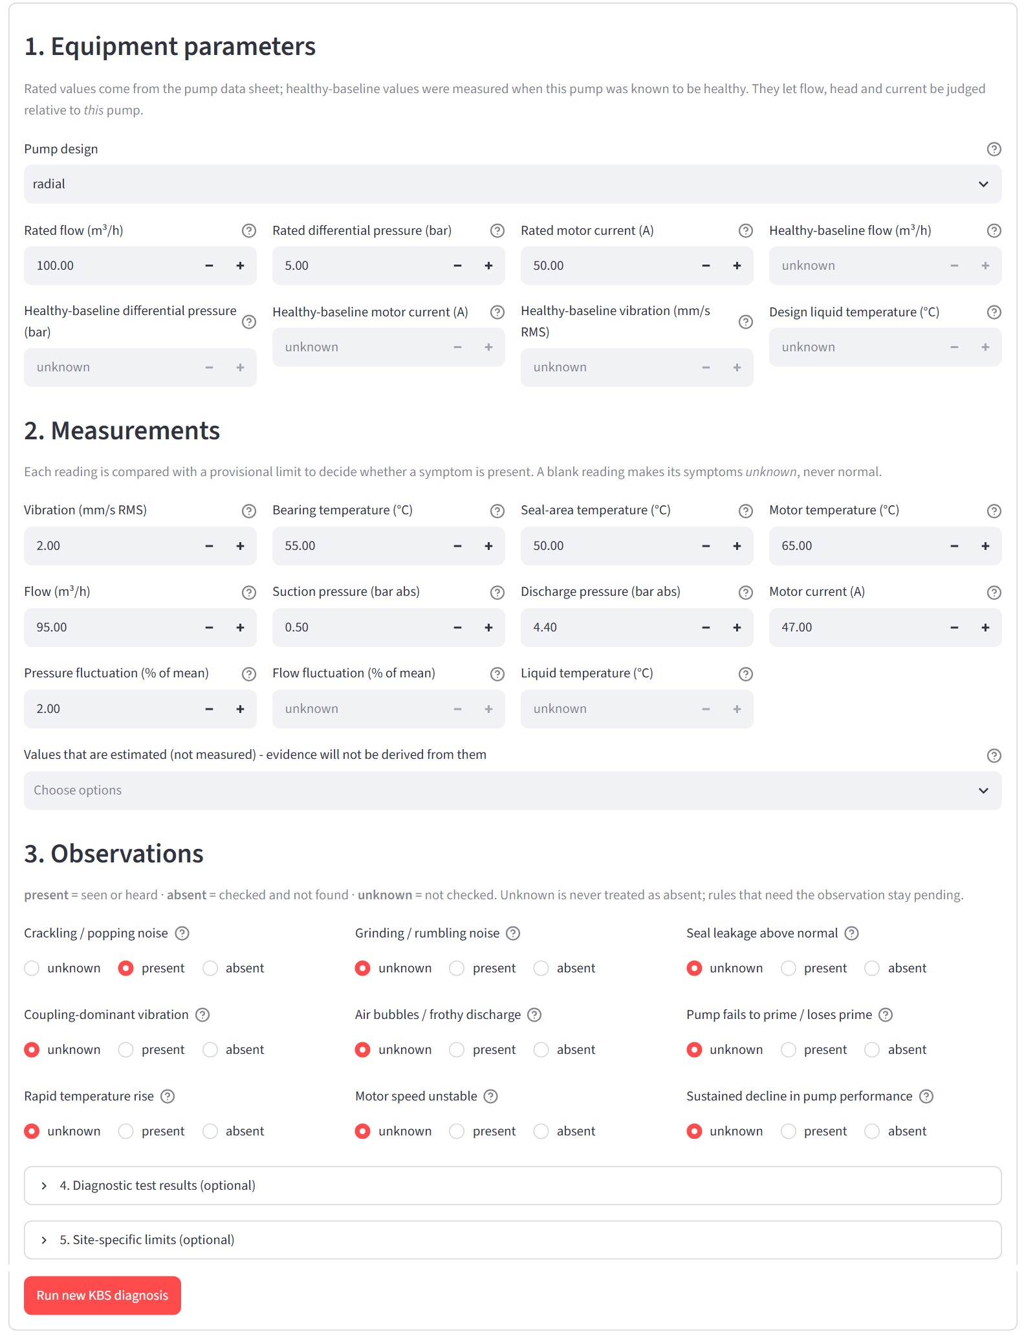
Figure 6: Input form (cavitation example loaded); sections 4 and 5 are collapsible
Outputs. The report opens with safety warnings, work precautions, outcome metrics and a "How to read this report" guide, followed by these tabs:
- Diagnoses: competing-diagnosis notice and labelled evidence panels;
- Root causes: concluded and candidate causes with confirming tests, and fault chains;
- Evidence: every reading and its limit, conflicts, and NOT USED flags;
- Tests & information needed: requested tests and missing observations;
- Maintenance actions: priority, cost and downtime, marked Unvalidated;
- Full report: downloadable as text.
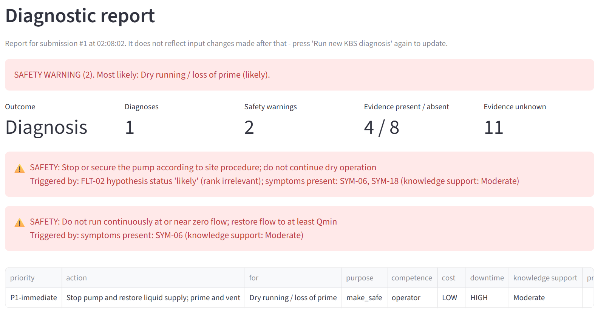
Figure 7: Dry running with loss of prime: two safety warnings, outcome metrics and the make-safe action at priority P1-immediate (excerpt; tab bar and caption omitted)

7. Testing and Results
Testing has four parts: automated tests, knowledge-base validation, 15 manually designed scenarios, and consistency checks on the synthetic dataset. None of these measures diagnostic accuracy on real pumps.

Automated tests and knowledge-base validation
Table 16: Automated test suites (pytest 9.2.0; latest run: 153 passed, 0 failed)
Suite | Tests | Covers
kbs_engine/tests/test_engine.py | 54 | Evidence derivation and threshold bases, faults, causes, chains, missing and conflicting evidence, safety, forward chaining, invariants on synthetic records
decision_support/tests/test_report.py | 21 | Report sections, safety vs precautions, nothing invented or dropped, text rendering
decision_support/tests/test_ui_adapter.py | 8 | Input validation, blank = unknown, estimated values
decision_support/tests/test_streamlit_pages.py | 7 | Page loads, examples, invalid input (Streamlit AppTest)
decision_support/tests/test_manual_scenarios.py | 22 | The 15 manual scenarios plus a dry-running variant at engine level, and key scenarios through the UI
decision_support/tests/test_cost_priority.py | 14 | Cost, downtime and priority attributes; diagnosis unaffected
decision_support/tests/test_page_audit.py | 27 | Every input changes the result as specified; tabs; scenarios through the real page
Total | 153 | 153 passed

The validator reports PASS: 0 errors, 0 warnings (8,756 error checks and 590 warning checks).

Manual scenario evaluation
Fifteen team-designed scenarios were run with all other inputs at healthy defaults and the pump primed unless stated, at engine level and through the user interface. Verdicts:
- Pass: the expected behaviour occurs;
- Partial: the behaviour is defensible but not what the scenario expected;
- Inconclusive: the input lacks evidence the knowledge base requires.
Table 17: Manual scenarios: actual results
# | Scenario (key inputs) | Actual result | Verdict
T1 | Healthy pump | Normal; no fault, warning or action | Pass
T2 | Crackling noise + performance decline | Unknown; cavitation pending (also needs low suction pressure or low head); wear-ring wear possible; NPSH check requested | Pass
T3 | Not primed, flow 100 % | Unknown; air ingress pending; dry running not concluded because flow is normal (contradictory input) | Inconclusive
T3b | Not primed, flow 3 m³/h | Dry running likely; SAF-01 + SAF-02; stop pump at P1-immediate | Pass
T4 | Air bubbles only | Unknown; bubbles shown as evidence linked to air ingress, but no rule fires | Pass
T5 | Vibration 7.0, bearing 85 °C, grinding | Bearing failure likely (Strong) | Pass
T6 | Seal-area 90 °C, seal leakage | Mechanical seal failure likely (Strong) | Pass
T7 | Flow 40 % | Unknown; discharge restriction and impeller blockage pending; inspection requested; no false dry running. Suction blockage is modelled as a cause | Partial
T8 | Flow 40 % + rapid temperature rise | Discharge restriction likely; SAF-02; P1 action | Pass
T9 | Vibration 7.0 + coupling vibration | Unknown; evidence linked to misalignment and coupling damage, but no rule fires | Pass
T10 | Flow 60 % + performance decline | Unknown; wear-ring wear possible; restriction and blockage pending; impeller damage not raised | Partial
T11 | All inputs blank | Unknown; no hypothesis; blanks not treated as zero | Pass
T12 | Discharge 1.0 < suction 1.25 bar | Inconsistent-measurement conflict; both readings unknown; not Normal | Pass
T13 | Bearing + seal evidence | Both likely with separate explanations; competing diagnoses flagged | Pass
T14 | Negative vibration, flow, temperature | Three input errors; diagnosis not run | Pass
T15 | Flow 0 %, pump primed | SAF-02 zero-flow warning; restriction and blockage pending; dry running not concluded (prime known) | Pass

Summary: 12 Pass (T1, T2, T4-T6, T8, T9, T11-T15), 2 Partial (T7, T10) and 1 Inconclusive (T3). T2, T4 and T9 pass because the system surfaced the evidence and linked it to the correct fault: cavitation pending with an NPSH check requested, air bubbles linked to air ingress, and coupling vibration linked to misalignment and coupling damage. By design, it does not conclude a fault from these single symptoms alone. The partial and inconclusive results follow from deliberate knowledge-base choices: suction blockage is modelled as a cause, not a fault, and T3's input is contradictory. The system therefore keeps those hypotheses pending and asks for evidence instead of guessing. T12 and T14 initially exposed defects (a Normal verdict on inconsistent pressures; invalid inputs being diagnosed); both were fixed and are covered by regression tests.
T15 depends on the loss-of-prime observation:
- Prime known OK (the scenario as specified): zero-flow warning SAF-02 only.
- Left unknown: dry running pending with both SAF-01 and SAF-02.
- Reported lost: dry running likely with both warnings and the P1 stop action, as in T3b.

Synthetic dataset consistency evaluation
This is separate from the manual scenarios: it checks engine behaviour on generated records, not correctness. Robustness run: all 7,210 cleaned records were processed by the engine and the report builder with 0 errors. The outcomes were 3,827 Normal, 1,923 Unknown and 1,460 diagnosis. All 104 records that produced a dry-running hypothesis also produced warning SAF-01.
Label consistency (Table 18) covers the 5,387 records labelled Confirmed (1,012) or No Fault Detected (4,375). No test results are supplied, unrecorded observations stay unknown, and pumps are treated as radial.
Table 18: Engine behaviour vs synthetic labels - consistency only, NOT diagnostic accuracy
Synthetic label | n | Label fault likely+ | Label fault pending | Outcome diagnosis | Outcome Unknown | Outcome Normal
Air Ingress | 57 | 16% | 84% | 16% | 84% | 0%
Bearing Failure | 250 | 84% | 8% | 84% | 14% | 2%
Cavitation | 86 | 71% | 28% | 71% | 29% | 0%
Discharge Restriction | 55 | 75% | 25% | 75% | 25% | 0%
Dry Running | 47 | 79% | 0% | 89% | 11% | 0%
Impeller Damage | 102 | 0% | 56% | 10% | 74% | 17%
Mech. Seal Leakage | 220 | 85% | 4% | 85% | 6% | 9%
Motor Fault | 63 | 59% | 0% | 59% | 41% | 0%
Normal | 4,347 | - | - | 0% | 17% | 83%
Pump Blockage | 49 | 0% | 12% | 0% | 98% | 2%
Shaft Misalignment | 76 | 0% | 1% | 0% | 100% | 0%
Unknown | 35 | - | - | 14% | 23% | 63%

Where the records contain the characteristic evidence the rules require, the engine usually reaches the labelled fault (bearing 84 %, seal 85 %, dry running 79 %), and 83 % of Normal records are judged Normal with none misdiagnosed. Agreement is low for impeller damage, blockage and misalignment for three reasons:
- their rules need tests or observations that the records lack;
- the generator's thresholds differ from the knowledge base's;
- missing observations stay unknown.
These figures describe agreement with labels the project itself generated; they are not accuracy on real equipment.

8. Evaluation, Limitations and Conclusion

8.1 Evaluation of the Proposed Approach
Table 19: Evaluation of the proposed KBS
Criterion | Assessment
Diagnostic behaviour | Correct and conservative on the designed scenarios: 12 of 15 pass, and the remainder stay pending or Unknown rather than guessing. Accuracy on real equipment is not established.
Explainability | Strong. Every conclusion lists its rules, labelled evidence, limits, sources, assumptions and missing evidence.
Safety | Strong in design. Safety rules are checked against every hypothesis, including pending ones, and make-safe actions get P1. The safety knowledge itself is Moderate or Unvalidated and does not replace site procedures.
Knowledge quality | Provenance on every item: 91 of 282 relationships and 15 of 36 rules are independently supported. Thresholds are provisional, and the validator passes.
System requirements | FR1-FR8 and NFR1-NFR6 are implemented; 153 automated tests pass; the system runs interactively.
Cost and maintenance decision support | Prioritised actions with precautions; cost and downtime classes, or an explicit UNKNOWN, for every fault and action. Qualitative and Unvalidated.

Table 20: Mapping to course learning outcomes and complex-problem attributes [C-1, C-3]
Outcome / attribute | Evidence | Sections
CLO 1 Knowledge representation | Validated knowledge base of entities, 282 typed relationships and 36 rules with provenance | 5.1, 5.2
CLO 2 Problem analysis and design | Stakeholders, requirements, constraints, conflicts and incomplete requirements; layered architecture | 4, 5.6
CLO 3 Method assessment | Seven alternatives compared; forward chaining justified and evaluated | 5.1, 5.3, 8.1
CPA-2 / CPA-3 / CPA-9 | Competing hypotheses and Unknown outcome; graded research with implementation; unclear requirements resolved | 4.4, 5.3, 6, 7

8.2 Limitations
- No real-world validation. There was no plant data and no expert review, and no industrial diagnostic accuracy is claimed.
- Synthetic dataset. Its relationships are simplified and its labels come from the project's own assumptions, so agreement with them is not ground truth.
- Provisional thresholds. 25 of 26 thresholds are Unvalidated, and 5 have no sourced value at all (site limits only).
- Unvalidated knowledge. 96 of 282 relationships and 6 of 36 rules rest only on project-authored knowledge.
- Incomplete rule coverage. Single symptoms (air bubbles, coupling vibration, crackling noise) do not conclude a fault. No test separates bearing from seal failure. Several test results are not interpreted by any rule.
- Qualitative cost and downtime. The classes and the priority policy are Unvalidated, and no case-specific severity is assessed.
- Scope. One equipment class, snapshot cases only, and design-dependent rules need the pump design to be entered.

8.3 Future Improvements
- Obtain ISO 10816-7, ANSI/HI 9.6.1 / 9.6.3 and a pump textbook, and validate each threshold.
- Review the knowledge base with a maintenance expert, and evaluate on real labelled cases.
- Add rules for single-symptom cases (e.g. crackling noise alone → cavitation possible [S-01, p.20]) and for the uninterpreted test results.
- Replace the qualitative cost and downtime classes with site data, and validate the priority policy.
- Add time-series trend handling and a second equipment class.

8.4 Conclusion
The project analysed an under-specified industrial diagnosis problem, resolved its unclear requirements through documented decisions, and built a working KBS for centrifugal pump sets:
- Knowledge base: knowledge from 16 external sources, structured into a validated base of frame-like entities, typed relationships and 36 production rules, each with provenance and a support level.
- Inference: stratified forward chaining handles unknown and conflicting evidence, keeps competing hypotheses open and requests discriminating tests.
- Decision support: safety warnings, prioritised maintenance actions with qualitative cost and downtime, and labelled explanations.
Results: 153 automated tests pass and validation is clean; 12 of 15 manual scenarios pass, 2 are partial and 1 inconclusive; behaviour on 7,210 synthetic records is consistent and conservative. The open issue is validation, not implementation: thresholds, cost, downtime and priority are provisional, and accuracy on real equipment is unmeasured.

9. References
Consulted engineering sources
[S-01] US DOE and Hydraulic Institute (2006). Improving Pumping System Performance: A Sourcebook for Industry, 2nd ed. (DOE/GO-102006-2079). https://www.energy.gov/sites/prod/files/2014/05/f16/pump.pdf
[S-02] Hydraulic Institute (P. Gaydon) (2022). The Basics of NPSH & Pump Operating Regions. https://www.pumps.org/2022/12/07/the-basics-of-npsh-pump-operating-regions/
[S-03] Hydraulic Institute / Pumps & Systems (2015). The Effects of Gas & Liquid Mixtures on Rotodynamic Pumps & Water Hammer Basics. https://www.pumpsandsystems.com/effects-gas-liquid-mixtures-rotodynamic-pumps-water-hammer-basics
[S-04] KSB (n.d.). Centrifugal Pump Lexicon: Cavitation. https://www.ksb.com/en-global/centrifugal-pump-lexicon/article/cavitation-1117364
[S-05] KSB (n.d.). Centrifugal Pump Lexicon: NPSH. https://ksb.com/en-global/centrifugal-pump-lexicon/article/npsh-1116954
[S-06] KSB (n.d.). Centrifugal Pump Lexicon: Dry running. https://www.ksb.com/en-global/centrifugal-pump-lexicon/article/dry-running-1116984
[S-07] KSB (n.d.). Centrifugal Pump Lexicon: Operating behaviour. https://www.ksb.com/en-global/centrifugal-pump-lexicon/article/operating-behaviour-1118222
[S-08] KSB (n.d.). Centrifugal Pump Lexicon: Shaft seal. https://www.ksb.com/en-global/centrifugal-pump-lexicon/article/shaft-seal-1116516
[S-09] KSB (n.d.). Centrifugal Pump Lexicon: Flow rate. https://www.ksb.com/en-global/centrifugal-pump-lexicon/article/flow-rate-1116844
[S-10] Grundfos (n.d.). FAQ: What is cavitation?. https://www.grundfos.com/us/support/faq/what-is-cavitation
[S-11] ITT Goulds Pumps (2008). Model 3408A Installation Operation and Maintenance manual (6/08) - troubleshooting printed pp. 23-24. https://www.manualsdir.com/manuals/461667/goulds-pumps-3408a-iom.html?page=31
[S-12] SKF (2019). Bearing damage analysis (ISO 15243) e-learning transcript R32. https://www.skf.com/skf/campaign/aptitudearchive/training/brgdam_v2/presentation_content/external_files/Brg%20damage%20transcript%20R32.pdf
[S-13] E. Vogel / Pumps & Systems (2011). Pump Alignment: Just the Facts. https://www.pumpsandsystems.com/pump-alignment-just-facts-0
Located but not read (scope only, or research leads for future validation)
[S-14] ISO (2009). ISO 10816-7:2009 Mechanical vibration - Part 7: Rotodynamic pumps for industrial applications. https://standards.globalspec.com/std/1157527/iso-10816-7 [scope only]
[S-15] Hydraulic Institute (2017). ANSI/HI 9.6.1-2017 Rotodynamic Pumps Guideline for NPSH Margin. https://law.resource.org/pub/us/cfr/ibr/inc/ansi/ansi.hi.9.6.1.2017.pdf [not read]
[S-16] ISO (2017). ISO 15243:2017 Rolling bearings - Damage and failures. https://www.iso.org/standard/59619.html [not read]
[L-01] Osman (EIJEST) (2019). Vibration Signature of Misaligned Rotors of Centrifugal Pump. https://eijest.journals.ekb.eg/article_97279.html [not read]
[L-02] Flowserve (n.d.). Self-Diagnose the Root Causes to Your Mechanical Seal Failure. https://kh.aquaenergyexpo.com/wp-content/uploads/2023/09/Self-Diagnose-the-Root-Causes-to-Your-Mechanical-Seal-Failure.pdf [not read]
[L-03] various (n.d.). Pump Handbook (Karassik et al.); Centrifugal Pumps (Guelich). [not read]
Software
[T-1] Python Software Foundation. Python 3.11. https://www.python.org
[T-2] Streamlit, version 1.66.1. https://streamlit.io
[T-3] pandas, version 3.1.0. https://pandas.pydata.org
[T-4] NumPy, version 2.4.6. https://numpy.org; scikit-learn, version 1.9.1. https://scikit-learn.org
[T-5] Matplotlib, version 3.11.2. https://matplotlib.org; seaborn, version 0.13.2. https://seaborn.pydata.org
[T-6] pytest, version 9.2.0. https://pytest.org
Course documents
[C-1] NED University of Engineering and Technology, Department of CS&IT. Knowledge Based System (CT-359): CCP brief and assessment rubric, 2026.
[C-2] NED University of Engineering and Technology. CCP Project Submission report template, Knowledge-Based Systems (CT-359).
[C-3] NCEAC Manual 2021 (complex problem attributes), as referenced in [C-1]. https://www.seoulaccord.org/document.php?id=79

