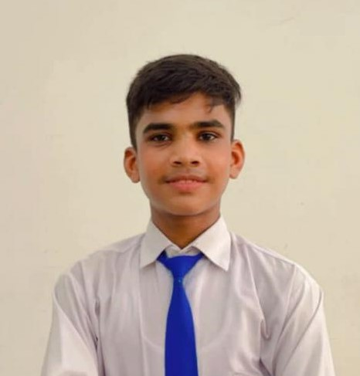

***Ahmed Shaikh***

House no: 73, unit 4/A, Latifabad, Hyderabad.

Contact: +923121228550

**To avail the challenging positon in a reputed organization, which provide me opportunities to utilize my entrepreneurial skills and achieve career growth.**

***Personal Information:***

Father’s Nome : Abdul Qayoom Surname : Shaikh

Date of Birth : 20-April-2009 Marital status : Single

Domicile : District Hyderabad Religion : Islam

Nationality : Pakistani

***Education Qualification:***

Intermediate : from B,I.S.E Hyderabad Year 2011

Matriculation : fromB.I.S.E Hyderabad Year 2007

**Other Course:**

Ms Office

English Langunge : From Deaf Reach Training Center- HYD

Diploma information technology : From Deaf Reach Training Center- HYD

**Languages:**

English,

Urdu