**Gauss Seidel Method Report**

**Introduction :**

It is an [iterative method](https://en.wikipedia.org/wiki/Iterative_method) used to solve a [linear system of equations](https://en.wikipedia.org/wiki/Linear_system_of_equations) of n linear equations with unknown x:

**A x = b**

Though it can be applied to any matrix with non-zero elements on the diagonals, convergence is only guaranteed if the matrix is either [diagonally dominant](https://en.wikipedia.org/wiki/Diagonally_dominant_matrix), or [symmetric](https://en.wikipedia.org/wiki/Symmetric_matrix) and [positive definite](https://en.wikipedia.org/wiki/Positive-definite_matrix).

**pseudo-code :**

inputs : A,B,x0,iterations, error

repeat from 1 to iterations

for i from 1 until (num of variables) do

temp = 0

for j from 1 until (num of variables) do

if j ≠ i then

temp = temp + A(i,j)*x0(j)

end if

end (j-loop)

Xi = (B(i) - temp )/A(i,i)

end (i-loop)

check if tolerance is reached

end (repeat)

**Flow Chart :**

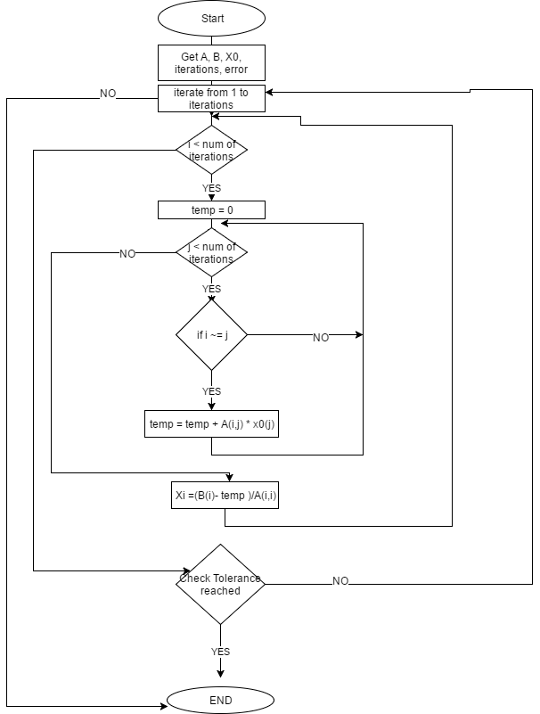

**Analysis for the behavior of different examples :**

Example :

5x – y + z = 10

2x + 8y – z = 11

-x + y + 4z = 3

X0[0 0 0]

Solution :

Iterations x y z

1.0000 0 0 0 2.0000 0.8750 1.0313 0

2.0000 2.0000 0.8750 1.0313 1.9688 1.0117 0.9893 0.0313

3.0000 1.9688 1.0117 0.9893 2.0045 0.9975 1.0017 0.0357

4.0000 2.0045 0.9975 1.0017 1.9992 1.0004 0.9997 0.0053

5.0000 1.9992 1.0004 0.9997 2.0001 0.9999 1.0001 0.0010

6.0000 2.0001 0.9999 1.0001 2.0000 1.0000 1.0000 0.0002

Example :

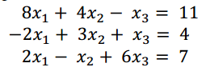

Solution :

Iterations x y z

1.0000 0 0 0 1.3750 2.2500 1.0833 0

2.0000 1.3750 2.2500 1.0833 0.3854 1.2292 1.2431 0.9896

3.0000 0.3854 1.2292 1.2431 0.9158 1.5295 1.1163 0.5304

4.0000 0.9158 1.5295 1.1163 0.7498 1.4611 1.1603 0.1660

5.0000 0.7498 1.4611 1.1603 0.7895 1.4729 1.1490 0.0397

6.0000 0.7895 1.4729 1.1490 0.7822 1.4718 1.1512 0.0073

7.0000 0.7822 1.4718 1.1512 0.7830 1.4716 1.1509 0.0008

8.0000 0.7830 1.4716 1.1509 0.7831 1.4717 1.1509 0.0001

9.0000 0.7831 1.4717 1.1509 0.7830 1.4717 1.1509 0.0001

Example :

2*x1+x2+1*x3 = 3

4*x1+2*x2+x3 = 4

x1+2*x2+3*x3 = 4

Solution :

Iterations x y z

1.0000 1.0000 2.0000 1.0000 0 1.5000 0.3333 0

2.0000 0 1.5000 0.3333 0.5833 0.6667 0.6944 0.5833

3.0000 0.5833 0.6667 0.6944 0.8194 0.0139 1.0509 0.2361

4.0000 0.8194 0.0139 1.0509 0.9676 -0.4606 1.3179 0.1481

5.0000 0.9676 -0.4606 1.3179 1.0714 -0.8017 1.5107 0.1038

6.0000 1.0714 -0.8017 1.5107 1.1455 -1.0464 1.6491 0.0741

7.0000 1.1455 -1.0464 1.6491 1.1986 -1.2218 1.7483 0.0531

8.0000 1.1986 -1.2218 1.7483 1.2367 -1.3477 1.8195 0.0381

9.0000 1.2367 -1.3477 1.8195 1.2641 -1.4379 1.8706 0.0273

10.0000 1.2641 -1.4379 1.8706 1.2837 -1.5026 1.9072 0.0196

11.0000 1.2837 -1.5026 1.9072 1.2977 -1.5490 1.9334 0.0141

12.0000 1.2977 -1.5490 1.9334 1.3078 -1.5823 1.9523 0.0101

13.0000 1.3078 -1.5823 1.9523 1.3150 -1.6062 1.9658 0.0072

14.0000 1.3150 -1.6062 1.9658 1.3202 -1.6233 1.9755 0.0052

15.0000 1.3202 -1.6233 1.9755 1.3239 -1.6356 1.9824 0.0037

16.0000 1.3239 -1.6356 1.9824 1.3266 -1.6444 1.9874 0.0027

17.0000 1.3266 -1.6444 1.9874 1.3285 -1.6507 1.9909 0.0019

18.0000 1.3285 -1.6507 1.9909 1.3299 -1.6552 1.9935 0.0014

19.0000 1.3299 -1.6552 1.9935 1.3308 -1.6584 1.9953 0.0010

20.0000 1.3308 -1.6584 1.9953 1.3315 -1.6608 1.9967 0.0007

21.0000 1.3315 -1.6608 1.9967 1.3321 -1.6624 1.9976 0.0005