Biologically Inspired Computation (F21BC)
Group29
Arsany Zaki
Chaouki Ouadah

Table of Contents
Introductions 2
Implementation 2
Solution structure 2
Converting NN weights & biases to PSO position 3
Experiment implementation (parameter sweep systems) 4
Train activation function 5
Results and Discussion 5
Acceleration Coefficients Effect 5
Solution Evaluation Allocation (Fixed Budget) 6
NN Architecture and Activation Function Effect 7
PSO Boundary Handling and Informants Selection Effect 8
Conclusion 9
References 9
(1) Innocente, M.S. and Sienz, J., 2011. Particle swarm optimization with inertia weight and constriction factor. In: ICSI 2011: International Conference on Swarm Intelligence. pp.8 9
Appendices 9

Introductions
This report illustrates the implementation (in python) and experiments of using PSO to train ANN to predict Concrete Compressive Strength based on the following dataset
https://archive.ics.uci.edu/dataset/165/concrete+compressive+strength

Implementation
Solution structure
The python solution is mainly composed of the following sections (folders).
- data: folder containing raw input dataset
- src: folder containing all code for all packages. Each package has its own entities (data classes), constants (enumerations or static variables) and logic files. It contains the following folders (each folder is a python package)
  - data_prep: loading raw input data from csv file, normalizing it then splitting it into training and testing data
  - nn: running a neural network forward path and calculating predicted output, cost for a point and total cost for a dataset.
  - pso: running pso algorithm based on BC week7 lecture
  - pso_nn_coupling:
    - converting the pso particle position into nn weights and biases
    - orchestrate calls to pso algorithm and nn forward path run
    - calculating pso position boundaries (based on nn structure, activation functions used and their corresponding recommended weight boundaries)
  - utilities: helper code including printing to terminal
  - config: generic global configuration including paths
  - main.py: execute sample configuration (hard-coded) in the file
  - execute_exp_suite.py: execute a suite of experiments whose configurations are in experiments/config.yaml
- experiments: experiments configurations, run results and analysis notebooks
  - config.yaml: contains parameters’ ranges to experiment.
  - result.json: contains experiments parameters and metadata along with all results for a certain config.yaml file
  - result_viewer.ipynb: jupyter notebook to read result.json file (in the same folder) and view tables and diagrams to analyse experiments outputs
Note: note all the cells are relevant to all experiments types
  - config_archive: folder containing all previously run experiments configurations, each file name has the time when the experiment run finished
  - result_archive: folder containing all previously run experiments results, each file name has the time when the experiment run finished. config_{timestamp}.yaml and its result_{timestamp}.json files in the config_archive and result_archive have the same time timestamp.
- tests: code for testing main parts of the solution
- logs: to log data for debugging
Converting NN weights & biases to PSO position
The following approach was used to convert NN weights & biases to PSO position
- Loop through NN layers
  - Loop through inputs feeding the layer
    - Loop through neurons of the layer
      - Consider the neuron weight receiving the current input
  - Loop through neuron of the layer
    - Consider neuron bias
When applying this algorithm to the following diagram, the PSO position features will be as follows in order:
(1) N11_W1 (2) N12_W1 (3) N11_W2 (4) N12_W2 (5) N11_W3 (6) N12_W3
(7) N11_B (8) N12_B (9) N21_W1 (10) N22_W1 (11) N21_W2 (12) N22_W2
(13) N21_B (14) N22_B (15) N31_W1 (16) N31_W2 (17) N31_B
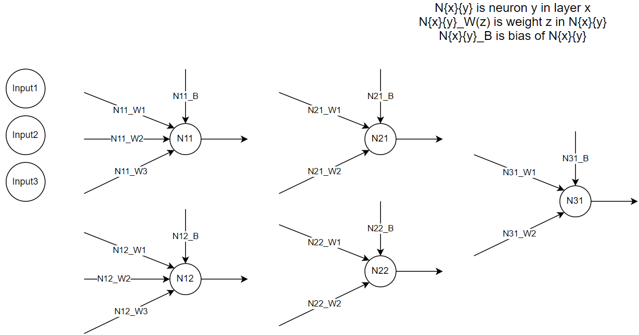
Fig1- NN Weights and Biases
When converting from PSO position to NN weights & biases, we applied the opposite conversion
Experiments using parameter sweep system (Go Beyond)
Regarding the experiment’s implementation, we have gone beyond what’s required. We implemented parameter sweep system for 2 different types of experimentation.
- Velocity coefficient experimentation
In this type of experimentation, a config file contains a range and a step for each of inertia, personal, global and social coefficients. The solution creates a combination of all possible values of the 4 parameters then merge each combination with the rest of the constant variables. Then, the solution runs the PSO NN training algorithm using each set of parameters and finally logs all the parameters and results.
- Fixed Budget experimentation
In this type of experimentation, a config file contains a fixed budget number and a range of swarm sizes. For each swarm size the solution calculates the iterations count (by dividing the fixed budget by the swarm size) then run the PSO NN training algorithm with the combination of swarm size and iterations count
Config File for Parameters Sweep System (experiments/config_template.yaml)
The experiments configuration file contains the following yaml nodes
- Investigations: contains multiple investigations
- investigation: has a type (vel_coeffs or fixed_budget) and contains multiple groups of the same type
- groups: contains multiple groups
- group: contains a set of fixed parameters and a set of ranges for the remaining parameters. This represents a set of experiment with different but related parameter to answer a certain question.
  - if group type is vel_coeffs
    - the values of the inertia, personal, global and social coefficients parameters will be ranges in the form of [start, end, step]
    - other parameters are constants
  - if group type is fixed_budget
    - the value of swarm size will be a range in the form of [start, end, step]
    - informants size will be in the form of a list (one informant size per swarm size)
    - budget size value will be fixed number
    - iteration count will not have any value as it will be calculated
    - other parameters are constants
How did we answer the assignment 3 questions
- To investigate the effect of velocity coefficients, we used investigation of type “vel_coeffs”
- To investigate the effect of allocating solution budget to swarm size and iteration count, we used investigation of type “fixed_budget”
- To investigate the effect of NN architecture and activation functions, we used the investigation of type “vel_coeffs” with fixes ranges and multiple groups where each group has different NN architecture and activation functions.
Train activation function
“Training activation function by encoding them in PSO features”
Implementing this requirement could result in an unsmooth particle movement for the following reason.
- Each activation function type has recommended weight boundaries to ensure stability.
- Weight boundaries are particle position boundaries, so modifying activation functions between PSO iterations means modifying position boundaries between iterations
- However, particle position boundaries are supposed to be constant through the entire POS run and modifying position boundaries between iterations could result in unsmooth movements (big jumps) of particles.

Results and Discussion
This section illustrates the results of the conducted experiments. The configs, results and analysis notebooks of these experiments are under “experiments/report_notebooks” in the solution
Acceleration Coefficients Effect
The following experiment investigates the effect of varying PSO acceleration coefficients
Question:
What is the best sum of personal, global and social coefficients given inertia is 0.72 (best according to literature “ref1”)?
Fixed parameter across all experiments
- Inertia: 0.72
- iteration count: 50, swarm size: 10, informants size: 5
- NN layers sizes: [8, 1]
- NN layer activation functions: ['relu', 'linear']
Variable parameters across experiments
(combinations of all the following values for each parameter)
Note: range is in the form of [start, end, step]
- personal coefficient : [0.6, 1.4, 0.2] 0.6, 0.8, 1.0, 1.2, 1.4
- global coefficient : [0.6, 1.4, 0.2] 0.6, 0.8, 1.0, 1.2, 1.4
- social coefficient : [0.6, 1.4, 0.2] 0.6, 0.8, 1.0, 1.2, 1.4
Result
The following diagram illustrates the cost per coefficients sum
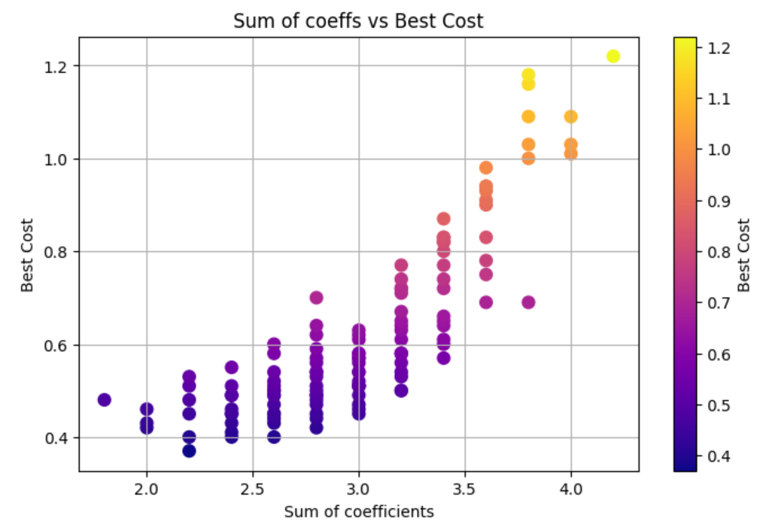
Fig1: Best Cost and coefficients Sum
Conclusion
The best sum of PSO 3 coefficients (personal, global and social) is approximately 2.2
Note: Given the sweep system implemented heaps of experiments of different parameter combinations could be conducted. However, due to report size limitations and computational power limitations, we included just the above experiment for velocity coefficients effect area.
Solution Evaluation Allocation (Fixed Budget)
Question
What is the best way of allocating solution evaluations of 2000?
Fixed parameter across all experiments
- inertia:0.7, personal:0.7, global:0.7, social:0.7
- informants size: 5
- NN layers sizes: [8, 1]
- NN layer activation functions: ['relu', 'linear']
- fixed budget: 2000
Variable parameters across experiments
- swarm size: 10, 20, … 100
- iteration count: 2000 / swarm size
Result
The following table shows the cost per swarm size and iterations count combination. The following diagram (after the table) shows the cost per swarm size of a fixed budget
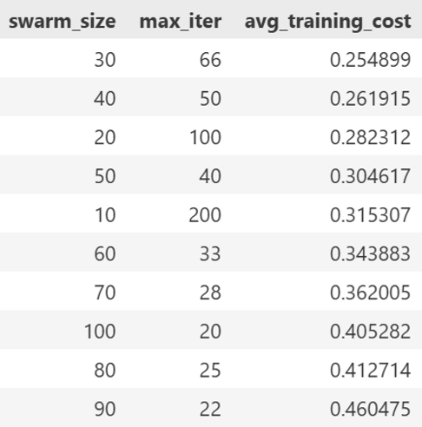
Table: Performance of Fixed Budget Combinations

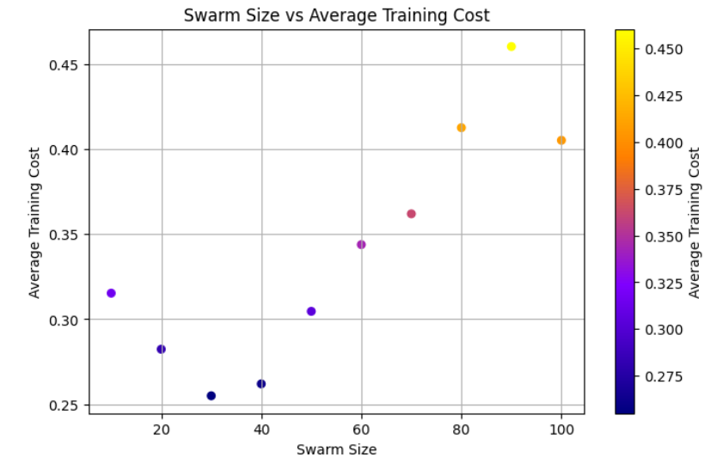
Fig: Cost against swarm size of fixed budget
Conclusion
Allocating more budget to iteration over swarm size is more beneficial.
NN Architecture and Activation Function Effect
Question
How small and medium size NN architectures along with different activation function compare?
Fixed parameter across all experiments
- inertia: 0.7, personal: 0.7, global: 0.7, social: 0.7
- Iteration count: 100, swarm size: 20, informants size: 5
Result
The follow table shows the cost against different NN architectures and activation functions
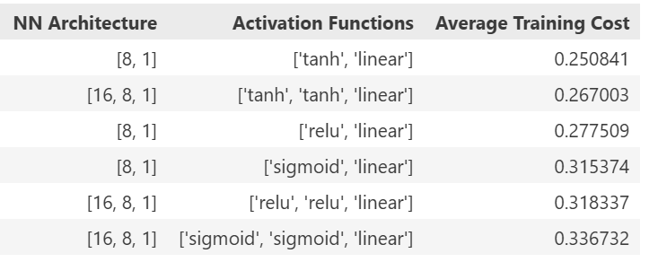
Table: Cost per NN architecture
Conclusion
Small size NN with tanh gives better performance compared to other activation functions and NN sizes
PSO Boundary Handling and Informants Selection Effect (Go Beyond)
Question
What is the effect of boundary handling and informants’ selection methods on performance?
Fixed parameters
- Iteration: 100, Swarm Size: 30, Informants count: 10
- Inertia:0.7, personal:0.7, global:0.7, social: 0.7
Output
The following table shows the cost against the different values of PSO boundary handling and informants’ selection methods
Boundary handling | Informants’ selection | Cost
Reflect | Static Random | 0.27
Clip | Static Random | 0.3
Reflect | Spatial Proximity | 0.24
Clip | Spatial Proximity | 0.31
Reflect | Dynamic Random | 0.26
Clip | Dynamic Random | 0.26
Table: Boundary handling and informants selection method performance
Conclusion
- Regarding boundary handling method, Reflect is better than clip.
- Regarding informants’ selection method, static random is the worst.
- Best combination is
  - Boundary handling: Reflect
  - Informants’ Selection: Spatial Proximity (take more time than others)

Conclusion
Note: Since there are many parameters, the conclusions below are specific to the experiments’ conditions (parameters used)
- Sum of 3 coefficients (personal, global and social) is recommended to be 2.2
- Increasing iteration is favourable over increasing swarm size for a fixed budget
- Small size NN with tanh activation function tend to perform better than linear function or medium size NN
- For better training cost, it is recommended to use “Spatial Proximity” as the informants selection method (but it consumes more computational resources) and “Reflect” as the boundary handling method

References

Innocente, M.S. and Sienz, J., 2011. Particle swarm optimization with inertia weight and constriction factor. In: ICSI 2011: International Conference on Swarm Intelligence. pp.8

Appendices
- Generative AI using GitHub Copilot (version: 1.388.0) and GitHub Copilot Chat (version: 0.33.2) were used.
- Gen AI has been used mainly to identify and fix errors

