

CS 322: Database Systems

Alexandria University

Faculty of Engineering

Computer and System Engineering

Department

Book Store Project

Students’ Name:

- Arsany Atef Abdo (10)

- Kirelos Malak Habib (35)

- Michael Said Beshara (38)

Professor’s Name:

DR. Yousry Taha

TA’s Name:

Eng. Reham Osama

Links of SQL Scripts for the Project

* **Creation of schema and tables:**

**https://drive.google.com/file/d/1zLamEgX6NuQAIKfeeksTPk4iwL038-xx/view?usp=sharing**

* **Creation Triggers:**

[**https://drive.google.com/file/d/1KyWXpBBcbY1WiUg53u-yj-ZL7DX2FLGQ/view?usp=sharing**](https://drive.google.com/file/d/1KyWXpBBcbY1WiUg53u-yj-ZL7DX2FLGQ/view?usp=sharing)

* **ERD Diagram:**

**https://drive.google.com/file/d/1aD5W_v6yhnA2Yrn2JSrubOvKlR__Q3_O/view?usp=sharing**

Links of Jasper files

**I open them with atom editor**

* **Link of the folder contains the three files:**

**https://drive.google.com/drive/folders/1KbhlU_T6WdUKzCTMPHZEf4sxIVKvDjrQ?usp=sharing**

* Database ERD diagrams:

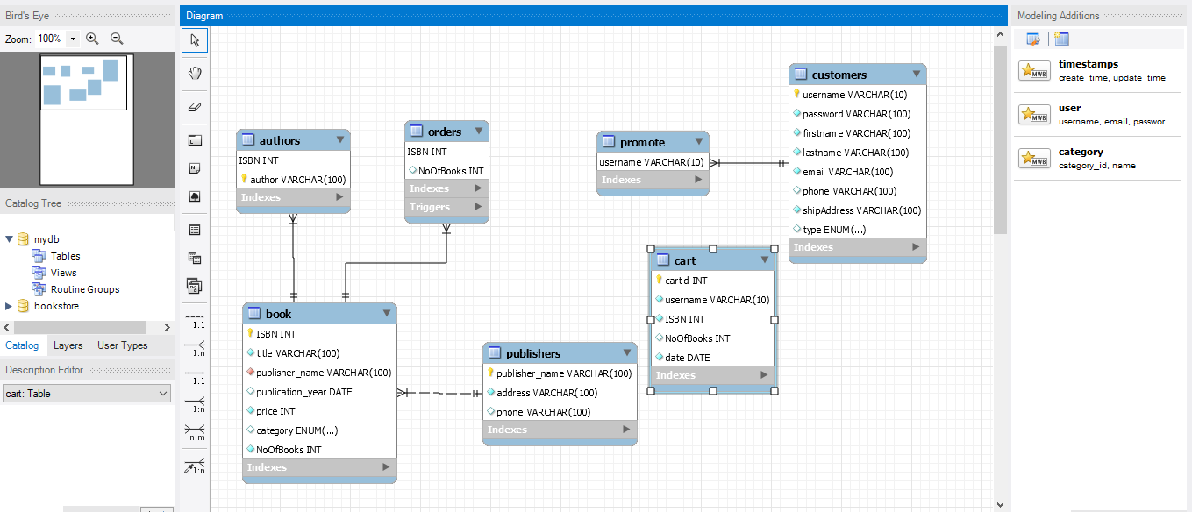

* Description, Analysis:
* **Schema Assumptions:**
* There are 7 tables (publishers, book, authors, orders, customers, cart and promote).
* Orders table has the orders have been done buy the managers, has two attributes (ISBN and number of books).
* Cart has the sells of the book store, has four attributes (cart id (auto generated and incremented), username, ISBN, and number of books).
* Promote has the user who want to be a manager and has attribute which is the users’ names.
* Book table will have ISBN auto generated and increment one by one with each insertion in it.
* The Authors have another table extracted from the book table to accomplish the BCNF to be atomic as authors are multivalued.
* **Triggers used and its assumptions:**
* Check number of books to not to be negative.
* Order books of about 20 new books if number of books reach 5.
* Confirm the order by the manager.
* **Schema screenshots:**

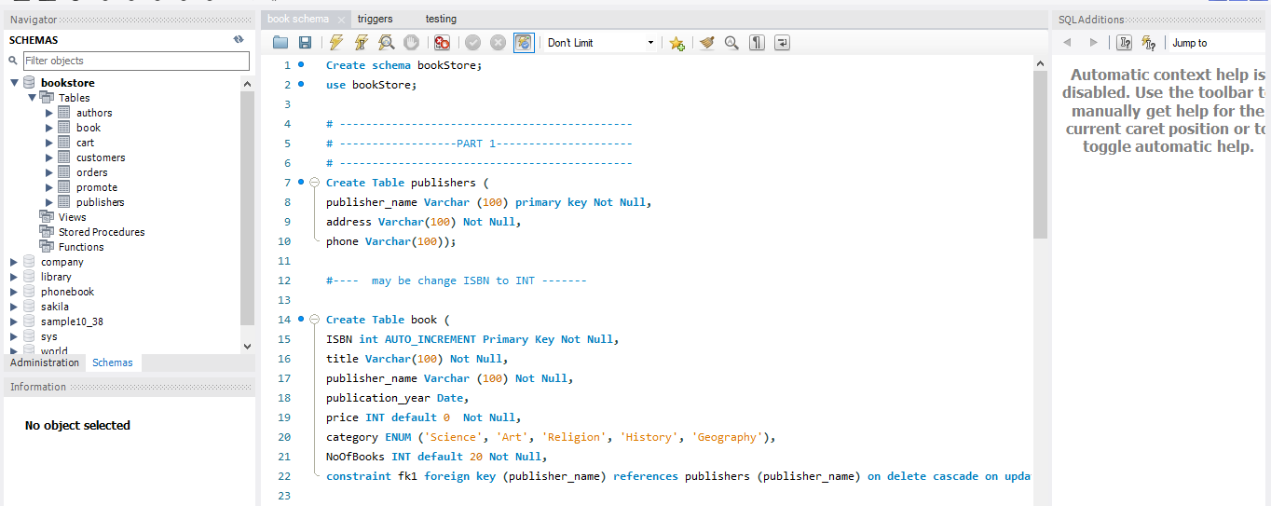

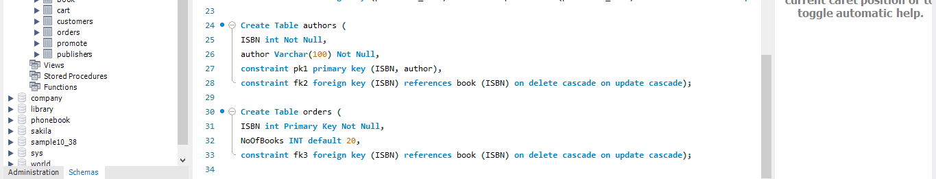

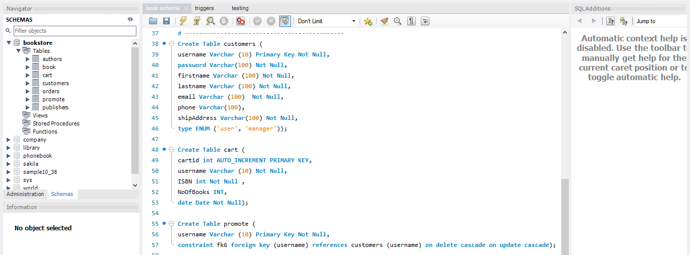

* **Triggers screenshots:**

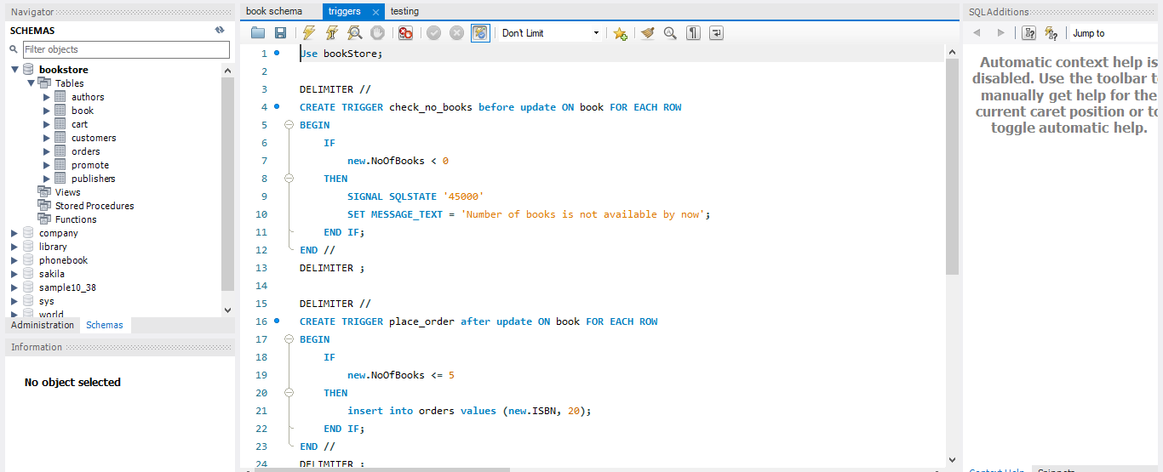

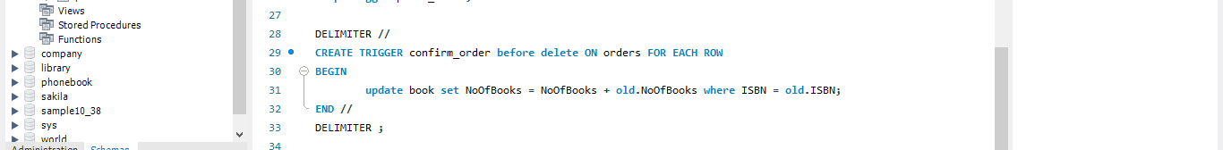

* **Java description and assumptions:**
* **Components:**
* *Book*

Contains the book attributes identified in the SQL.

* *Cart*

Contains the cart attributes identified in the SQL.

* *Person*

Abstract class contain the name, address and phone of person.

* *User*

Class extends from the person in addition to the rest of attributes of the customer in the SQL file.

* *Publisher*

Class extends from the person.

* **Back end:**
* *Book Store*

Needed to be updated

* *My sql connection*
  + - Singleton class identified in it the connection between the java and MySQL Server.
    - Contains four function which implements the search, insertion, delete, and update from tables.
    - ***Search function:***

Takes the table name, attributes of the table and conditions of the search.

Return the result set of the search operation.

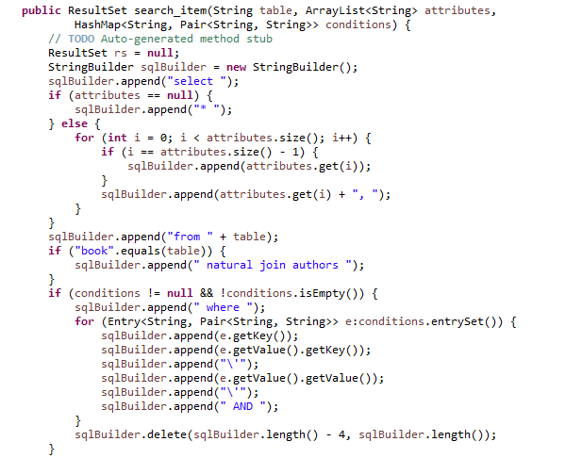

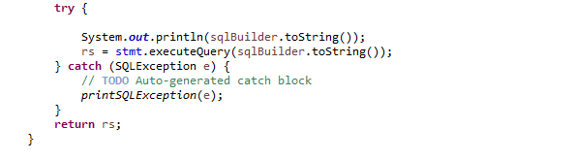

* + - ***Insert function:***

Takes the table name and attributes of the table.

Return the Boolean that the insertion is been done in right way or not.

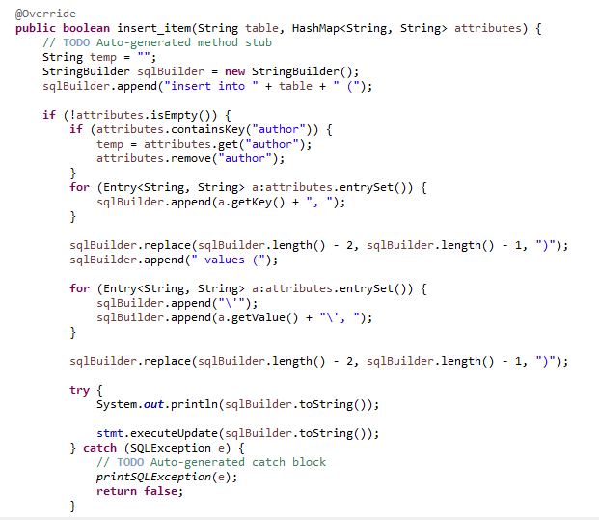

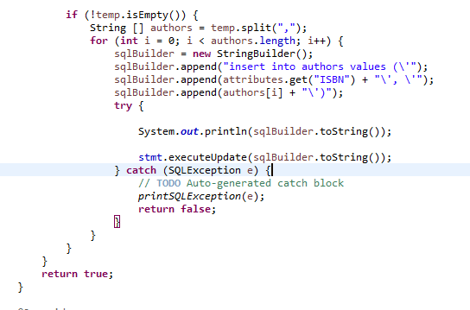

* + - ***Update function:***

Takes the table name, attributes of the table and conditions of the update.

Return the Boolean that the update is been done in right way or not.

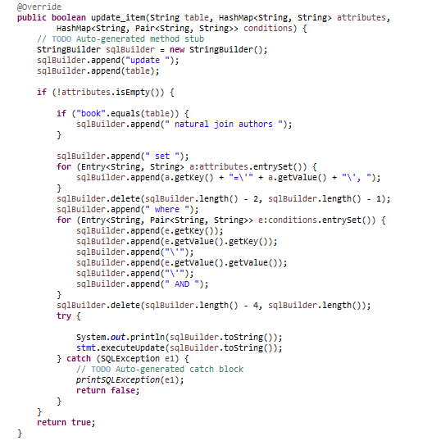

* + - ***Delete function:***

Takes the table name and conditions of the search.

Return the Boolean that the delete is been done in right way or not.

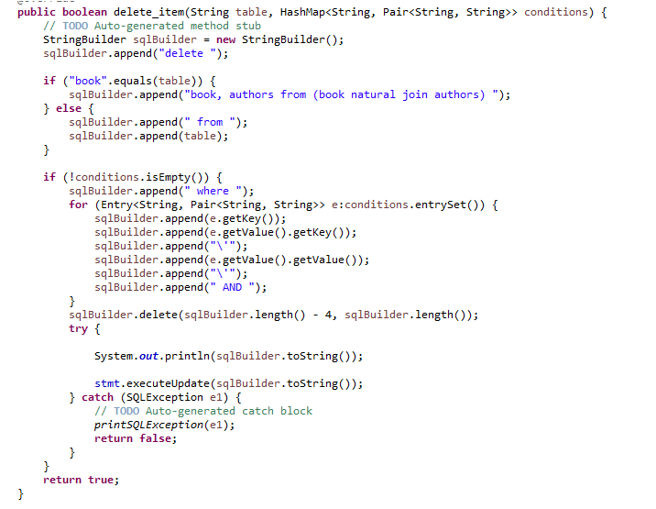

* + - ***Print SQL Exception function:***

Prints the exception expected from the SQL Server.

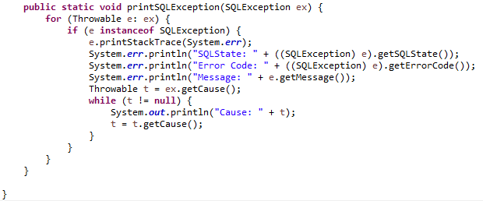

* **GUI:**

**Needed to be updated**

* **Jasper using Jaspersoft studio:**

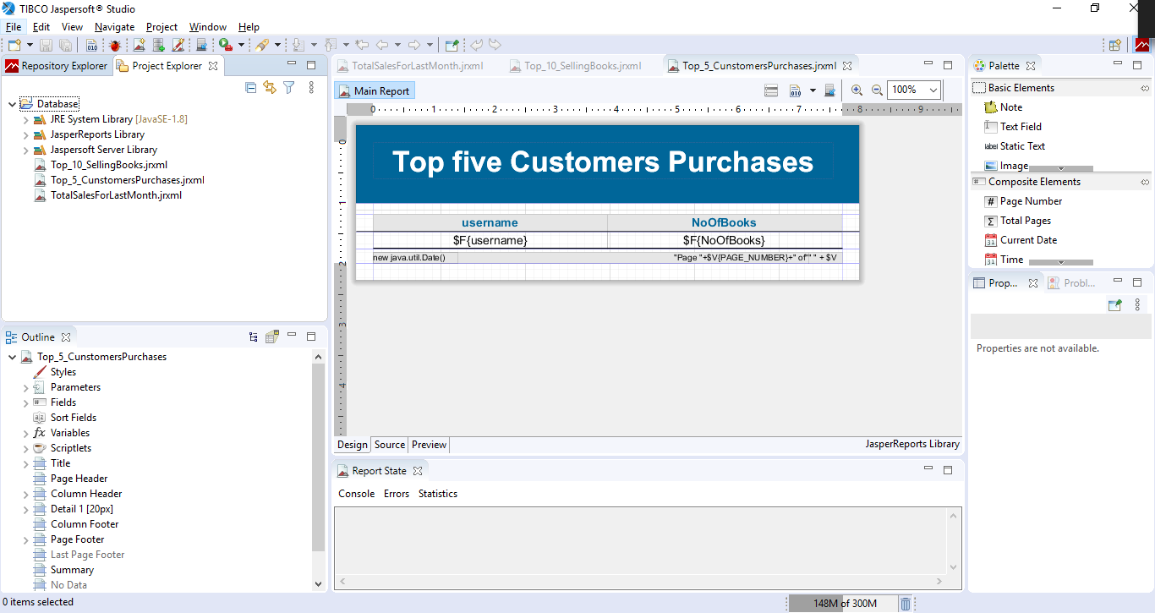

* **Top 10 selling books:**

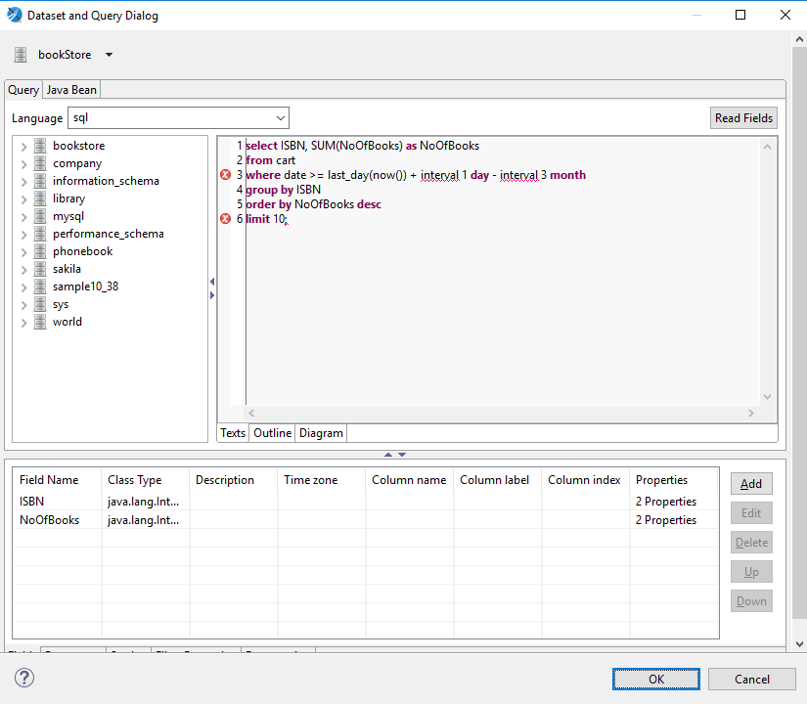

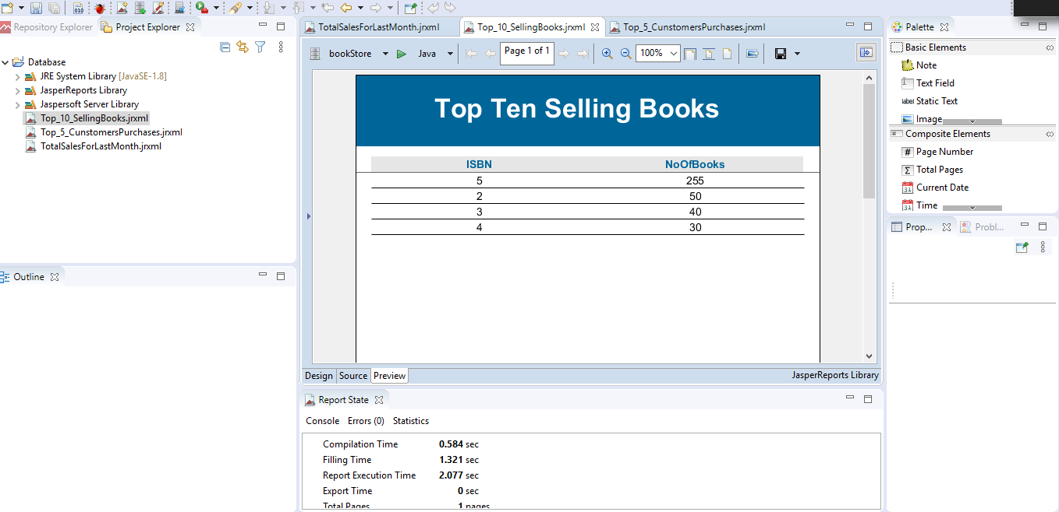

* **Top 5 customers purchase:**

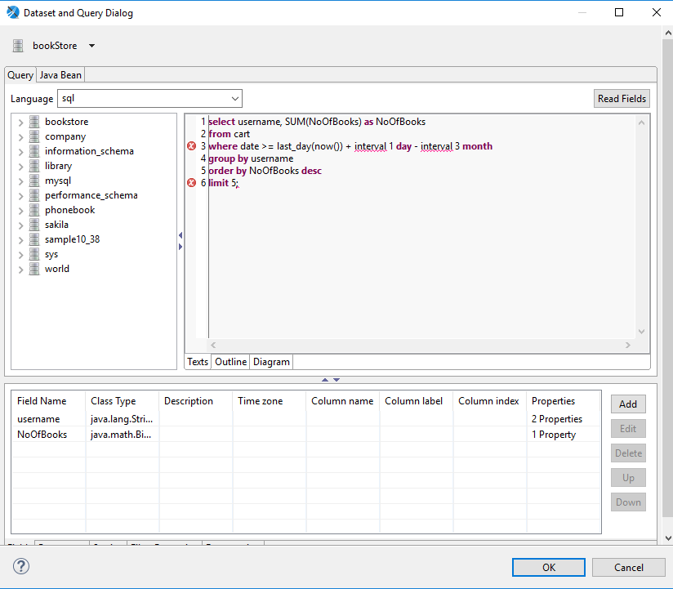

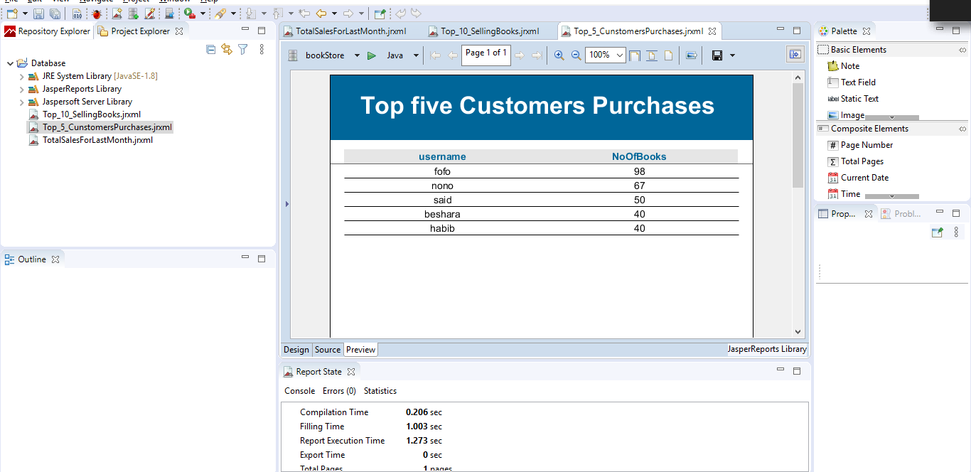

* **Total sales for last month**

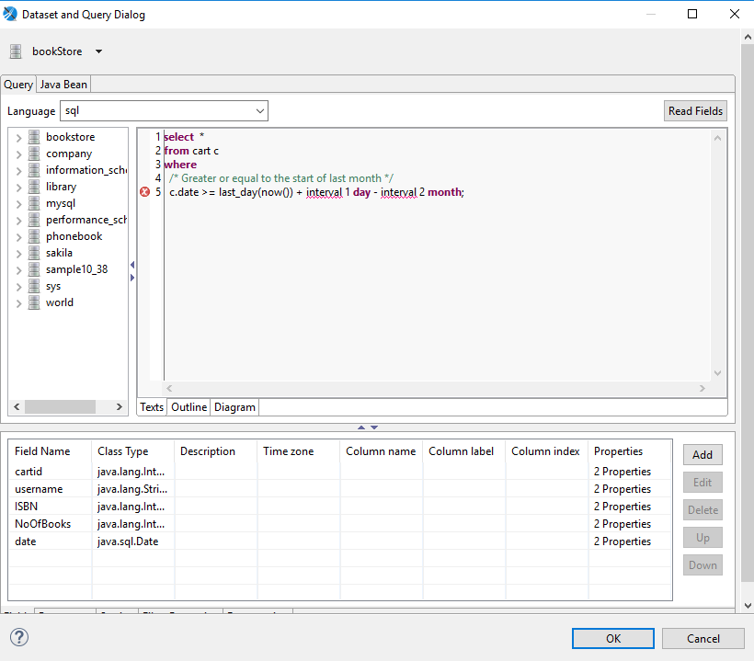

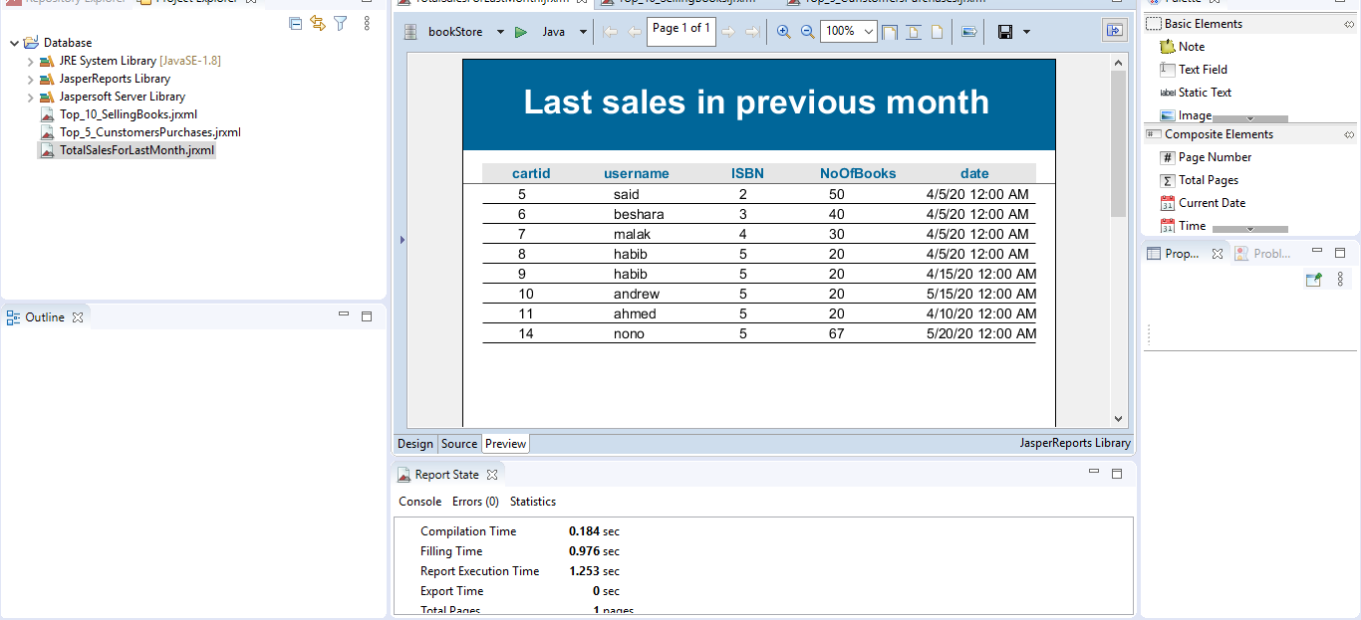

* Program screenshots:
* **Log in and Sign up:**

**Photo**

* **Managers GUI:**

**Photo**

* **Users GUI:**

**Photo**

* **Cart:**

**Photo**

**Continue in the same way**